INTERNET PROGRAMMING LAB
EXPERIMENT – 8
MEDCARE HOSPITAL ONLINE APPOINTMENT BOOKING SYSTEM
Name | Venkateswarlu
Register Number | 192411239
Course code | CSA4304

AIM
To create a simple MedCare Hospital Online Appointment Booking System using HTML, CSS, and JavaScript. Patients can enter their details, select a department, choose an appointment date, and view a confirmation.

TOOL REQUIRED
1. Visual Studio Code or any text editor
2. Web browser such as Google Chrome
3. HTML, CSS, and JavaScript

ALGORITHM
1. Start the program.
2. Create an HTML form for patient name, age, department, and appointment date.
3. Use CSS to style the hospital appointment page.
4. Use JavaScript to read the form values.
5. Validate all required fields and the patient's age.
6. Display an appointment confirmation with the submitted details.
7. Stop the program.

PROGRAM

File 1: index.html
<!DOCTYPE html>
<html lang="en">
<head>
<meta charset="UTF-8">
<meta name="viewport" content="width=device-width, initial-scale=1.0">
<title>MedCare Hospital Appointment</title>
<link rel="stylesheet" href="style.css">
</head>
<body>
<div class="container">
<h1>MedCare Hospital</h1>
<p>Online Doctor Appointment Booking</p>
<form id="appointmentForm">
<label for="name">Patient Name</label>
<input type="text" id="name" required>
<label for="age">Age</label>
<input type="number" id="age" min="1" max="120" required>
<label for="department">Choose Department</label>
<select id="department" required>
<option value="">Select department</option>
<option>General Medicine</option>
<option>Cardiology</option>
<option>Dermatology</option>
<option>Orthopedics</option>
<option>Pediatrics</option>
</select>
<label for="date">Appointment Date</label>
<input type="date" id="date" required>
<button type="submit">Book Appointment</button>
</form>
<div id="confirmation"></div>
</div>
<script src="script.js"></script>
</body>
</html>

File 2: style.css
body {
font-family: Arial, sans-serif;
background: #eaf5fb;
margin: 0;
padding: 20px;
}
.container {
max-width: 540px;
margin: 20px auto;
padding: 25px;
background: white;
border-radius: 10px;
box-shadow: 0 3px 12px #c8dce8;
}
h1, p { text-align: center; }
h1 { color: #12618a; }
form { display: flex; flex-direction: column; gap: 10px; }
label { font-weight: bold; }
input, select, button {
padding: 11px;
border: 1px solid #bbb;
border-radius: 5px;
font-size: 15px;
}
button { background: #087eaa; color: white; border: none; cursor: pointer; }
button:hover { background: #065f80; }
#confirmation { margin-top: 20px; color: #176b3a; font-weight: bold; line-height: 1.6; }
@media (max-width: 600px) {
.container { padding: 15px; }
input, select, button { box-sizing: border-box; width: 100%; }
}

File 3: script.js
document.getElementById("appointmentForm").addEventListener("submit", function(event) {
event.preventDefault();
const name = document.getElementById("name").value.trim();
const age = Number(document.getElementById("age").value);
const department = document.getElementById("department").value;
const date = document.getElementById("date").value;
const confirmation = document.getElementById("confirmation");
if (!name || !department || !date || age < 1 || age > 120) {
confirmation.textContent = "Please enter valid details in all fields.";
return;
}
confirmation.innerHTML =
"Appointment booked successfully!<br>" +
"Patient Name: " + name + "<br>" +
"Age: " + age + "<br>" +
"Department: " + department + "<br>" +
"Appointment Date: " + date;
});

OUTPUT
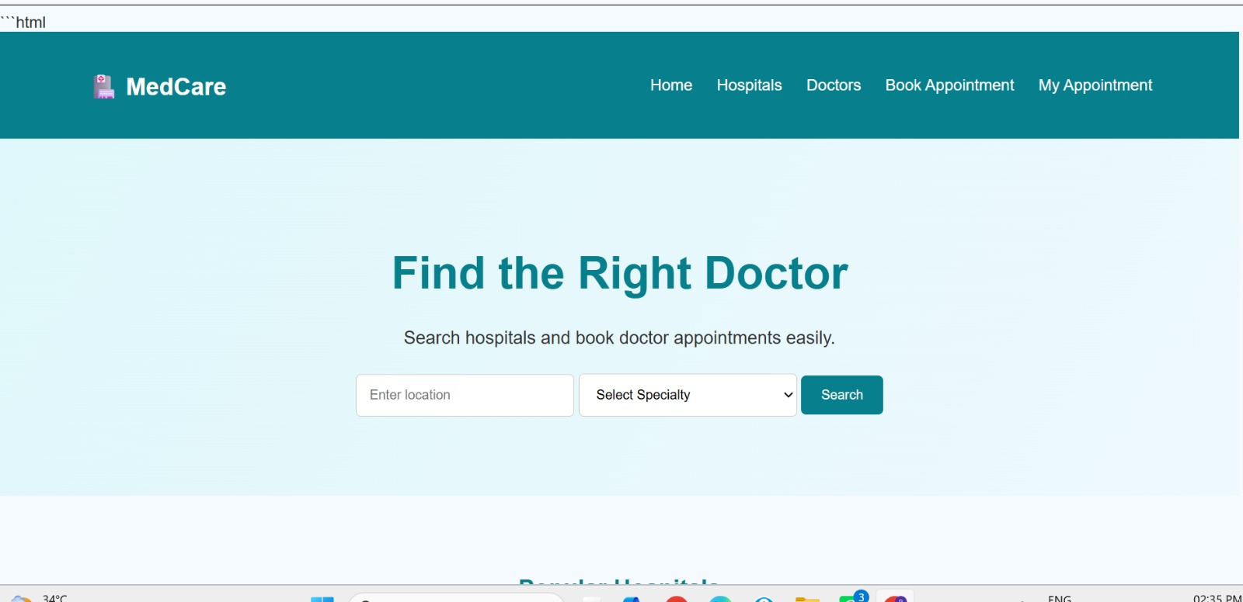

RESULT
Thus, the MedCare Hospital Online Appointment Booking System was created using HTML, CSS, and JavaScript. It validates basic details and displays an appointment confirmation. This front-end demonstration does not save bookings to a hospital database.

