SIMATS ENGINEERING
ASSESSMENT TOOL 2

COURSE NAME: INTERNET PROGRAMMING
COURSE CODE: CSA43

COURSE OUTCOME COVERED
CO -2 : Apply CSS layout and styling techniques to create visually appealing and
responsive web interfaces, and use JavaScript to enable interactive client-side behavior.
(L3)
Assessment Tool : Design Task
Weightage: 20%
Code of Conduct:

I venkateswarlu-192411239 (Name / Reg No) certify that this submission is my
original work and that I have adhered to the guidelines specified for this assessment.
I understand that any violation of academic integrity rules will result in disciplinary
action.
Signature of the student: 
Question 1: Responsive Navigation Bar Design (4 Marks)
(a) Identify key components required in a navigation bar.
The key components of an e-commerce navigation bar are:
- Logo or website name.
- Home, Products, Offers, and Contact links.
- Search bar for finding products.
- Shopping cart icon.
- Login or user account option.
- Hamburger menu for mobile devices.
(b) Design a responsive navigation bar using appropriate CSS techniques.
A responsive navigation bar can be designed using CSS Flexbox to align the logo and menu links. Media queries adjust the layout according to screen size.
(c) Demonstrate how the navigation adapts to smaller screens.
On desktop screens, all navigation links appear horizontally. On mobile screens, the links are hidden and a hamburger button is displayed. JavaScript toggles the menu when the user clicks the button.
(d) Evaluate usability and suggest improvements.
A responsive navigation bar improves accessibility and makes navigation easier on all devices. Improvements include readable text, sufficient spacing between links, clear labels, keyboard accessibility, and a visible focus indicator.
Question 2: Product Hover Effect (4 Marks)
(a) Identify suitable CSS properties for hover effects.
The suitable CSS properties are:
- transform – moves or scales a product card.
- box-shadow – adds a shadow effect.
- background-color – changes the background color.
- opacity – changes transparency.
- transition – creates smooth visual changes.
(b) Suggest appropriate CSS animation or transition.
The transition property can create smooth effects when the user moves the pointer over a product. For example:
.product-card {
transition: transform 0.3s ease, box-shadow 0.3s ease;
}
(c) Design a hover effect for a product card.
.product-card:hover {
transform: translateY(-8px);
box-shadow: 0 8px 20px #0002;
}
This moves the product card slightly upward and adds a shadow when the pointer hovers over it.
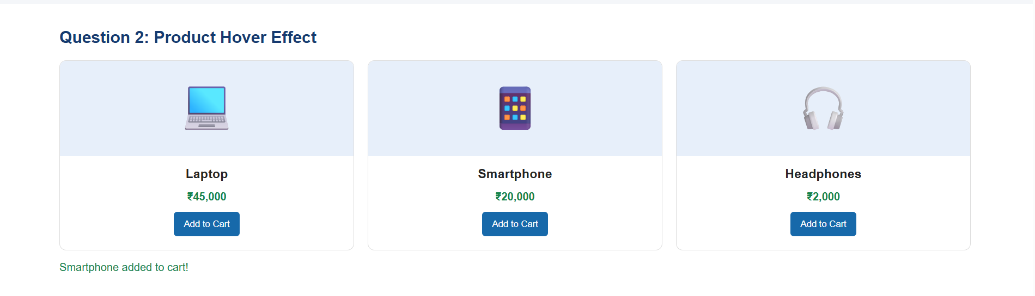

(d) Evaluate performance and user experience considerations.
Hover effects improve the visual appearance and interactivity of product cards. For better performance, use lightweight transitions and avoid unnecessary animations. Important information must remain accessible on touchscreens, where hover effects may not work.
Question 3: Layout Selection (Flexbox vs Grid) (4 Marks)
(a) Identify layout requirements of a dashboard.
A dashboard requires rows and columns to display statistics, charts, reports, and navigation panels. It should provide proper alignment, consistent spacing, and responsive resizing.
(b) Compare Flexbox and Grid based on layout needs.
Feature | Flexbox | CSS Grid
Layout | One-dimensional | Two-dimensional
Arrangement | Row or column | Rows and columns
Alignment | Excellent for linear alignment | Excellent for structured layouts
Best use | Navigation bars and toolbars | Dashboards and card layouts
Responsiveness | Supports flexible items | Supports responsive rows and columns
(c) Choose the most suitable layout technique and justify your choice.
CSS Grid is the most suitable technique for a dashboard because it manages rows and columns together. It allows statistics, charts, and reports to be arranged in a structured layout.
Example:
.dashboard {
display: grid;
grid-template-columns: repeat(3, 1fr);
gap: 15px;
}
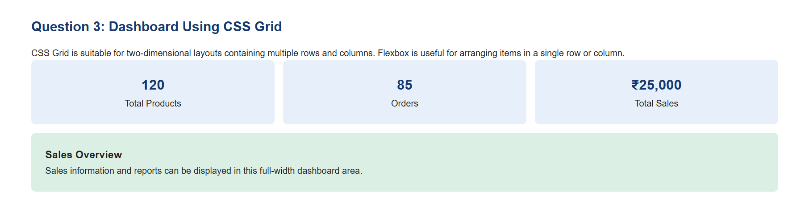

(d) Evaluate scalability and responsiveness.
CSS Grid makes it easy to add or remove dashboard sections. Media queries can change the number of columns according to screen size. For example, a three-column desktop dashboard can become a single-column layout on mobile devices.
Question 4: Mobile-First Blog Layout (4 Marks)
(a) Identify key sections of a blog layout.
The main sections of a blog layout are:
- Header and navigation bar.
- Main content area containing blog posts.
- Sidebar containing recent posts or categories.
- Footer containing copyright and contact information.
(b) Design a mobile-first layout using CSS.
A mobile-first layout starts with a single-column design that works well on small screens.
.blog-layout {
display: grid;
grid-template-columns: 1fr;
gap: 20px;
}
(c) Demonstrate how the layout scales for larger screens.
Media queries change the layout for larger screens.
@media (min-width: 768px) {
.blog-layout {
grid-template-columns: 2fr 1fr;
}
}
On mobile devices, the blog content and sidebar appear vertically. On larger screens, the content occupies two-thirds of the available space and the sidebar occupies one-third.
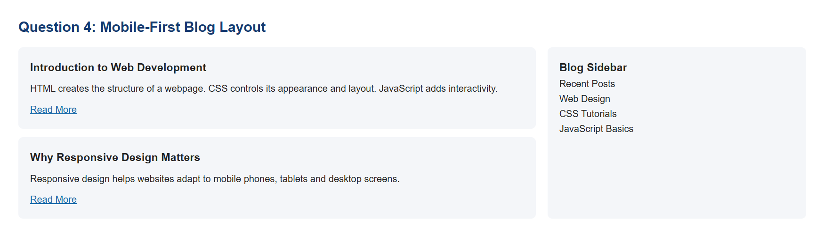

(d) Evaluate accessibility and readability.
A mobile-first design improves readability on smaller screens. Use readable font sizes, sufficient contrast, descriptive headings, semantic HTML elements, meaningful link text, and keyboard-accessible controls. Images should include suitable alternative text.
Question 5: JavaScript Event Handling for Dynamic Menu (4 Marks)
(a) Identify appropriate JavaScript events for menu interaction.
Suitable JavaScript events include:
- click – opens or closes the menu.
- mouseover – responds when the pointer enters an element.
- mouseout – responds when the pointer leaves an element.
- keydown – supports keyboard interactions.
(b) Design event-handling logic for menu toggle functionality.
JavaScript can use addEventListener() to detect a click and classList.toggle() to show or hide the menu.
(c) Implement interaction for user actions.
Example:
const button = document.getElementById("menuBtn");
const menu = document.getElementById("navLinks");

button.addEventListener("click", function () {
const isOpen = menu.classList.toggle("active");
button.setAttribute("aria-expanded", isOpen);
});
The button toggles the active class on the menu. CSS determines whether the menu is displayed or hidden.
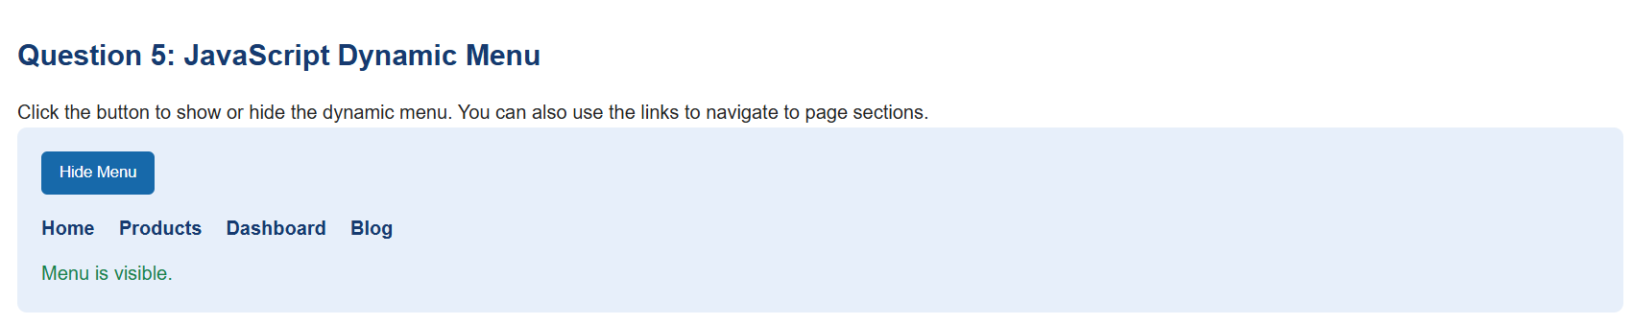
(d) Evaluate performance and suggest improvements.
Event handling makes the menu interactive and improves navigation. Use event listeners efficiently, avoid unnecessary DOM updates, provide keyboard support, and use the aria-expanded attribute to communicate the menu state to assistive technologies.

