Design of a Biosignal Based Stress Detection System Using Machine Learning Techniques

**Dr. V. Venkat Rao**,M.E,Ph.D

Associate Professor & HOD,  
Dept of ECE

Narasaraopeta Engineering College- Narasaraopet

[hodece@nrtec.in](mailto:hodece@nrtec.in)

**Dr. Sk. Ebraheem Khaleelullah**

Associate Professor

Dept of ECE

Narasaraopeta Engineering

College -Narasaraopet

[Example@gmail.com](mailto:Example@gmail.com)

G. Sai Prakash

Dept of ECE

Narasaraopeta Engineering College- Narasaraopet

[saiprakashgundemeda@gmail.com](mailto:saiprakashgundemeda@gmail.com)

P.Venkateswarlu

Dept of ECE

Narasaraopeta Engineering College-Narasaraopet

[pambavenkateswarlu0@gmail.com](mailto:pambavenkateswarlu0@gmail.com)

G. Harshitha

Dept of ECE

Narasaraopeta Engineering College-Narasaraopet

[harshithagundupalli1@gmail.com](mailto:harshithagundupalli1@gmail.com)

D. Abraham

Dept of ECE

Narasaraopeta Engineering

College- Narasaraopet

[doddaabraham41935@gmail.com](mailto:doddaabraham41935@gmail.com)

G. Usha Sri

Dept of ECE

Narasaraopeta Engineering

College- Narasaraopet

[keerthanagundla860@gmail.com](mailto:keerthanagundla860@gmail.com)

B. Raja Simha

Dept of ECE

Narasaraopeta Engineering

College- Narasaraopet

[simharaja903@gmail.com](mailto:simharaja903@gmail.com)

***Abstract*— This study proposes a robust detection system for stress leveraging machine learning algorithms and readily available bio-signals from the human body. Stress, characterized by disturbances in psychological equilibrium, poses significant health risks including cardiac rhythm abnormalities or arrhythmia. Utilizing various bio-signals such as ECG, EMG, Respiration, and GSR, our focus primarily lies on ECG due to its widespread availability and efficient feature extraction techniques. ECG not only offers easy access to recordings through mobile clinical-grade recorders but also facilitates the extraction of respiratory signal information, known as EDR (ECG Derived Respiration), obviating the need for separate sensors. We extracted features like RR interval, QT interval, and EDR from ECG signals for model development. Employing supervised machine learning, specifically Support Vector Machine (SVM) in MATLAB, we utilized Physionet’s "drivedb" database for training and validation. Different SVM model configurations were tested by varying feature selection and kernel types. Our results demonstrated a remarkable accuracy of 98.6% with the Gaussian Kernel function and utilizing all available features (RR, QT, and EDR), underscoring the significance of incorporating respiratory information in stress detection through Machine Learning.**

**Keywords: stress detection, arrhythmia, ECG Derived Respiration (EDR), Machine Learning, MATLAB, Support Vector Machine (SVM), bio-signals analysis.**

**INTRODUCTION**

Stress is typically viewed as a break in normal psychological homeostasis. When a person is unable to strike a balance between the expectations imposed on him/her and his/her ability to cope with them, it puts strain on mental health, resulting in stress. There are two types of stressors. Eustress is characterized as pleasant stress, whereas distress is the negative influence of stress on one's life. Long-term stress causes mental health problems and the emergence of many

diseases. Stress has an adverse effect on a person's social, intellectual, physical, economical, and professional well-being.

Stress can cause a variety of health issues, including numerous types of cardiovascular disease. Figure 1 depicts visually how various types of stress impact two branches of the autonomic nervous system and their subsequent repercussions, such as arrhythmogenesis. Physiological stress stimulates the sympathetic nervous system (SNS), which can lead to arrhythmias, particularly ventricular tachycardias.

The activation of SNS affects several physiological indicators, including pupil dilation, skin conductivity, respiration, and muscular activity. Furthermore, stress affects many ECG parameters such as RR, ST, QT intervals, and heart rate variability (HRV). Stress has been shown to cause decreased heart rate variability, increased QT dispersion, and altered breathing patterns. People with these alterations are at the highest risk of developing deadly ventricular arrhythmias. As a result, the diagnosis or identification of stress is critical in preventing the onset of cardiac complications.

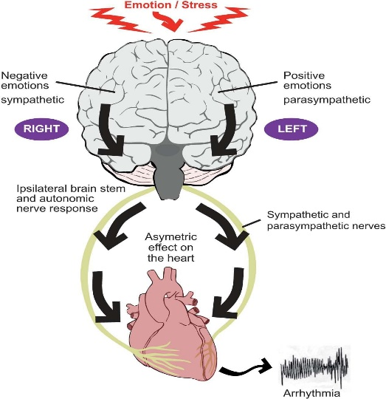

Figure 1: How Stress induces Arrhythmia

To identify stress, questionnaire-based counseling is a conventional method commonly used. However, this method may be perceived as time-consuming and costly, requiring a psychological expert to assess stress levels. Bio-signal-based detection techniques are gaining popularity due to their ability to determine real-time stress levels, thereby saving time and cost. Researchers have explored various bio-signals for stress identification, including ECG, galvanic skin response (GSR), electromyogram (EMG), skin temperature (ST), skin conductivity, respiratory rate, respiration amplitude, and blood pressure. ECG signals are particularly prominent in stress research due to their simplicity, distinctiveness, and affordability, facilitated by advances in mobile ECG recorders. Additionally, ECG provides valuable information beyond heart rate variability (HRV) parameters, including respiratory patterns, making it an ideal choice for stress detection.

Until now, most methods for stress detection have primarily relied on HRV (i.e., RR interval-based statistical features). However, in our study, we opted to utilize three key features extracted from ECG signals: QT interval, RR interval, and EDR (ECG Derived Respiration). Individuals under stress often exhibit a prolongation of the QT interval. Stress impacts the sympathetic nervous system, leading to changes in QT intervals, which tend to shorten during periods of stress. Additionally, stress influences respiratory and cardiovascular systems, with stressed individuals typically demonstrating faster and shallower breathing patterns. Parameters such as respiratory rate and respiration amplitude are closely linked to sympathetic nervous system activity, serving as indicators of stress. EDR, which mimics respiratory signals, serves as a viable alternative to separate respiration measurement systems. To detect stress, we employed a supervised machine learning approach utilizing Physionet’s "drivedb" database. Despite the potential of bio-signals for stress detection, previous research in this area has been limited, with little exploration of machine learning techniques and inconsistent model performance. The subsequent sections outline our model formulation and performance analysis..

**DATA FOR MODELLING**

For training the model, the Stress Recognition in Automobile Drivers database (“drivedb”) available at Physionet (www.Physionet.org) was utilized. This database contains ECG data recorded from healthy subjects in both normal and stressed conditions. An experimental protocol was established to detect stress induced by driving in heavy traffic conditions using physiological signals. During the experiment, subjects drove along a predefined route while their physiological reactions were monitored, including Electrocardiogram (ECG), Electromyogram (EMG), skin conductivity, and respiration. The driving protocol exposed drivers to varying road conditions and traffic levels to induce different levels of stress. A total of 15 healthy subjects' data were collected. In our study, 5 minutes of ECG signals were used for both resting and high-stress conditions. Resting conditions were categorized as "Not Stressed," while driving in heavy traffic conditions was labeled as "Stressed."

The ECG signals underwent preprocessing steps, including baseline removal filtering, to enhance signal clarity and accuracy. Following preprocessing, feature extraction was conducted utilizing a detailed methodology. Within this process, various peaks of the ECG waveform, such as the R wave peak, Q wave point, T wave peak, and T wave end, were accurately detected. From these peaks, time series data for RR interval (the interval between successive R peaks) and QT interval (the interval from the start of the Q wave to the end of the T wave) were meticulously formed, covering the entire duration of the ECG recording. Furthermore, the EDR signal was derived as a measure of the variation in R wave amplitude, which provides insight into respiratory patterns and their relationship with stress. This involved analyzing the amplitude changes of the R wave across the ECG signal. A substantial dataset comprising approximately 2500 observations was compiled for both resting and stressed conditions. These observations encompassed data points representing RR intervals, QT intervals, and EDR signals. This comprehensive dataset served as the foundation for training the stress detection model, providing a diverse and representative set of physiological responses to different stress levels.

**METHODOLOGY AND MODELING**

The modeling and validation procedures were conducted following the block diagram depicted in Figure 2. The Classification Learner app from MATLAB’s Machine Statistics and Machine Learning Toolbox was utilized for training and validating the model.

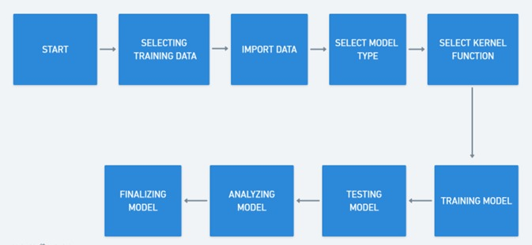

Figure 2: Block Diagram of SVN Model analysis

In this study, Supervised Machine Learning was employed for stress detection. The selected ECG features for stress identification include the QT interval, RR interval, and ECG Derived Respiration. Through analysis of these features, the model determines whether the subject is experiencing stress or relaxation. With precisely two class labels in our dataset (i.e., stressed and not stressed or relaxed), Support Vector Machine (SVM) was chosen for classification and stress detection.

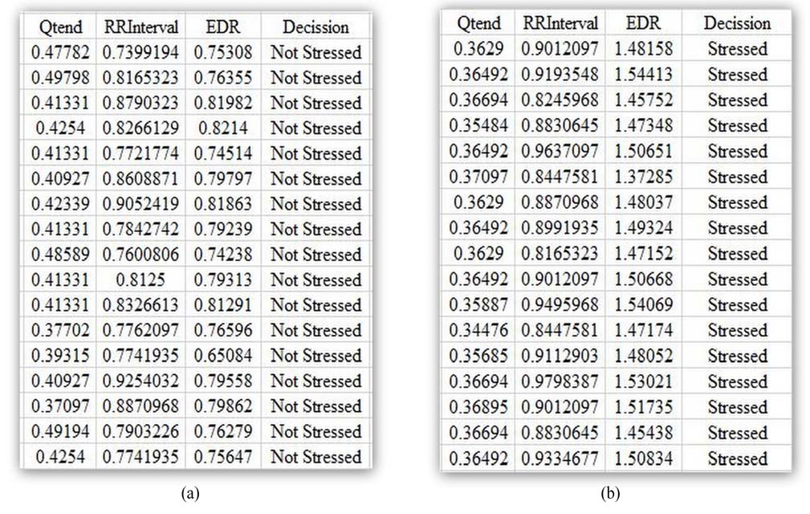

Figure 3: Training data selection

Support Vector Machine (SVM) can be used for both discrete and continuous data sets. Nevertheless, it is mostly used for discrete data sets, i.e. Classification Technique. In this method, the data is plotted into an n-dimensional plane where n is the number of features. Then classification is performed by finding the hyperplane that differentiates the two classes. Figure 3 shows the Data and decision variables processed for Model Training.

Initially, the model was trained using three SVM types (Linear, Quadratic, and Cubic) with default kernel functions. The holdout validation scheme was employed with a 50% validation split in the Classification Learner App. All three features, namely QT interval, RR interval, and ECG Derived Respiration (EDR), were utilized. Through analysis of scatter plots, confusion matrices, and ROC curves, the most accurate model was determined. Model accuracy across different SVM types is presented in Table.

1. Further adjustments to the model can be made to enhance result accuracy.

**Table 1:** Model accuracy for different types of SVM model using all the features and the default kernel function in MATLAB

|  |  |  |
| --- | --- | --- |
| **Model Name** | **Features Used** | **Accuracy** |
| Linear SVM | QT interval,  RR interval, EDR | 52.6% |
| Quadratic SVM | 88.6% |
| Cubic SVM | 97.2% |

To analyze the impact of individual features, the model was subsequently trained using only one feature to assess its effectiveness in accurately detecting stress. A notable decrease in model accuracy was observed when utilizing only a single feature, as indicated in Table 2. Furthermore, when the model was trained with only two features by deselecting any one of the three features using the "Feature Selection" option in Classification Learner and retraining the model, a decline in accuracy was evident compared to the previous iteration. Differences in model accuracy resulting from training with only two features are evident from Table 3.

**Table 2:** Model accuracy by using only one feature

|  |  |  |  |
| --- | --- | --- | --- |
| **Model Name** | **QT Interval** | **RR Interval** | **EDR** |
| Linear SVM | 50.5% | 61.3% | 48.6% |
| Quadratic SVM | 30.6% | 40.8% | 48.7% |
| Cubic SVM | 61.5% | 54.5% | 49.0% |

The combination of QT interval and RR interval yielded an accuracy of approximately 95%, surpassing the performance of other models utilizing two-feature combinations (Table 3). Previous model-based stress detection techniques predominantly relied on a single feature, typically RR interval, as evidenced in the literature. However, their performance often fell short of the desired accuracy levels for biomedical applications, typically below 95%. Therefore, in this study, we trained the model separately with QT interval, RR interval, and ECG Derived Respiration (EDR), and analyzed the results. EDR, serving as a surrogate for respiration signals, was chosen due to its similar properties and successful utilization in prior studies. Notably, no external sensors were required for recording the respiration signal. To our knowledge, no prior research has incorporated respiratory information from ECG (ECG Derived Respiration or EDR) and QT interval in stress detection using machine learning techniques.

Cubic Kernel type) the number of correctly predicted stressed and relaxed data of 98% and 97% respectively. Therefore, we can say that, without changing the default kernel function is in Classification Learner APP in MATLAB, Cubic SVM model is the best to detect stress.

If QT interval, RR interval and ECG Derived Respiration (EDR) are used separately to detect stress, the model shows very poor accuracy as shown in Table 2. Therefore, it can be concluded that the model performance will not be acceptable if we use only one feature of the ECG signal for stress detection.

If two features were used to train the model, the model accuracies were also found to be very low except of Cubic SVM for QT and RR interval. Changes with model accuracy after deducting one feature from the list can be observed in Table 3. In all cases, Linear SVM is showing very poor accuracy in detecting stress. Even if Cubic SVM is showing a bit of higher accuracy with QT interval and RR interval- based models, other feature combinations produce unacceptable performance. RR interval and EDR based

Table 3: Model accuracy by using combination of two features used for modeling

|  |  |  |  |
| --- | --- | --- | --- |
| **Model Name** | **QT, RR** | **QT, EDR** | **RR, EDR** |
| Linear SVM | 50.6% | 52.6% | 61.5% |
| Quadratic SVM | 83.5% | 86.3% | 51.2% |
| Cubic SVM | 94.9% | 89.2% | 53.1% |

“Kernel Function” can also be tuned to improve the model performance. Therefore, we have trained the models with different kernel functions. Linear and Quadratic kernel functions did not show good results. Only Gaussian and Cubic kernel function types showed promising results in detecting stress using all three features of ECG as shown in Table 4.

Table 4: Model performance by changing Kernel Functions

|  |  |  |
| --- | --- | --- |
| **Model Type** | **Kernel Function** | **Accuracy** |
| Linear SVM | Gaussian | 98.6% |
| Cubic | 97.2% |
| Quadratic SVM | Gaussian | 98.6% |
| Cubic | 97.1% |
| Cubic SVM | Gaussian | 98.6% |
| Cubic | 97.2% |

**DISCUSSION AND CONCLUSION**

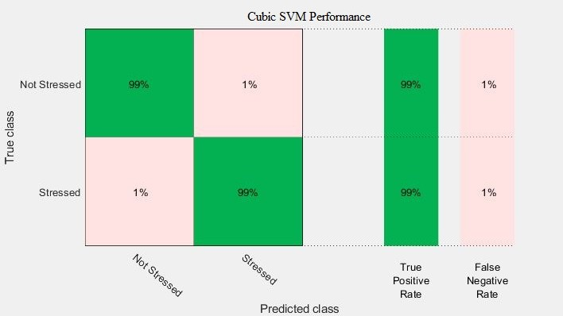Table 1 shows the model accuracies using three features of ECG. From Table 1, it was found that the model cannot be used for the detection of stress if we train it with linear SVM, because it shows only 52.6% accuracy. We analyzed the confusion matrix of linear SVM and noticed that the number of correctly predicted stressed and relaxed data is only 44% and 61% respectively. On the other hand, other SVM models i.e. Quadratic SVM, and Cubic SVM showed higher accuracy. Among them, Cubic SVM shows the highest accuracy of 97.2% with the default Kernel function (i.e. model was showing significantly lower accuracy than other feature-based models. Therefore, it can be concluded that the model will be more accurate if we use three features of ECG signal rather than two. Moreover, as long as QT interval and Respiratory information (EDR) are used as one of the two features, the model performs better than the models without QT interval. Therefore, it can be said that, QT interval and EDR are important parameters to detect stress as established by some recent studies.

Fig 4: Confusion Matrix for the Cubic SVM using

Gaussian Kernel function

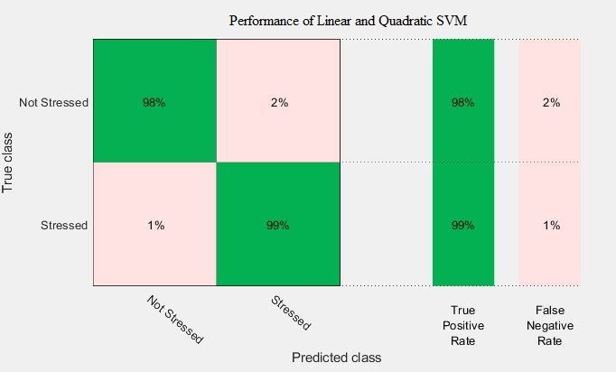We have also tried training different models by changing their kernel functions. During these training, three features of the ECG signal were used. We can easily compare the values of Linear SVM models from 1 with Table 4 and say that the model becomes very accurate if we use different kernel functions other than the default one (i.e. Linear Kernel) to modify the model. Moreover, it was found that all the models with Gaussian kernel function showed same level of high accuracy as shown in Table 4. In this case, he best model was chosen by analyzing their confusion matrix showing true positive and false negative rates. Cubic SVM with kernel function Gaussian having an accuracy of 98.6% was chosen as the best model to detect stress. It was chosen because it has correctly predicted stressed and relaxed data of 99% both where all other models with Gaussian kernel function have correctly predicted stressed and relaxed data of 99% and 98% respectively (Figure 4 and 5).

Fig 5: Confusion Matrix for the Linear and Quadratic

SVM using Gaussian Kernel function

In this paper, different models to detect stress has been trained using multiple ECG features such as QT interval, RR interval, and EDR. This method to detect stress from ECG signals can help an individual to assess one’s psychological condition as well as physical condition, from which he/she will be able to take necessary precautions. It was also concluded that the more features we use, the more accurate the model becomes.

**CONCLUSION**

After the implementation of bio-signal-based stress detection, we can finally that, the classifiers of SVM performed better compared to remaining implemented classifiers like KNN. SVM has more accuracy when trained with more features, that’s why MSVM has more accuracy than the SVM and BSVM. Stress has been classified from a dataset that was captured for drivers during the journey which produced many variations in captured signals.

**REFERENCES**

1. Fevre, Mark Le; Kolt, Gregory S.; Matheny, Jonathan,. "Eustress, distress and their interpretation in primary and secondary occupational stress management interventions: which way first?". *Journal of Managerial Psychology*, 2006, 21 (6): 547 -565. doi:10.1108/02683940610684391.
2. Das S, O'Keefe J. “Behavioral cardiology: recognizing and addressing the profound impact of psychosocial stress on cardiovascular health”. Curr Atheroscler Rep. 2006; 8:111-8.
3. Shusterman V, Aysin B, Gottipaty V, Weiss R, Brode S, Schwartzman D, Anderson KP. “Autonomic Nervous System Activity and the Spontaneous Initiation of Ventricular Tachycardia.” ESVEM Investigators. Electrophysiologic Study Versus Electrocardiographic Monitoring Trial. J Am Coll Cardiol. 1998; 32:1891-9.
4. Brodsky MA, Sato DA, Iseri LT, Wolff LJ, Allen BJ. “Ventricular Tachyarrhythmia Associated with Psychological Stress.” JAMA. 1987; 257:2064-7.
5. Leenhardt A, Lucet V, Denjoy I, Grau F, Ngoc DD, Coumel P. “Catecholaminergic polymorphic ventricular tachycardia in children. A 7-year follow-up of 21 patients.” Circulation. 1995;91:1512-9.
6. Brunckhorst CB, Holzmeister J, Scharf C, Binggeli C, Duru F. “Stress, depression and cardiac arrhythmias.” Ther Umsch. 2003;60:673-81.
7. Taggart, Peter & Boyett, Mark & Logantha, Sunil Jit & Lambiase, Pier. (2011). “Anger, Emotion, and Arrhythmias: From Brain to Heart. Frontiers in physiology.” 2. 67. 10.3389/fphys.2011.00067.
8. U. Lundberg, R. Kadefors, B. Melin et al., “Psychophysiological stress and emg activity of the trapezius muscle,” International Journal of Behavioral Medicine, vol. 1, no. 4, pp. 354–370, 1994.
9. J. Wijsman, B. Grundlehner, J. Penders, and H. Hermens, “Trapezius muscle EMG as predictor of mental stress,” in Proceedings of the 1st Wireless Health Conference (WH ’10), pp. 155–163, ACM, October 2010.
10. Crescentini C., Chittaro L., Capurso V., Sioni R., Fabbro F., “Psychological and physiological responses to stressful situations in immersive virtual reality: Differences between users who practice mindfulness meditation and controls”, Computers in Human Behavior, Vol. 59, June 2016, pp. 304-316.

model was showing significantly low accuracy than other feature-based models. Therefore, it can be concluded that the model will be more accurate if we use three features of ECG signal rather than two. Moreover, as long as QT interval and Respiratory information (EDR) are used as one of the two features, the model performs better than the models without QT interval. Therefore, it can be said that, QT interval and EDR are important parameters to detect stress as established by some recent studies.



Fig 4: Confusion Matrix for the Cubic SVM using Gaussian Kernel function

We have also tried training different models by changing their kernel functions. During these training, three features of the ECG signal were used. We can easily compare the values of Linear SVM models from 1 with Table 4 and say that the model becomes very accurate if we use different kernel functions other than the default one (i.e. Linear Kernel) to modify the model. Moreover, it was found that all the models with Gaussian kernel function showed same level of high accuracy as shown in Table 4. In this case, he best model was chosen by analyzing their confusion matrix showing true positive and false negative rates. Cubic SVM with kernel function Gaussian having an accuracy of 98.6% was chosen as the best model to detect stress. It was chosen because it has correctly predicted stressed and relaxed data of 99% both where all other models with Gaussian kernel function have correctly predicted stressed and relaxed data of 99% and 98% respectively (Figure 4 and 5).



Fig 5: Confusion Matrix for the Linear and Quadratic SVM using Gaussian Kernel function

In this paper, different models to detect stress has been trained using multiple ECG features such as QT interval, RR

interval, and EDR. This method to detect stress from ECG signal can help an individual to assess one’s psychological condition as well as physical condition, from which he/she will be able to take necessary precautions. It was also concluded that, the more features we use, the more accurate the model becomes.

REFERENCES

1. Fevre, Mark Le; Kolt, Gregory S.; Matheny, Jonathan,. "Eustress, distress and their interpretation in primary and secondary occupational stress management interventions: which way first?". *Journal of Managerial Psychology*, 2006, 21 (6): 547 -565. doi:10.1108/02683940610684391.
2. Das S, O'Keefe J. “Behavioral cardiology: recognizing and addressing the profound impact of psychosocial stress on cardiovascular health”. Curr Atheroscler Rep. 2006; 8:111-8.
3. Shusterman V, Aysin B, Gottipaty V, Weiss R, Brode S, Schwartzman D, Anderson KP. “Autonomic Nervous System Activity and the Spontaneous Initiation of Ventricular Tachycardia.” ESVEM Investigators. Electrophysiologic Study Versus Electrocardiographic Monitoring Trial. J Am Coll Cardiol. 1998; 32:1891-9.
4. Brodsky MA, Sato DA, Iseri LT, Wolff LJ, Allen BJ. “Ventricular Tachyarrhythmia Associated with Psychological Stress.” JAMA. 1987; 257:2064-7.
5. Leenhardt A, Lucet V, Denjoy I, Grau F, Ngoc DD, Coumel P. “Catecholaminergic polymorphic ventricular tachycardia in children. A 7-year follow-up of 21 patients.” Circulation. 1995;91:1512-9.
6. Brunckhorst CB, Holzmeister J, Scharf C, Binggeli C, Duru F. “Stress, depression and cardiac arrhythmias.” Ther Umsch. 2003;60:673-81.
7. Taggart, Peter & Boyett, Mark & Logantha, Sunil Jit & Lambiase, Pier. (2011). “Anger, Emotion, and Arrhythmias: From Brain to Heart. Frontiers in physiology.” 2. 67. 10.3389/fphys.2011.00067.
8. U. Lundberg, R. Kadefors, B. Melin et al., “Psychophysiological stress and emg activity of the trapezius muscle,” International Journal of Behavioral Medicine, vol. 1, no. 4, pp. 354–370, 1994.
9. J. Wijsman, B. Grundlehner, J. Penders, and H. Hermens, “Trapezius muscle EMG as predictor of mental stress,” in Proceedings of the 1st Wireless Health Conference (WH ’10), pp. 155–163, ACM, October 2010.
10. Crescentini C., Chittaro L., Capurso V., Sioni R., Fabbro F., “Psychological and physiological responses to stressful situations in immersive virtual reality: Differences between users who practice mindfulness meditation and controls”, Computers in Human Behavior, Vol. 59, June 2016, pp. 304-316
11. J. Taelman, S. Vandeput, A. Spaepen, and S. V. Hu el, “Influence of mental stress on heart rate and heart rate variability,” in Proceedings 4th European Conference of the International Federation for Medical and Biological Engineering (IFMBE ’09), pp. 1366–1369,2009.
12. T.S. Lorig, “The Respiratory System,” *Handbook of Psychophysiology*, J.T. Cacioppo, L.G. Tassinary, and G.G.

Berntson, eds., Cambridge Univ. Press, 2007.