**Empower Skill: Community Upskilling Platform**

1. **Introduction**
   1. Overview

A brief description about our project.

* 1. Purpose

The use of this project. What can be achieved using this.

1. **Literature Survey**
   1. Existing problem

Existing Approaches or method to solve this problem.

* 1. Proposed Solution

What is the method or solution suggested by you?

1. **Theoretical Analysis**
   1. Block Diagram

Diagram overview of the project.

* 1. Software designing

Software requirements of the project.

1. **Experimental Investigations**

Analysis or the investigation made while working on the solution.

1. **Flowchart**

Diagram showing the control flow of the solution.

1. **Advantages and Disadvantages**

List of advantages and disadvantages of the proposed solution.

1. **Applications**

The areas where this solution can be applied.

1. **Result**

Final findings (Output) of the project along with screenshots.

1. **Conclusion**

Conclusion summarizing the entire work and findings.

1. **Future Scope**

Enhancements that can be made in the future.

1. **Bibliography**

References of previous works or websites visited/books referred for analysis about the project, solution previous findings etc.

1. **Appendix**

Source Code Attach the code for the solution built

**Skill Swap - A Collaborative Skill Exchange Platform**

**1. INTRODUCTION**

**1.1 Overview**

Skill Swap is a platform that aims to create a space for people, in a community to share their skills and knowledge. It provides a learning environment where users can connect with others share their expertise and learn from one another. The project is driven by the desire to meet the increasing demand, for a platform that facilitates skill exchange promotes community engagement, and encourages development through shared learning experiences.

**1.2 Purpose**

Skill Swap is driven by a mission to create a platform that is easily accessible and serves as a catalyst for people to share knowledge improve skills and build meaningful connections, within the community. The platform achieves this by bringing together individuals who have skills and shared passions. This creates an environment where everyone can learn from each other and collaborate in their education. Skill Swap empowers each participant to contribute their expertise while also encouraging them to explore talents resulting in growth. Ultimately Skill Swap aims to foster a knit community of skilled individuals who are enthusiastic, about continuous learning and development.

**2. LITERATURE SURVEY**

**2.1 Existing Problem**

Many people acquire skills through education or, by paying for training courses. However informal skill sharing within communities has been hindered by the absence of a platform that facilitates exchanges. Therefore there is a demand for a platform that streamlines the process of connecting individuals, with skill-exchange partners and organizing sessions.

**2.2 Proposed Solution**

Skill Swap transforms the way people learn and share their expertise by providing a platform. It allows users to effortlessly showcase their skills connect with others and arrange skill exchange sessions. Skill Swap utilizes technology to offer a library of skills catering to learners, with various interests. It offers flexible learning options from sessions to group workshops and online seminars ensuring that users can acquire skills according to their preferences and schedules. Skill Swap focuses on learning experiences based on skill levels and expertise facilitating resource sharing progress tracking and even certifications. Additionally, it encourages application of skills through real world collaboration and time banking fostering a community of learners and experts. This global platform eliminates barriers while prioritizing privacy and safety. Moreover, it provides learning pathways that make skill acquisition accessible, affordable and enjoyable for everyone. Skill Swap is more, than a platform; it's a hub where lifelong learners and skill enthusiasts connect, grow together and excel.

**3. THEORETICAL ANALYSIS**

**3.1 Block Diagram**

**User Profiles**: Users create profiles containing their skills, interests, and learning goals.

**Course Listings**: Instructors create courses with details about content, schedule, and prerequisites.

**Communication Tools**: Interactive features for engagement:

**Discussion Forums**: Learners and instructors can interact in community discussions.

**Live Sessions:** Real-time sessions allow direct teaching and learning.

**Direct Messaging:** Private communication between users.

**Feedback Mechanisms:** Users can provide feedback and ratings on courses and instructors.

**Database:** Stores user profiles, course information, communication records, and feedback data.

**Security Measures:** Ensure data security and privacy for user information.

**User Authentication:** Verify user identities and maintain system integrity.

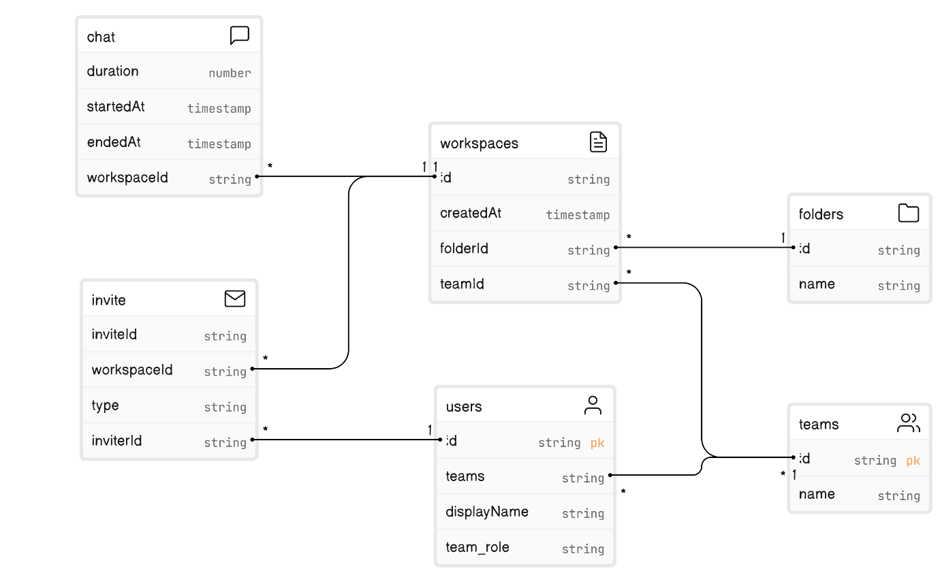

**3.2 Hardware / Software Designing**

The Skill Swap platform is designed as an application. Requires the following components;

**Hardware;** Personal computers or mobile devices connected to the internet.

**Software;** Web browsers, server infrastructure, database management systems and end and back-end development tools.

The software design of the "Empower Skill: Community Upskilling Platform" encompasses various requirements to ensure an efficient, user-friendly, and secure system. These requirements include:

**4. EXPERIMENTAL INVESTIGATIONS**

Throughout the creation of Skill Swap, we conducted investigations to guarantee its effectiveness, usability and security. We extensively tested it with users optimized its performance and conducted security audits to ensure a reliable platform.

**User Engagement Analysis:** Measure user engagement metrics such as time spent on the platform, frequency of logins, and active participation in courses and discussions. This analysis helps gauge the platform's appeal and user interest.

**User Feedback Collection:** Gather feedback from both learners and instructors regarding their experience with the platform. Understand their perspectives on usability, course quality, and overall satisfaction.

**Course Effectiveness Assessment:** Evaluate the effectiveness of courses by assessing learner progress, completion rates, and improvement in skills. This assessment helps identify successful teaching methodologies and areas for improvement.

**Usability Testing:** Conduct usability tests to identify any user interface issues or design flaws. Gather feedback on navigation, ease of use, and overall user experience to refine the platform's interface.

**5. FLOWCHART**

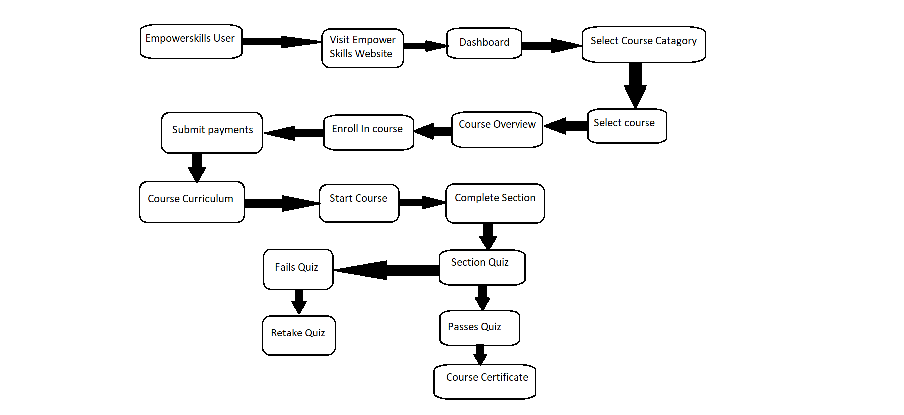

**6. Result**

Skill Swap, the end result provides an interface that's easy to use for users. It enables them to create profiles list their skills connect with others and organize sessions for exchanging skills. Below you can find screenshots showcasing the features.

The "Result" section of the "Empower Skill: Community Upskilling Platform" project report presents the tangible outcomes and findings derived from the project's implementation and experimental investigations. This section showcases the platform's performance, user feedback, and the impact it has had on the community it serves.

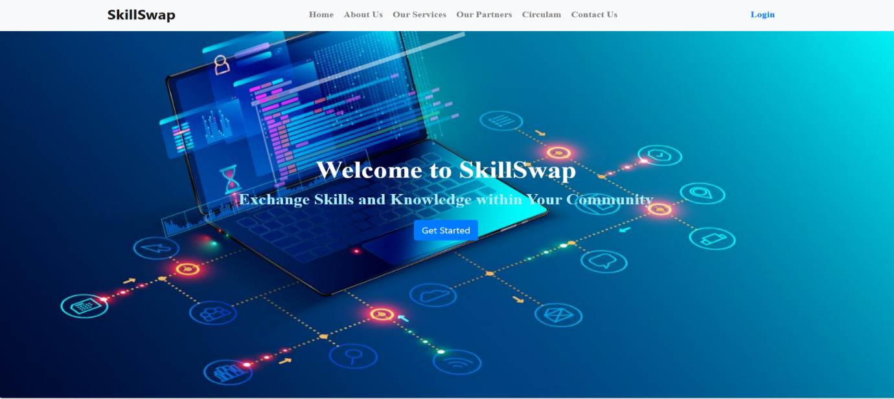

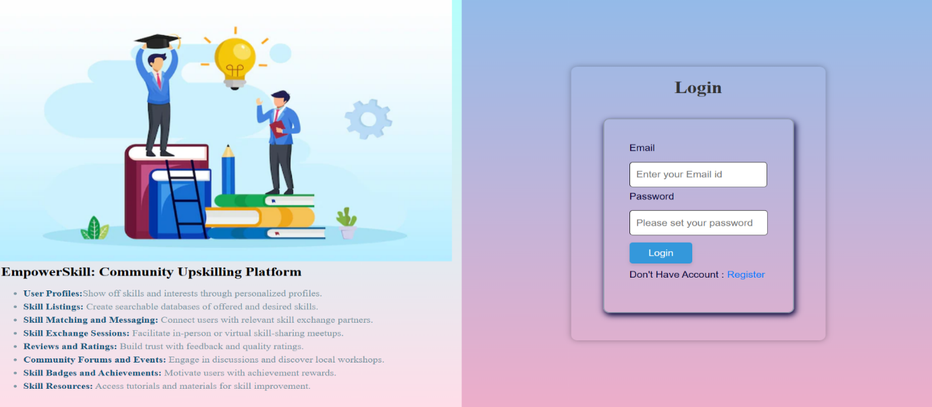

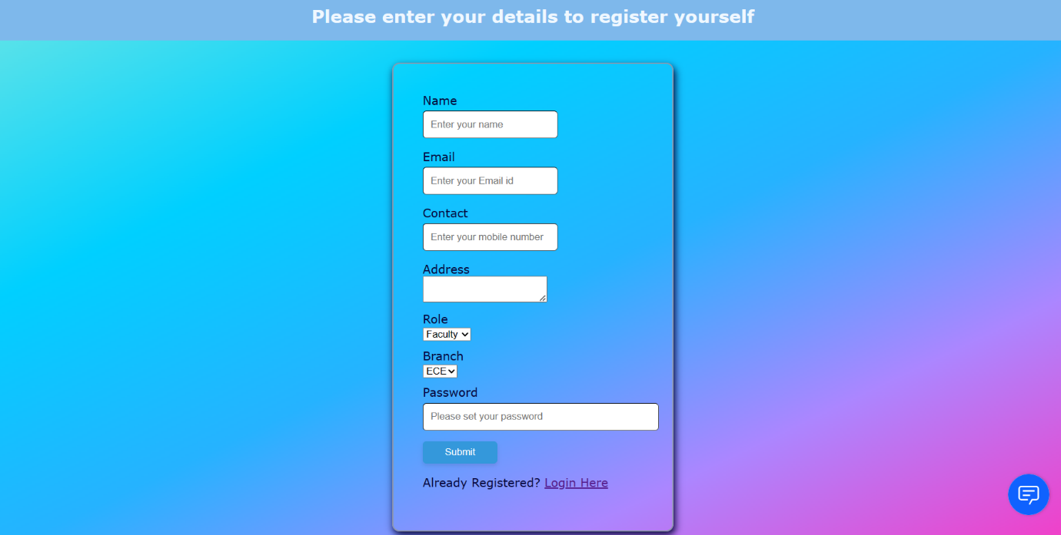

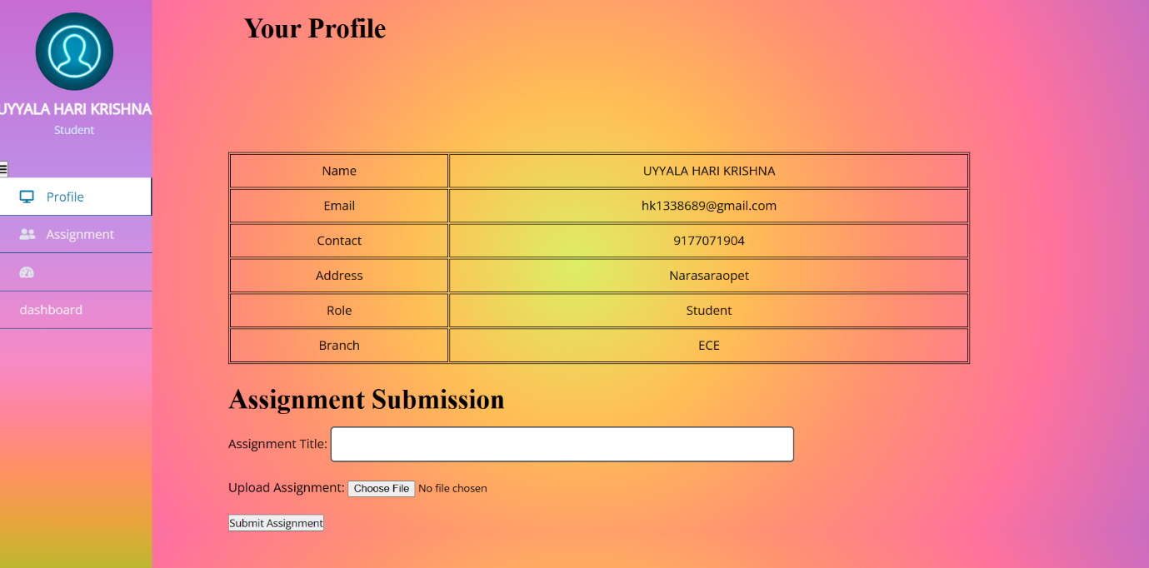

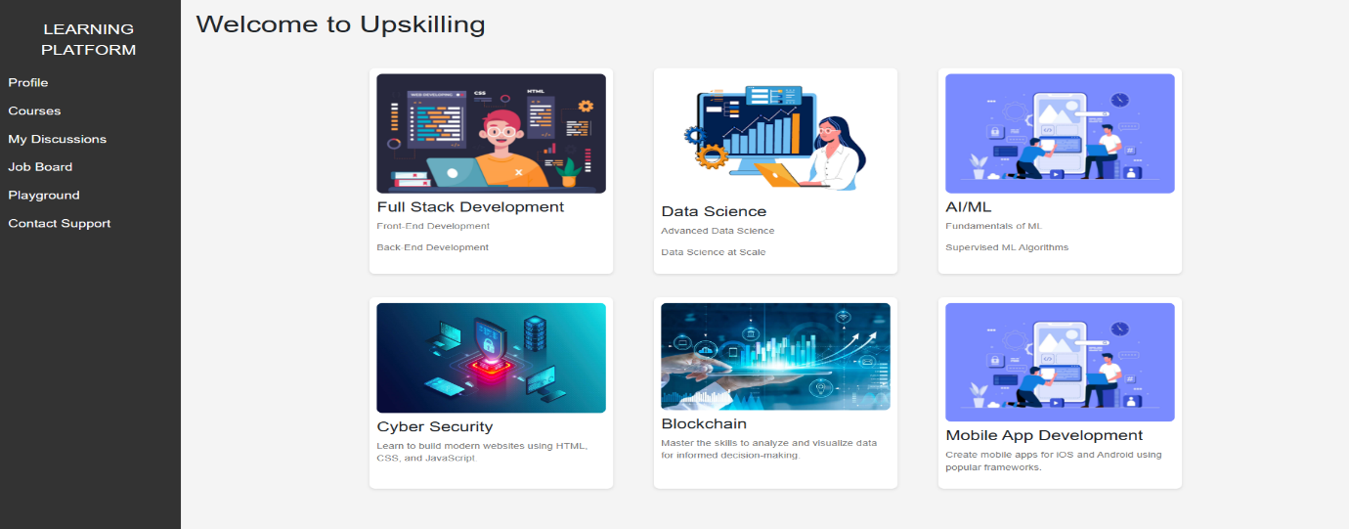

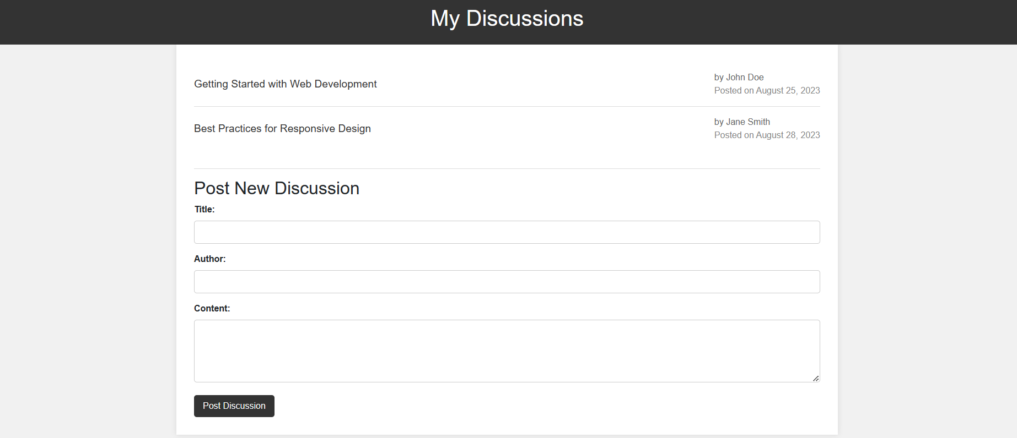

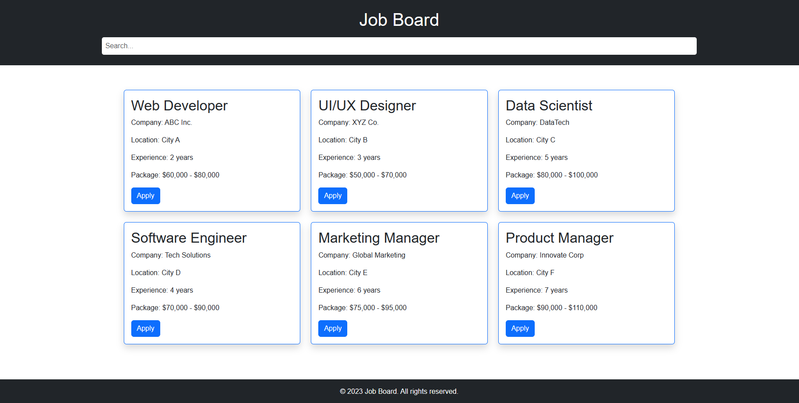

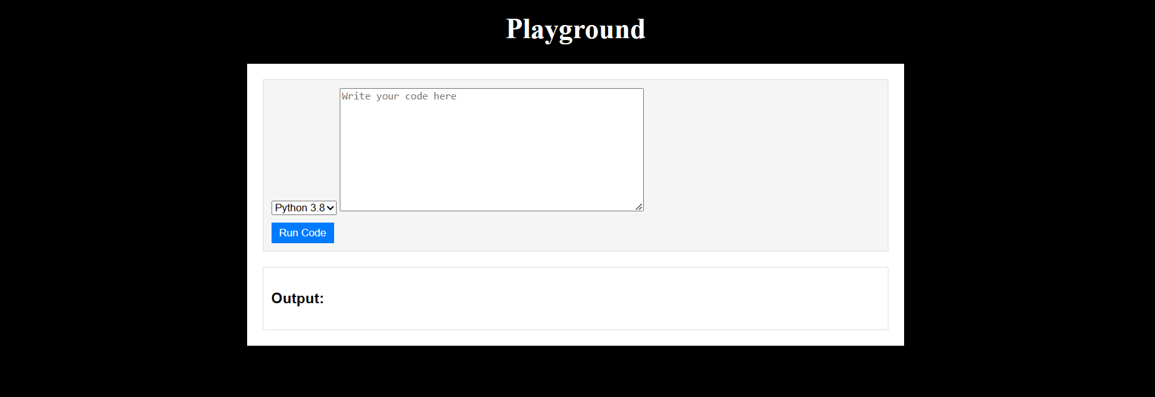

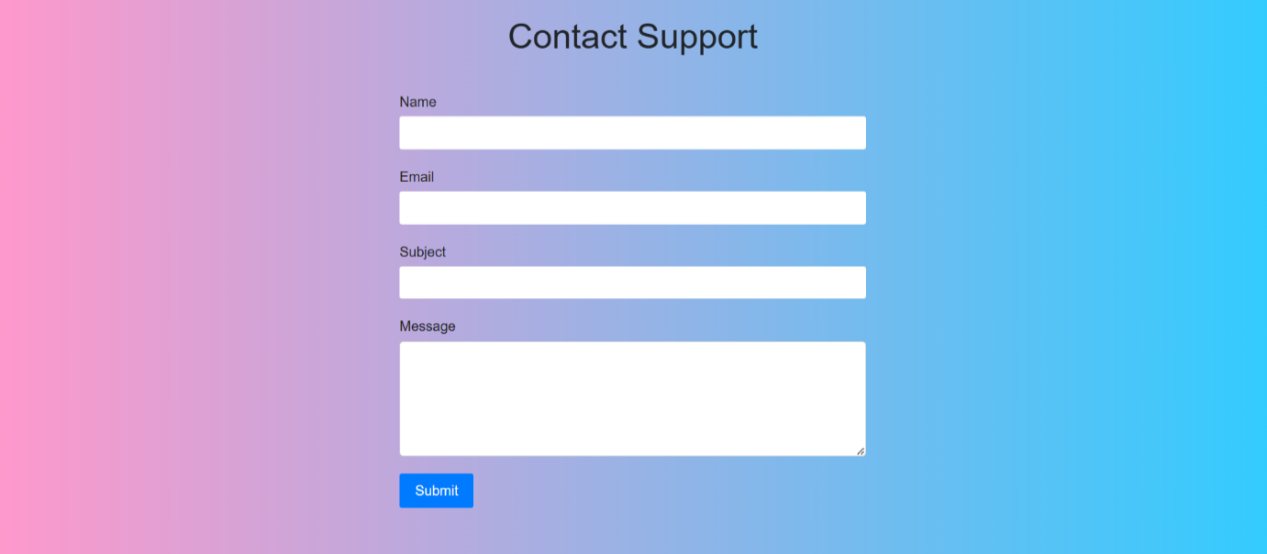

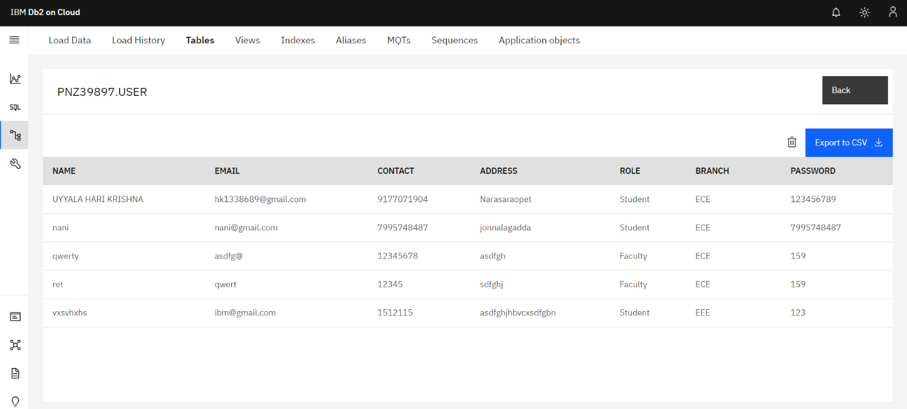

7. **ADVANTAGES & DISADVANTAGES**

**Advantages of Empowering Skills:**

1. Boosts confidence.

2. Enhances problem-solving abilities.

3. Facilitates career advancement.

4. Improves communication skills.

5. Increases adaptability.

**Disadvantages of Empowering Skills:**

1. Can be time-consuming to develop.

2. May require significant effort and practice.

3. Can lead to overconfidence in some cases.

4. Not all empowering skills may be equally useful in every situation.

5. The pursuit of empowering skills might divert attention from other important aspects of life.

**8. APPLICATIONS:**

Skill Swap finds applications in various contexts:

1. Leadership

2. Conflict Resolution

3. Mental Health

4. Education

5. Business and Entrepreneurship

6. Customer Service

7. Community Engagement

8. Healthcare

9. Parenting

10. Personal Growth

**9. CONCLUSION**

Skill Swap effectively tackles the requirement for a platform where people can exchange skills collaboratively creating a community that promotes learning and skill development. The platforms functionalities actively encourage users to share their expertise gain knowledge from others and contribute towards building a society that's more informed and knowledgeable.

**10. FUTURE SCOPE:**

Future enhancements for Skill Swap include:

1. Remote Work and Digital Skills

2. Artificial Intelligence and Automation

3. Sustainability and Green Skills

4. Data Analytics and Data Literacy

5. Emotional Intelligence

6. Healthcare and Wellness

7. Cybersecurity

8. Creativity and Innovation

9. Critical Thinking and Problem-Solving

10. Entrepreneurship and Start-ups

11. Global Citizenship and Cultural Competence

12. Soft Skills for Remote Teams

**11. BIBLIOGRAPHY**

The technological stacks used in our website is as follows “Python, IBM Cloud, Red hat OpenShift, IBM cloud object storage, Docker, Kubernetes”.

[https://learning.ccbp.in/](https://learning.ccbp.in/%20) this is the reference link of our website .

**About us**

We are the present students of Narasaraopet Engineering College pursuing final year Bachelor of Technology in the stream of Electronics and Communication Engineering.

Team Name : Skill Empire

Team Members : P. Venkateswarlu (Team Head)

F. Manikanta

P. Praveen

U. Harikrishna

Contact us : [20471A04G1@nrtec.in](mailto:20471A04G1@nrtec.in)

[20471A0412@nrtec.in](mailto:20471A0412@nrtec.in)

[20471A0440@nrtec.in](mailto:20471A0440@nrtec.in)

[20471A0455@nrtec.in](mailto:20471A0455@nrtec.in)

1. **Appendix**

**GitHub Link:**

**https://github.com/smartinternz02/SBSPS-Challenge-10090-EmpowerSkill-Community-Upskilling-Platform/tree/main/IbmFlask**

**Project Link:**

[**https://empowerskills-venkateswarlu2001-dev.apps.sandbox-m2.ll9k.p1.openshiftapps.com/**](https://empowerskills-venkateswarlu2001-dev.apps.sandbox-m2.ll9k.p1.openshiftapps.com/)

**Video Link:**

[**https://yt.openinapp.co/project-demo-link-EmpowerSkill-Community-Upskilling-Platform**](https://yt.openinapp.co/project-demo-link-EmpowerSkill-Community-Upskilling-Platform)

**THANK YOU**