AI Product Intelligence System
Project Report
Name: Venkat Gopi Juturi | Batch: 2027, AI & ML
Email: venkatgopi2005@gmail.com
Models used: BLIP, CLIP (ViT-B/32), FAISS

1. Project Overview
This project builds an AI-powered Product Intelligence System for a fashion e-commerce catalogue. It uses two vision-language models, BLIP for image captioning and CLIP for joint image-text embeddings, along with FAISS for fast similarity search. Together these power three practical e-commerce features described below.
Task | Description | Model(s) Used
Setup | Load dataset, load BLIP and CLIP, build a FAISS index | BLIP + CLIP
Task 1 | Smart product recommendation (items bought together) | CLIP similarity
Task 2 | Unique product catalog creation (deduplication) | CLIP + cosine clustering
Task 3 | Reverse product search (text to products) | CLIP shared embedding space
Dataset: Fashion Product Images (Small) by paramaggarwal, with 44,419 labelled fashion products (images, categories, colours, gender). A random sample of 500 products was used to build the embedding index, since this keeps runtime practical on Kaggle while still proving the approach works at scale.

2. System Setup

2.1 Environment and Device
The notebook checks for a GPU and falls back to CPU automatically, so it runs without changes on Kaggle, Colab, or a local machine.

2.2 Dataset Statistics
After loading styles.csv and dropping rows whose image files are missing, the notebook prints basic statistics: number of master categories, article sub-types, colours, gender split, and the most common article types such as T-shirts, shirts, casual shoes, and watches.

2.3 Model Loading
- BLIP (Salesforce/blip-image-captioning-base) for automatic image captioning.
- CLIP (ViT-B/32) to generate 512-dimensional embeddings for both images and text in one shared space.

2.4 Building the FAISS Index
CLIP image embeddings were generated for the 500-product sample and normalised. A FAISS IndexFlatIP (inner product) index was built over these 512-D vectors, which behaves the same as cosine similarity once vectors are normalised. This index is what powers Task 1 and Task 3.
Metric | Value
Total products in dataset | 44,419
Sample indexed | 500
Embedding dimension | 512 (CLIP ViT-B/32)
Index type | FAISS IndexFlatIP (cosine similarity)

3. Task 1 — Smart Product Recommendation Engine

3.1 Problem
Suggest complementary products that are usually bought together with a given item — for example, recommending shoes to go with sunglasses, or a belt to go with a shirt.

3.2 Approach
A complementary-category map was created by hand for 16 categories (for example, Shirts maps to Trousers, Formal Shoes, and Belts). For a given product, candidates are pulled from its mapped categories, then re-ranked using CLIP similarity to the query product, so the most visually matching items are shown first.

3.3 Demo Run
Query product: Image Women Classic Eyewear Brown Sunglasses (Accessories, Sunglasses, Brown, Women)
Top complementary recommendations returned:
Rank | Product | Type | Colour | CLIP Score
1 | Enroute Women DK.Grey Shoes | Casual Shoes | Grey | 0.849
2 | Enroute Women Beige Shoes | Casual Shoes | Beige | 0.843
3 | Arrow Men Olive Shoes | Casual Shoes | Olive | 0.832
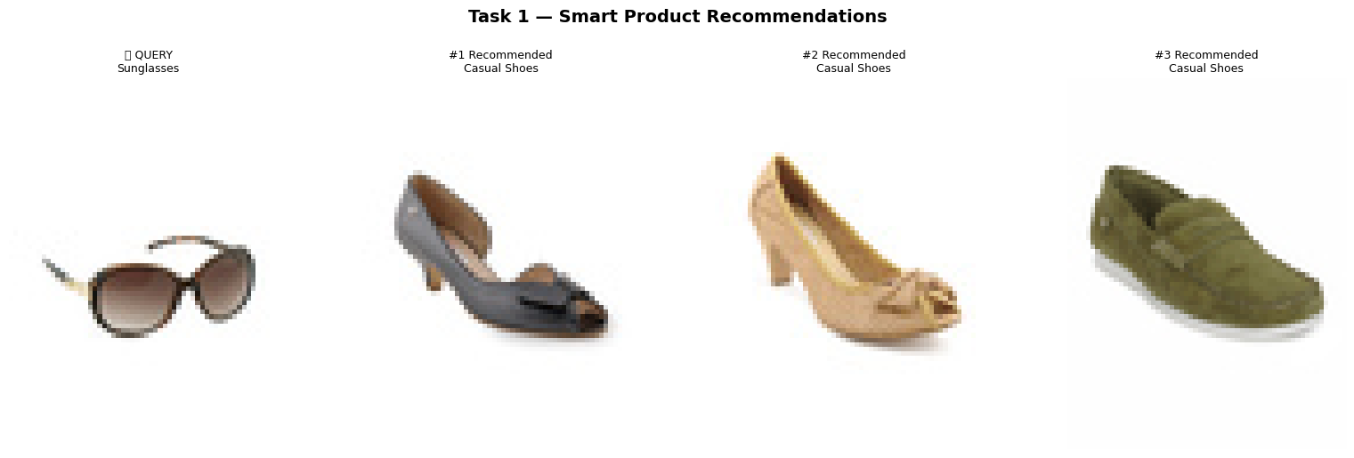
Figure 1: Query product (sunglasses) with its top three recommended items.
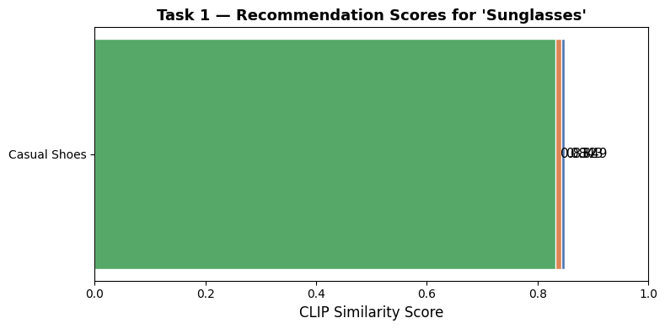
Figure 2: CLIP similarity scores for the recommended items.

3.4 Result
The recommender finds cross-category, style-matching products without needing any purchase history, which a typical collaborative-filtering recommender would normally require.

4. Task 2 — Unique Product Catalog Creation (Deduplication)

4.1 Problem
Large marketplaces often end up with duplicate or near-duplicate listings of the same physical product, uploaded by different sellers or with slightly different titles. The goal is to automatically collapse these into one listing per unique product.

4.2 Approach
A greedy clustering method goes through the catalogue in order. Each product becomes a new representative unless its CLIP cosine similarity to an already-chosen representative is above 0.92, in which case it is grouped as a duplicate of that representative instead.

4.3 Results
Metric | Value
Similarity threshold | 0.92
Original products | 500
Unique products kept | 328
Duplicates removed | 172 (34.4%)
Duplicate groups found | 70
Example: one duplicate group had 10 listings collapse into 1. A brown women's sunglasses listing was kept as the representative, while nine visually similar sunglasses listings from other brands (Opium, Ray-Ban, M.tv, Louis Philippe, Idee, Van Heusen, Polaroid, United Colors of Benetton) were grouped as duplicates of it.
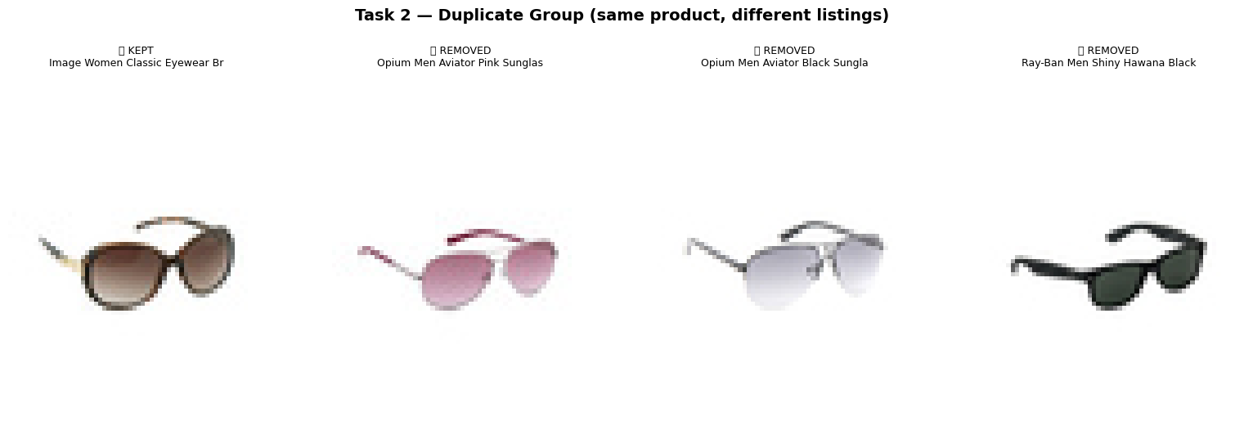
Figure 3: One duplicate group — the kept item next to three removed near-duplicates.
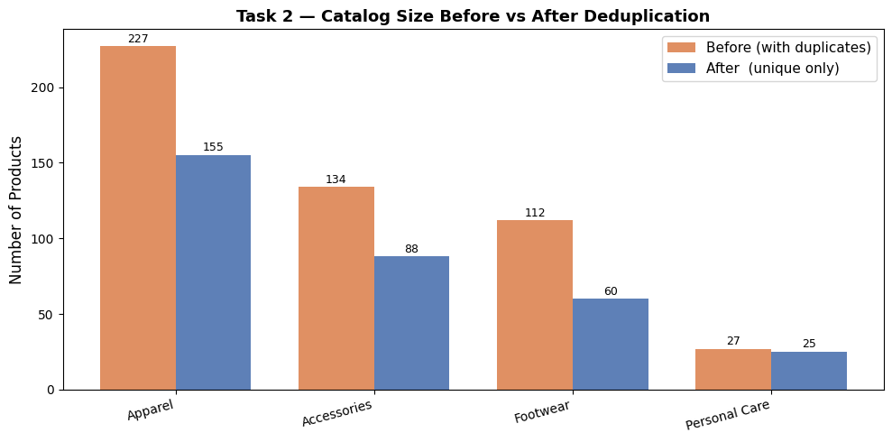
Figure 4: Catalog size before and after deduplication, by category.

4.4 Result
Across the main categories — Apparel, Accessories, Footwear, and Personal Care — the catalogue shrank noticeably while still keeping one image per visually distinct product. This directly fixes the kind of duplicate-listing clutter that hurts both search quality and seller-side analytics.

5. Task 3 — Reverse Product Search (Text to Products)

5.1 Problem
Let users search the catalogue with a plain-language description, such as "blue casual shirt for men", instead of needing an example image to search with.

5.2 Approach
CLIP places images and text into the same 512-dimensional space. So a text query can be embedded once with the CLIP text encoder and compared directly against the same FAISS image index already built earlier — no retraining or second index is needed.

5.3 Demo Queries and Results
Query: "blue casual shirt for men"
Rank | Product | Type / Colour | Score
1 | French Connection Men Light Blue Shirt | Shirts / Blue | 0.332
2 | Wrangler Men Stampede Green Shirt | Shirts / Green | 0.325
3 | Basics Men Navy Shirt | Shirts / Navy | 0.323
4 | Highlander Men Check Blue Shirt | Shirts / Blue | 0.321
5 | Myntra Men Blue and Green Check Shirt | Shirts / Blue | 0.321
Three more queries were tested: "red dress for women", "white sports shoes", and "black leather handbag". Each one returned correct top matches (red tops and kurtas for the dress query, white casual or sports shoes for the shoe query, black handbags and clutches for the handbag query), showing that the shared embedding space generalises well across categories.
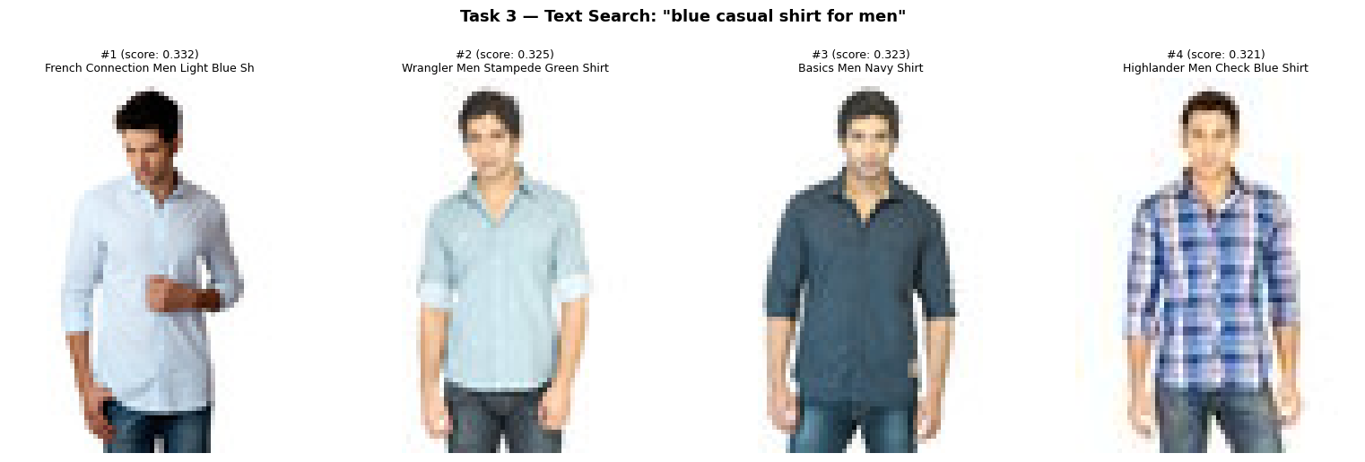
Figure 5: Top four results for the query "blue casual shirt for men".
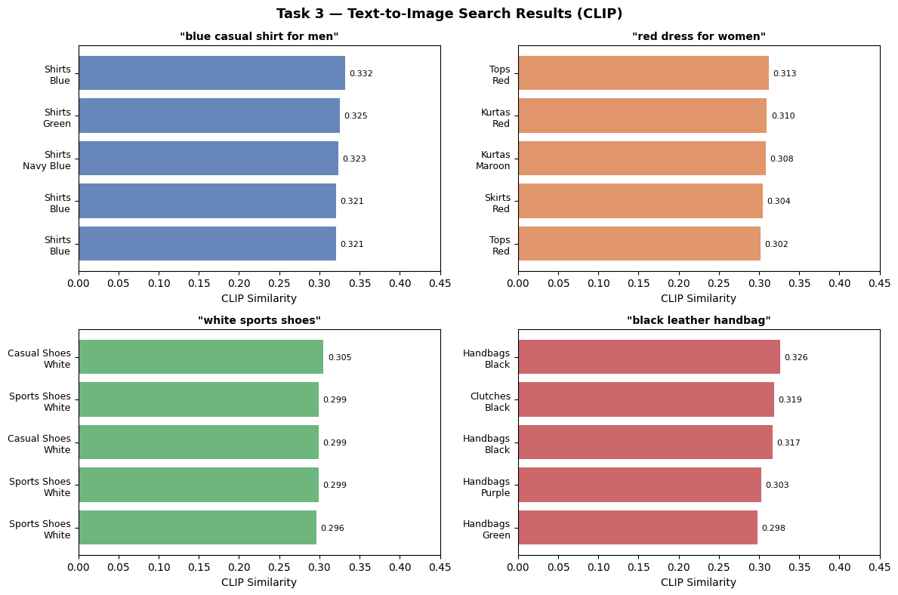
Figure 6: CLIP similarity scores for all four test queries.

5.4 Result
Text-to-image search consistently pulled up relevant products for plain free-text descriptions. This shows one pre-trained CLIP model can drive both visual recommendation (Task 1) and natural-language search (Task 3) without any extra training.

6. Final Summary

6.1 Consolidated Results
Task | Method | Key Result
Task 1: Recommendation | Category map + CLIP re-ranking | 16 category mappings; top 3 per query, 0.83-0.85 similarity for sunglasses to shoes
Task 2: Deduplication | Greedy cosine clustering, threshold 0.92 | 500 to 328 unique products; 172 duplicates removed (34.4%) across 70 groups
Task 3: Text Search | CLIP text embedding to FAISS search | 4 queries tested, all returned correct top 5 matches

6.2 Key Takeaway
A single CLIP embedding space, paired with a lightweight FAISS index, is enough to power three different e-commerce features: recommendation, deduplication, and natural-language search, with no extra model training needed. This makes the approach simple to deploy and easy to scale up to the full 44,419-product catalogue.

6.3 Possible Extensions
- Move to an approximate-nearest-neighbour FAISS index (such as IVF or HNSW) to search the full catalogue in under a second.
- Use BLIP-generated captions as an extra text signal to improve search relevance for products with limited metadata.
- Learn the complementary-category map from real co-purchase data instead of defining it manually, once such data becomes available.
7. Conclusion
This project set out to show that a single pair of pre-trained vision-language models, BLIP and CLIP, can solve three different real-world e-commerce problems without training anything from scratch. All three tasks were completed and tested on a 500-product sample drawn from the larger 44,419-product catalogue. The recommendation engine correctly paired sunglasses with stylistically matching shoes using a simple category map plus CLIP re-ranking. The deduplication system cut the sample catalogue down from 500 to 328 unique listings, removing 172 near-duplicate entries across 70 groups, using nothing more than a cosine-similarity threshold. The reverse text search returned relevant, category-correct products for four different natural-language queries, confirming that CLIP's shared image-text space works reliably in practice and not just in theory.
The biggest takeaway is that one FAISS index built on CLIP embeddings is reusable across all three tasks. This keeps the system simple to build, cheap to run, and easy to extend to the full catalogue or to new product categories. Overall, the project demonstrates a practical, low-cost blueprint for adding intelligent search, recommendation, and catalogue-cleaning features to an online store.

Kaggle Link: https://www.kaggle.com/code/venkatgopijuturi/notebookfa4d4b5d92

