Dhani-Stock-Project-Documentation

As per the requirement:

- Nginx (1 instance) on small ec2
- Tomcat instance - OL - on medium ec2
- Weblogic setup on medium ec2"
- Login service - Springboot setup on medium ec2
- weblogic and login service connect to oracle (oracle will remain on -premise) need SSH tunnel to our UAT Oracle DB
- New domain
- VPC Peering connections

Dhani-Architecture

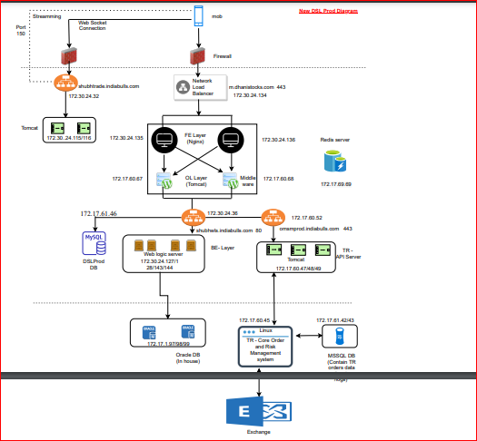

Sample Architect:

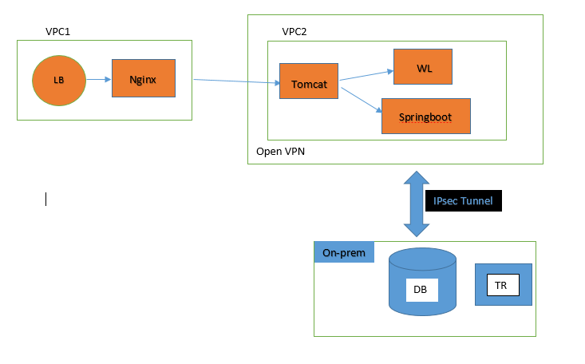

Stage 1:
Nginx
As per the requirement Follows:
- Create two VPC’s (VPC1, VPC2) in the same region.
- Create the EC2 instance in VPC1 for nginx server .
- Create the 4 EC2 instances for Tomcat, Weblogic, Spring boot and Open VPN.
- Creating the IPSEC Tunnel (Internet Protocol Security) to On-Premises DB.
- Before installation of the server, we have to download java.

Stage 2:

- In VPC1 EC2 instance
- Login to AWS -CLI
- While using the Public IP: 3.7.186.66 for nginx server.

Nginx Server IP: 3.7.186.66

- Create a EC2 Instance to launch nginx server and using elastic IP for the purpose of permanent IP (3.7.186.66)
- Uisng Public IP (3.7.186.66) login to CLI (Command Line Interface).
- Install Nginx server and run the server using (: Service nginx start).
- Using Config file to place a Config directory.

Installation and Configuration of Nginx on CentOS 7 or RHEL 7

First, update the system packages and install the default available version.
- sudo yum update -y

To install latest stable nginx server, run the following
- $ sudo yum install nginx

Redhat subscription.
- $ cat /etc/resdv.conf
Start/stop/restart nginx server
- $ sudo systemctl enable nginx
- $ sudo systemctl start nginx
- $ sudo systemctl stop nginx
- $ sudo systemctl restart nginx
- $ sudo systemctl status nginx

Config dir – /etc/nginx/
- Master/Global config file – /etc/nginx/nginx.conf
- Port 80 http config file – /etc/nginx/conf.d/default
- TCP ports opened by Nginx – 80 (HTTP), 443 (HTTPS)
- Document root directory – /usr/share/nginx/html
To edit files use a text editor such as vi
- $ sudo vi /etc/nginx/conf.d/default
You can upload or copy your html/css/js and images to /usr/share/nginx/html/
- $ cd /usr/share/nginx/html/
- $ sudo cp /backups/theos.in/*.html
- $ sudo cp /backups/theos.in/*.css

Configuring NGINX as an HTTP load balancer:

Edit the /etc/nginx/nginx.conf file and add the following settings

http {

upstream backend {

least_conn;

server server1.example.com;

server server2.example.com;

server server3.example.com backup;

}

server {

location / {

proxy_pass http://backend;

}

}

}

Stage 3:

In VPC2 EC2 Instances.
Login to AWS-CLI
While using the Public IP: 52.66.176.43 for Tomcat server.
Tomcat Server IP: 52.66.176.43
- Create a EC2 Instance to launch nginx server and using elastic IP for the purpose of permanent IP (52.66.176.43)
- Using Public IP (52.66.176.43) login to CLI (Command Line Interface).
- Install Tomcat server and run the server using (: Service Tomcat start).
- Using the Dhanistocksorchestration.war placed it on config files.
- Login to the Tomcat Browser using public ip and port (52.66.176.43 :80) and go to manage app.
- Deployed files are shown and click on start.
- Changing the paths on Master and slave scripts.
- Changig the location ip address to trigger the werblogic server and springboot on script.
- Mention the server ip Files are deployed and Tomcat server is Successfully running.

Configure Tomcat repo for CentOS or RHEL 7

First, update the system packages and install the default available version.
- sudo yum update -y

Install JAVA in Redhat
==================
$ yum provides \*/bin/java
$ yum list available \*openjdk\*
$ sudo yum install java-1.8.0-openjdk-devel java-11-openjdk-devel maven
$ java -version
$ alternatives --list
$ sudo alternatives --config java
Installing Apache Tomcat on RHEL 8
# cd /usr/local
# wget http://www-us.apache.org/dist/tomcat/tomcat-9/v9.0.24/bin/apache-tomcat-9.0.24.tar.gz
# tar -xvf apache-tomcat-9.0.24.tar.gz
# mv apache-tomcat-9.0.24 tomcat9

Save the file reload the systemd configuration to apply the recent changes using the following command.
# systemctl daemon-reload
Then start the tomcat service, enable it to auto-start at system boot and check the status using the following commands.
# systemctl start tomcat.service
# systemctl enable tomcat.service
# systemctl status tomcat.service

http://localhost:8080

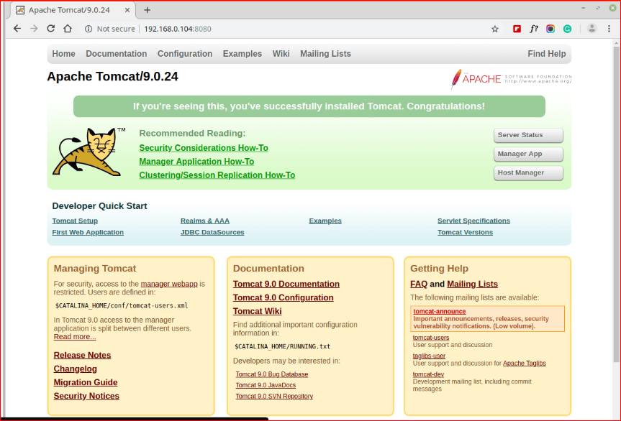

Enable HTTP Authentication for Tomcat Manager and Host Manager

# vi /usr/local/tomcat9/conf/tomcat-users.xml
<role rolename="admin-gui,manager-gui"/>
<user username="admin" password="tomhost@80" roles="admin-gui,manager-gui"/>
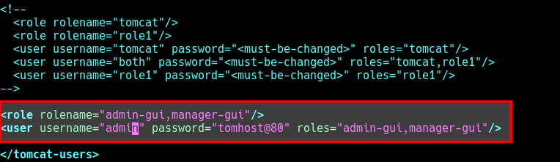

# systemctl restart tomcat.service

Stage 4:

- In VPC2 EC2 Instances.
- Login to AWS-CLI
- While using the Public IP: 13.127.202.145 for Weblogic server.
Weblogic Server IP: 13.127.202.145
- Create a EC2 Instance to launch Weblogic server and using elastic IP for the purpose of permanent IP (13.127.202.145)
- Uisng Public IP (13.127.202.145) login to CLI (Command Line Interface).
- Install weblogic server and run the server using username and password.
- Go the the path
- (/home/ec2-user/Oracle/Middleware/Oracle_Home/user_projects/domains/base_domain/bin)
- Using the Server1 to run the deployment files.
- Using the path the list shown startweblogic.sh
- using the command ./startweblogic.sh login ---username and password
- Open duplicate session of weblogic CLI and go the above path list shown startmanagedweblogic.sh.
- Using the command ./startmanagedweblogic.sh login ----username and password.
- Login to the Weblogic Browser using public ip and port (13.127.202.145 :7001/console) and go to Environment and click the deployments and start the Server1.
- Weblogic server is Successfully running.

First, update the system packages and install the default available version.
- sudo yum update -y
Java installation:-
##Login as a root user
- sudo su -
##Change dir to /opt
- cd /opt
- yum install wget -y
- wget-c--header"Cookie:oraclelicense=accept-securebackup-cookie"http://download.oracle.com/otn-pub/java/jdk/8u131-b11/d54c1d3a095b4ff2b6607d096fa80163/jdk-8u131-linux-x64.rpm
- yum install jdk-8u131-linux-x64.rpm -y
- java -version
Download Weblogic 12.2.1.4.0_wls JAR File…
- $ unzip fmw_12.2.1.4.0_infrastructure_Disk1_1of1.zip
- $ $JAVA_HOME/bin/java -jar fmw_12.2.1.4.0_infrastructure.jar

- fmw_12.2.1.4.0_wls_lite_generic.jar
- java -jar fmw_12.2.1.4.0_wls_lite_generic.jar

If this is is the first installation on the machine you will need to specify an inventory location. Enter the inventory like"/home/ec2-user/Oracle/Middleware/Oracle_Home/user_projects/domains/base_domain " and click the "OK" button.

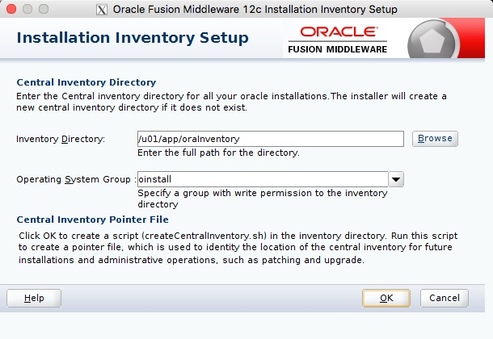
Click the "Next" button on the welcome screen.
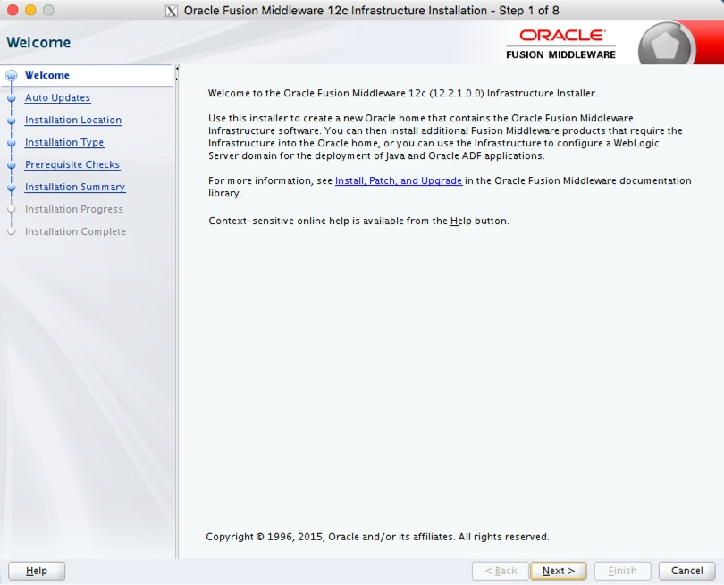
Select the "Skip Auto Updates" options, then click the "next" button.
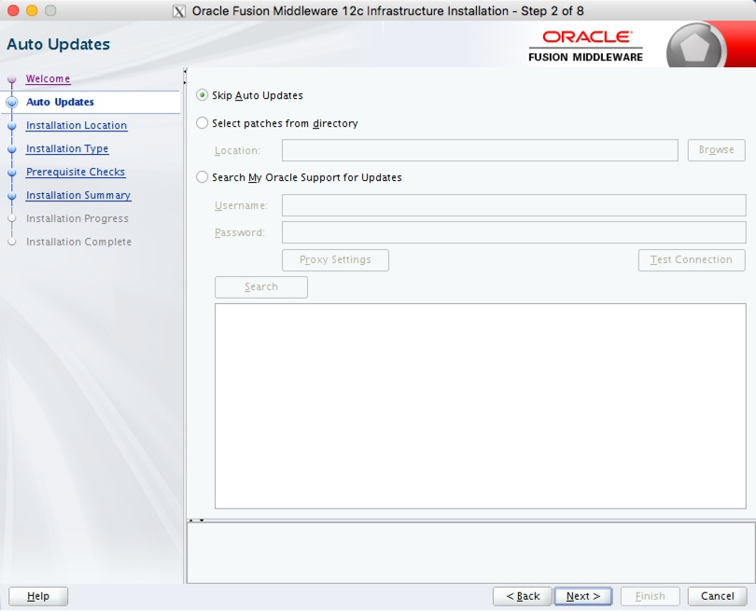

Enter the middleware home ("/home/ec2-user/Oracle/Middleware/Oracle_Home/user_projects/domains/base_domain/12.2.1.4.0") and click the "Next" button.

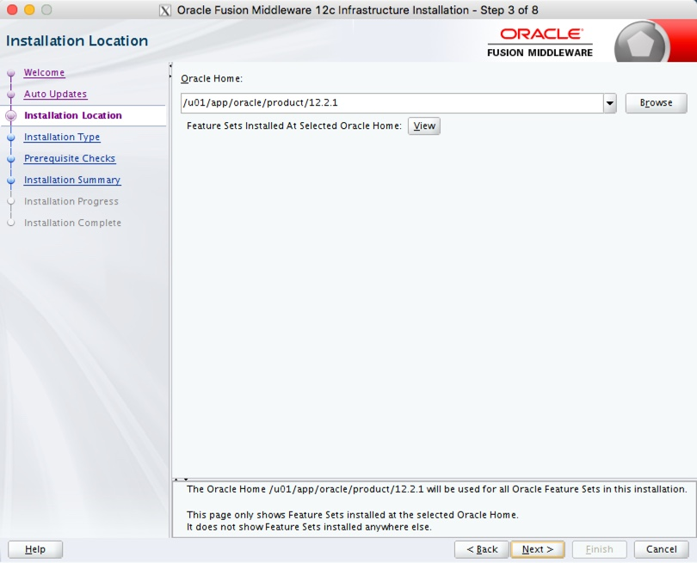
Accept the "Fusion Middleware Infrastructure" option by clicking the "Next" button.
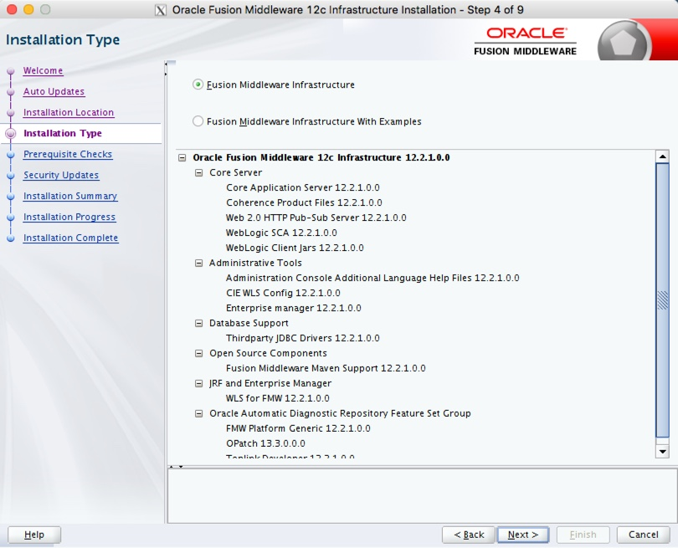
Wait for the prerequisite checks to complete. If there are failures, correct them and rerun the checks. If there are no failures, click the "Next" button.

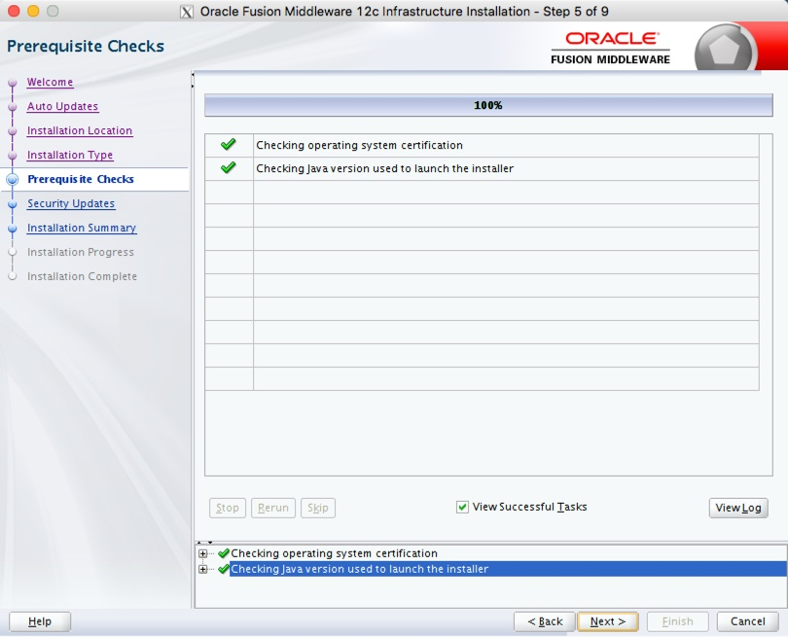
Either enter your support details, or uncheck the security updates checkbox. Click the "Next" button. If you chose not to receive security updates, click the "Yes" button on the warning dialog.
If you are happy with the summary information, click the "Install" button.
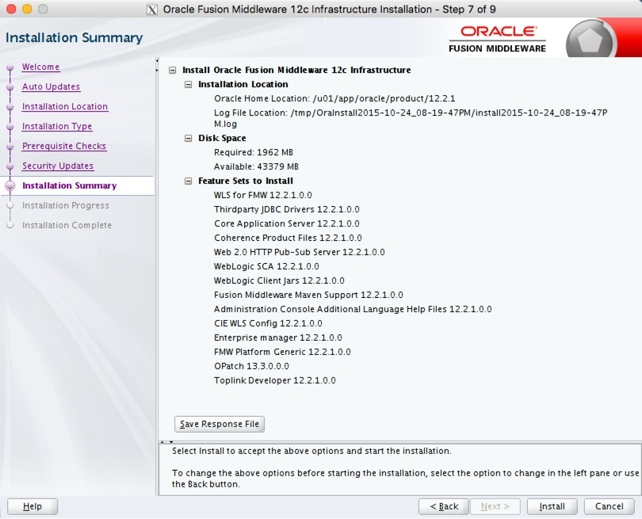
Wait for the installation to complete, then click the "Next" button.
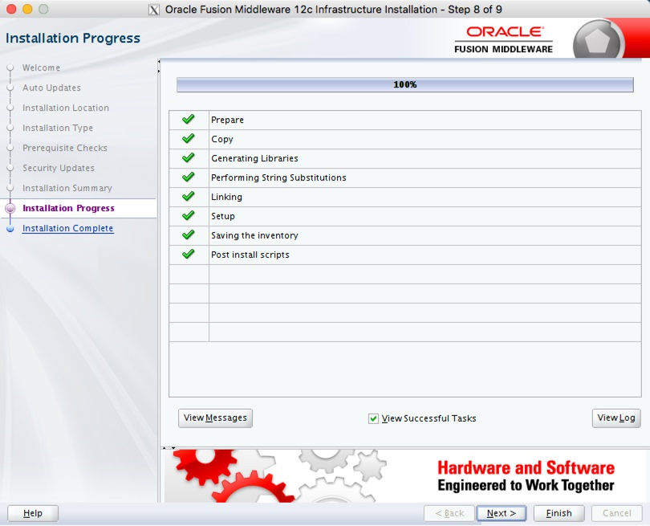
On the installation complete screen, click the "Finish" button to launch the Configuration Wizard.
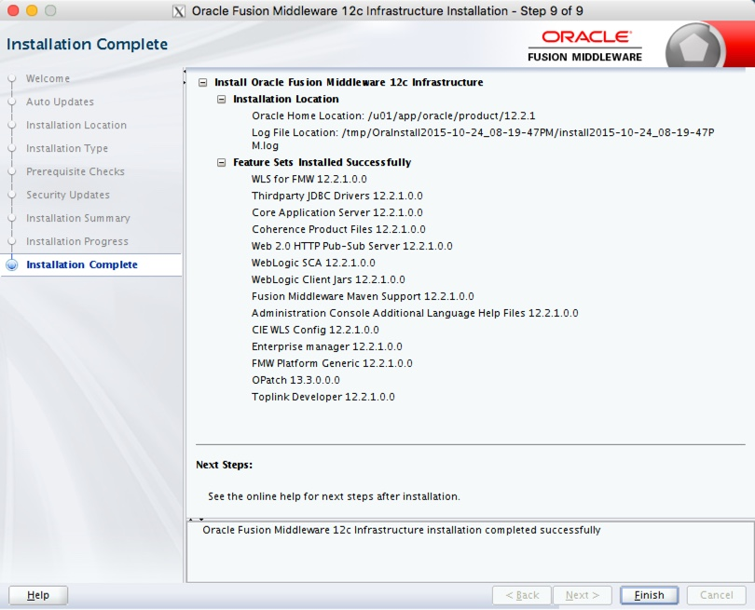
If you are doing an installation for Oracle Forms and Reports Services, you don't need to create the domain at this point, so stop here.

Create Domain
Launch the Configuration Wizard with the following command.
$ /home/ec2-user/Oracle/Middleware/Oracle_Home/oracle_common/common/bin/config.sh
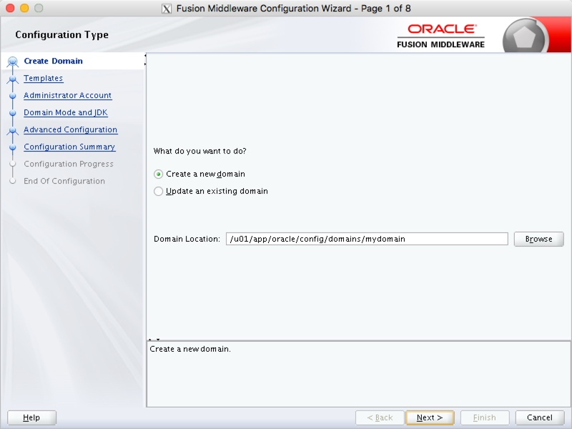

Select the required product template and click the "Next" button.

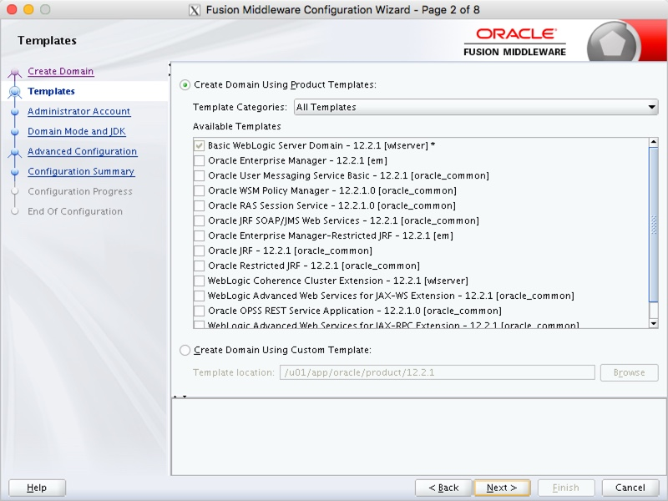
Enter the administrator credentials and click the "Next" button.
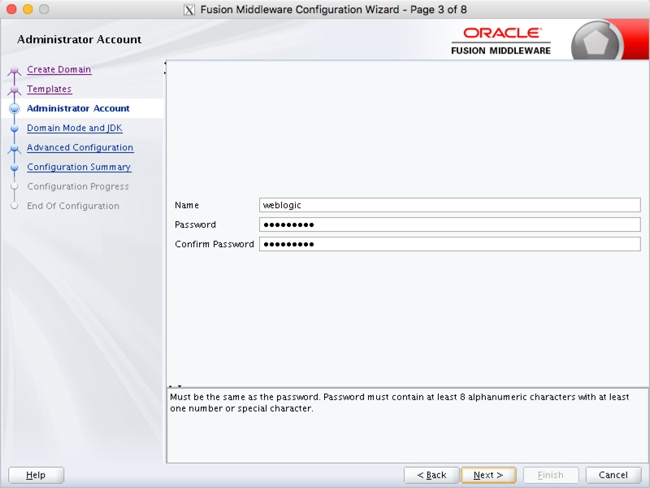
Enter the domain mode and JDK details, then click the "Next" button.
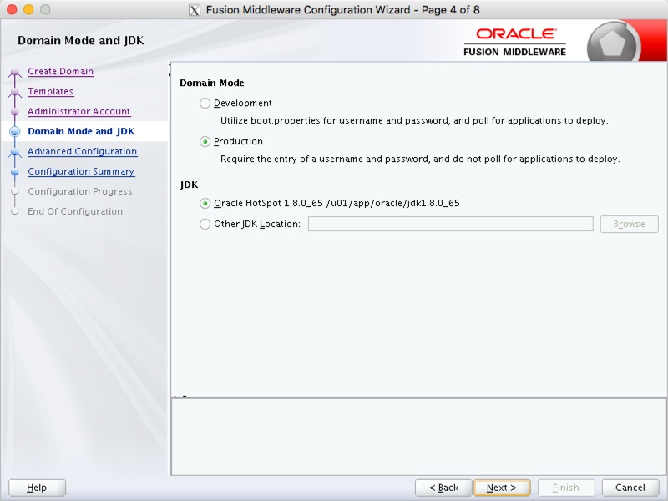
Select any required advanced configuration options. For this example I ignored the advanced configuration. Click the "Next" button.
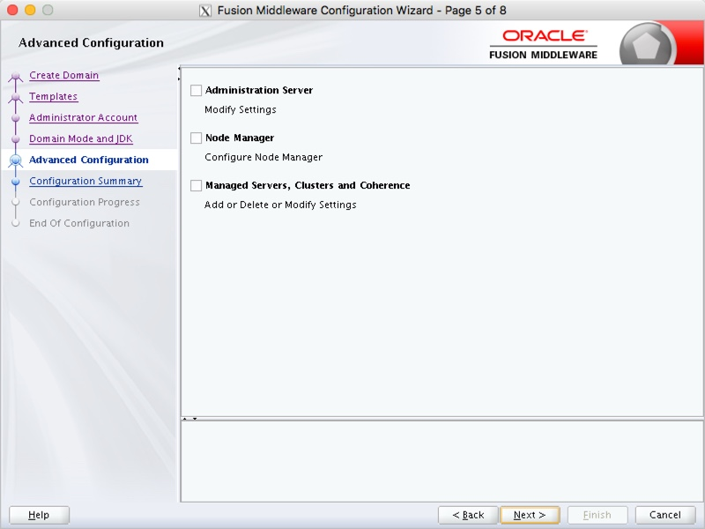
If you are happy with the configuration summary screen, click the "Create" button.
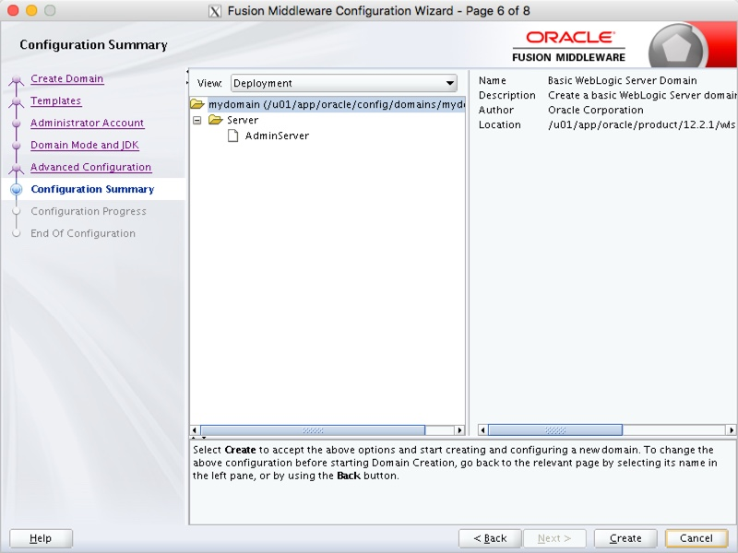
Once the domain is created, click the "Next" button.
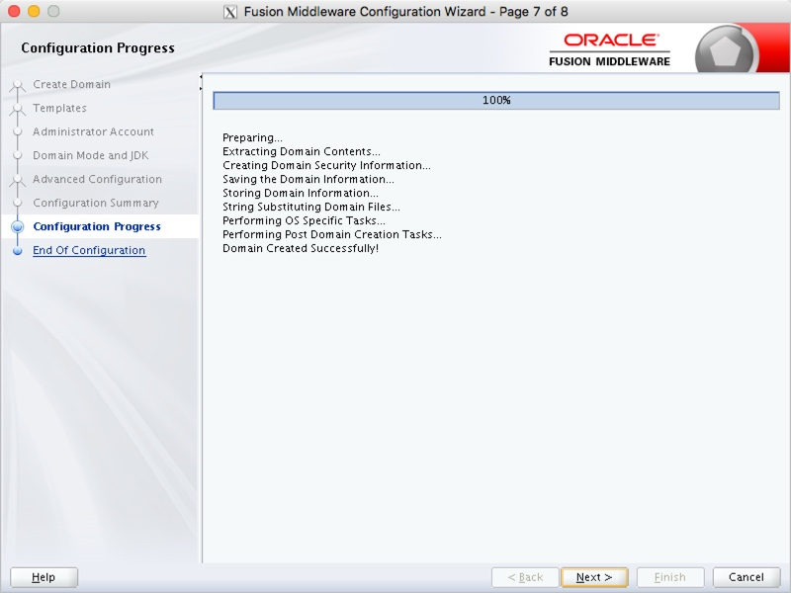
Make a note of the Admin Server URL and click the "Finish" button.
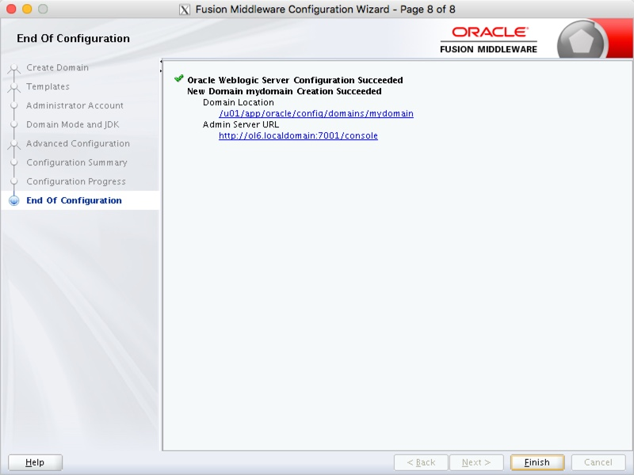
- ./startWebLogic.sh
- ./startmanagedweblogic.sh Server name http://Public IP:7001

Once the server is started you can access the administrator console using the "http://hostname:port/console" URL. Log in using the username and password provided in the previous step.
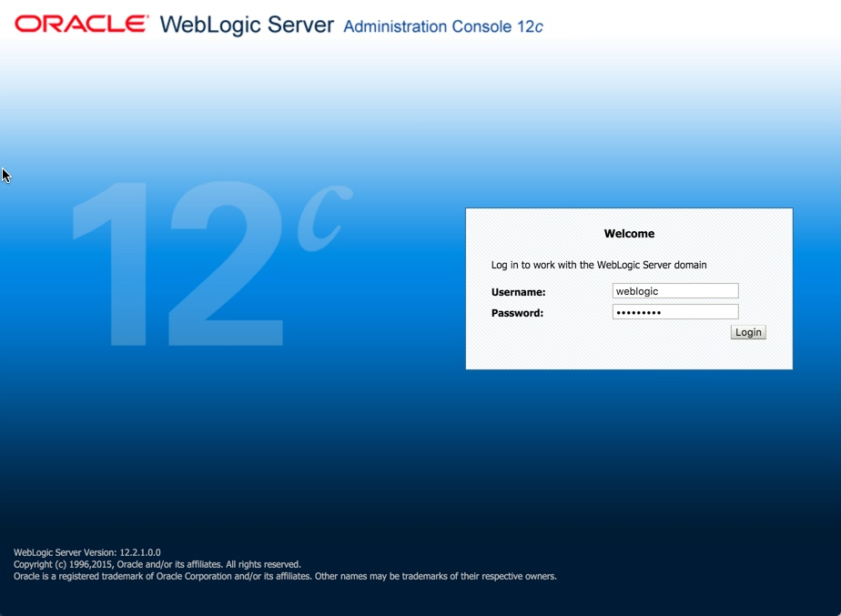

Steps to Deploy Spring Boot Application on AWS EC2

Step 1: Create a Spring Boot project using Spring Initializr
If you already have a working Spring Boot application, you can go to Step 5 directly. If not let’s create a new spring boot application together.
let’s go to sprint initilizer page and quickly bootstrap a simple spring boot web application.
Open https://start.spring.io/ and fill up details such as Group, Artifact, Name and dependency.
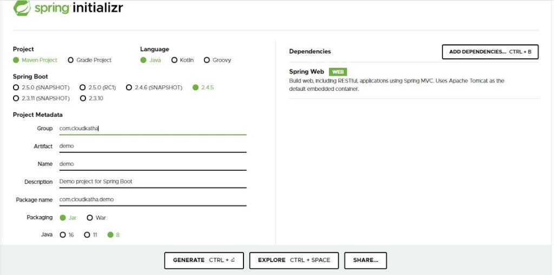
Note: Please not that I have added a single dependency Spring Web as you can see in above screenshot.
After filling up details and selecting web dependency, click on Generate
This will download the zipped project into your local system.

Step 2: Import the project into your favorite IDE

Unzip the downloaded project and import the project into your IDE. I will be importing to eclipse for this tutorial.

Click on File -> Import -> Maven -> Existing Maven Project

Click Next
Click on Browse and navigate to your unzipped project folder and select that. Selecting that should show the pom.xml file as shown in below screenshot.

Click on Finish to the project into the IDE.

Step 3: Add a RestController to be able to test

Now, we have the project imported into the IDE. Let’s add a Rest Controller into our spring boot project so that we can test it.
Click on your project and create a controller class with endpoint of /health. We will use minimal code like below.
package com.cloudkatha.demo.controller;

import org.springframework.web.bind.annotation.GetMapping;
import org.springframework.web.bind.annotation.RestController;

@RestController
public class TestController {

@GetMapping("/health")
public String health() {
return "Hello & Welcome to CloudKatha !!!";
}
}

Step 4: Test the application locally
Before we test it, let’s build the project using-
mvn clean install
Once build is successful, let’s run the project locally.
Right click on the class annotated with @SpringBootApplication and Run as Java Application.

Our application is running fine locally and you can access it like localhost:8080/health

Step 5: Prepare the final jar file
Our application is working perfectly in local environment. Let’s prepare the final jar file and keep it handy in a folder as we will need the jar file du ring the deployment.
Run maven build to package the application as a fat jar.
- $ mvn clean install
Once your build is successful, you will find the jar file in target folder. Copy the jar file and keep it in your system at a convenient location.

Step 6 : Launch an EC2 Instance and keep the key pair handy

Before we deploy our spring boot app, we need to launch an EC2 instance. You can find a step by step tutorial to launch an instance below.
Launch an EC2 instance in AWS EC2 Step by Step
Note: Please keep the keypair handy in the same folder as jar file.

Step 7: Copy jar file to AWS EC2
Let’s keep the KeyPair and the Jar to be deployed into the same folder like below.
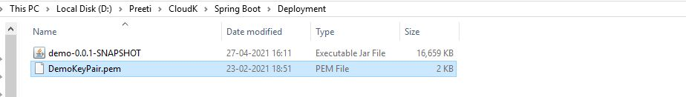
Please note that If you are using a linux machine you can use scp command out of the box. But if you are using windows, It doesn’t come with scp client and you must install one before you can copy file to EC2.
See: How to Copy a File into EC2 Instance from Windows Machine
So, If you are a linux user, continue below steps
Navigate to folder containing your jar and keypair
cd /path/to/folder
Prepare the copy command as per below syntax
scp -i ./DemoKeyPair.pem . <username>@<public-ip or DNS>:/pathwhere/you/needto/copy
After putting the details, command result like below.
scp -i ./DemoKeyPair.pem ./demo-0.0.1-SNAPSHOT.jar ec2-user@ec2-34-240-45-168.eu-west-1.compute.amazonaws.com:~
Please note that before you can run above command you must set the permissions of your private key file so that only you can read it. If you don’t set the permission then you can not connect to your instance using keypair.
chmod 400 DemoKeyPair.pem
Type above command in your terminal and hit enter.
Now permission on your private key is set and you can run your copy command.
scp -i ./DemoKeyPair.pem ./demo-0.0.1-SNAPSHOT.jar ec2-user@ec2-34-240-45-168.eu-west-1.compute.amazonaws.com:~
As confirmed by ls command, you can see that jar is copied to the home directory of my EC2 instance.
Note: Please notice the tilda(~) sign at the end. It means jar file is being copied to home directory of the instance.

Step 8: SSH into the EC2 instance and Install Java 1.8
There are multiple ways to SSH but I prefer browser based SSH connection using EC2 Instance Connect feature. In this way I don’t depend on my local system. But please note that at the time of writing only below linux distribution are supported.
- Amazon Linux 2 (any version)
- Redhat or later
So, If your instance type is one of the above, feel free to use EC2 Instance Connect.
Since, I launched an Amazon Linux 2 so I will go ahead and connect using EC2 Instance Connect.

SSH into Instance using Instance Connect.
1.SSH into your Instance using Instance Connect.
Select your EC2 Instance and click on Connect as shown in above screenshot.
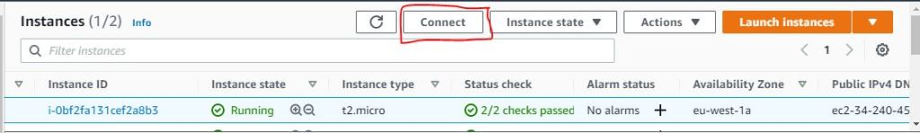
Verify If username is correct for your type of instance and click connect.
In a matter of seconds, you are connected to your Instance.

2.SSH into your instance from your Local machine
If you have linux system, you can use below command to SSH into your instance.
ssh -i path/to/DemoKeyPair.pem ec2-user@ec2-12-34-567-890.compute-1.amazonaws.com
In case of window, you can use putty to SSH into your instance.
Here is how: SSH into your linux instance from windows using putty

Install Java 1.8

We are connected to our EC2 instance so Let’s start with checking current version of Java.
java -version
sudo yum install java-1.8.0

Step 9 : Run the Spring Boot Jar File on EC2
Java is installed in the EC2 instance and our jar file is present in the home directory of the instance. So let’s go ahead and run the jar file using below command.
java -jar demo-0.0.1-SNAPSHOT.jar
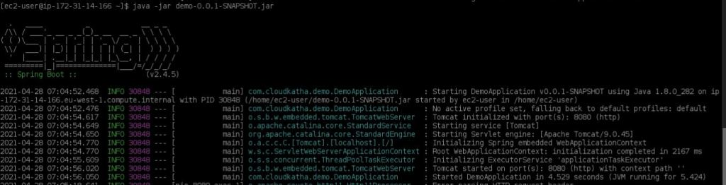
As you can see, Spring Boot application is running on EC2 instance on Port 8080.
As of now, If you try to access your application on-
https://ec2-34-240-45-168.eu-west-1.compute.amazonaws.com:8080/health
You will not get any response and your request will time out in the end. In most of the cases security group is the culprit.

Step 10: Allow Port 8080 on Your Instance Security Group
By default an EC2 instance security group allow only port 22 for SSH access. Let’s go ahead and allow port 8080.
Click on Your Instance.
Go to Security -> Click on instance security group.
Check inbound rules and Edit the Inbound rules as shown in below screenshot.
Click on Add Rule.
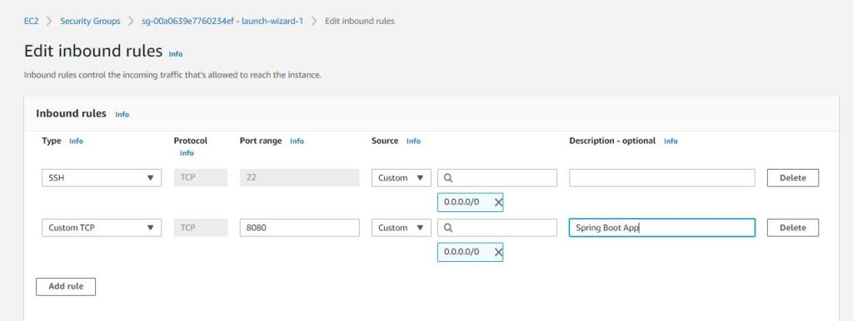
Add a rule for type Custom TCP and port range will be 8080. We will allow it from everywhere as you can see on above screenshot.
Click Save Rules

Step 11: Test Your spring boot endpoint deployed on EC2
Hit your application endpoint now.
http://ec2-34-240-45-168.eu-west-1.compute.amazonaws.com:8080/health
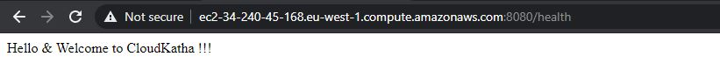
Congratulations !!!
You have successfully deployed your spring boot application on to AWS EC2.

Conclusion
In this in-depth tutorial, You learnt to deploy spring boot application in AWS EC2.
Let’s summarize what we did-
- Created and tested an Spring Boot application from scratch
- Prepared the jar file and copied to EC2 instance.
- Connected to EC2 instance using SSH and checked Java version
- Deployed the Spring Boot application to EC2 and tested the endpoint

Openvpn:
In VPC2 EC2 Instances.
Login to AWS-CLI
While using the Public IP: 65.0.26.51 for Openvpn.
Openvpn IP: 65.0.26.51
Step1:
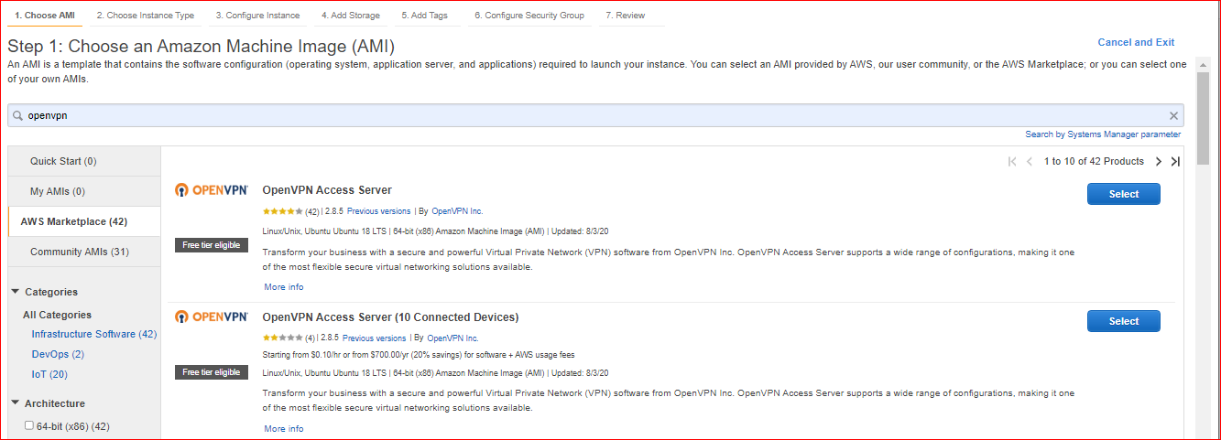
Login to AWS-CLI
- $ openvpnas
- $ sudo -i
- $ passwd openvpn
- $ *******

Login localhost: http:// public ip:8080
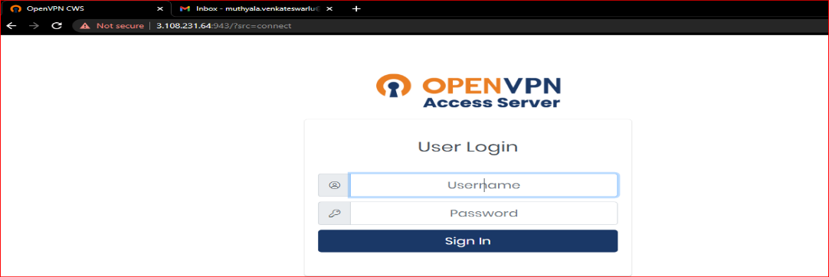
Login to user
- $ username vpndhani
- $ password ********

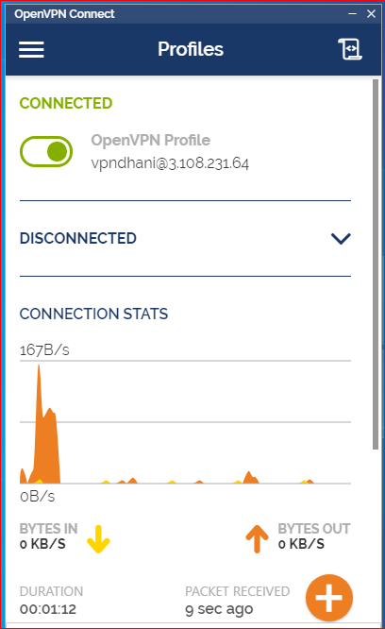

Ec2-user connect with private IP
- $ Ping IP Address
- $ ssh ec2-user@IP Address
- $ vi pemfail.pem
- $ ssh -i pemfail.pem ec2-user@IP Address

Stage 5:
- Using the AWS Console buy the domain and Register the Domain name.
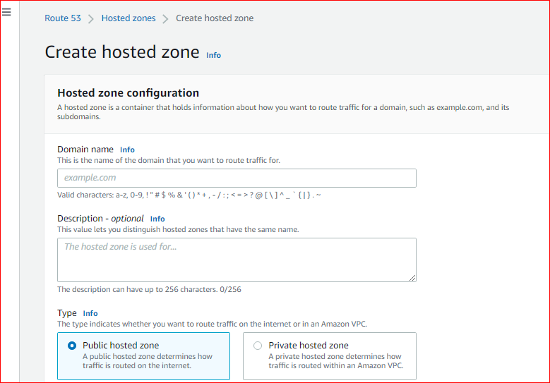
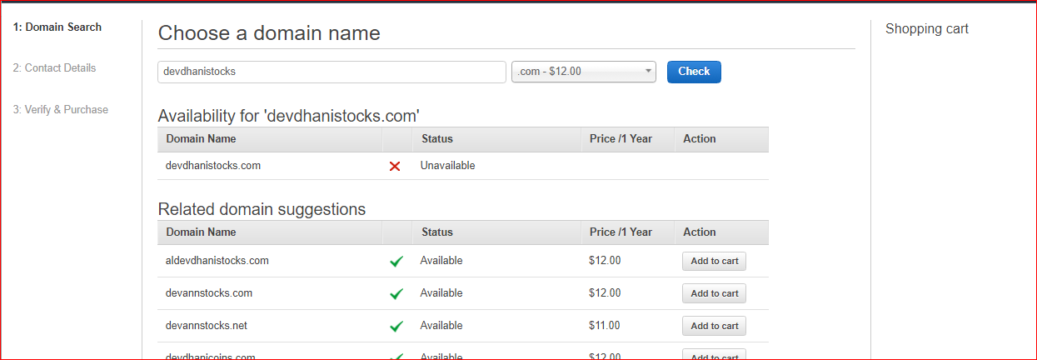

- Fill the required details using the IP address and Domain name.
- Create records mention the IPS and the domain name servers in following steps.
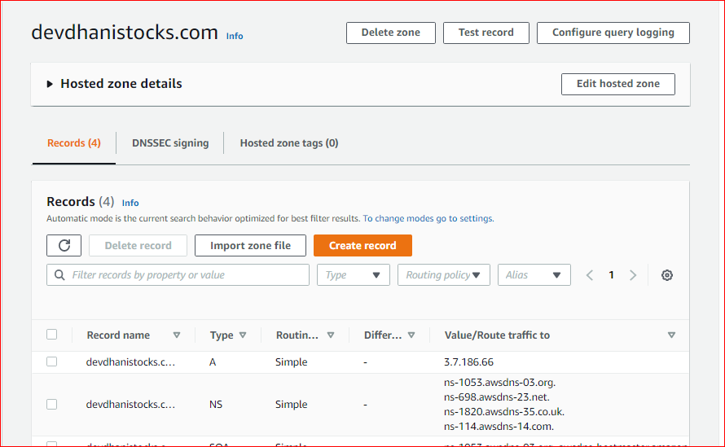

VPC Peering connections:
A VPC peering connection is a networking connection between two VPCs that enables you to route traffic between them privately. Instances in either VPC can communicate with each other as if they are within the same network. You can create a VPC peering connection between your own VPCs, with a VPC in another AWS account, or with a VPC in a different AWS Region.
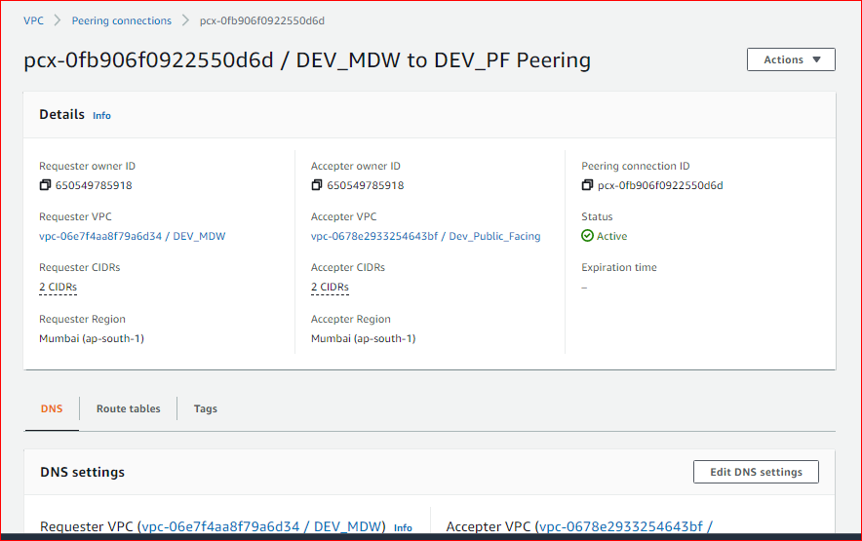

VIRTUAL PRIVATE NETWORK (VPN)
- Create Customer Gateway
- Create Virtual Private Gateway
- Site-to-Site VPN Connection
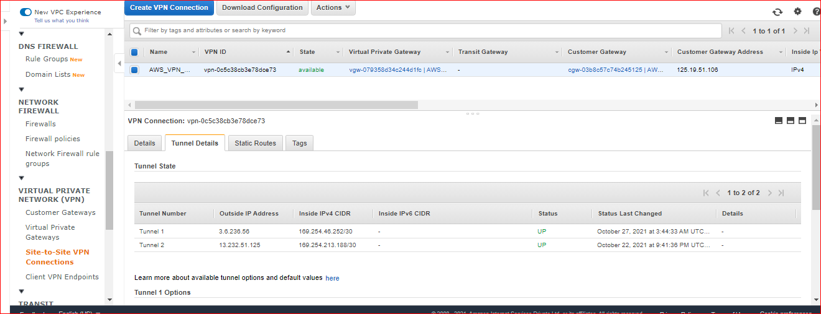

Domain name: http://www.devdhanistocks.com/ (OR) 3.7.186.66

