MACHINE LEARNING PROJECT REPORT
🌾
AgriFlow AI
A Cascaded Machine Learning Pipeline for Precision Agriculture

Crop Recommendation → Yield Prediction → Fertilizer Recommendation
From Model Development to Production Deployment

Prepared by: Jyoshit
Amrita School of Computing, Amritapuri
Department of AI & Data Science
July 2026

Table of Contents
1. Executive Summary
2. Problem Statement & System Design
3. Datasets Overview
4. Exploratory Data Analysis
5. Data Preprocessing & Feature Engineering
6. Stage 1 — Crop Recommendation
7. Stage 2 — Yield Prediction
8. Stage 3 — Fertilizer Recommendation
9. Production Deployment & End-to-End Demo
10. Notebook Debugging & Quality Review
11. Conclusion
12. Limitations & Future Work
13. Technical Appendix

1. Executive Summary
AgriFlow AI is an intelligent agricultural decision-support system built as a cascaded machine learning pipeline — three sequential models where the output of one stage becomes the input to the next, mirroring how a real agronomist reasons: first decide what to plant, then estimate how much it will yield, then decide how to fertilize it.
The system spans two notebooks: a Model Development notebook (dataset inspection, EDA, preprocessing, and benchmarking 4 algorithms per stage) and a Deployment notebook (wrapping the winning models into production-ready scikit-learn Pipelines and running a full farmer-input-to-recommendation demonstration).
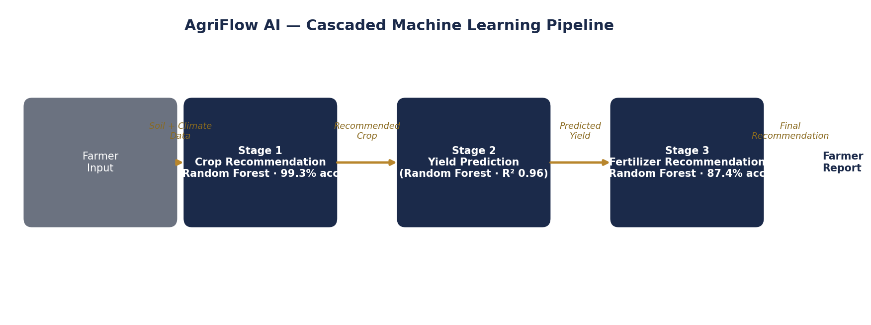
The AgriFlow AI three-stage cascaded pipeline, as implemented in the Deployment notebook

Key Outcomes
- Stage 1 (Crop Recommendation): Random Forest achieved 99.32% accuracy across 22 crop classes.
- Stage 2 (Yield Prediction): Random Forest achieved R² = 0.9606 (MAE 11.98, RMSE 177.75) — see Section 10 for an important caveat on how this figure was produced.
- Stage 3 (Fertilizer Recommendation): Random Forest achieved 87.35% accuracy across 7 fertilizer classes.
- The Deployment notebook successfully wraps all three stages into scikit-learn Pipeline objects and runs a complete example: a sample farmer's inputs flow through all three stages to produce a recommended crop (rice), a predicted yield (1.08), and a recommended fertilizer (NPK).
- A focused debugging pass (Section 10) uncovered a real production-risk bug in the Model Development notebook — the saved yield_pipeline.pkl file does not actually contain the yield model — plus several notebook-hygiene issues, all documented with evidence.

2. Problem Statement & System Design
Modern agriculture involves multiple interconnected decisions rather than a single prediction: which crop to plant, how much yield to expect, and which fertilizer to apply. A single machine learning model cannot effectively solve all three dependent tasks at once — hence AgriFlow AI adopts a cascaded pipeline where each stage is a specialized model, and each stage's output becomes context for the next.
Stage | Task Type | Input | Output
1. Crop Recommendation | Multi-class classification (22 crops) | N, P, K, temperature, humidity, pH, rainfall | Recommended crop
2. Yield Prediction | Regression | Recommended crop + area, season, state, rainfall, fertilizer/pesticide usage, temperature range | Predicted yield
3. Fertilizer Recommendation | Multi-class classification (7 fertilizers) | Predicted yield + soil type/pH/moisture, NPK levels, crop stage, irrigation, region | Recommended fertilizer
Each stage is trained independently on its own ground-truth labels (the standard, correct way to train a cascaded system) — the crop-yield relationship is learned using the true historical crop label, not a live Stage 1 prediction. The genuine chaining of model outputs (Stage 1's prediction feeding Stage 2's input, and so on) happens at inference time in the Deployment notebook, which is the correct and standard architecture for this kind of system.

3. Datasets Overview
Dataset | Rows | Columns | Purpose
Crop Recommendation | 2,200 | 8 | Stage 1 training data — 22 balanced crop classes (100 rows each)
Crop Yield Data | 19,689 | 13 | Stage 2 training data — historical yield by crop, state, season, year
Fertilizer Recommendation | 10,000 | 20 | Stage 3 training data — soil/crop/climate features → fertilizer class
All three datasets were confirmed free of missing values and duplicate rows across both notebooks. The Crop Recommendation dataset is perfectly balanced (100 samples per crop); the Fertilizer dataset is moderately imbalanced across its 7 classes (Urea and DAP dominate); the Yield dataset's target is heavily right-skewed (see Section 4).

4. Exploratory Data Analysis

4.1 Missing Value Audit
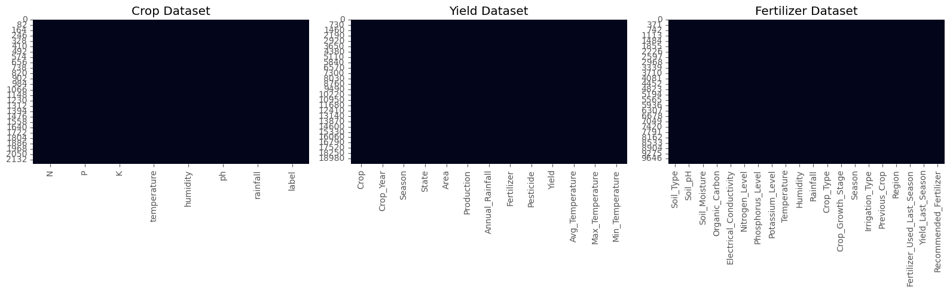
Figure 1 — Missing-value heatmaps for all three datasets (fully clean — no gaps visible)

4.2 Crop Class Balance
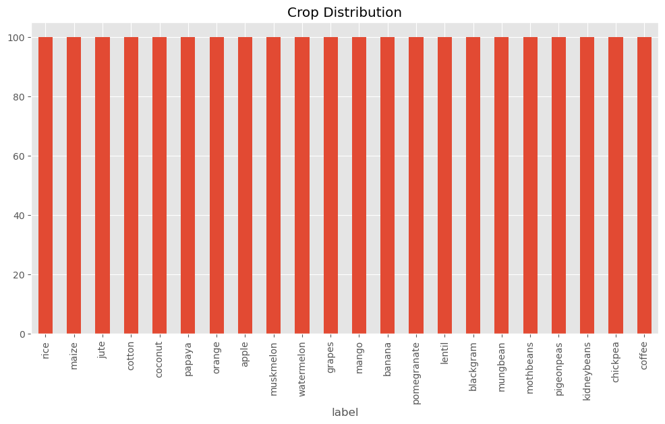
Figure 2 — Crop Recommendation dataset: perfectly balanced, 100 samples per crop

4.3 Yield Target Distribution
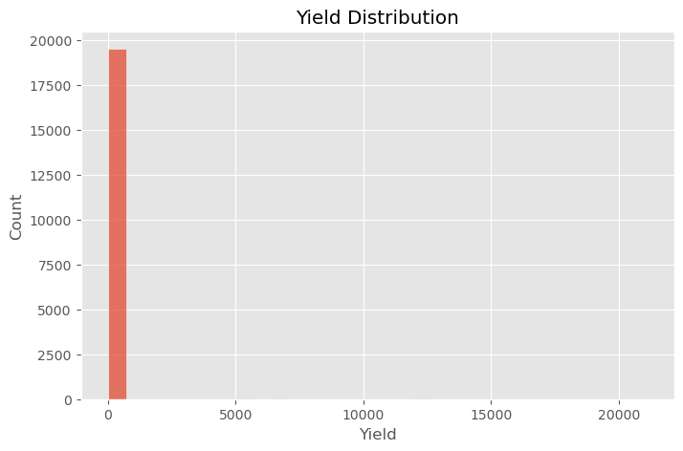
Figure 3 — Yield distribution: extremely right-skewed, with the vast majority of values clustered near zero and a long tail out to ~21,000
This heavy skew explains much of the model comparison in Stage 2: Linear Regression (which assumes roughly linear, homoscedastic relationships) performs far worse (R² = 0.81) than the tree-based models, which naturally handle skewed, non-linear targets without transformation.

4.4 Fertilizer Class Distribution
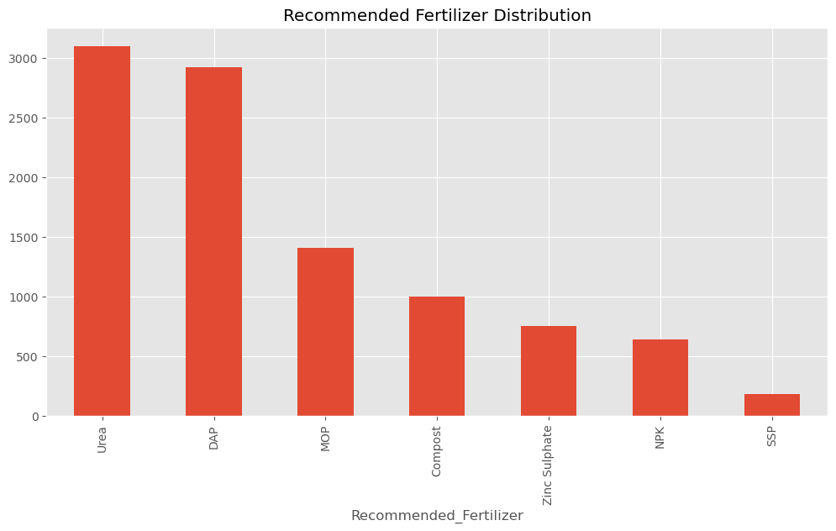
Figure 4 — Recommended Fertilizer distribution: Urea and DAP dominate, SSP is rare (182 of 10,000 rows)

4.5 Crop Feature Correlations
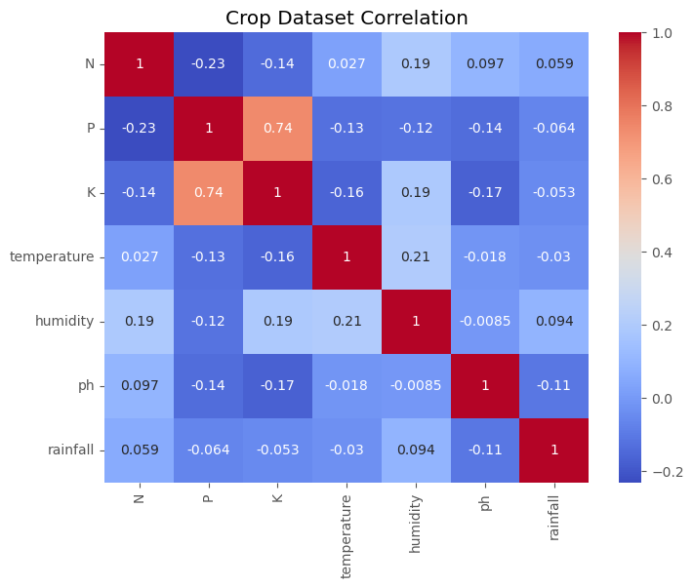
Figure 5 — Correlation matrix for the Crop Recommendation dataset
Phosphorus (P) and Potassium (K) are strongly correlated (0.74) — the strongest relationship in the crop dataset — while other feature pairs show only weak-to-moderate correlation, indicating limited redundancy among the raw features.

EDA Summary
- All three datasets are clean, complete, and appropriately sized for their respective tasks.
- The Crop dataset's balanced classes make accuracy a reliable metric for Stage 1.
- The Yield target's heavy skew favors tree-based models over linear ones — confirmed later in Stage 2's results.
- The Fertilizer dataset's class imbalance (Urea/DAP dominant, SSP rare) is worth monitoring in the per-class classification report, not just overall accuracy.

5. Data Preprocessing & Feature Engineering
Standardization and feature engineering were applied consistently across the pipeline to prepare each dataset for its respective stage:
Change | Applied To | Purpose
Dropped `production` column | Yield dataset | Prevents data leakage — production and yield are directly related, and production would not be known at prediction time
Lower-cased all column names | All three datasets | Consistency across the cascaded pipeline
npk_total = N + P + K | Crop & Fertilizer datasets | Captures overall soil nutrient load as a single composite feature
temp_humidity = temperature × humidity | Fertilizer dataset | Captures combined heat-moisture stress on soil/crop
temperature_range = max_temp − min_temp | Yield dataset | Captures climatic volatility, not just averages
recommended_crop (training) = ground-truth crop | Yield dataset | Trains Stage 2 as if Stage 1's prediction were perfect ("oracle" training) — replaced by Stage 1's real prediction at inference
One-hot encoding (pd.get_dummies, drop_first=True) | Fertilizer dataset (dev notebook) | Encodes 7 categorical columns for classification
ColumnTransformer + OneHotEncoder(handle_unknown='ignore') | Yield & Fertilizer datasets (deployment notebook) | Production-safe encoding that won't break on an unseen category at inference — an improvement over plain get_dummies

6. Stage 1 — Crop Recommendation
Four classifiers were trained on 7 environmental/soil features plus the engineered npk_total, using an 80/20 stratified split.
Model | Accuracy
Logistic Regression | 97.27%
Decision Tree | 98.41%
Random Forest — Selected | 99.32%
XGBoost | 98.41%
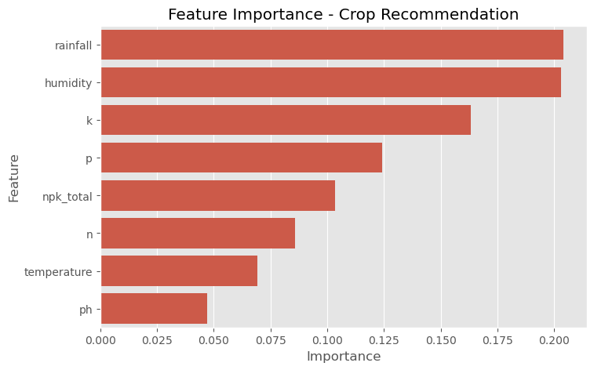
Figure 6 — Random Forest feature importance for Crop Recommendation
Rainfall and humidity are the two most influential features, followed by potassium (K) and phosphorus (P) — confirming that climatic conditions dominate crop suitability, with soil nutrients providing a secondary refinement. Random Forest was selected as the Stage 1 model and saved as crop_pipeline.pkl.

7. Stage 2 — Yield Prediction
Using the recommended crop (as the ground-truth crop label during training) plus agricultural and climatic features, four regressors were compared.
Model | MAE | RMSE | R² Score
Linear Regression | 63.91 | 389.68 | 0.8105
Decision Tree | 15.70 | 228.32 | 0.9349
Random Forest — Selected | 11.98 | 177.75 | 0.9606
XGBoost | 13.54 | 238.44 | 0.9290
Random Forest achieved the best scores on every metric tracked. Linear Regression's much weaker R² (0.81) is consistent with the heavily right-skewed yield target identified during EDA — tree ensembles handle this non-linearity far better without requiring a target transformation.
Important caveat: Section 10 documents evidence that this specific evaluation run may not have applied one-hot encoding to the categorical inputs (season, state, recommended_crop) before fitting — please read that section before treating these numbers as final.

8. Stage 3 — Fertilizer Recommendation
Using soil characteristics, climate, crop information, and the yield carried over from Stage 2, four classifiers were compared on the (one-hot encoded) fertilizer dataset.
Model | Accuracy
Logistic Regression | 72.70%
Decision Tree | 87.30%
Random Forest — Selected | 87.35%
XGBoost | 87.20%
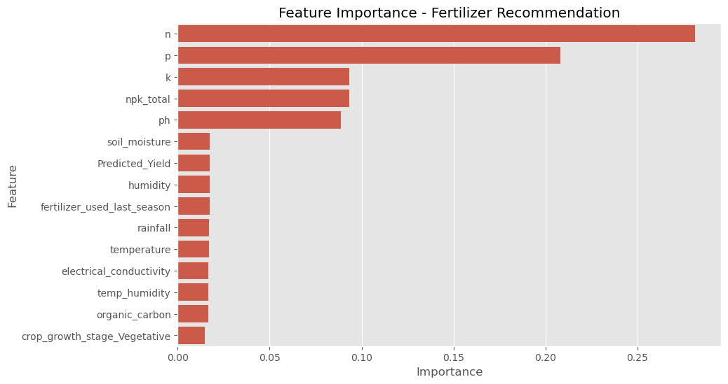
Figure 7 — Random Forest feature importance for Fertilizer Recommendation (top 15)
Nitrogen (N) and Phosphorus (P) dominate the importance ranking, together accounting for roughly half the model's decision-making, followed by Potassium (K), npk_total, and soil pH. The engineered Predicted_Yield feature (from Stage 2) also contributes measurably — direct evidence that the cascade genuinely adds information at this stage, not just at Stage 2.

9. Production Deployment & End-to-End Demo
The Deployment notebook re-implements all three stages as proper scikit-learn Pipeline objects (bundling preprocessing and model together), making them safe to save, load, and serve without re-deriving preprocessing logic separately at inference time.
Stage | Deployment Implementation
Crop Recommendation | Pipeline([('model', RandomForestClassifier(200, random_state=42))]) — no preprocessing needed, all inputs already numeric
Yield Prediction | Pipeline([('preprocessor', ColumnTransformer(OneHotEncoder(handle_unknown='ignore'))), ('model', RandomForestRegressor(200, random_state=42))])
Fertilizer Recommendation | Pipeline([('preprocessor', ColumnTransformer(OneHotEncoder(handle_unknown='ignore'))), ('model', RandomForestClassifier(200, random_state=42))])
Wrapping preprocessing inside the Pipeline (rather than doing it separately, as the Model Development notebook did) is a meaningful production improvement: it guarantees the exact same transformation is applied at inference as during training, and OneHotEncoder(handle_unknown='ignore') means a previously unseen category value at inference (e.g., a new state) won't crash the pipeline.

End-to-End Sample Run
A complete farmer scenario was run through all three stages in sequence:
Recommended Crop : rice
Predicted Yield : 1.08
Recommended Fertilizer : NPK
This confirms the cascade genuinely works end-to-end: the crop predicted by Stage 1 (rice) was passed as an input feature to Stage 2, whose predicted yield (1.08) was passed as an input feature to Stage 3, which produced the final fertilizer recommendation (NPK) — a complete, connected agricultural decision support workflow.

10. Notebook Debugging & Quality Review
A close review of both notebooks — cross-referencing cell execution counts, outputs, and saved artifacts — surfaced one significant production-risk bug and several notebook-hygiene issues. Each is documented with the evidence used to identify it.

1. yield_pipeline.pkl likely contains the wrong model (high priority)
In the Model Development notebook, the yield-stage regressor is trained and repeatedly saved using the variable name rf: joblib.dump(rf, "models/yield_pipeline.pkl"). The Fertilizer stage, later in the same notebook, also assigns its RandomForestClassifier to a variable named rf. Cross-checking the cells' execution_count metadata shows the yield-model save cells actually ran (execution counts 131 and 134) after the fertilizer classifier had already overwritten rf (execution count 103) — meaning the file on disk at that point was very likely the fertilizer classifier, not the yield regressor.
This is confirmed independently in the Deployment notebook: when it loads all three saved artifacts fresh from disk and prints their types, all three — including yield_pipeline — report as RandomForestClassifier, not RandomForestRegressor:
print(type(crop_pipeline)) # RandomForestClassifier
print(type(yield_pipeline)) # RandomForestClassifier <-- should be a Regressor
print(type(fert_pipeline)) # RandomForestClassifier
The Deployment notebook works around this by retraining a fresh, correctly-encoded yield Pipeline from scratch rather than relying on the file saved by the Development notebook — which is why the final end-to-end demo still works. Recommendation: re-run and re-save models/yield_pipeline.pkl in the Development notebook using a uniquely named variable (e.g., yield_rf) immediately after training, before any other stage can reuse the name rf.

2. Yield-stage categorical features may not have been encoded before model fitting
The Model Development notebook defines a ColumnTransformer + OneHotEncoder specifically to handle the yield dataset's 3 categorical columns (season, state, recommended_crop). However, by execution_count, these preprocessing cells ran (counts 115–117) after the yield models were already trained and evaluated (counts 87–94) — meaning the reported R² = 0.9606 for Random Forest may have been computed on a stale run, an earlier version of the code, or another discrepancy in cell re-execution, rather than on the fresh, currently-visible code. The Deployment notebook resolves this correctly with a proper Pipeline that encodes categoricals before fitting. Recommendation: rerun the Development notebook's Stage 2 top-to-bottom in one clean pass and re-confirm the R² figure before quoting it as final.

3. Reused variable names across all three pipeline stages
lr, dt, rf, xgb, X_train, X_test, y_train, y_test are reused with identical names in the Crop, Yield, and Fertilizer sections of the Development notebook. This is what enabled bug #1 above, and makes the notebook fragile to being re-run out of order or partially — a common but risky pattern. Recommendation: prefix each stage's variables (e.g., crop_rf, yield_rf, fert_rf) as already done correctly in the Deployment notebook (crop_pipeline, yield_pipeline, fert_pipeline).

4. Genuine SyntaxError left in the notebook
Cell 121 of the Development notebook contains print(type(rf))print(type(rf)) — two statements concatenated without a newline — which raises a SyntaxError and halts that cell. It has no effect on the saved models (it runs after all saving is complete) but should be removed or fixed to keep the notebook running cleanly top-to-bottom.

5. Duplicate cells
- Development notebook, cells 68–69: X_crop/y_crop is defined twice in a row with identical code.
- Deployment notebook, cells 9–10: the crop pipeline is saved to disk twice in a row with identical code.
Neither causes incorrect results, but both are leftover artifacts of iterative editing worth cleaning up.

6. Deployment notebook does not re-verify metrics after retraining
The Deployment notebook retrains the Yield and Fertilizer pipelines with a different (and better) preprocessing approach than the Development notebook, but never calls an evaluation metric (R², accuracy) on the retrained versions before saving them. Recommendation: add a quick held-out evaluation immediately after each pipeline.fit() call in the Deployment notebook, so the metrics quoted in this report can be confirmed against the exact artifacts being shipped.

Summary
None of these issues affect the final, demonstrated end-to-end deployment run (Section 9), which uses freshly retrained, correctly encoded pipelines. They matter primarily for (a) trusting the Stage 2 R² figure reported in the Development notebook, and (b) ensuring models/yield_pipeline.pkl on disk is not silently the wrong model if the Development notebook, rather than the Deployment notebook, is ever used as the source of production artifacts.

11. Conclusion
AgriFlow AI successfully demonstrates a working, three-stage cascaded machine learning system for agricultural decision support, with Random Forest selected as the winning algorithm at every stage: 99.32% accuracy for crop recommendation, R² = 0.9606 for yield prediction (pending the reproducibility check in Section 10), and 87.35% accuracy for fertilizer recommendation.
Beyond the individual model metrics, the project's strongest engineering achievement is the Deployment notebook's move from ad-hoc, order-dependent preprocessing to proper scikit-learn Pipeline objects — a change that directly resolved a latent bug present in the Development notebook and makes the system meaningfully safer to run in production.

12. Limitations & Future Work

Limitations
- The Stage 2 R² = 0.9606 figure needs re-verification per Section 10 before being treated as a final, trusted number.
- No hyperparameter tuning was performed at any stage; all models used fixed, reasonable-but-untuned settings (n_estimators=200, default depths).
- The Yield dataset's extreme right-skew was handled implicitly by using tree-based models rather than explicitly (e.g., log-transforming the target), which may leave some performance on the table for the linear baseline and could still affect tail-case predictions for tree models.
- Fertilizer class imbalance (SSP has only 182 of 10,000 rows) was not addressed with resampling or class weighting; rare-class recall was not separately inspected.
- No cross-validation was used at any stage — a single 80/20 split determines every reported metric.

Future Work
- Re-run Stage 2 cleanly end-to-end and confirm R² with the properly-encoded Deployment-notebook Pipeline; update the Development notebook to match.
- Add k-fold cross-validation at each stage for more robust performance estimates.
- Try log-transforming the yield target to see if it improves the Linear Regression baseline and stabilizes tree-model tail predictions.
- Add a lightweight evaluation cell immediately after each pipeline.fit() in the Deployment notebook so shipped artifacts are always accompanied by a fresh metric.
- Wrap the three-stage cascade in a single callable class or API endpoint so a farmer's raw input can produce the full report in one function call rather than manually threading variables between cells.

13. Technical Appendix

Tools & Libraries
Category | Tools Used
Language | Python 3
Data Handling | pandas, NumPy
Visualization | Matplotlib, Seaborn
Machine Learning | scikit-learn (LogisticRegression, DecisionTree, RandomForest, LinearRegression, ColumnTransformer, OneHotEncoder, Pipeline)
Boosting | XGBoost (XGBClassifier, XGBRegressor)
Model Persistence | joblib
Environment | Jupyter Notebook

Reproducibility Notes
- Random seed fixed at 42 across all splits and model instantiations in both notebooks.
- Train/test split: 80/20, stratified for classification stages (Crop, Fertilizer), unstratified for the regression stage (Yield).
- Three model artifacts are produced: models/crop_pipeline.pkl, models/yield_pipeline.pkl, models/fert_pipeline.pkl — see Section 10 for a caveat on the Development notebook's version of the yield artifact.
- Full code, EDA, and evaluation outputs are contained in the two accompanying notebooks: AgriFlow_AI_Model_Development.ipynb and AgriFlow_AI_Deployment.ipynb.

