MACHINE LEARNING PROJECT REPORT
🏨
Hotel Booking Cancellation Prediction
Using Ensemble Learning

A Comparative Study of Decision Tree, Random Forest, and XGBoost
with SHAP-Based Model Explainability

Prepared by: Jyoshit
Amrita School of Engineering, Amritapuri
Department of Machine Learning / Data Science
July 2026

Table of Contents
1. Executive Summary
2. Introduction & Objective
3. Dataset Overview
4. Exploratory Data Analysis
5. Data Cleaning
6. Feature Engineering
7. Model Development & Evaluation
7.1 Logistic Regression (Baseline)
7.2 Decision Tree Classifier
7.3 Random Forest Classifier
7.4 XGBoost Classifier
8. Final Model Comparison & Selection
9. Model Explainability (SHAP)
10. Conclusion
11. Limitations & Future Work
12. Technical Appendix

1. Executive Summary
Hotel booking cancellations create significant revenue leakage and operational planning challenges for the hospitality industry. This project develops and evaluates a machine learning pipeline that predicts whether an incoming hotel booking will be cancelled, using the public Hotel Booking Demand dataset comprising 119,390 reservation records across 32 attributes.
Four classification algorithms were trained and benchmarked under an identical evaluation protocol: Logistic Regression (baseline), Decision Tree, Random Forest, and XGBoost. The workflow spans data cleaning, exploratory data analysis, twelve engineered business features, categorical encoding, an 80/20 stratified train-test split, and a consistent evaluation framework built on Accuracy, Precision, Recall, and F1-Score.
XGBoost emerged as the best-performing model, achieving 84.20% accuracy, 75.27% precision, 63.31% recall, and a 68.78% F1-score — the strongest overall balance among the four candidates. To move beyond a black-box result, SHAP (SHapley Additive exPlanations) was applied to the final model, confirming that country of origin, parking requirements, lead time, and special requests are the dominant real-world drivers of cancellation risk.

Key Outcomes
- Cleaned and de-duplicated a 119K-row dataset, removing 31,994 duplicate records and handling missing values across three columns.
- Engineered 12 domain-driven features (e.g., risk_score, estimated_booking_value, changes_per_night) that materially improved model discrimination.
- Benchmarked 4 algorithms on 5 metrics with visual diagnostics (confusion matrices, feature importance, SHAP summary plots).
- Selected XGBoost as the production-candidate model based on holistic performance, not a single metric.
- Delivered an explainable AI layer via SHAP to support stakeholder trust and business interpretation.

2. Introduction & Objective
Booking cancellations are one of the most costly sources of uncertainty in hotel revenue management. Every cancelled reservation represents lost inventory that could otherwise have been sold, and unpredictable cancellation patterns make it difficult for hotels to plan staffing, overbooking strategy, and dynamic pricing.
The objective of this project is to build a predictive system that classifies whether a booking will be cancelled (is_canceled = 1) or honoured (is_canceled = 0), using information available at the time of booking — guest profile, stay characteristics, market segment, and reservation metadata.

Project Scope
- Exploratory Data Analysis (EDA) to understand distributions, missingness, and correlations.
- Data preprocessing: de-duplication, missing-value imputation, and encoding.
- Feature engineering to translate raw columns into business-meaningful predictors.
- Training and hyperparameter-aware comparison of Decision Tree, Random Forest, and XGBoost against a Logistic Regression baseline.
- Model explainability using SHAP to validate that predictions align with domain intuition.

Why Ensemble Learning?
Single decision trees are prone to overfitting and instability. Ensemble methods — Random Forest (bagging) and XGBoost (boosting) — combine many weak learners to produce a stronger, more generalizable classifier. Comparing these against a linear baseline (Logistic Regression) and a single Decision Tree provides a clear, evidence-based justification for the added complexity of ensembling.

3. Dataset Overview
The analysis uses the publicly available Hotel Booking Demand dataset, which records bookings for a City Hotel and a Resort Hotel.
Attribute | Value
Total records | 119,390
Total columns | 32
Target variable | is_canceled (binary: 0 = kept, 1 = cancelled)
Overall cancellation rate | 37.04%
Hotel types | Resort Hotel, City Hotel
Time span | 2015 – 2017

Feature Groups
- Stay details: lead_time, stays_in_weekend_nights, stays_in_week_nights, arrival dates
- Guest profile: adults, children, babies, is_repeated_guest, customer_type
- Commercial: market_segment, distribution_channel, deposit_type, adr (average daily rate)
- Booking history: previous_cancellations, previous_bookings_not_canceled, booking_changes
- Logistics: reserved_room_type, assigned_room_type, agent, company, days_in_waiting_list

Data Quality Snapshot
An initial null-value audit revealed missing data concentrated in three columns:
Column | Missing Count | Missing %
company | 112,593 | 94.31%
agent | 16,340 | 13.69%
country | 488 | 0.41%
children | 4 | 0.003%

4. Exploratory Data Analysis
EDA was performed to understand the target distribution, missing-value patterns, feature distributions, and inter-feature relationships before any modelling decisions were made.

4.1 Target Variable Distribution
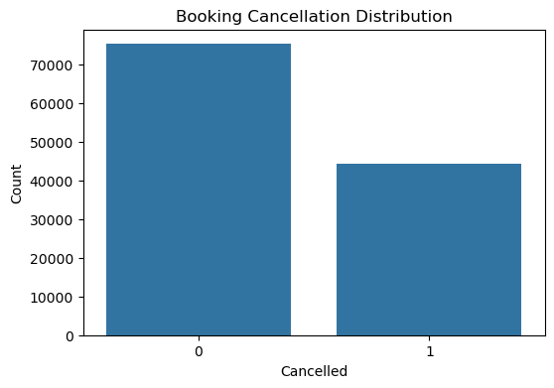
Figure 1 — Booking cancellation distribution (0 = Not Cancelled, 1 = Cancelled)
The dataset is moderately imbalanced, with roughly 63% of bookings honoured and 37% cancelled — imbalanced enough to warrant precision/recall-based evaluation rather than accuracy alone, but not extreme enough to require synthetic resampling.

4.2 Missing Value Heatmap
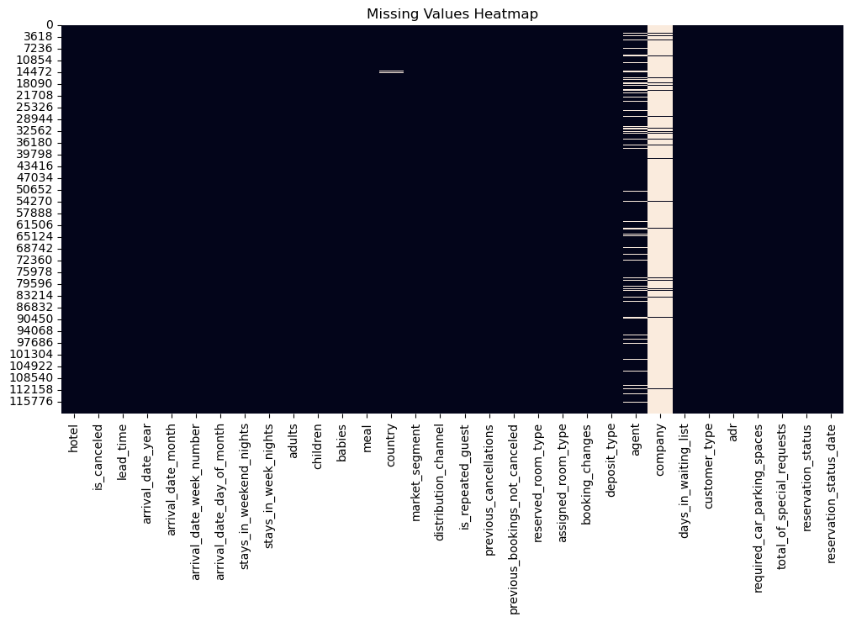
Figure 2 — Missing values heatmap across all columns
The heatmap visually confirms that missingness is concentrated in the company and agent columns, with sparse gaps in country, guiding the imputation strategy adopted later.

4.3 Numerical Feature Distributions
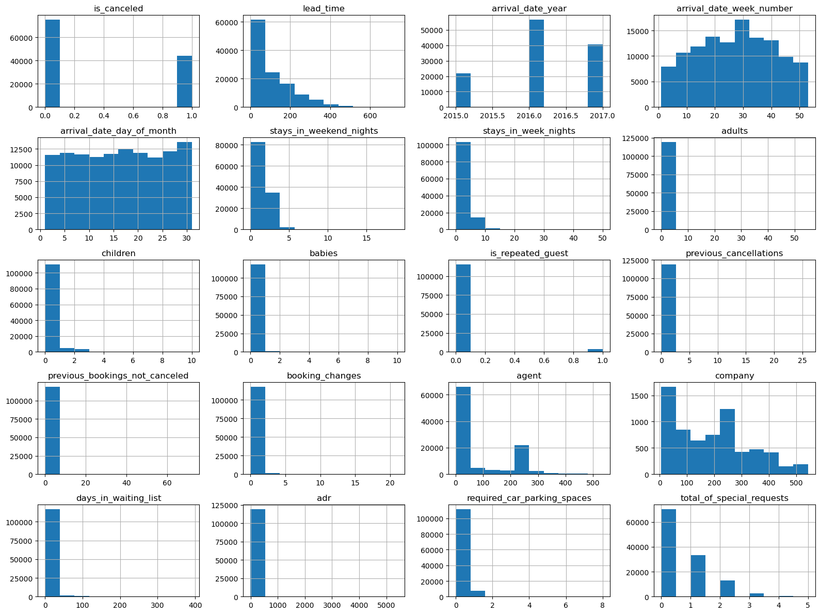
Figure 3 — Histograms of all numerical features
Several features (lead_time, adr, days_in_waiting_list) exhibit strong right-skew with long tails, typical of booking and pricing data, informing the choice of tree-based models that are robust to skewed, non-Gaussian distributions.

4.4 Correlation Matrix
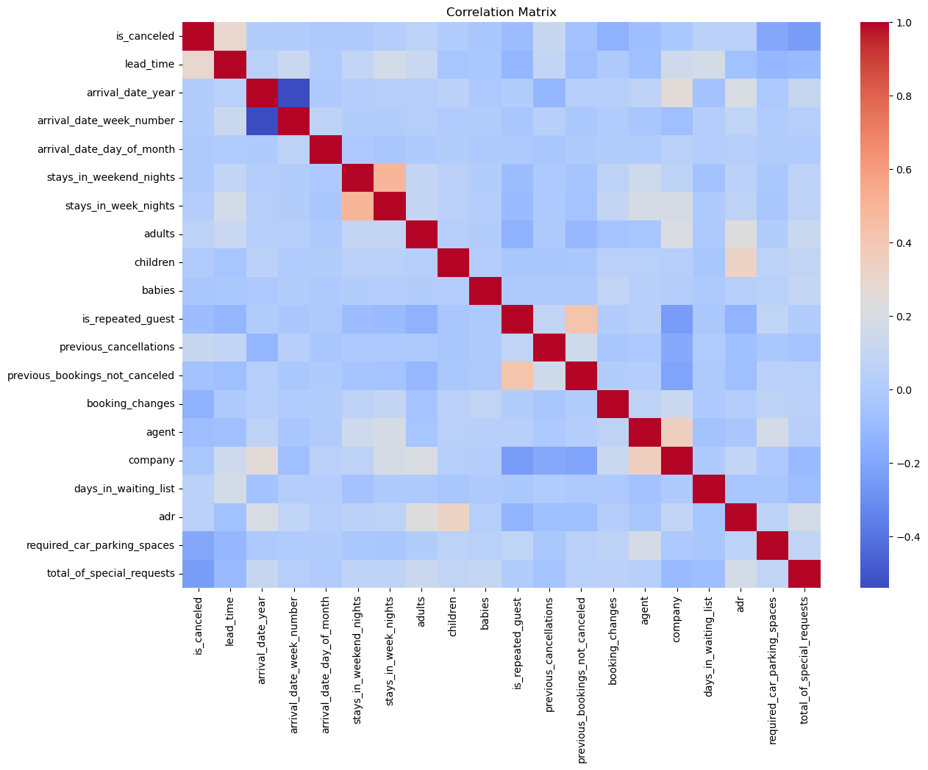
Figure 4 — Correlation matrix of numerical features
No pair of raw numerical features showed extreme multicollinearity, suggesting limited redundancy among the original numeric predictors.

4.5 Hotel Type Distribution
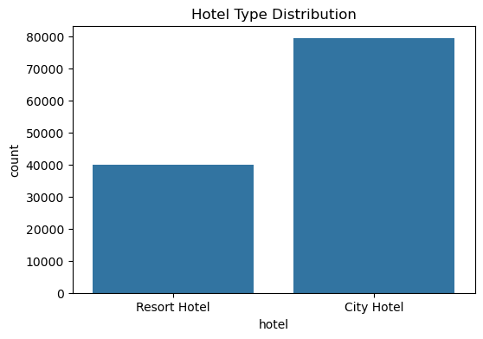
Figure 5 — Distribution of bookings by hotel type

4.6 Cancellation Rate by Hotel Type
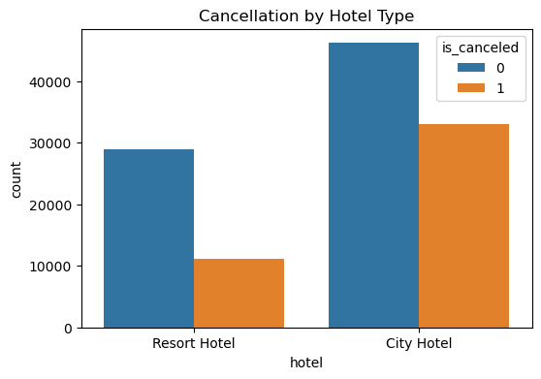
Figure 6 — Cancellation counts split by hotel type
City Hotel bookings show a visibly higher cancellation propensity than Resort Hotel bookings, indicating that hotel type is a meaningful segmentation variable.

4.7 Lead Time Distribution
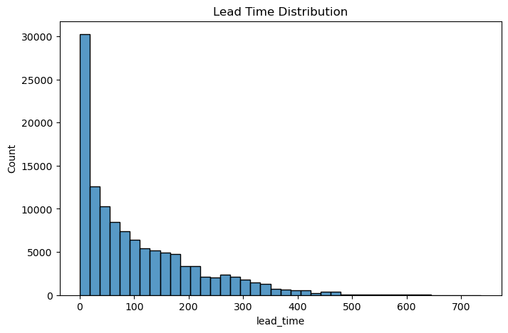
Figure 7 — Distribution of booking lead time (days between booking and arrival)
Lead time is heavily right-skewed, with most bookings made within roughly 100 days of arrival, and a long tail extending beyond 500 days. Longer lead times are later confirmed by SHAP to correlate with higher cancellation probability.

EDA Summary
- Target distribution is moderately imbalanced (63/37).
- Missingness is concentrated and explainable, not random.
- Several numerical features are skewed, favouring tree-based algorithms.
- Hotel type and lead time both show visible relationships with cancellation.

5. Data Cleaning

5.1 Duplicate Removal
The raw dataset contained 31,994 duplicate rows (26.8% of all records). These were removed to prevent the model from over-weighting repeated observations, reducing the dataset from 119,390 to 87,396 rows.
Step | Row Count
Before de-duplication | 119,390
After de-duplication | 87,396
Duplicates removed | 31,994 (26.8%)

5.2 Column Removal
The company column was dropped entirely, as it contained 94.31% missing values — far too sparse to impute reliably without introducing bias.

5.3 Missing Value Imputation
Column | Strategy | Rationale
children | Median imputation | Numerical feature; median is robust to outliers
country | Mode imputation | Categorical feature; most frequent category preserves distribution
agent | Mode imputation | Treated as a categorical identifier rather than continuous value
After imputation, the dataset contained zero missing values across all remaining 31 columns, providing a clean foundation for feature engineering.

6. Feature Engineering
Beyond the raw columns, twelve engineered features were created to encode business logic that raw columns do not directly capture — guest composition, booking value, and behavioural risk signals.
Feature | Definition | Business Rationale
total_guests | adults + children + babies | Overall party size
total_nights | weekend nights + week nights | Total length of stay
is_family | 1 if children or babies > 0 | Family vs. non-family segment
previous_customer | Copy of is_repeated_guest | Loyalty / repeat-guest flag
high_special_requests | 1 if special requests ≥ 2 | Engagement / service-intensity signal
estimated_total_cost | adr × total_nights | Total booking value
estimated_booking_value | adr × total_nights | Alternate booking-value framing
cost_per_guest | adr ÷ total_guests | Price sensitivity per traveller
changes_per_night | booking_changes ÷ (total_nights+1) | Booking volatility rate
risk_score | lead_time × previous_cancellations | Composite cancellation-risk indicator
is_couple | 1 if 2 adults, 0 children/babies | Couple-travel segment
long_stay | 1 if total_nights ≥ 7 | Extended-stay flag
Categorical variables (hotel, arrival month, meal, country, market segment, distribution channel, room types, deposit type, customer type) were one-hot encoded using pd.get_dummies with drop_first=True to avoid the dummy-variable trap, expanding the feature space from 30 to 258 predictors.
The reservation_status and reservation_status_date columns were dropped prior to modelling, since they leak the outcome directly (reservation_status effectively restates is_canceled).

Final Modelling Dataset
Split | Rows | Columns
Full feature matrix (X) | 87,396 | 258
Target vector (y) | 87,396 | 1
Training set (80%) | ≈ 69,917 | 258
Test set (20%, stratified) | ≈ 17,479 | 258

7. Model Development & Evaluation
All models were evaluated on the same held-out test set (20%, stratified by target) using Accuracy, Precision, Recall, and F1-Score, ensuring a fair, apples-to-apples comparison. Feature scaling (StandardScaler) was applied only for Logistic Regression; tree-based models used the raw encoded features.

7.1 Logistic Regression (Baseline)
A Logistic Regression model with max_iter=1000 was trained on standardized features to establish a linear baseline for comparison.
Metric | Value
Accuracy | 79.69%
Precision | 68.33%
Recall | 48.64%
F1 Score | 56.83%
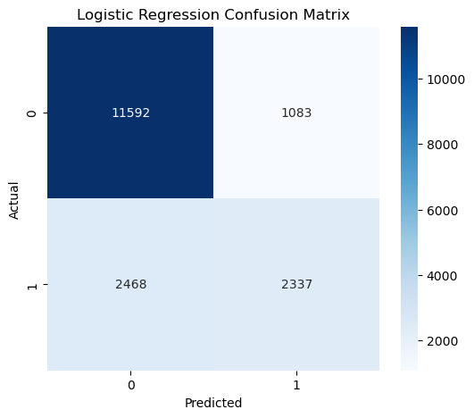
Figure 8 — Logistic Regression confusion matrix
Logistic Regression achieves reasonable accuracy but the lowest recall of all four models — it misses over half of actual cancellations, since a purely linear decision boundary struggles with the non-linear interactions present in booking behaviour.

7.2 Decision Tree Classifier
A single Decision Tree (unrestricted depth, random_state=42) was trained directly on the encoded features to capture non-linear splits.
Metric | Value
Accuracy | 79.13%
Precision | 61.93%
Recall | 63.29%
F1 Score | 62.60%
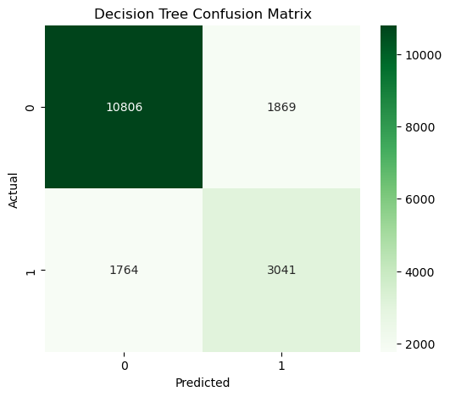
Figure 9 — Decision Tree confusion matrix

Logistic Regression vs. Decision Tree
Metric | Logistic Regression | Decision Tree
Accuracy | 79.69% | 79.13%
Precision | 68.33% | 61.93%
Recall | 48.64% | 63.29%
F1 Score | 56.83% | 62.60%
The Decision Tree trades a small amount of precision and accuracy for a substantial recall gain (+14.6 points), which is more aligned with the business goal of catching as many at-risk cancellations as possible.

7.3 Random Forest Classifier
A Random Forest ensemble of 100 trees (n_jobs=-1 for parallelism) was trained to reduce the variance of a single tree via bootstrap aggregation.
Metric | Value
Accuracy | 84.07%
Precision | 76.75%
Recall | 60.31%
F1 Score | 67.54%
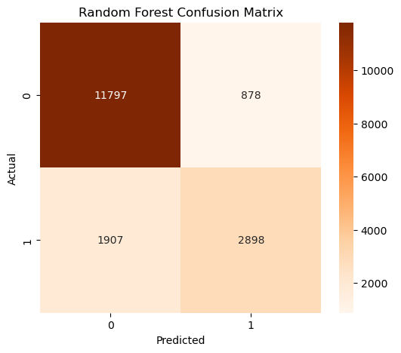
Figure 10 — Random Forest confusion matrix

Top 10 Important Features (Random Forest)
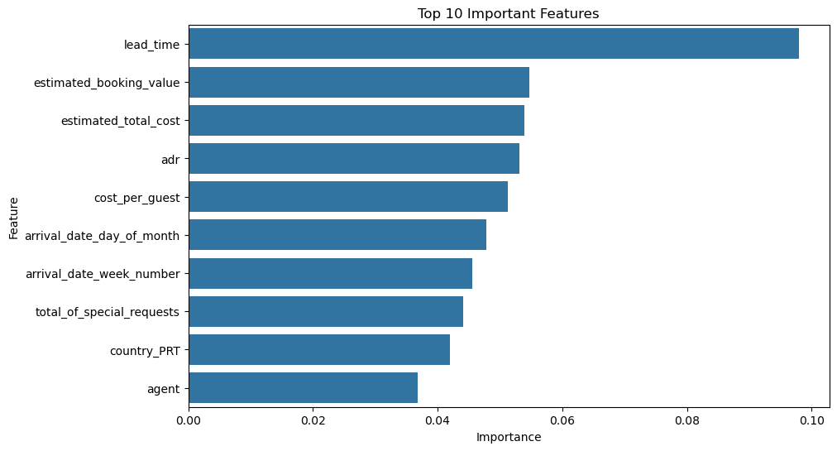
Figure 11 — Random Forest feature importance ranking
lead_time dominates the importance ranking, followed by several engineered cost-based features (estimated_booking_value, estimated_total_cost, cost_per_guest) — direct evidence that the feature engineering stage materially strengthened the model rather than only adding noise.
Random Forest delivers the best precision of all four models (76.75%) and a large jump in accuracy over the baseline, making it a strong candidate where false-positive cost matters most.

7.4 XGBoost Classifier
An XGBoost classifier (100 estimators, max_depth=6, learning_rate=0.1, logloss evaluation metric) was trained to sequentially correct residual errors via gradient boosting.
Metric | Value
Accuracy | 84.20%
Precision | 75.27%
Recall | 63.31%
F1 Score | 68.78%
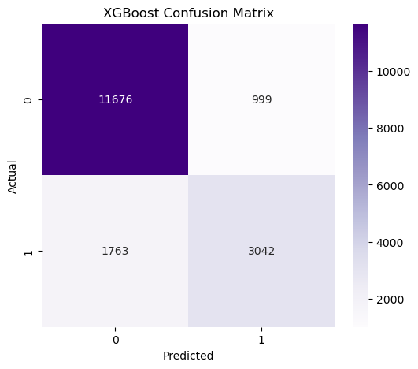
Figure 12 — XGBoost confusion matrix

Top 10 Important Features (XGBoost)
Rank | Feature | Importance
1 | market_segment_Online TA | 0.0920
2 | required_car_parking_spaces | 0.0913
3 | country_PRT | 0.0706
4 | total_of_special_requests | 0.0503
5 | market_segment_Direct | 0.0407
6 | reserved_room_type_D | 0.0388
7 | deposit_type_Non Refund | 0.0370
8 | customer_type_Transient | 0.0291
9 | agent | 0.0270
10 | lead_time | 0.0251
XGBoost achieved the highest accuracy, recall, and F1-score of all four models, while retaining strong precision — the best overall balance across every metric tracked in this study.

8. Final Model Comparison & Selection
Model | Accuracy | Precision | Recall | F1 Score
Logistic Regression | 79.69% | 68.33% | 48.64% | 56.83%
Decision Tree | 79.13% | 61.93% | 63.29% | 62.60%
Random Forest | 84.07% | 76.75% | 60.31% | 67.54%
XGBoost (Selected) | 84.20% | 75.27% | 63.31% | 68.78%

Performance Narrative
- Logistic Regression: reliable linear baseline; lowest recall of the group.
- Decision Tree: strong recall gain over the baseline, at the cost of some precision and mild overfitting risk.
- Random Forest: best precision; substantially reduces the overfitting seen in a single tree via bagging.
- XGBoost: best accuracy, recall, and F1-score; sequential boosting captures complex feature interactions most effectively.

Selected Model: XGBoost
XGBoost is selected as the final model because it delivers the best overall balance across Accuracy, Precision, Recall, and F1-Score, rather than excelling on a single metric at the expense of others. This holistic strength makes it the most suitable candidate for a production cancellation-risk scoring system, where both catching true cancellations (recall) and avoiding false alarms (precision) carry real operational cost.

9. Model Explainability (SHAP)
Ensemble models like XGBoost are powerful but opaque. To build stakeholder trust and validate that the model is learning genuine business signal rather than spurious correlations, SHAP (SHapley Additive exPlanations) was applied to a 300-row sample of the test set using shap.TreeExplainer.
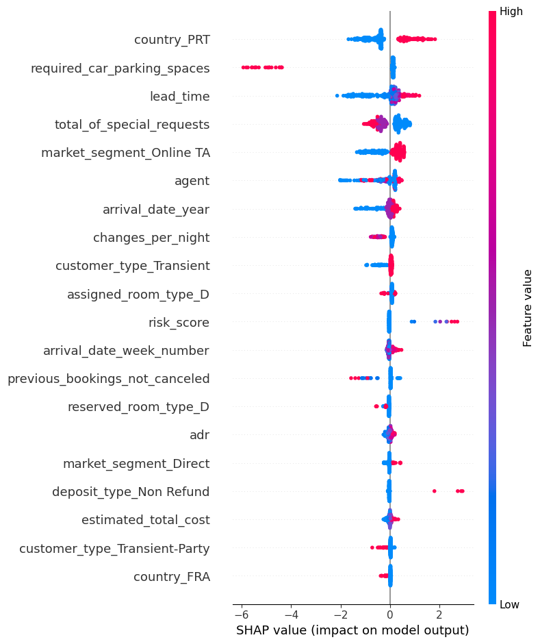
Figure 13 — SHAP summary plot for the XGBoost model

Key Observations
- country_PRT is one of the most influential features affecting cancellation predictions.
- required_car_parking_spaces strongly reduces cancellation likelihood when present.
- lead_time increases cancellation probability as it grows larger.
- total_of_special_requests contributes meaningfully, reflecting distinct guest engagement patterns.
- Market segment, customer type, room type, and deposit type also play significant roles.
- Engineered features changes_per_night and risk_score appear among the influential contributors, confirming that the feature engineering stage added genuine predictive signal.
The SHAP analysis confirms that the XGBoost model's decisions are grounded in interpretable, business-relevant features — an important validation step before any such model is considered for operational deployment.

10. Conclusion
This project developed and rigorously benchmarked four machine learning models to predict hotel booking cancellations, spanning data cleaning, EDA, feature engineering, model training, and explainability. Among Logistic Regression, Decision Tree, Random Forest, and XGBoost, XGBoost emerged as the best-performing model with 84.20% accuracy, 75.27% precision, 63.31% recall, and a 68.78% F1-score.
The results demonstrate that thoughtful, business-driven feature engineering — rather than raw column count — was a key driver of performance improvement, as evidenced by engineered features repeatedly appearing among the top predictors across both Random Forest and XGBoost. SHAP-based explainability further confirmed that the final model's decisions are grounded in intuitive, business-relevant signals such as lead time, parking requirements, and guest nationality.
Overall, this study reinforces a central principle of applied machine learning: model selection should be driven by a holistic view of business objectives and multiple evaluation metrics, not by optimizing a single number in isolation.

11. Limitations & Future Work

Limitations
- No formal hyperparameter search (e.g., GridSearchCV / Optuna) was performed; models used largely default or lightly-tuned settings.
- Class imbalance (63/37) was handled implicitly through metric choice rather than explicit resampling (SMOTE, class weighting).
- The dataset spans 2015–2017 only; cancellation behaviour may shift with post-pandemic travel patterns and OTA (Online Travel Agency) dynamics.
- One-hot encoding of high-cardinality categorical features (e.g., country, agent) inflated the feature space to 258 columns, which may increase training time without proportional gains.

Future Work
- Perform systematic hyperparameter tuning (grid/random/Bayesian search) for Random Forest and XGBoost.
- Experiment with class-imbalance techniques (SMOTE, class_weight='balanced') to further raise recall without sacrificing precision.
- Explore gradient boosting alternatives (LightGBM, CatBoost) and stacking ensembles.
- Deploy the selected model behind a lightweight API for real-time cancellation-risk scoring at the point of booking.
- Extend SHAP analysis to individual-prediction (force plot) explanations for front-line revenue-management staff.

12. Technical Appendix

Tools & Libraries
Category | Tools Used
Language | Python 3
Data Handling | pandas, NumPy
Visualization | Matplotlib, Seaborn
Machine Learning | scikit-learn (Logistic Regression, Decision Tree, Random Forest)
Boosting | XGBoost
Explainability | SHAP
Environment | Jupyter Notebook

Reproducibility Notes
- Random seed fixed at 42 across all train/test splits and model instantiations.
- Train/test split: 80/20, stratified on the target variable is_canceled.
- Feature scaling (StandardScaler) applied only for Logistic Regression.
- Full code, EDA, and evaluation outputs are contained in the accompanying Jupyter notebook: Hotel_Booking_Ensemble_Study.ipynb.

