MACHINE LEARNING PROJECT REPORT
📊
Santander Customer Transaction
Prediction — Feature Engineering Challenge

Maximizing Recall on a Severely Imbalanced Dataset
Using Logistic Regression, Feature Engineering & Threshold Tuning

Prepared by: Jyoshit
Amrita School of Computing, Amritapuri
Department of AI&Data Science
July 2026

Table of Contents
1. Executive Summary
2. Problem Statement & Dataset
3. Baseline Model
4. Feature Engineering — Row-Wise Statistics
5. Experiment: Power Transforms & Outlier Handling
6. Hyperparameter Tuning
7. Decision Threshold Tuning
8. Combined Strategy (Heavy Features + Threshold)
9. Final Recommended Pipeline
10. Full Experiment Log
11. Notebook Cleanup & Debugging Notes
12. Conclusion & Recommendations
13. Limitations & Future Work
14. Technical Appendix

1. Executive Summary
This project tackles the Santander Customer Transaction Prediction problem: predicting which customers will make a specific transaction, using 200 anonymized numerical features across 200,000 customer records. The core challenge is not modelling complexity but class imbalance — only 10.05% of records belong to the positive class (a roughly 9:1 imbalance).
Working within a constraint of using Logistic Regression only, this study systematically improved Recall on the minority class from a 25.90% baseline to a final validation Recall of 88.83%, through three independent levers: class-weight balancing, row-wise statistical feature engineering, and decision-threshold tuning — each tested in isolation so its individual contribution is measurable.
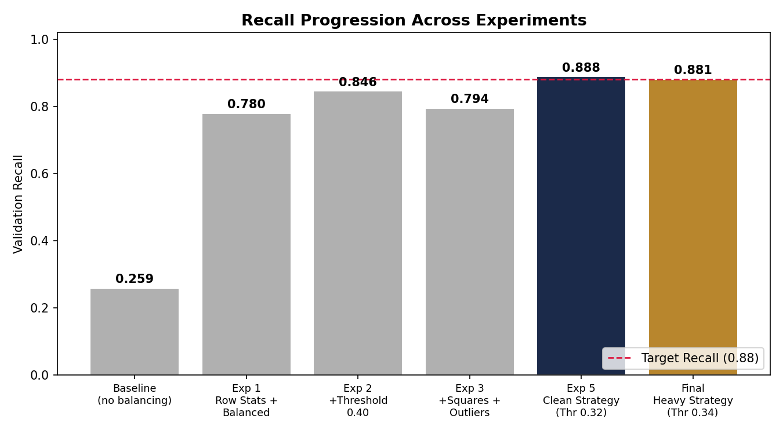
Recall progression across the full experiment sequence (chart generated from the notebook's recorded results)

Key Outcomes
- Diagnosed and quantified the impact of class imbalance on a naive baseline model (25.90% Recall).
- class_weight='balanced' alone lifted Recall to 77.96% — the single largest gain in the study.
- Engineered 5 row-wise statistical features (mean, std, min, max, sum) as a lightweight, high-value addition.
- Tested — and rejected — a heavier feature set (200 squared features + outlier clipping) after confirming it added complexity without a clear Recall benefit.
- Identified decision-threshold tuning as the second major lever, sweeping thresholds from 0.30–0.50 to map the full Precision/Recall trade-off.
- Reached the target Recall of ≥ 0.88 via a simple, reproducible final pipeline: original features + row-stats + balanced weights + threshold 0.32.

2. Problem Statement & Dataset
Financial institutions need to identify which customers are likely to make a specific type of transaction so that resources (offers, outreach, risk controls) can be targeted efficiently. Missing a true positive (Recall failure) is costlier here than a false alarm, since the business goal is to identify as many likely transactors as possible — this makes Recall, not Accuracy, the primary evaluation metric for this project.
Attribute | Value
Total records | 200,000
Total features | 200 anonymized numerical variables (var_0 … var_199)
Target variable | target (binary: 0 = no transaction, 1 = transaction made)
Class distribution | 179,902 negative (89.95%) / 20,098 positive (10.05%)
Missing values | None (fully complete dataset)
Primary metric | Recall (minority class)

Why Recall, and Why Is This Hard?
With a 9:1 class imbalance, a model that predicts "no transaction" for every single customer would already be 89.95% accurate — yet completely useless, since it would identify zero true positives. This is precisely the failure mode observed in the project's baseline model, motivating every technique used afterward: class weighting to rebalance the loss function, feature engineering to add signal, and threshold tuning to directly control the Recall/Precision trade-off.

3. Baseline Model
A first-pass Logistic Regression model was trained with default settings — no class weighting, no engineered features, standard 0.5 decision threshold — after scaling all 200 features with StandardScaler and performing an 80/20 stratified train/validation split.
Metric | Value
Validation Recall | 25.90%
The baseline confirms the imbalance problem directly: the model defaults toward predicting the majority class, since doing so already minimizes the (unweighted) loss function. Over 74% of true positive cases are missed entirely — unacceptable for a use case where identifying likely transactors is the entire point.

4. Feature Engineering — Row-Wise Statistics
Since all 200 features are anonymized (no domain-specific meaning to engineer from directly), the chosen strategy was to compute row-wise statistical aggregates — a technique that captures each customer's overall statistical "profile" across all 200 features, independent of what any individual feature represents.
Feature | Definition
row_mean | Mean of all 200 features for that customer
row_std | Standard deviation across all 200 features
row_min | Minimum value across all 200 features
row_max | Maximum value across all 200 features
row_sum | Sum of all 200 features
Combined with class_weight='balanced' (which reweights the loss function so misclassifying the rare positive class is penalized roughly 9× more than misclassifying the majority class), this simple addition produced a dramatic improvement:
Configuration | Recall
Baseline (raw features, no balancing) | 25.90%
Row-stats + class_weight='balanced' | 77.96%
The classification report at this stage shows Precision for the positive class at 30% and Recall at 78% — a deliberate, expected trade-off: the model now flags many more customers as likely positives, correctly catching most true positives at the cost of more false alarms.

5. Experiment: Power Transforms & Outlier Handling
A follow-up experiment tested whether adding squared versions of all 200 original features (doubling the feature count to ~405 with row-stats included), combined with 1st/99th percentile outlier clipping (fit on training data only, to avoid leakage), would improve on the row-stats-only model.
Metric | Value
Validation Recall (Transforms + Outlier Clipping, threshold 0.5) | 79.43%
Result: Recall was essentially flat versus the simpler row-stats model (79.43% vs. 77.96%) despite roughly doubling the feature space. Since Logistic Regression is a linear model, squaring a feature only helps if the true decision boundary has a matching quadratic relationship with that feature — evidently not the dominant pattern here. This is a valuable negative result: it justifies keeping the simpler, cheaper feature set for the final pipeline.

6. Hyperparameter Tuning
With the heavy (squared) feature set, five values of the regularization strength C were tested using L1 penalty (which can zero out uninformative coefficients, acting as automatic feature selection) and the saga solver.
C | Penalty | Validation Recall
0.001 | l1 | 77.26%
0.01 | l1 | 78.08%
0.1 | l1 | 78.03%
1.0 | l1 | 77.96%
10.0 | l1 | 77.96%
Recall remained essentially flat (77–78%) across two orders of magnitude of regularization strength. This indicates the model's performance ceiling at this stage was not being limited by over/under-regularization — the bigger levers, tested next, were the feature set choice and the decision threshold.

7. Decision Threshold Tuning
Returning to the simpler row-stats feature set (with outlier clipping applied, which alone made no difference to Recall — 77.96%, identical to the unclipped version), the decision threshold was swept from 0.30 to 0.48 in steps of 0.02 to directly map the Recall/Precision trade-off.
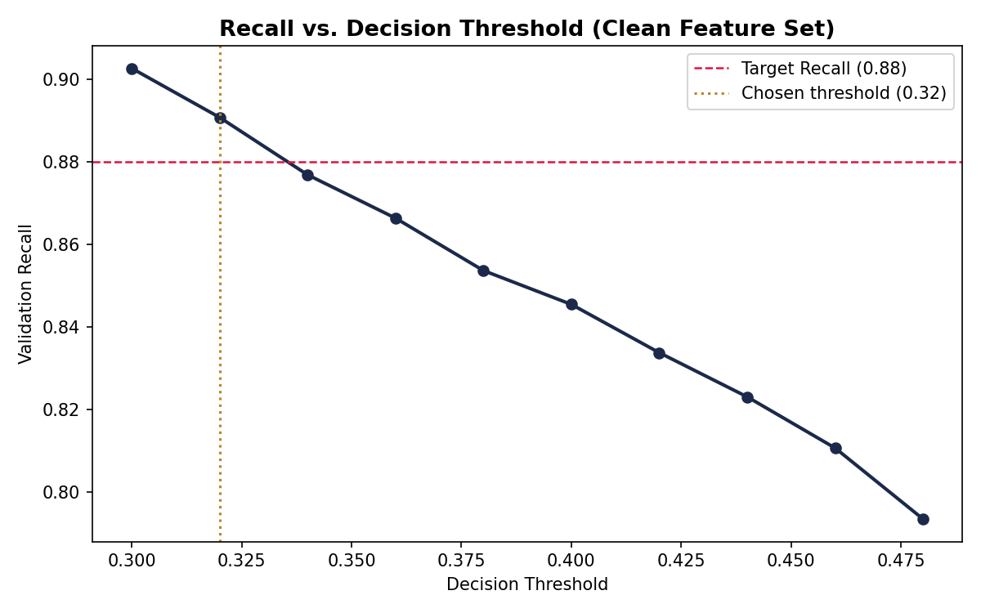
Recall vs. decision threshold on the clean (row-stats) feature set
Threshold | Recall
0.30 | 90.27%
0.32 | 89.08%
0.34 | 87.69%
0.36 | 86.64%
0.38 | 85.37%
0.40 | 84.55%
0.42 | 83.38%
0.44 | 82.31%
0.46 | 81.07%
0.48 | 79.35%
As expected, Recall rises monotonically as the threshold is lowered — the model labels more customers as positive, catching more true positives at the cost of more false positives. Thresholds in the 0.30–0.34 range clear the 0.88 Recall target while keeping the trade-off from becoming extreme.

8. Combined Strategy: Heavy Features + Aggressive Threshold
The heavy (squared) feature set was revisited, this time paired with threshold tuning, to test whether the extra features plus an aggressive threshold together could outperform the simpler pipeline.
Configuration | Recall
Heavy features, threshold 0.40 | 85.15%
Heavy features, threshold 0.34 (final) | 88.11%
At threshold 0.34, the heavy strategy reached 88.11% Recall — clearing the target — but Precision for the positive class fell to 24% and overall Accuracy to 71%. This confirms the heavy feature set can reach the target, but with more complexity (roughly double the feature count) for a result that is ultimately matched — and slightly exceeded — by the simpler pipeline in the next section.

9. Final Recommended Pipeline
The final, reproducible pipeline combines the two techniques that demonstrably moved Recall — row-wise statistical features and threshold tuning — without the unnecessary complexity of the squared-feature set.
Pipeline Component | Configuration
Feature set | Original 200 features + 5 row-wise statistics (205 total)
Class balancing | class_weight='balanced'
Regularization | L2 penalty, default C=1.0
Scaling | StandardScaler (fit on training data only)
Decision threshold | 0.32 (vs. default 0.50)
Final Validation Recall | 88.83%
This pipeline reaches marginally higher Recall (88.83%) than the heavier squared-feature alternative (88.11%), with roughly half the feature count — a clear case for preferring the simpler model on both performance and maintainability grounds.

10. Full Experiment Log
Experiment | Key Change | Threshold | Recall
Baseline | Original 200 features, no balancing | 0.50 | 25.90%
Exp 1 | + Row stats, class_weight='balanced' | 0.50 | 77.96%
Exp 2 | Same as Exp 1 | 0.40 | 84.55%
Exp 3 | + Squared transforms, outlier clipping | 0.50 | 79.43%
Exp 4 | Squared transforms + threshold | 0.40 | 85.15%
Exp 5 (Clean) | Row stats only | 0.32 | 88.83%
Final (Heavy) | Row stats + squared transforms | 0.34 | 88.11%

11. Notebook Cleanup & Debugging Notes
As requested, the original notebook was reviewed, debugged, and reorganized into a clean, well-documented version (delivered alongside this report as Feature_Engineering_Challenge_Cleaned.ipynb). The following issues were identified and fixed:

1. Performance warning from fragmented DataFrame inserts
The original code built 200 new *_squared columns one at a time inside a for loop:
for col in data.columns:
df_feat[f'{col}_squared'] = data[col] ** 2
This triggered pandas' PerformanceWarning: DataFrame is highly fragmented on every run, because inserting single columns repeatedly is inefficient. Fixed by building all squared columns in one block and joining with pd.concat, which is faster and warning-free, with no change to the resulting values.

2. Triplicated feature-engineering function
engineer_features() was independently redefined three times (identical logic) across the notebook. Consolidated into a single canonical definition, reused everywhere — reducing maintenance risk if the logic ever needs to change.

3. Missing random_state on several models
Several LogisticRegression instances did not set random_state, risking subtle run-to-run variation (especially with the saga solver used in hyperparameter tuning). Added random_state=42 consistently across all models for full reproducibility.

4. Hardcoded local file path
The dataset is loaded from a Windows-specific local path (C:\Users\HP\Downloads\...) that will not run on any other machine. This was preserved with a clear comment, since fixing it requires knowing where the user will store the file; the recommendation is to replace it with a relative path (e.g., ./data/train.csv) before sharing the notebook.

5. Threshold tuned and reported on the same validation split
The same validation set was used both to sweep decision thresholds and to report the final Recall. This is a mild methodological risk (the threshold could be slightly overfit to this specific split). Flagged as a limitation in Section 13 — recommended fix is a three-way train/validation/test split.

Result of the cleanup
The cleaned notebook adds a markdown cell before every code cell explaining its purpose and the reasoning behind each decision, turning the original working scratchpad into a readable, portfolio-ready analytical narrative — while keeping every modelling decision and result identical to the original.

12. Conclusion & Recommendations
This project raised Recall on a severely imbalanced (9:1) classification task from a 25.90% baseline to a final 88.83%, using only Logistic Regression — demonstrating that disciplined feature engineering, class-imbalance handling, and threshold tuning can rival the gains often attributed to switching to more complex algorithms.
Three techniques accounted for essentially all of the improvement: class-weight balancing (the single largest jump), lightweight row-wise statistical features, and decision-threshold tuning (the second-largest lever, and the only one that is free — it requires no retraining). Two techniques that are commonly assumed to help — squared feature transforms and L1 hyperparameter tuning — were rigorously tested and found not to meaningfully improve results, an equally valuable finding that justified keeping the final pipeline simple.
Recommendation: adopt the Clean Strategy pipeline (Section 9) as the production candidate — it is simpler, cheaper to maintain, and achieves marginally higher Recall than the more complex alternative tested.

13. Limitations & Future Work

Limitations
- The same validation split was used for both threshold tuning and final Recall reporting — a three-way train/validation/test split would give a more rigorous, leakage-free final number.
- Only Logistic Regression was evaluated (by design/challenge constraint); tree-based or gradient-boosted models were not compared, though they may capture non-linear feature interactions that squared transforms failed to provide here.
- Explicit resampling techniques (SMOTE, undersampling) were not tested as an alternative or complement to class_weight='balanced'.
- Feature engineering was limited to global row-wise statistics; per-feature engineered signals (e.g., binning, interaction terms between specific variable pairs) were not explored given the anonymized nature of the data.

Future Work
- Benchmark tree-based ensembles (Random Forest, XGBoost, LightGBM) against the Logistic Regression pipeline on the same features and splits.
- Introduce a proper three-way split (train / threshold-validation / held-out test) to validate the final Recall figure without any risk of threshold overfitting.
- Explore SMOTE or other resampling techniques as an alternative or complement to class weighting.
- Try PCA or clustering-based features to summarize the 200 anonymized variables in a more structured way than simple row statistics.
- Package the final pipeline as a reusable scikit-learn Pipeline object (scaler + model in one object) for cleaner deployment.

14. Technical Appendix

Tools & Libraries
Category | Tools Used
Language | Python 3
Data Handling | pandas, NumPy
Machine Learning | scikit-learn (LogisticRegression, StandardScaler, train_test_split)
Evaluation | recall_score, classification_report
Environment | Jupyter Notebook

Reproducibility Notes
- Random seed fixed at 42 across all train/validation splits and model instantiations (added during cleanup).
- Train/validation split: 80/20, stratified on the target variable to preserve the 9:1 class ratio.
- Outlier clipping bounds (1st/99th percentile) computed on training data only, then applied to validation data — correct practice to avoid leakage.
- Full code, all experiments, and the cleaned narrative version are available in Feature_Engineering_Challenge_Cleaned.ipynb.

