**Circuit Simulation Project**

**[https://esim.fossee.in/circuit-simulation-project](https://esim.fossee.in)**

**Name of the participant :**

**CH.VENKAT KESHAV**

**Title of the circuit :**

4 BIT COMPARATOR

**Theory/Description :**

A magnitude digital Comparator is a combinational circuit that compares two digital or binary numbers in order to find out whether one binary number is equal, less than or greater than the other binary number. We logically design a circuit for which we will have two inputs one for A and other for B and have three output terminals, one for A > B condition, one for A = B condition and one for A < B condition.

A comparator used to compare two binary numbers each of four bits is called a 4-bit magnitude comparator. It consists of eight inputs each for two four bit numbers and three outputs to generate less than, equal to and greater than between two binary numbers.

In a 4-bit comparator the condition of A>B can be possible in the following four cases: 

If A3 = 1 and B3 = 0

If A3 = B3 and A2 = 1 and B2 = 0

If A3 = B3, A2 = B2 and A1 = 1 and B1 = 0

If A3 = B3, A2 = B2, A1 = B1 and A0 = 1 and B0 = 0

Similarly the condition for A<B can be possible in the following four cases: 

If A3 = 0 and B3 = 1

If A3 = B3 and A2 = 0 and B2 = 1

If A3 = B3, A2 = B2 and A1 = 0 and B1 = 1

If A3 = B3, A2 = B2, A1 = B1 and A0 = 0 and B0 = 1

The condition of A=B is possible only when all the individual bits of one number exactly coincide with corresponding bits of another number.

From the above statements logical expressions for each output can be expressed as follows:

AA, 831331 r: (A3 EioNor 33)A2132′ a (A3 Ex-Nor 133) (A2 Ex-Nor 132)A131′ a (A3 Ex-Nor 33) (A2 ENor132) (Al Ex-Nor 31)A01301   
,13: A3’03 a (A3 Ex-Nor 33)A211:12 a (A3 Ex-Nor 83) (A2 Ex-Nor 132)Ar131 a (A3 Ex-Nor 33) (A2 Ex-Nor32) (Al Ex-Nor 131)A0N30   
A=B: (A3 Ex-Nor B3) (A2 Ex-Nor 82) (Al Ex-Nor BI) (AO Ex-Nor BO)

Comparators are used in central processing units (CPUs) and microcontrollers (MCUs).

These are used in control applications in which the binary numbers representing physical variables such as temperature, position, etc. are compared with a reference value.

**Circuit Diagram(s) :**

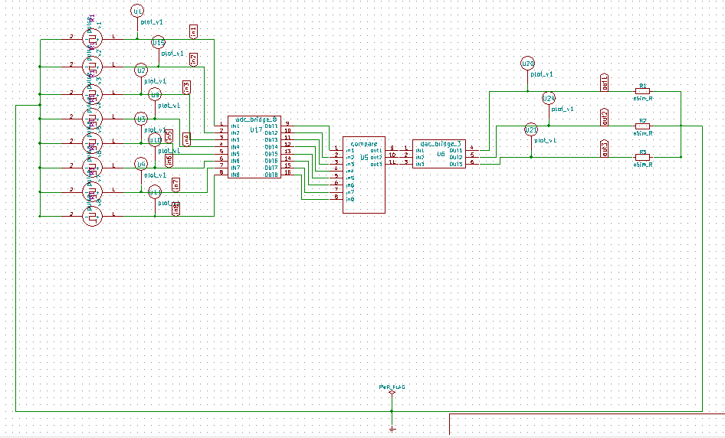

**Results (Input, Output waveforms and/or Multimeter readings) :**

**INPUTS:**

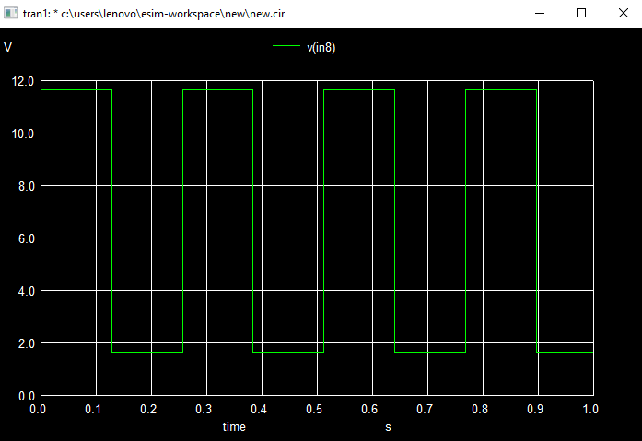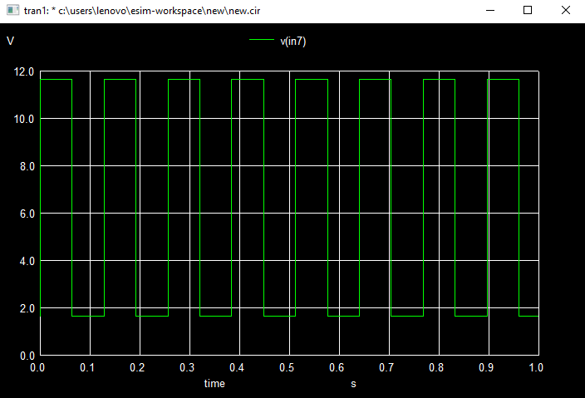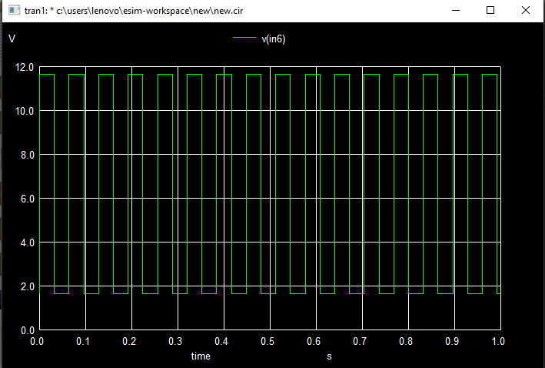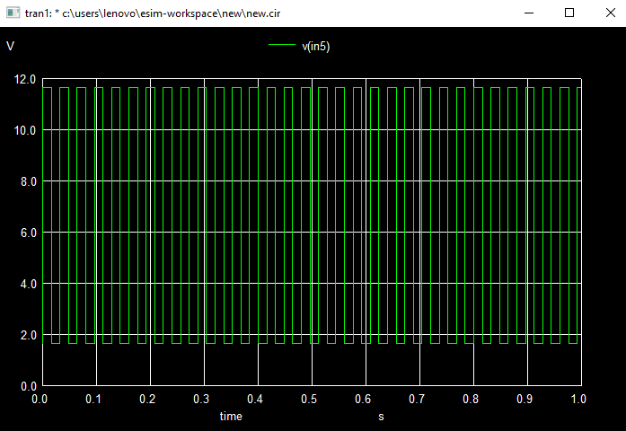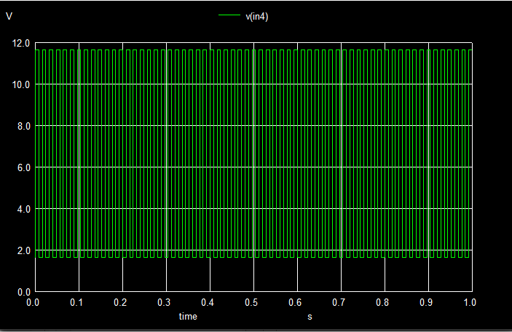

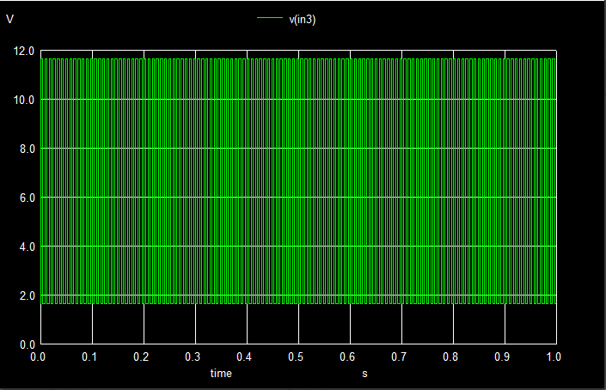

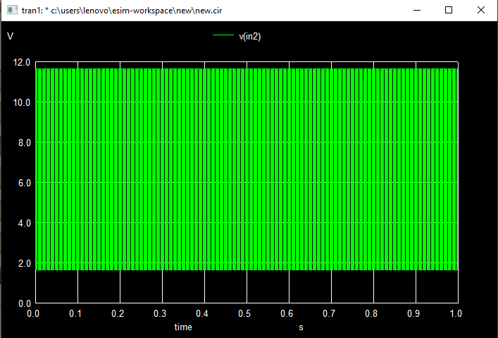

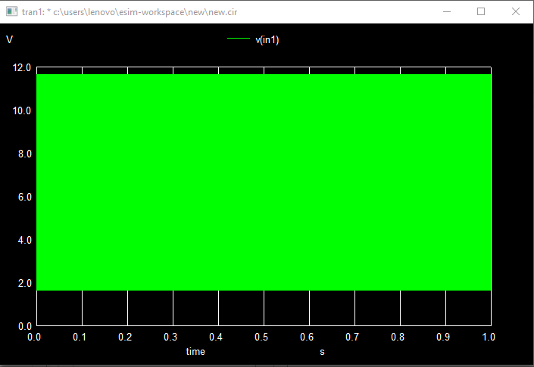

**Output:**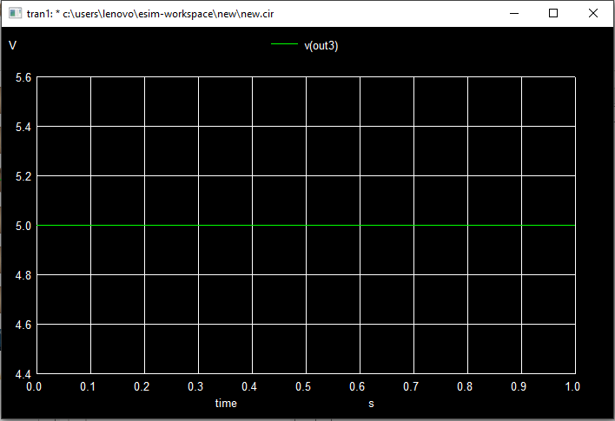

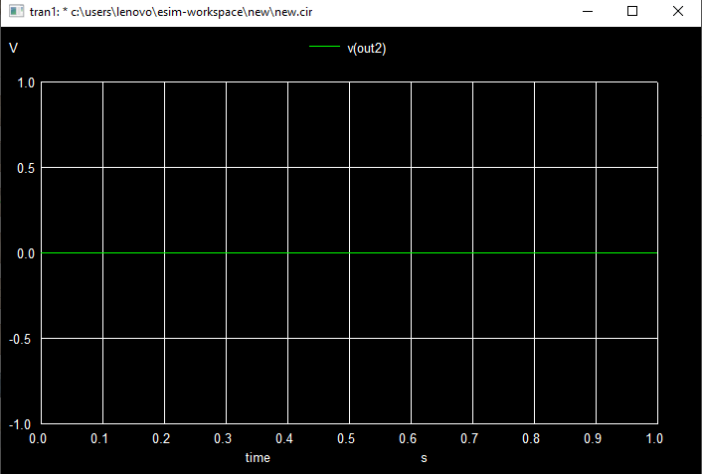

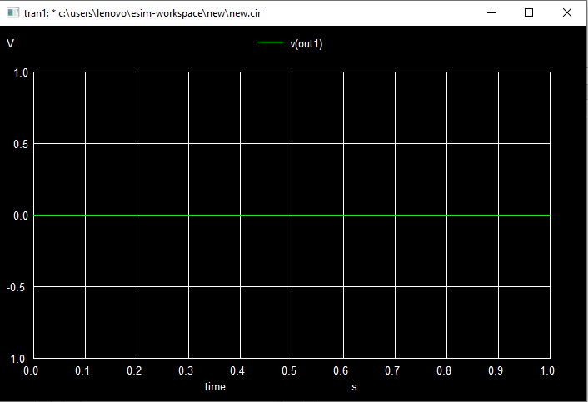

**PYTHON PLOT:**

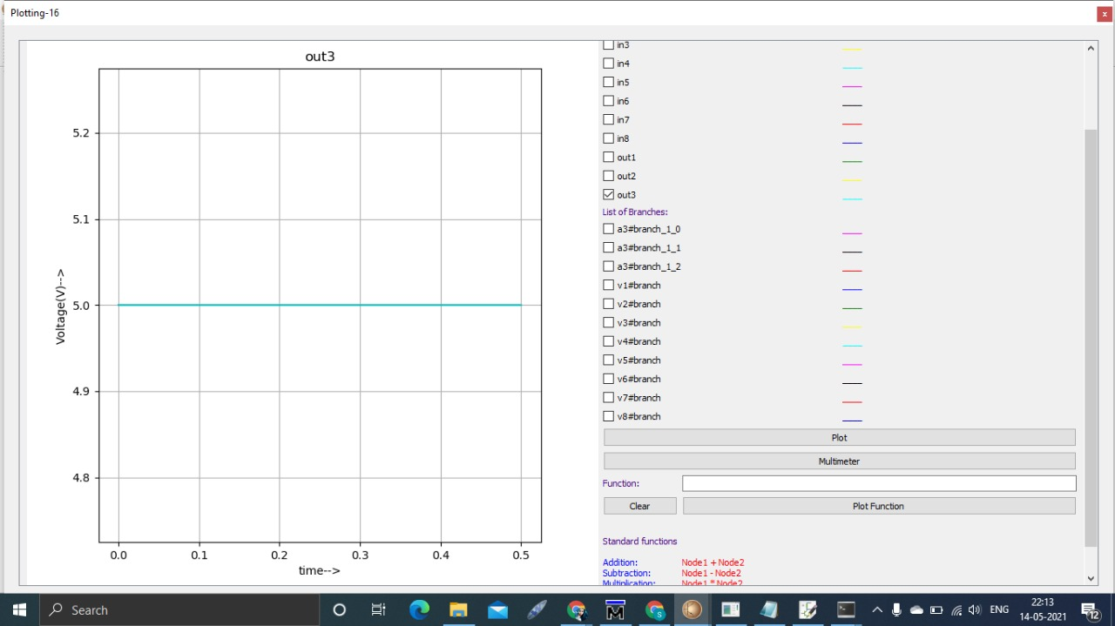

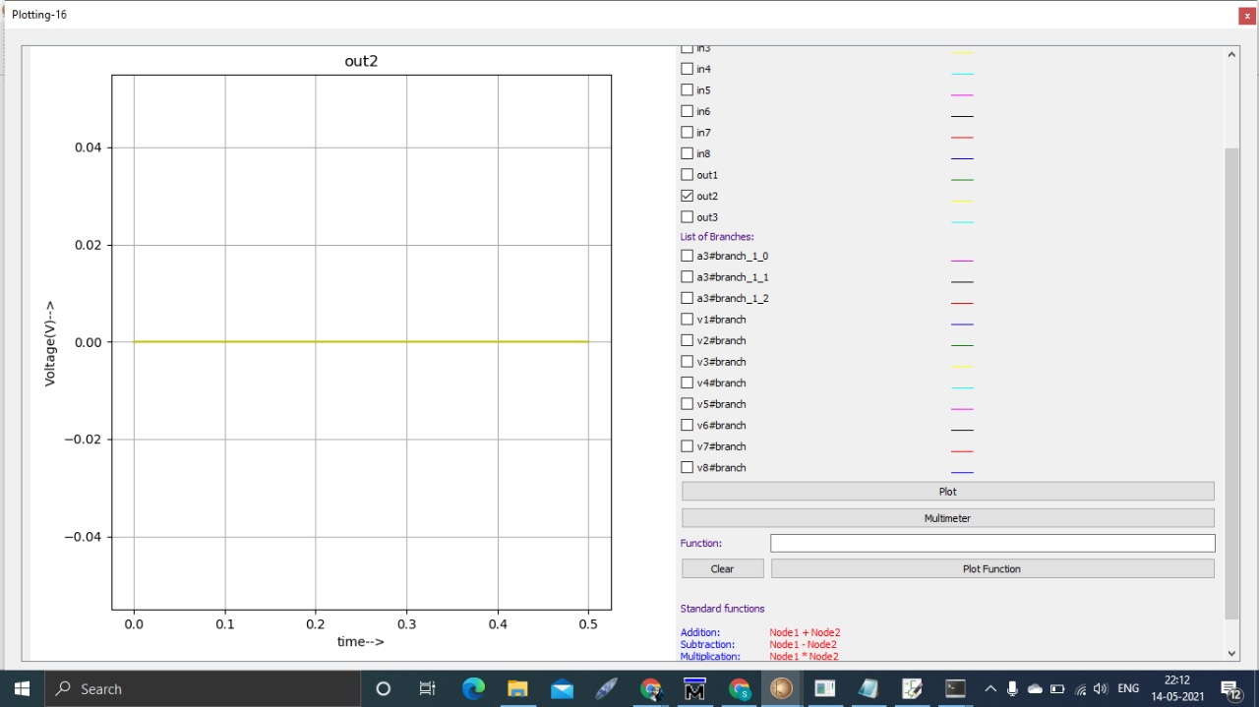

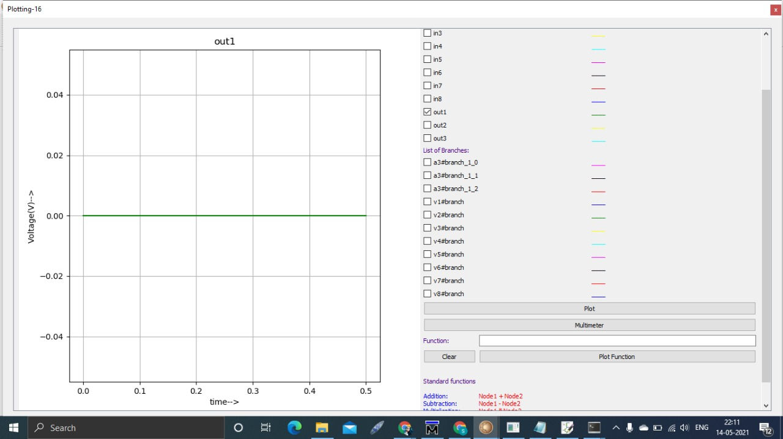

**Source/Reference(s) :**

**https://www.geeksforgeeks.org/magnitude-comparator-in-digital-logic/**