# **MPower Health:Invoice Processing System**

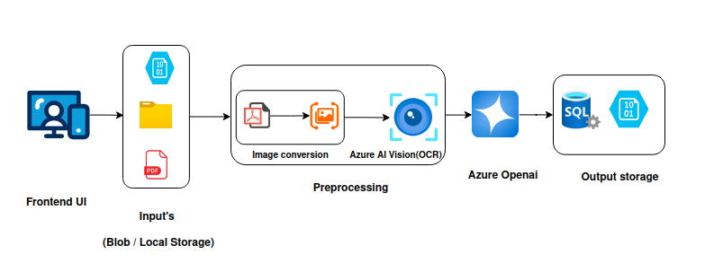

**Solution Overview:**

Our Invoice Field Parsing Solution automates the extraction of specific data fields from invoice documents. The system uses advanced AI and optical character recognition to identify, extract, and process information from invoices regardless of format or vendor.

## **System Architecture**

**Frontend UI:** User-friendly interface for uploading invoices and viewing extracted data.

**Input Storage:** Secure document storage supporting multiple input methods including Azure Blob Storage for cloud storage, local folder access, and direct PDF uploads.

**Preprocessing**: Automated document preparation with image conversion for optimal processing and Azure AI Vision with OCR technology to convert text from images to machine readable format.

**Azure OpenAI:** Intelligent processing with field identification based on context and position, pattern recognition for invoice-specific data, and validation of extracted information.

**Output Storage:** Structured data management with SQL database for organized storage of extracted fields and Azure Blob for document