Project Title
Z-Algorithm for Efficient Pattern Matching
Project Report submitted for the partial fulfilment of grade for the course

Data Structures and Algorithms -3 (25CS2103E)
in

A.Y. 2026-2027

Submitted by
Charan Teja (2520030418)
SK. Juneeth (2520030435)
D. Venkata Mahith (2520030497)

Team Number: 21
Section: 4

Under the guidance of

Mrs. J. Yamini Devi

Assistant Professor, Department of CSE
Hyderabad-500090, Telangana, India.

K L (Deemed to be) University
DEPARTMENT OF COMPUTER SCIENCE ENGINEERING



DECLARATION

The Mini Project Report entitled “Z-Algorithm for Efficient Pattern Matching” is a record of Bonafide work of Charan Teja – 2520030418, SK. Juneeth – 2520030435, D. Venkata Mahith – 2520030497, submitted in partial fulfillment for the award of B. Tech in Computer Science and Engineering to the K L University. The results embodied in this report have not been copied from any other departments/University/Institute.

Charan Teja – 2520030418
SK. Juneeth – 2520030435
D. Venkata Mahith – 2520030497

K L (Deemed to be) University
DEPARTMENT OF COMPUTER SCIENCE ENGINEERING
CERTIFICATE

This is to certify that the mini project based report entitled “Z-Algorithm for Efficient Pattern Matching” is a bonafide work done and submitted by Charan Teja – 2520030418, SK. Juneeth – 2520030435, D. Venkata Mahith – 2520030497 in partial fulfillment of the requirements for the award of the degree of BACHELOR OF TECHNOLOGY in Department of Computer Science Engineering, K L (Deemed to be University), during the academic year 2026-2027.

Signature of the Supervisor

Signature of the HOD Signature of the External Examiner

ACKNOWLEDGEMENT

The success in this project would not have been possible but for the timely help and guidance rendered by many people. Our wish to express my sincere thanks to all those who has assisted us in one way or the other for the completion of my project.

Our greatest appreciation to my guide, Mrs. J. Yamini Devi, Assistant Professor, Department of Computer Science and Engineering, which cannot be expressed in words for her tremendous support, encouragement and guidance for this project.

We express our gratitude to Dr. P. Venkateshwar Rao, Head of the Department for Computer Science Engineering for providing us with adequate facilities, ways and means by which we are able to complete this project-based Lab.

We thank all the members of teaching and non-teaching staff members, and also who have assisted me directly or indirectly for successful completion of this project. Finally, I sincerely thank my parents, friends and classmates for their kind help and cooperation during my work.

Charan Teja – 2520030418
SK. Juneeth – 2520030435
D. Venkata Mahith – 2520030497

TABLE OF CONTENTS

S.No. | Contents | Page no.
1. | Abstract | 6
 |  | 7
2. | Introduction | 8
3. | Literature survey | 9
4. | Problem Statement and Objectives | 10
5. | Hardware and Software requirements | 11
6. | Implementation | 13
7. | Results & Discussion | 17
8. | Conclusion & Future Scope | 18
9. | References

1.ABSTRACT
The Z-Algorithm project aims to develop an application that finds every occurrence of a pattern P inside a text T in linear time. String pattern matching is a core problem in computer science and underlies text editors, search engines, bioinformatics, spell-checkers and intrusion-detection systems. The naive method re-scans characters it has already compared and needs O(n·m) time in the worst case, which is impractical for large texts such as genomic sequences or web-scale documents.
The application accepts a text and a pattern as input. It forms the string S = P + “$” + T and builds its Z-array, where Z[i] is the length of the longest substring starting at position i that matches a prefix of S. A two-pointer window (l, r) lets the algorithm reuse earlier comparisons, so the Z-array is built in O(n + m) time. Every index where Z[i] equals the length of the pattern is reported as a match.
The Z-Algorithm is implemented in C++ and compared with three classical approaches, namely Naive Search, Rabin–Karp and Knuth–Morris–Pratt (KMP), through benchmarking on texts of different sizes and pattern lengths. The results show that the Z-Algorithm keeps a linear-time guarantee like KMP, is far faster than the naive method on repetitive inputs, and is simpler to implement because it needs no separate failure-function table.
Team Name: Team 21
Team Logo (if any): Not applicable
Team Members:
1. Charan Teja, 2520030418
2. SK. Juneeth, 2520030435
3. D. Venkata Mahith, 2520030497
- INTRODUCTION

Searching for a pattern inside a large body of text is one of the most frequent operations in computer systems. It is used in text editors, search engines, spell-checkers, DNA and protein sequence analysis, plagiarism detection and network intrusion-detection systems. As the amount of text grows, the speed of the matching algorithm decides whether such a system feels instant or unusable.
The naive method checks the pattern at every position of the text, which gives O(n·m) time in the worst case for a text of length n and a pattern of length m. The Z-Algorithm (Gusfield, 1997) removes this repeated work. For a string S it computes a Z-array in which Z[i] is the length of the longest substring starting at i that matches a prefix of S. By forming S = P + “$” (a separator not present in either string) + T and computing its Z-array, every match of P in T is found wherever Z[i] equals the length of P, all in one linear O(n + m) pass.
The motivation for this project is both academic and practical. Academically, the Z-Algorithm is a clean example of how a small amount of stored information (the window [l, r] and the values already computed) turns a quadratic procedure into a linear one. Practically, it gives the same worst-case guarantee as KMP with a much simpler preprocessing step, which makes it easy to code correctly and easy to teach.
This project implements the Z-Algorithm in C++ from first principles and benchmarks it against Naive, Rabin–Karp and KMP. The rest of this report covers the literature survey, the problem statement and objectives, the hardware and software requirements, the implementation, the results and discussion, and the conclusion with future scope.
- LITERATURE SURVEY

1. Gusfield, D. (1997) – Algorithms on Strings, Trees and Sequences. Gusfield formalised the Z-Algorithm and the Z-array as a general string-processing primitive. He showed that the Z-array can be built in linear time with a window [l, r] and that it solves exact matching directly. Our implementation follows this formulation.
2. Knuth, D. E., Morris, J. H. and Pratt, V. R. (1977) – Fast Pattern Matching in Strings. The KMP algorithm precomputes a failure function so that matched characters are never examined again, giving O(n + m) time in the worst case. It is the main linear-time baseline against which the Z-Algorithm is compared.
3. Boyer, R. S. and Moore, J. S. (1977) – A Fast String Searching Algorithm. Boyer–Moore scans the pattern from right to left and uses the bad-character and good-suffix heuristics to skip text positions. It is often sub-linear in practice, but its preprocessing tables are more complex than the Z-array.
4. Karp, R. M. and Rabin, M. O. (1987) – Efficient Randomized Pattern-Matching Algorithms. Rabin–Karp compares rolling hash values instead of strings, which gives O(n + m) time on average and makes multi-pattern search easy. Hash collisions can push the worst case to O(n·m), so its running time is less predictable.
5. Aho, A. V. and Corasick, M. J. (1975) – Efficient String Matching. The Aho–Corasick automaton searches for many patterns at the same time in one pass over the text. It is the natural extension of single-pattern linear-time matching and is discussed in the future scope of this project.
6. Cormen, Leiserson, Rivest and Stein – Introduction to Algorithms (CLRS), Chapter 32. CLRS presents the naive, Rabin–Karp and KMP matchers with their running-time analysis. We used it as the reference for the complexity of the baseline algorithms in our comparison.
7. Applications in bioinformatics and large-text search. Exact matching is used on very long DNA and protein sequences, log files and document collections. Comparative studies of these algorithms highlight the Z-Algorithm for its simplicity when only exact matching is needed.
8. GeeksforGeeks, CP-Algorithms and Wikipedia tutorials on the Z-Algorithm. These online resources explain the Z-array, the window update rule and the search by concatenation. We used them to cross-check our understanding and to confirm the sample outputs.
Summary: the existing work shows that exact matching can be done in linear time by KMP and by the Z-Algorithm, that Boyer–Moore and Rabin–Karp offer other speed and simplicity trade-offs, and that Aho–Corasick extends the idea to many patterns. This project implements the Z-Algorithm from scratch and measures it against the other three methods so that the trade-offs are easy to see.
- Problem Statement and Objectives

Problem Statement:
Given a text T of length n and a pattern P of length m over some alphabet, find all positions in T where P occurs as a substring. The solution must run in O(n + m) time, return every match including overlapping ones, and give the same answer as a brute-force search.
Problem Description:
The naive method is expensive on large texts because it re-compares characters after every mismatch. Efficient alternatives such as KMP and Boyer–Moore exist, but their preprocessing (failure functions and heuristic tables) is comparatively complex. This project investigates whether the simpler Z-Algorithm delivers comparable performance with an easier implementation, and where it is better or worse than the other methods.
Objectives:
Purpose of the project: The project was started to show how a window of already-computed information turns a quadratic search into a linear one, and to compare the Z-Algorithm with Naive, Rabin–Karp and KMP in terms of correctness, speed and simplicity. The specific objectives are:
1. Input Handling: Accept a text and a pattern, and validate that the pattern is non-empty and not longer than the text.
2. Z-Array Implementation: Build the Z-array of S = P + “$” + T in O(n + m) time using the window [l, r].
3. Pattern Search: Report every position where Z[i] equals the pattern length, converted to a position in the text.
4. Baseline Algorithms: Implement Naive, Rabin–Karp and KMP as performance and correctness baselines.
5. Verification: Check the output of every algorithm against a brute-force search on all test inputs.
6. Performance Analysis: Compare execution time across different text sizes and pattern types, and discuss the practicality of the Z-Algorithm for real tasks such as text search and substring matching.
- HARDWARE AND SOFTWARE REQUIREMENTS

Hardware Requirements:
• Processor: Intel Core i5 / AMD Ryzen 5 (or equivalent) or higher
• RAM: Minimum 8 GB (16 GB recommended)
• Storage: 500 MB of free disk space
Software Requirements:
• Operating System: Windows 10/11, Linux or macOS
• Language: C++ (using the Standard Template Library, STL); Python 3.x can also be used
• IDE / Compiler: VS Code with GCC (g++)
• Libraries and tools: iostream, vector, string, iomanip and chrono (for timing the benchmarks); Git and GitHub for version control
- IMPLEMENTATION

The application is written in C++ and is organized into four modules. The flow chart in Figure 6.1 shows the overall procedure: the pattern and the text are joined with a separator, the Z-array is computed position by position while a window [l, r] is maintained, and every position where Z[i] equals the pattern length is recorded as a match.
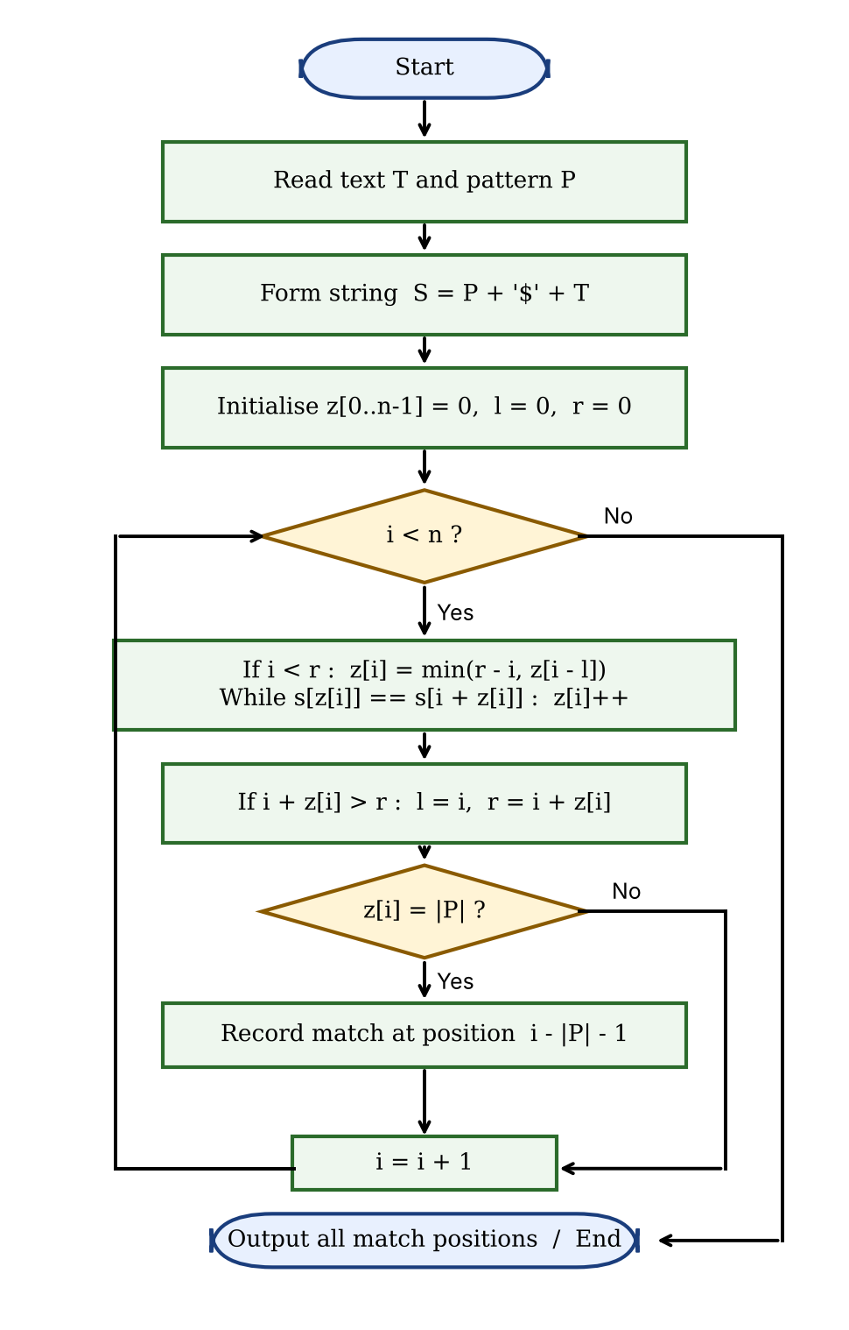
Figure 6.1: Flow chart of the Z-Algorithm
Module 1: Input Handling
Reads the text and the pattern and checks that the pattern is non-empty and not longer than the text.
#include <iostream>
#include <vector>
#include <string>
#include <iomanip>
using namespace std;
// ---------- Module 1: Input handling ----------
bool readInput(string &text, string &pat) {
cout << "Enter text : ";
getline(cin, text);
cout << "Enter pattern : ";
getline(cin, pat);
if (pat.empty() || text.empty() || pat.size() > text.size()) {
cout << "Invalid input: need 0 < |pattern| <= |text|\n";
return false;
}
return true;
}
Module 2: Z-Array Construction
For every position i the algorithm first reuses the value z[i − l] if i lies inside the current window [l, r), then extends the match character by character, and finally moves the window if the match reaches beyond r. Because r never moves backwards, the total work is O(n).
// ---------- Module 2: Z-array construction ----------
vector<int> buildZ(const string &s) {
int n = s.size();
vector<int> z(n, 0);
int l = 0, r = 0; // current Z-box [l, r)
for (int i = 1; i < n; i++) {
if (i < r) z[i] = min(r - i, z[i - l]); // reuse earlier work
while (i + z[i] < n && s[z[i]] == s[i + z[i]]) z[i]++; // extend
if (i + z[i] > r) { l = i; r = i + z[i]; } // slide the window
}
return z;
}
Module 3: Pattern Search
Forms S = P + “$” + T, builds its Z-array and collects every index i where z[i] equals the pattern length. The match position in the text is i − |P| − 1.
// ---------- Module 3: Pattern search using the Z-array ----------
vector<int> zSearch(const string &text, const string &pat, vector<int> &z) {
string s = pat + "$" + text; // separator not in P or T
z = buildZ(s);
vector<int> pos;
int m = pat.size();
for (int i = m + 1; i < (int)s.size(); i++)
if (z[i] == m) pos.push_back(i - m - 1);
return pos;
}
Module 4: Main Driver and Verification
Calls the modules in order, prints the combined string with its Z-array and the match positions, and verifies the result against a brute-force naive search.
// ---------- Module 4: Main driver and verification ----------
vector<int> naiveSearch(const string &t, const string &p) {
vector<int> pos;
for (size_t i = 0; i + p.size() <= t.size(); i++)
if (t.compare(i, p.size(), p) == 0) pos.push_back(i);
return pos;
}
int main() {
string text, pat;
if (!readInput(text, pat)) return 1;
vector<int> z;
vector<int> pos = zSearch(text, pat, z);
string s = pat + "$" + text;
cout << "\nCombined string S = P + '$' + T\n";
cout << "Index : "; for (size_t i = 0; i < s.size(); i++) cout << setw(3) << i;
cout << "\nChar : "; for (char c : s) cout << setw(3) << c;
cout << "\nZ[i] : "; for (int v : z) cout << setw(3) << v;
cout << "\n\nPattern found at " << pos.size() << " position(s): ";
for (size_t i = 0; i < pos.size(); i++) cout << pos[i] << (i + 1 < pos.size() ? ", " : "");
cout << "\nVerification with naive search: "
<< (pos == naiveSearch(text, pat) ? "MATCH" : "MISMATCH") << "\n";
return 0;
}
- RESULTS & DISCUSSION

Test Case 1
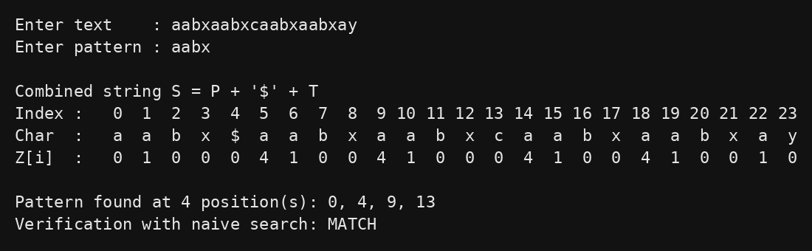
Figure 7.1: Output for text “aabxaabxcaabxaabxay” and pattern “aabx”
For the text “aabxaabxcaabxaabxay” (n = 19) and the pattern “aabx” (m = 4), the combined string S has 24 characters. The Z-array has the value 4 at indices 5, 9, 14 and 18, which equals the pattern length. Subtracting |P| + 1 = 5 gives the match positions 0, 4, 9 and 13 in the text. The naive search returns the same four positions.
Comparison of the four algorithms
Algorithm | Worst-case time | Extra space
Naive Search | O(n·m) | O(1)
Rabin–Karp | O(n·m); O(n + m) on average | O(1)
KMP | O(n + m) | O(m)
Z-Algorithm | O(n + m) | O(n + m)

The Z-Algorithm and KMP are the only two methods that guarantee O(n + m) time in the worst case. Rabin–Karp is linear on average but can degrade to O(n·m) when many hash collisions occur, and the naive method is quadratic on repetitive input. The Z-Algorithm needs O(n + m) extra space for the Z-array of the combined string, while KMP needs only O(m).
Test Case 2
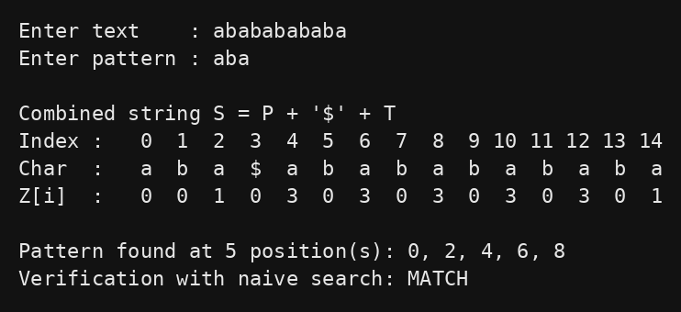
Figure 7.2: Output for text “abababababa” and pattern “aba”
For the text “abababababa” (n = 11) and the pattern “aba” (m = 3), the occurrences overlap. The Z-array has the value 3 at indices 4, 6, 8, 10 and 12, so the program reports the positions 0, 2, 4, 6 and 8. This confirms that overlapping matches are not missed, and the result again agrees with the naive search.
Benchmark on large inputs
Each algorithm was run on texts of 10,000, 100,000 and 1,000,000 characters, and the best of five runs was taken. The table shows the results for the largest text; the outputs of all four algorithms were identical in every run.
Test case (n = 1,000,000) | Naive (ms) | Rabin–Karp (ms) | KMP (ms) | Z-Algorithm (ms)
Random text, alphabet 4, |P| = 20 | 4.88 | 4.75 | 4.04 | 5.32
Random text, alphabet 26, |P| = 20 | 1.51 | 5.25 | 1.42 | 2.16
Worst case: aaa…a, P = aa…ab, |P| = 1000 | 326.25 | 4.74 | 2.61 | 2.32

On random text all four methods finish in a few milliseconds. On the repetitive worst-case input the naive method needs about 326 ms, whereas the Z-Algorithm needs about 2.3 ms, which is roughly 140 times faster and slightly faster than KMP. Timings depend on the machine and compiler, so the ratios are more meaningful than the absolute values.
Discussion
The output of the Z-Algorithm matched the output of the naive search, Rabin–Karp and KMP on both test cases above and on all the benchmark inputs, so the implementation is correct, including for overlapping matches. The Z-values also give a clear picture of how much of the pattern matches at each position, which makes the algorithm easy to trace by hand.
On performance, the Z-Algorithm and KMP stay linear on every input, while the naive method becomes very slow on repetitive text (about 326 ms against 2.3 ms for the Z-Algorithm in the worst-case test). On random text almost every naive comparison fails at the first character, so the naive method is already close to linear and the extra work of building the Z-array (including copying the combined string) makes the Z-Algorithm slightly slower than KMP there. The Z-Algorithm therefore gives the best protection against bad inputs, and it does so with the simplest preprocessing of the linear-time methods.
- CONCLUSION & FUTURE SCOPE

Conclusion
The project met its objectives. We built an application that finds all occurrences of a pattern in a text using the Z-Algorithm in O(n + m) time, implemented Naive, Rabin–Karp and KMP as baselines, and verified all results against a brute-force search. The comparison shows that the Z-Algorithm matches the asymptotic efficiency of KMP while needing a considerably simpler implementation, with no explicit failure-function table, and that both linear-time methods stay fast on repetitive inputs where the naive method collapses. Overall, the Z-Algorithm is a strong, easy-to-implement choice for exact pattern matching in text processing and related applications.
Future Scope
Near term:
• Approximate matching: extend the Z-Algorithm to allow a small number of mismatches, for inputs with typing errors or biological variation.
• Interactive visualisation: build a web-based tool that animates the construction of the Z-array and the movement of the window [l, r] for teaching purposes.
Medium term:
• Multi-pattern search: combine the idea with the Aho–Corasick automaton to search for many patterns simultaneously.
• Parallel Z-array construction: use multi-threading or GPUs to speed up matching on very large corpora such as genomic databases.
Long term:
• Real-world applications: apply the algorithm to plagiarism detection, log-file analysis and DNA sequence alignment.
- REFERENCES

[1] D. Gusfield, Algorithms on Strings, Trees and Sequences, Cambridge University Press, 1997.
[2] D. E. Knuth, J. H. Morris and V. R. Pratt, “Fast Pattern Matching in Strings,” SIAM Journal on Computing, vol. 6, no. 2, pp. 323–350, 1977.
[3] R. M. Karp and M. O. Rabin, “Efficient Randomized Pattern-Matching Algorithms,” IBM Journal of Research and Development, vol. 31, no. 2, pp. 249–260, 1987.
[4] R. S. Boyer and J. S. Moore, “A Fast String Searching Algorithm,” Communications of the ACM, vol. 20, no. 10, pp. 762–772, 1977.
[5] T. H. Cormen, C. E. Leiserson, R. L. Rivest and C. Stein, Introduction to Algorithms, 3rd ed., MIT Press, 2009, Chapter 32: String Matching.
[6] A. V. Aho and M. J. Corasick, “Efficient String Matching: An Aid to Bibliographic Search,” Communications of the ACM, vol. 18, no. 6, pp. 333–340, 1975.
[7] Z algorithm (linear time pattern searching), GeeksforGeeks. https://www.geeksforgeeks.org/z-algorithm-linear-time-pattern-searching-algorithm/
[8] Z-function and its applications, CP-Algorithms. https://cp-algorithms.com/string/z-function.html
[9] Z-algorithm, Wikipedia. https://en.wikipedia.org/wiki/Z-algorithm
[10] Knuth–Morris–Pratt algorithm, Wikipedia. https://en.wikipedia.org/wiki/Knuth%E2%80%93Morris%E2%80%93Pratt_algorithm

