PROJECT DOCUMENTATION
Company | Food Box Pvt. Ltd.
Project Name | Food Box Online Food Delivery
Developer | Venkata Manikanta

Requirement :
Food box is a restaurant chain that delivers food items of different cuisines at affordable prices. It was established in 2014 in Bengaluru, India. It had been serving fine all these years, however, the business analysts noticed a decline in sales since 2016. They found out that the online ordering of food items with companies, such as Swiggy and Foodpanda were gaining more profit by eliminating middlemen from the equation.
Admin Portal:
The admin portal deals with all the backend data generation and product information. The admin user should be able to:
- Add or remove different cuisines to or from the application to build a rich product line
- Edit food item details like name, price, cuisine, description, and offers to keep it aligned to the current prices
- Enable or disable the food items
User Portal :
It deals with the user activities. The end-user should be able to:
- Sign-in to the application to maintain a record of activities
- Search for food items based on the search keyword
- Apply filters and sort results based on different cuisines to get the best deals
- Add all the selected food items to a cart and customize the purchase at the end
- Perform a seamless payment process
- Get an order summary details page once the payment is complete

Sprint Plan :
Sprint Story 1 : Design, Develop, Test and Deploy in AWS Basic features like Food Box Home page, food items page and payment gateway.
Sprint Story 2 : Design and Develop Admin features like create new category, create new food item, CRUD operations and Reports on food items.
Sprint Story 3 : Test and Deploy in AWS Admin features like create new category, create new food item, CRUD operations Reports on food items.
Sprint Story 4 : Test the Overall Application and fix issues and Re-Deploy into AWS Cloud.

Team :
Team Member | Position | Email
Manikanta | Product Owner | Manikanta@mail.com
Manikanta | Scrum Master | Manikanta@mail.com
Manikanta | Developer | Manikanta@mail.com
Manikanta | QA | Manikanta@mail.com

Sprints :
Sprint Number | Code Name | Start Date | End Date | Status
1 | Design, Develop, Test and Deploy in AWS Basic features like Food Box Home page, food items page and payment gateway. | 15-05-2021 | 16-05-2021 | Done
2 | Design and Develop Admin features like create new category, create new food item, CRUD operations and Reports on food items. | 18-05-2021 | 19-05-2021 | Done
3 | Test and Deploy in AWS Admin features like create new category, create new food item, CRUD operations Reports on food items. | 22-05-2021 | 23-05-2021 | Done
4 | Test the Overall Application and fix issues and Re-Deploy into AWS Cloud. | 25-05-2021 | 26-05-2021 | Done
Product Backlog :
Priority | Story Name | Sprint | Sprint Code Name | Story Status
1 | Main Requirements | 1 | Design, Develop, Test and Deploy in AWS Basic features like Food Box Home page, food items page and payment gateway. | Done
1 | Admin Requirements | 2 | Design and Develop Admin features like create new category, create new food item, CRUD operations and Reports on food items. | Done
1 | Test and Validate Admin Requirements | 3 | Test and Deploy in AWS Admin features like create new category, create new food item, CRUD operations Reports on food items. | Done
1 | Overall Test and Re-Deploy | 4 | Test the Overall Application and fix issues and Re-Deploy into AWS Cloud. | Done
Task Planning :
Story | Task | Person | Actual Efforts | Task Status | Done | Completion Date
Main Requirements | Sprint 1 Task | Manikanta | 5 | Development | Done | 15-05-2021
Main Requirements | Sprint 1 Task | Manikanta | 3 | Test | Done | 16-05-2021
Admin Requirements | Sprint 2 Task | Manikanta | 6 | Development | Done | 18-05-2021
Admin Requirements | Sprint 2 Task | Manikanta | 2 | Test | Done | 19-05-2021
Test and Validate Admin Requirements | Sprint 3 Task | Manikanta | 5 | Development | Done | 22-05-2021
Test and Validate Admin Requirements | Sprint 3 Task | Manikanta | 3 | Test | Done | 23-05-2021
Overall Test and Re-Deploy | Sprint 4 Task | Manikanta | 3 | Test | Done | 25-05-2021
Overall Test and Re-Deploy | Sprint 4 Task | Manikanta | 3 | Deploy | Done | 26-05-2021
Alogorithm :
Step 1 : Start
Step 2 : Displays Food Box Home page with Options like
1.Home
2.Sign In
3.Register
4.Category

Step 3 : Home Page having different Categories like Biryani, Pizza, Burger, Shawarma, Ice Creams, Beverages etc. By clicking on required category we can find the multiple Food items with their images and descriptions.
Step 4 : By Click on Add button click to item Adds to the cart.
Step 5 : By click on place order button to pay the amount using dummy Payment Gateway. Later BACK TO HOME click to navigates home page.
Step 6 : By Clicking on Register option to register the new user. In Registration Form having two options like Admin User and Normal User .Based on selection user will create.
Step 7 : By clicking on Sign in Option to login Admin User or Normal User based on user type options in the form
Step 8 : If login Admin user he having special rights like Change Password , Add Items , Delete items , Update items and he can see Sales Report etc.
Step 9 : Admin having special dashboard in that having following Options
- Categories
- Food Items
- Add Category
- Add Item
- Change Password
- Reports
- Logout
1.Categories :-
- In categories options it will show all categories available in the store with complete details. In this page admin wants to Update or Delete the Category.
- If admin wants he can enable or disable Category.
2.Food Items :-
- In Food Items options it will show all Items available in the store with complete details. In this page admin wants to Update or Delete the Food Item.
- If admin wants he can enable or disable Food Items.

3.Add Category :-
- By click on Add Category option one form is open in that fill the all available fields and click on Add Category button to Create new Category.
4.Add Item :-
- By click on Add Item option one form is open in that fill the all available fields and click on Add Item button to Create new Food Item.
5.Change Password :-
- Admin can Change his Password if he wants.
6.Reports :-
- Displays Sales Reports of Food Items.
7.Logout :-
- By click on Logout option to sign out from Admin dashboard and redirect to Home Page.
- Normal user Purchasing any item Login is Compulsory.
Step 10 :Purchase any Food Item with dummy payment gateway.
Step 11 : By selecting Category dropdown option to list out the all the categories available in the Food Box Application. You can switch any category easily.
Step 12: Angular is Used for Developing Food Box Front End Application.
Step 13: Spring Boot Rest Web Service Used for Developing Food Box Back End Application.
Step 14: MySql Database is used for Food Box Database Operations.
Step 15: Selenium and Testng used for Food Box Automation Testing.
Step 16: Pushed entire Source code of Food Box Front end and Back end Application into GitHub.
Step 17 : With the help of AWS Cloud Platform Food Box Application Deployed into AWS Cloud Server. For deploying Application used following AWS Services .
- S3
- RDS
- EC2
S3 :-
- Generated Food Box Backend Application into .jar file using Maven Tool and Generated Food Box Front End Application into Published file and Stored Both Publish files into AWS S3 Service.
RDS :-
- Created Free tier MYSQL RDS in AWS for Food Box Application
EC2 :-
- Take EC2 Linux instance in AWS. Installed Food Box Backend Application in that instance.
Step 18 : Auditing the entire flow Application. Stores the Activities in Audit table.
Step 19 : Deployed Food Box URL is http://foodboxfrontend.s3-website.us-east-2.amazonaws.com/home (Currently application Down)
Step 20 : Stop.
Technology Information :
IDE: STS(for Backend), VS Code(for Frontend)
Project Type: SpringBoot Maven Restful Web Project with embedded tomcat (for Backend),Angular (for Frontend)
DataBase: MySql
Cloud: AWS(RDS,S3,EC2)
Automation Testing : Selenium and TestNG
Flow of Application :
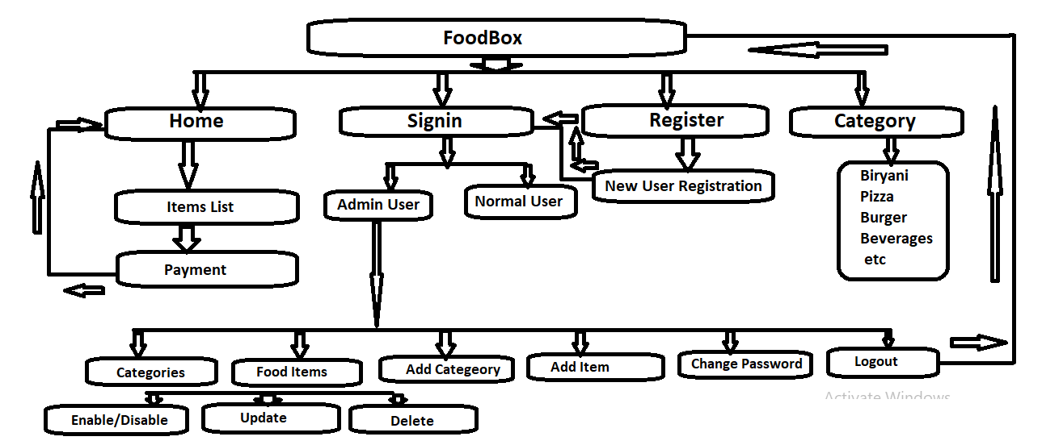
Source Code :
https://github.com/venkatmanikanta516/FoodBoxFinalRepo.git

