PROJECT DOCUMENTATION
Company | Kitchen Story Pvt. Ltd.
Project Name | Kitchen Story Website
Developer | Venkata Manikanta

Requirement :
Kitchen Story is an e-commerce portal that lets people shop basic food items on their website. The website needs to have the following features:

- A search form in the home page to allow entry of the food items to be purchased by the customer.
- Based on item details entered, it will show available food items with price.
- Once a person selects an item to purchase, they will be redirected to the list of available items. In the next page, they are shown the complete breakout of the order and details of the payment to be made in the payment gateway. When payment is done, they are shown a confirmation page with details of the order.
For the above features to work, there will be an admin backend with the following features:
- Admin login page where admin can change password after login if he wants to
- A master list of food items available for purchase
- A functionality to add or remove food items

Sprint Plan :
Sprint Story 1 : To Design and Implement the main requirements like Home ,Admin Page,Change Password and master list of food items.
Sprint Story 2 : Design and Implement the Sign up ,Food Items Selection Forms, Payment pages etc.
Sprint Story 3 : Check the validation and Test the Entire Kitchen Story Application.
Team :
Team Member | Position | Email
Manikanta | Product Owner | Manikanta@mail.com
Manikanta | Scrum Master | Manikanta@mail.com
Manikanta | Developer | Manikanta@mail.com
Manikanta | QA | Manikanta@mail.com

Sprints :
Sprint Number | Code Name | Start Date | End Date | Status
1 | To Design and Implement the main requirements like Home ,Admin Page,Change Password,Users Details,Reports ,Products Categerisation. | 27-03-2021 | 27-03-2021 | Done
2 | Design and Implement the Sign up ,Products Selection Forms, Payment pages etc. | 28-03-2021 | 28-03-2021 | Done
3 | Check the validation and Test the Entire SportyShoes Online Application. | 29-03-2021 | 29-03-2021 | Done
Product Backlog :
Priority | Story Name | Sprint | Sprint Code Name | Story Status
1 | Main Requirements | 2 | To Design and Implement the main requirements like Home ,Admin Page,Change Password and master list of food items. | Done
1 | Admin Requirements | 2 | Design and Implement the Sign up ,Food Items Selection Forms, Payment pages etc. | Done
1 | Validations and Unit Test | 2 | Check the validation and Test the Entire Kitchen Story Application. | Done

Task Planning :
Story | Task | Person | Actual Efforts | Task Status | Done | Completion Date
Main Requirements | Sprint 1 Task | Manikanta | 5 | Development | Done | 27-03-2021
Main Requirements | Sprint 1 Task | Manikanta | 3 | Test | Done | 27-03-2021
Admin Requirements | Sprint 2 Task | Manikanta | 6 | Development | Done | 28-03-2021
Admin Requirements | Sprint 2 Task | Manikanta | 2 | Test | Done | 28-03-2021
Validations and Unit Test | Sprint 3 Task | Manikanta | 5 | Development | Done | 29-03-2021
Validations and Unit Test | Sprint 3 Task | Manikanta | 3 | Test | Done | 29-03-2021
Alogorithm :
Step 1 : Start
Step 2 : Displays Home page with Options like
1.Home
2.Sign In
3.Sign Up

Step 3 : Home Page having Different categeories like Biryanies ,Pizzas,Burgers etc.By clicking on required category we can find the multiple Fooditems with their images and descriptions.
Step 4 : By Add button click to required Fooditem with quantity add to the cart .
Step 5 : By click on place order button to pay the amount using dummy payment gataway.later backtohome button click to navigate home page.
Step 6 : using signup to register new customer .and signin form to login admin with valid credentials
Step 7 : In change Password admin can give present present password and new password .
Step 8 : Admin can see all Food products .if he wants he can delete and update the product.
Step9 : Admin can Add new Food Item in Add new Item form.
Step 10 : By Clicking on Logout button confirmation to signout from the Admin Operations.
Step 11 : Purchase any product with dummy payment gateway.
Step 12: Signup option for New User Login.
Step 13: For FrontEnd Application Used Angular.
Step 14: For BackEnd Application Used SpringBoot Rest
Step 15 : Stop.

Technology Information :
IDE: STS(for Backend),VS Code(for Frontend),
Project Type: SpringBoot Maven Rest Web Project with embedded tomcat (for Backend),Angular (for FrontEnd)
DataBase: MySql

Flow of Application :
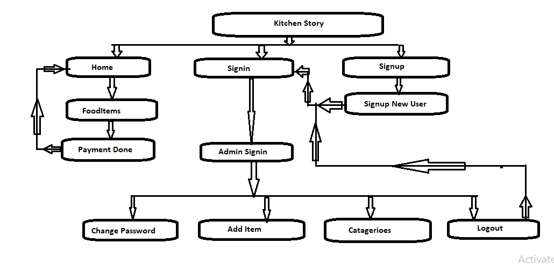

Source Code :
https://github.com/venkatmanikanta516/KitchenStoryFinalGit.git

