PROJECT DOCUMENTATION
Company | Sporty Shoes Pvt. Ltd.
Project Name | Sporty Shoes Online Shopping Application
Developer | Venkata Manikanta

Requirement :
● Presenting the specification document which has the product’s capabilities, appearance, and user interactions
● Setting up Git and GitHub account to store and track your enhancements of the prototype
● Explaining the Java concepts used in the project
● Discussing the generic features of the product:
● There will be an admin to manage the website. An administrator login will be required to access the admin page.

The admin should be able to change his password if he wants, he should be able to:
● Manage the products in the store including categorizing them
● Browse the list of users who have signed up and be able to search users
● See purchase reports filtered by date and category

Sprint Plan :
Sprint Story 1 : To Design and Implement the main requirements like Home ,Admin Page,Change Password,Users Details,Reports ,Products Categeorisation.
Sprint Story 2 : Design and Implement the Sign up ,Products Selection Forms, Payment pages etc.
Sprint Story 3 : Check the validation and Test the Entire SportyShoes Online Application.

Team :
Team Member | Position | Email
Manikanta | Product Owner | Manikanta@mail.com
Manikanta | Scrum Master | Manikanta@mail.com
Manikanta | Developer | Manikanta@mail.com
Manikanta | QA | Manikanta@mail.com

Sprints :
Sprint Number | Code Name | Start Date | End Date | Status
1 | To Design and Implement the main requirements like Home ,Admin Page,Change Password,Users Details,Reports ,Products Categerisation. | 27-02-2021 | 27-02-2021 | Done
2 | Design and Implement the Sign up ,Products Selection Forms, Payment pages etc. | 28-02-2021 | 28-02-2021 | Done
3 | Check the validation and Test the Entire SportyShoes Online Application. | 01-03-2021 | 01-03-2021 | Done
Product Backlog :
Priority | Story Name | Sprint | Sprint Code Name | Story Status
1 | Main Requirements | 2 | To Design and Implement the main requirements like Home ,Admin Page,Change Password,Users Details,Reports ,Products Categerisation. | Done
1 | Admin Requirements | 2 | Design and Implement the Sign up ,Products Selection Forms, Payment pages etc. | Done
1 | Validations and Unit Test | 2 | Check the validation and Test the Entire SportyShoes Online Application. | Done

Task Planning :
Story | Task | Person | Actual Efforts | Task Status | Done | Completion Date
Main Requirements | Sprint 1 Task | Manikanta | 5 | Development | Done | 27-02-2021
Main Requirements | Sprint 1 Task | Manikanta | 3 | Test | Done | 27-02-2021
Admin Requirements | Sprint 2 Task | Manikanta | 6 | Development | Done | 28-02-2021
Admin Requirements | Sprint 2 Task | Manikanta | 2 | Test | Done | 28-02-2021
Validations and Unit Test | Sprint 3 Task | Manikanta | 5 | Development | Done | 01-03-2021
Validations and Unit Test | Sprint 3 Task | Manikanta | 3 | Test | Done | 01-03-2021
Alogorithm :
Step 1 : Start
Step 2 : Displays Home page with Options like
1.Home
2.Sign In
3.Sign Up
4.MenShoes
5.WomenShoes
6.KidsShoes

Step 3 : Home Page having three categeories like Mens Wears ,Womens Wears,Kids Wears.By clicking on required category we can find the multiple products with their images and descriptions.
Step 4 : By selecting required Product to get the complete details of the product.if you want we can purchase the product and give required quantity not more than.
Step 5 : In the application we can easly switch from one place to another place.
Step 6 : Another option called admin signin .he having special right to change the password ,Add new Product,he can see users details,Update the product and Delete the product also.
Step 7 : In change Password admin can give present present password and new password .
Step 8 : Admin can see all products .if he wants he can delete and update the product.
Step9 : Admin can Add new Product in Add new Product form.
Step10 : Admin can see purchase reports based on categeroy and date.
Step 11 : By Clicking on Logout button confirmation to signout from the Admin Operations.
Step 12 : Purchase any product with dummy payment gateway.
Step 13 : Signup option for New User Login.
Step 14 :Admin can see Sales Reports base on Date and the Categeory.
Step 15 : Stop.

Technology Information :
IDE: Eclipse
Project Type: SpringBoot Maven Web Project with embedded tomcat
DataBase: MySql

Flow of Application :
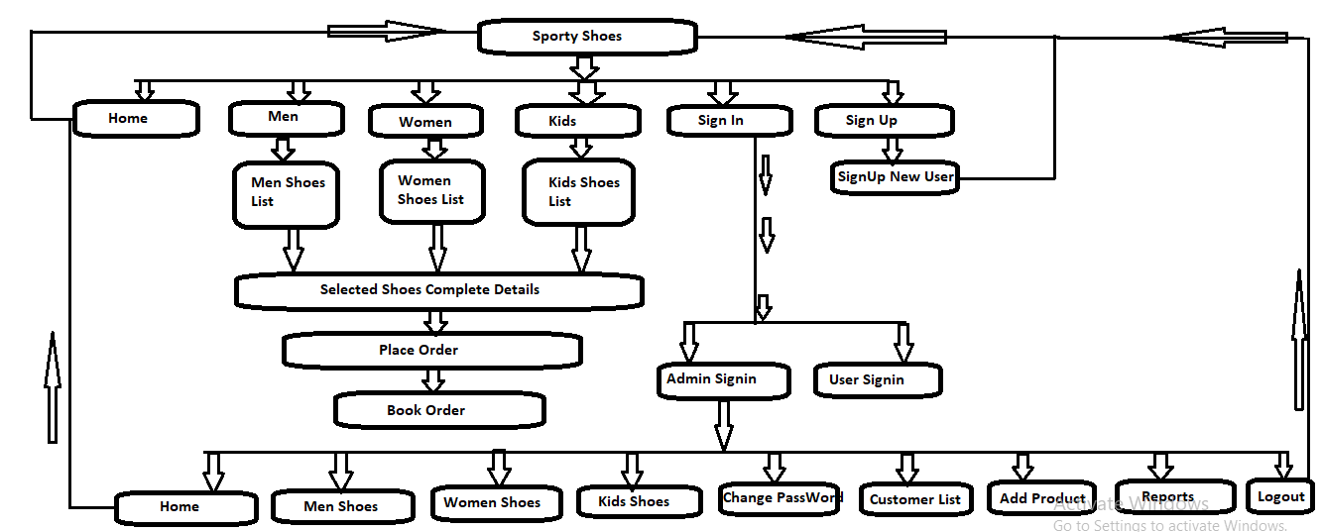

Source Code :
https://github.com/venkatmanikanta516/SprotyShoesOnlineAppGit.git

