**Cloud Computing – Homework 2: Docker & Web Services**

Meenakshi Venkatasubramanian

**Application:** Want to know where your favorite artist is performing next that is close to you? This simple web service can provide you with the details of the singer and their future events.

**Inputs:** Enter your favorite artist’s complete name (Starting letters in Caps) and your zipcode(US States only) and see his/her most famous songs, popularity and their next performance closest to you .

**Description**: This is a simple web service that uses three publically available web services (API) (echonest, Songkick and google maps) to read an artist’s complete details, events and then calculate the event whose longitude and latitude is the closest to the zipcode you provided.For each of these API’s, the api key was provided by the website to use their services . These keys help them constrict the number of calls made to the website at a time.

For example:

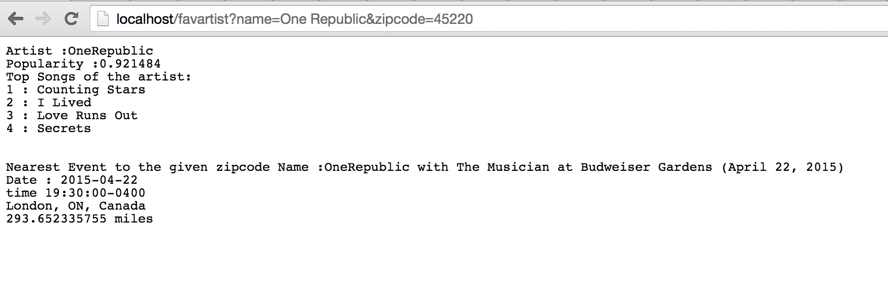

**Future Scope:**

1) Displaying the events on google maps rather than just mentioning it. Handling the errors better.

2) Songkick, which provides the information for the events, sometimes provides incorrect location information. Need to validate that information with data from google maps.

3) Enhance the UI with images and links.

**Steps to follow:**

1. Download the Cloudhw.tar.gz
2. Following are the commands to run on the terminal:

*Docker load < Cloudhw.tar.gz*

*Docker run –d –p 8080:80 adder /startme.sh*

1. Open a browser and launch the website:

*Localhost:8080/favartist?name=<Artist Name>&zipcode=45220*

*Eg:- Localhost:8080/favartist?name=Imagine Dragons&zipcode=45220*