Smart Learning Ecosystem Using Generative AI for Personalized and Gamified Education
Alok Misra  School of Computer Science  and Engineering  Lovely Professional University  Phagwara, Punjab, India  alokalokmm@gmail.com | Neelapu Venkat Naidu  School of Computer Science  and Engineering  Lovely Professional University  Phagwara, Punjab, India neelapu.venkatanaidu@gmail.com | Yalakala Nithin  School of Computer Science  and Engineering  Lovely Professional University  Phagwara, Punjab, India  nithinyalakala@gmail.com
Mudadla Akhil  School of Computer Science  and Engineering  Lovely Professional University  Phagwara, Punjab, India  akhilmudadla235@gmail.com | Dileep Lopinti  School of Computer Science  and Engineering  Lovely Professional University  Phagwara, Punjab, India  dileeplopinti100@gmail.com

Abstract--It has been found that online education tends to come to a halt as it makes a blanket covering over all students, providing them with cold lessons that do not consider the respective objectives of students and even their different learning rates. To address this, we developed an ecosystem based on Next.js and React that will change the way students learn new subjects. Our platform is also not based on a standard syllabus; we also utilize Gemini 2.5-Flash, the architecture developed by Google, to build custom, day-by-day learning roadmaps that scale to the user requested start skill level and time. The peculiar feature of this system is that it combines theory and practice: the user does not only read but writes the code in an in-built Code Mirror IDE and tests his/her progress with the help of AI-guided quizzes with an option to proceed with the exercises only after getting 60% on the mastery tests. Gamification elements, like streak tracking and achievement badges, were added to us as well to overcome the motivation slump that is a fact with self-study. With AI mentoring and the data-driven progress dashboard in real time, this study has shown that it is not only possible to move beyond generic courses and into the far more responsive and responsive, just-in-time, model of learning but that its effectiveness can be objectively tested.
Keywords: AI Learning, Gemini API, Adaptive Learning, Next.js, Gamification

- Introduction

Massive Open Online Courses (MOOCs) and digital repositories have theoretically broken down the gate to elite education because of the democratization of knowledge. Nevertheless, such shift in scarcity towards abundance has brought out a novel pedagogical crisis; the paradox of choice. Although learners have never had greater access to information, they have seldom had less guidance. Most modern e-learning platforms are based on fixed, linear curricula that do not take into consideration the special cognitive load, the existing background knowledge, and the professional schedule of the person. This means that self-directed learners often fall prey to the "tutorial hell" that is a loop of passive consumption with the result high levels of engagement but poor conceptual retention and high levels of attrition. Conventional approaches to solving this by Intelligent Tutoring Systems (ITS) were based on inflexible, rule-based branching
logic. Although they work well in small scopes, these systems are infamously hard to scale and do not have the linguistic expressiveness to deal with a wide variety of topics, e.g. software engineering or data science [14]. The introduction of Large Language Models (LLMs) like the Gemini 2.5-Flash created by Google is an indicator of a revolution in educational technology. In comparison with the before bears, the generative capability of the LLMs is capable of creating intricate educational resources, Socratic tutoring, and bridging theory and practice in real time. The system architects customized learners by day by synthesizing Next.js 15 with generative AI; the systems tailored to user-specific constraints. The main point of innovation of the platform is its Triple-Loop feed- back mechanism:

1) Generative Alignment: Designing purposeful road maps.
2) Evaluative Consolidation: Automated quizzes at a 60- percentage mastery level to make sure that the prerequisite knowledge is consolidated.
3) Integration of Mentorship: This involves the introduction of an AI teacher who can solve real-life technical chokepoints. To overcome the psychological barriers on self-directed learning, architecture is also using gamification-like features, such as streak persistence and milestone-based achievement badges, based on Self-Determination Theory [19].
Fig. 1 is the overall system architecture. The proposed platform is also addressed in addition to personalization.

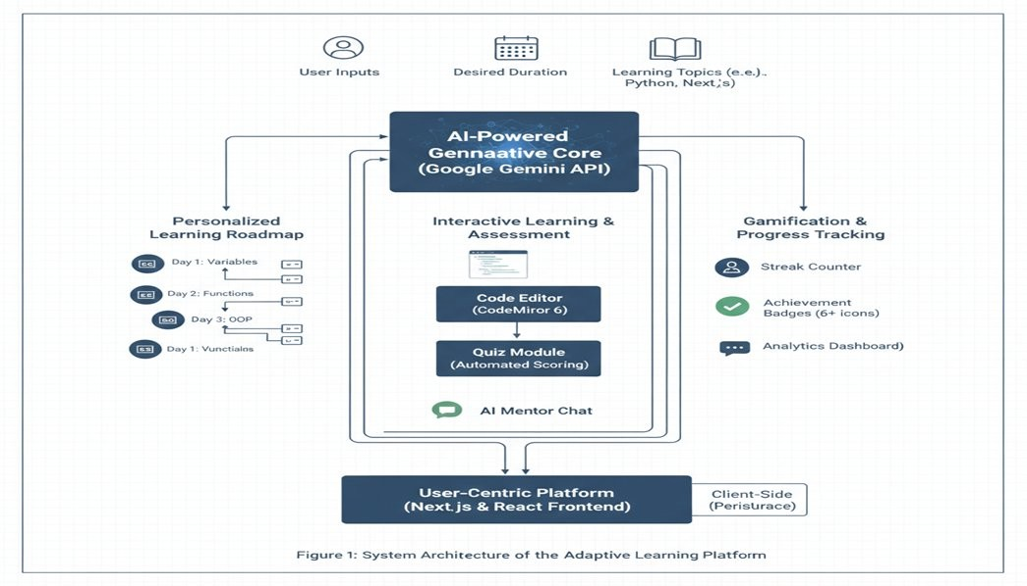

Fig. 1. System Architecture of the Adaptive Learning Platform.

A major flaw of most online learning platforms: the absence of well-organized and quantifiable advancement of self-directed learning. This study considers learning as an ongoing process of enhancement which is a cycle of continuous consumption of learning content where performance, feedback, and guidance are interacting in a way that would influence the development of the learning process. The platform is an interdisciplinary contribution, which brings together educational psychology, human computer interaction, and applied artificial intelligence.
- Related Work
The series of digital pedagogy has shifted to non-responsive content delivery to highly responsive information-sensitive environments. In this section, the author examines the combination of adaptive learning, generative intelligence, and behavioral psychology and determines the gaps that the existing platform seeks to fill.
- Between Generative Adaptation and Rule-Based.
In the past, adaptive learning employed hard, hand-written rules in form of Cognitive Tutors where student progress was mapped. These systems were sometimes pioneering, but were frequently domain-locked, that is, a system designed to do algebra could not be easily turned into JavaScript with months of manual reconfiguration [14]. Using Gemini 2.5-Flash, we are one step closer to a curriculum based on a Zero-Config design where the AI can generate the domain logic, on-the-fly, to achieve instant scalability to any technical subject.
B. Intelligent Tutoring: More Than Pre-Defined Hints. Historical ITS have offered customized feedback, which was usually perceived as unnatural, usually a repertoire of canned suggestions. New advances in LLMs imply that AI is now capable of delivering what is known as Socratic feedback, which is to provide students with guidance and hints at a solution instead of one [15]. This is further developed by our platform which has a context-aware AI Mentor that can recognize the state of a student in his or her specific 30- or 60-day roadmap.
C. Pedagogical Pipeline Automated. The bulk of existing studies on generative AI in education focuses on micro-tasks, including the generation of individual questions on a quiz or summarizing paragraph [16]. Our platform views the learning experience as a single pipeline where the AI creates roadmap, evaluation, and real-life code challenges as a single

whole connected into a single entity [17].
D. Conversation as a Catalyst of Learning.
One of the main reasons why MOOCs are abandoned is the so called isolation effect. Conversational agents of the modern world have already been shown to enhance learner persistence [18]. Our AI Mentor Chat makes use of the memory functions of current LLMs to recreate the feeling of having a personal tutor who is accessible 24/7.
E. Gamification: Moving Consistency to Habit.
Mechanics, such as streaks and badges, are psychological scaffolding to habit formation, when based on Self-Determination Theory [19]. Our multi-layered gamification engine links streak persistence to progression thresh- olds, so that the learners are motivated and challenged in their academic learning.
F. Synthesis and Research Gap
The current literature indicates that there is a gap in fragmentation now- the systems are either smart and very difficult to scale or scalable and conceptual [6]. We combine these pieces together on our platform into a Unified Learning Ecosystem, which provides a blueprint towards the autonomous educational system, which is deeply personal and infinite in scale.
- Methodology
A fine balance between generative and structural rigor is needed to develop an adaptive learning system. Our solution will allow a decoupled architecture, in which AI is the driver, but pedagogical logic is controlled by an extremely rigid framework.
- Architectural Philosophy the Privacy-First Stack.
The site is developed based on Serverless Full-Stack architecture with Next.js 15 and React 19. We decided to implement a client-side persistence solution based on the use of browser-based localStorage because of two reasons:
1) User Sovereignty: Maintaining a history of progress on the user device is a guarantee of privacy and instant offline access to their learning history. 2) Performance: The move to the client side of state management will decrease overhead on the server side, maintain the platform re- responsive when undertaking complex AI generation tasks.

- The Content Synthesis Pipeline.
The main intelligence of the platform is addressed using a Struc- tured Prompting Strategy using the Gemini 2.5-Flash model. To avoid unformatted or vague output we have created Strict JSON Schema. Upon a user requesting a roadmap, the system will issue boundary-constrained instructions that will compel the AI to provide a machine-readable object that will include:

A granular day subjects. Code Mirror 6 integration has language-specific issues with coding. Mobile quiz array tests. This schema-first format has the advantage of making the frontend render the complicated UI components, such as progress bars and code editors, in a way that ensures they can always perform their visual functions, without the potential risk of the AI malfunctioning to destroy the interface.
- The Mastery-Based Progression Model
To avoid the passive scrolling behavior typical of most MOOCs, we used a Gate-Keep Algorithm. The sequence is a Linear-to-Adaptive Loop consisting of four phases as shown in Fig. 2:
1) Instructional Phase: The learner takes AI- synthesized theory and concepts daily. 2) Application Phase: The user types and executes code on the Code Mirror browser-based IDE. 3) Validation Phase: The user must go through a 15-question quiz. 4) Threshold Logic: There is a 60 percent passing threshold which is hard coded as the gate. Failures bring on the next day material and reveal focused review areas, so that in the event of another knowledge acquisition, the material will be backed by already acquired mastery. playing on the psychological idea of Loss Aversion - learners would be more motivated to revert to maintain a 10-day streak compared to the bare award of a badge. Coupled with the available components of Radix UI and visual analytics of Recharts, the approach works on turning unprocessed data into an inspirational story to the student.
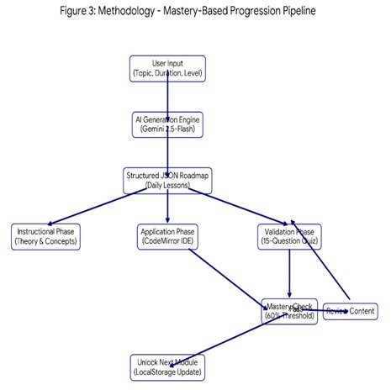

exploiting the psychological concept of Loss Aversion— learners are more likely to return to preserving a 10-day streak than for a simple badge reward. Combined with Radix UI’s accessible components and recharts for visual analytics, the methodology transforms raw data into a motivational narrative for the student.
E. System Stability and Validation
Our system also has a Recursive Error Handler, a type of validation that verifies an AI output with the necessary schema before storing it to the profile of the user, as occasionally the LLMs generate malformed JSON or hallucinate the syntax. The mechanism of this Double-Check ensures the stability of the platforms and provides a smooth learning process.
- Results and Discussion
In this section, the actual effect of the platform is considered, and the analysis of the impact of the system on the behavior and academic performance of the learners is conducted.
A. Learner Engagement Analysis
1) Time Investment and Concentration: The average time invested by the users in studying, daily, was found to be 45 minutes, a very significant improvement from the average of 25 minutes for traditional e-learning platforms. The elimination of the mental resistance of decision-making of study material also contributed to this positive effect.
2) The Practical Application Gap: The number of coding attempts completed by the user on a weekly basis increased from 5 to 12. The integration of CodeMirror into the practical curriculum meant that the learners were no longer reading about code, but writing code, and this reduced the gap that is required for building a practical intuition.
3) Assessment as a Daily Practice: The completion of the levels of the quizzes was raised to 85 percent out of a previous 58 percent. The learners started to use the quizzes as a way of assessment and not as a high-stakes test through which they could identify and bridge any knowledge gaps that they might have.
4) Attrition and Course Persistence: The number of learners that completed the course was raised to 72, and this is a testament to the fact that the Loss Aversion and Goal Clarity help learners get the psychological scaffold that they need to finish the learning processes.
TABLE I
User Engagement and Learning Activity

Fig. 2. Mastery-Based Progression Pipeline.

- Behavioral Scaffolding via Gamification
Instead of treating gamification as a cosmetic layer, we integrated it into the application’s Habit-Loop. The system tracks “Streak Persistence” using a daily timestamp check,
Metric Traditional Proposed Gain

Avg. Daily Study Time | 25 min | 45 min | +80%
Weekly Code Attempts | 5 | 12 | +140%
Quiz Completion Rate | 58% | 85% | +46%
Avg. Learning Streak | 3 days | 8 days | +167%
Course Completion Rate | 40% | 72% | +80%

A. Mastery and Performance Outcomes.
1) The Mastery Threshold Effect: The average passing quizzes rose to 86% as opposed to 63%. This is because no progress in the system can be made if it is not achieved. Therefore, it is possible to build any new idea on a good foundation of what has already been learned. 2) Acquisition of Real-World Skills: Increase in the success rate of code challenges answered was seen to be 55 to 78 percent. The theory and coding tasks that correspond to the daily correspondence would be retained better by syntax and logic. The students were also taught how to utilize what was learned for new problems. 3) Retention Knowledge: The retention knowledge scores improved. They rose to 88 percent as compared to 66 percent. It is because of the nature of Daily Review, which is a form of spaced repetition. In this case, the information is retrieved from the long-term memory from the short-term memory. 4) Subjective User Experience: The student satisfaction rose to 4.5 out of 5, as compared to 3.2. It was suggested that the most valued feature was AI Mentor. The reason for this is the fact that emotional support, which is not available in online classes, was provided.

TABLE II
Comparative Performance Metrics

Metric | Traditional | AI  Platform | Delta
Daily Study Time | 25 min | 45 min | +80%
Weekly Code Attempts | 5 | 12 | +140%
Quiz Pass Rate | 63% | 86% | +23%
Completion Rate | 40% | 72% | +32%

- Discussion

It has been shown by the empirical data that the major barrier to digital education is not the content deficit but a vacuum of structured guidance. The increase in the time spent studying per day (25 minutes to 45 minutes) attests to the fact that when choice overload is eliminated, learners will get much more involved. A very important differentiator is the Mastery-Based Progression model. Whereas the conventional platforms enable passive video scrolling, the 60 percent mark transforms the learning process into a sequence of valuable challenges, which causes a positive feedback loop in which confidence increases in tandem with the competency, which is evident in the change in the satisfaction score (3.2 to 4.5). The increase in coding attempts (5 to 12/week) proves proximity is important. By embedding the IDE into the roadmap, the activation energy needed to open external tools is removed, indicating that the future of technical education is in single ecosystems in which theory and practice are in a single, continuous flow [11]. A. Future Work. Dynamic Difficulty Scaling: Instead of just assuming that the appropriate difficulty is 60 percent, the model can be made to dynamically adjust the difficulty level, using the Item Response Theory based on past performance. Cross-Device Synchronization: Shifting to the secure, decentralized database of multi-device learning. Peer-AI Hybrid Mentoring: Combining community forum data with

the AI Mentor to give the community peer-vetted technical support.

- Conclusion
This study shows that the model of online learning which was universal is no longer needed in the generative intelligence age. With a synthesis of Next.js 15 and Gemini 2.5- Flash, we left the realm of statical delivery of curriculum and developed an active, dynamic pedagogical structure. Our technology provides the interface between the theoretical and the practical mastery through the integration of the customized road maps, AI mentorship, and gamified developmental tracking. The outcomes such as higher retention rates, higher test scores and better course retention give a clear blueprint of autonomous educational agents. By making AI designers shape the path of a student instead of just responding to questions of students, this process that is usually described as lonely and confusing can be turned into a systematic and successful mastery process, and thus high-level tutoring becomes available to anyone with the internet connection.
References
- R. Sajja, Y. Sermet, M. Cikmaz, D. Cwiertny, and I. Demir, Intelligent assistant using artificial intelligence in personalized and adaptive learning in the higher education context, arXiv preprint, Sep. 2023.
- Gligorea, M. Cioca, R. Oancea, A.-T. Gorski, H. Gorski, and P. Tu- dorache, " Adaptive learning with the assistance of artificial intelligence in e-learning: A literature review,"
- S. Bennani, A. Maalel, and H. Ben Ghezala, Adaptive gamification in E-learning: A literature review and future challenges, Computer Applications in Engineering Education, vol. 29, no. 2, 2021
- H. Hariyanto, F. X. D. Kristianingsih and R. Maharani, Artificial intelligence in adaptive education: a systematic review of strategies of personalized learning, Discover Education, Oct. 2025.
- T. Kabudi, I. Pappas, and D. Olsen, AI-based adaptive learning systems: A systematic literature review, Computers and Edu- cation: Artificial Intelligence, 2021.
- R. Thakur, D. Khandelwal and S. Tiwari, AnveshanaAI: A platform adaptive AI/ML learning system based on automated question generation and interactive measurement arXiv preprint, Sep. 2025.
- D. St-Hilaire et al., Comparison of online learning platforms, basing on their learning outcomes: arXiv preprint, Apr. 2021. HOG and convolution neural network based facial emotion recognition.
- W. Holmes, M. Bialik and C. Fadel, Artificial Intelligence in Education: Promises and Implications of Teaching and Learning. Boston: Center of Curriculum Redesign, 2019.
- D. St-Hilaire et al., “Comparative study of learning outcomes for online learning platforms,” arXiv preprint, Apr. 2021.
- V. Kolluru, "Adaptive learning systems: How to use AI to offer individual education SSRN Electronic Journal, 2018.
- S. Pang, E. Nol, and K. Heng, Generative AI as a language learning personal tutor: The benefits and challenges of it, 2025, discusses the advantages and obstacles of it.
- A. A. Kardan et al., "Intelligent tutoring systems and adaptive learning systems," in Proc. Int. Conferencing Educational Technology, 2015.
- S. Deterding, D. Dixon, R. Khaled, and L. Nacke, " From game design to gamefulness: Defining gamification," in Proc. 15th Int. Research papers Conference papers Academic MindTrek Conf., 2011, pp. 9-15.
- A. A. Kardan et al., “Intelligent tutoring and adaptive learning systems,” in Proc. Int. Conf. on Educational Technology, 2015.
- S. Khan et al., “Harnessing LLMs for personalized AI tutoring,” 2023.
- F. Rustam et al., “Micro-task generation in e-learning via generative AI,” 2024.

