Guidelines for CA2: CSE435

(Comprehensive Seminar)



Jan- Apr 2026

Lovely Professional University Punjab

Seminar Report
On
AI-Powered Personalized Learning Platform: An Intelligent System for Adaptive Educational Roadmap Generation and Real-Time Progress Tracking
Submitted by
Neelapu Venkata Naidu 12213327
Bachelor of Technology
IN
(Computer Science and Engineering)
Under the Supervision of

Ojasvee Kaneria
Assistant Professor


LOVELY PROFESSIONAL UNIVERSITY PUNJAB
(Mar 2026)

TABLE OF CONTENTS

S. No. | Title | Page No.
 | Abstract…………………………………………………… | i
 | List of Figures……………………………………………... | ii
 | List of Tables……………………………………………… | iii
1 | Chapter 1: Introduction
 | 1.1 Title of the Seminar…………………………………… | 1
 | 1.2 Background and Importance of the Topic………………... | 2
 | 1.3 Objectives of the Seminar……………………………….. | 3
 | 1.4 Overview of the Methodology…………………………... | 4
2 | Chapter 2: Literature Review
 | 2.1 Evolution of Adaptive Learning Systems………………... | 5
 | 2.2 Large Language Models (LLMs) in Education…………... | 6
 | 2.3 Gamification and Student Retention……………………... | 7
3 | Chapter 3: Conceptual Study / Seminar Work
 | 3.1 Core Concepts…………………………………………... | 8
 | 3.2 System Architecture…………………………………….. | 9
 | 3.3 Workflow & Conceptual Framework…………………… | 10
 | 3.4 Technology Stack & Tools Studied……………………...  3.5 Frontend Design………………………………………... | 11  12
4 | Chapter 4: Results and Discussion
 | 4.1 Key Observations………………………………………. | 13
 | 4.2 Conceptual Comparison………………………………… | 14
 | 4.3 Interpretation of System Performance…………………… | 15
 | 4.4 Advantages, Limitations, and Insights…………………… | 16
5 | Chapter 5: Conclusion and Future Scope
 | 5.1 Summary of the Seminar Work…………………………. | 17
 | 5.2 Major Learning Outcomes……………………………… | 18
 | 5.3 Conclusions…………………………………………….. | 19
 | 5.4 Future Scope……………………………………………. | 20
 | Professional Profiles | 21
 | Declaration | 22

ABSTRACT
The rapid evolution of digital education has significantly increased access to learning resources; however, it has also introduced challenges such as information overload, lack of structured guidance, and low learner retention. Traditional e-learning platforms follow static curricula that fail to adapt to individual learner needs, resulting in inefficient learning paths and reduced engagement.
This seminar presents the design and conceptual framework of an AI-Powered Personalized Learning Platform that leverages Generative Artificial Intelligence to create adaptive, user-specific educational roadmaps. The system utilizes Large Language Models (LLMs), specifically the Gemini 2.5-flash model, to dynamically generate structured learning plans based on user inputs such as topic, duration, and proficiency level.
The platform integrates multiple components including real-time quizzes, in-browser coding environments, and an AI-driven mentorship interface to provide immediate feedback and continuous guidance. A structured JSON-based output mechanism ensures consistency in AI-generated content, enabling seamless integration with the user interface. Additionally, gamification strategies such as streak tracking, achievement badges, and performance analytics are incorporated to enhance learner motivation and long-term engagement.
The system is developed using modern web technologies including Next.js, Tailwind CSS, and CodeMirror, ensuring a responsive and interactive user experience. The implementation demonstrates that AI-driven systems can significantly reduce the time required to design learning paths while improving personalization and scalability.
The study concludes that integrating Generative AI into educational platforms enables a shift from static content delivery to intelligent, adaptive learning ecosystems. This approach not only improves knowledge retention and engagement but also provides a scalable solution to personalized education. Future enhancements such as cloud-based data persistence, multi-modal content integration, and collaborative learning environments can further strengthen the effectiveness of the platform.

CHAPTER 1: INTRODUCTION
1.1 Title
AI-Powered Personalized Learning Platform: An Intelligent System for Adaptive Educational Roadmap Generation and Real-Time Progress Tracking

1.2 Background and Importance of the Topic
The rapid digital transformation of education has made learning resources more accessible than ever. However, this "information explosion" has led to cognitive overload and the "tutorial hell" phenomenon, where learners struggle to find a structured path suited to their specific skill level and goals. Traditional E-learning platforms often offer a "one-size-fits-all" curriculum that fails to account for individual pacing, prior knowledge, or practical application.
The importance of this topic lies in the shift toward Hyper-Personalization. By leveraging Generative AI (Large Language Models), we can now move beyond static video playlists to dynamic, responsive systems. This research explores how AI can act as both an architect (creating the roadmap) and a mentor (providing real-time feedback), significantly increasing learner retention and reducing the time required to master complex technical skills.

1.3 Objectives of the Seminar
The primary objectives of this project and seminar are:
- To Develop an Automated Curriculum Architect: Create a system capable of generating structured, day-wise learning paths based on specific user constraints (topic, duration, and proficiency).
- To Bridge the Theory-Practice Gap: Integrate a browser-based coding environment and automated quizzes to ensure learners apply concepts immediately after consumption.
- To Implement Real-Time Intelligent Mentorship: Deploy an AI-driven chat interface that provides instant conceptual clarity, simulating a 1-on-1 human tutoring experience.
- To Enhance Engagement through Gamification: Utilize behavioural psychology elements—such as streaks, badges, and progress analytics—to maintain long-term user motivation.

1.4 Overview of the Methodology
The study and development of this platform follow a Full-Stack Agile Methodology, focusing on the integration of Generative AI into a modern web ecosystem:
- Requirement Analysis: Identifying the core pain points of self-paced learners and defining the necessary data structures for AI-generated roadmaps.
- System Architecture Design: Utilizing a Next.js 15 (App Router) framework to build a responsive, server-side rendered frontend that communicates with AI endpoints.
- AI Integration Layer: Developing structured prompt engineering techniques to interface with the Google Gemini 2.5-flash model, ensuring the output is received in a strictly formatted JSON structure for seamless UI rendering.
- Interactive Logic Development: Implementing client-side state management for progress tracking and integrating Code Mirror 6 to facilitate real-time code execution and validation.
- Evaluation & Testing: Testing the accuracy of the AI-generated content against various technical topics to ensure educational pedagogical standards are met.

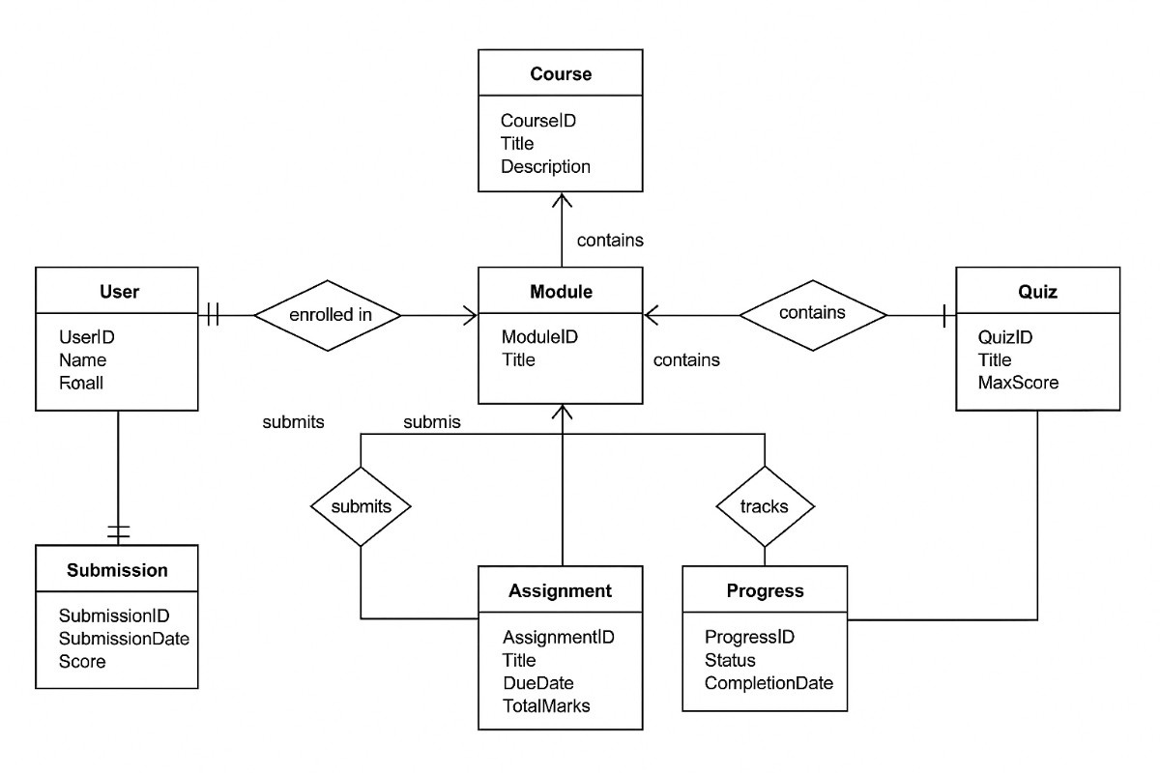

CHAPTER 2: LITERATURE REVIEW

The development of AI-powered educational systems is grounded in several decades of pedagogical research and recent breakthroughs in Natural Language Processing (NLP).

2.1 Evolution of Adaptive Learning Systems
Early Adaptive Learning Systems (ALS) relied on "Rule-Based" logic, where developers manually programmed "if-then" scenarios to direct students. While effective, these systems were rigid and expensive to scale. The shift toward Intelligent Tutoring Systems (ITS) introduced Bayesian networks to predict student performance, but they still lacked the ability to generate original content.

2.2 Large Language Models (LLMs) in Education
The integration of LLMs, such as the Gemini series, marks a paradigm shift. Research shows that LLMs can perform "zero-shot" curriculum generation, creating structured paths without specific training on a particular syllabus. Recent studies emphasize the importance of Chain-of-Thought (CoT) prompting to ensure AI-generated quizzes maintain logical difficulty progression.
2.3 Gamification and Student Retention
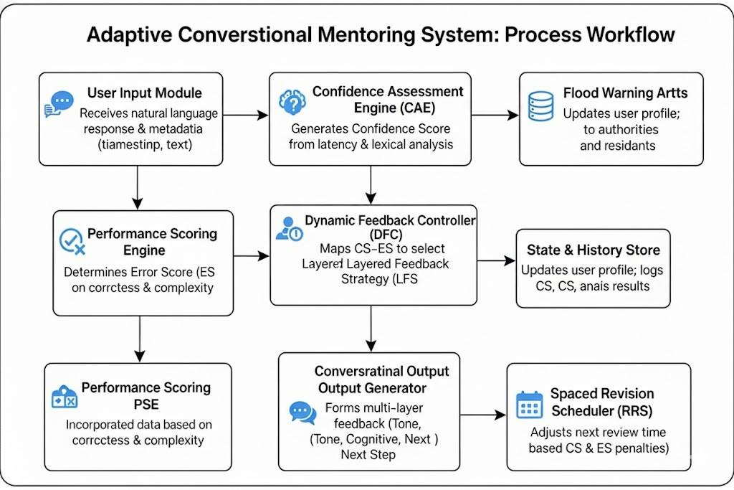
Literature on Behavioural Design (e.g., the Octalysis Framework) highlights that elements like "Streaks" and "Badges" trigger the release of dopamine, which is crucial for self-paced learning environments where external accountability is low. This project incorporates these findings to solve the high drop-out rates seen in traditional MOOCs.

CHAPTER 3: CONCEPTUAL STUDY
3.1 Core Concepts
- Generative Roadmap Logic: The process of transforming a high-level goal (e.g., "Full-Stack Dev") into a granular, time-bound sequence of sub-topics.
- Adaptive Assessment: A testing mechanism where the difficulty or focus of the next unit is influenced by the user's performance in current quizzes.
- In-Browser Compilation: Using web-based editors to execute code locally, providing an "IDE-like" experience without local environment setup.
3.2 System Architecture
The platform follows a Decoupled Client-Server Architecture optimized for real-time AI interaction:
- User Interface Layer: Built with Next.js 15 and Tailwind CSS v4, utilizing the App Router for efficient data fetching and rendering.
- Logic & Validation Layer: Employs Zod for schema validation of AI outputs and React Hook Form for managing complex user inputs.
- Intelligence Layer: The Google Gemini 2.5-flash model serves as the core engine, processing prompts through Next.js API routes to maintain secure communication.
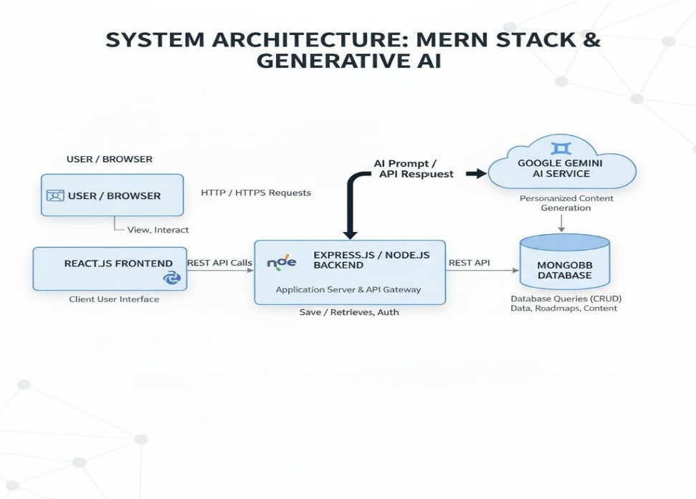
- Persistence Layer: Utilizes Browser LocalStorage for maintaining state, progress, and streaks across sessions.

3.3 Workflow & Conceptual Framework
The operational flow follows a circular feedback loop:
- Input: User provides Topic, Level, and Duration.
- Generation: AI generates a JSON-structured roadmap.
- Engagement: User consumes daily theory and attempts the coding challenge.
- Validation: 15-question quiz evaluates mastery (60%).
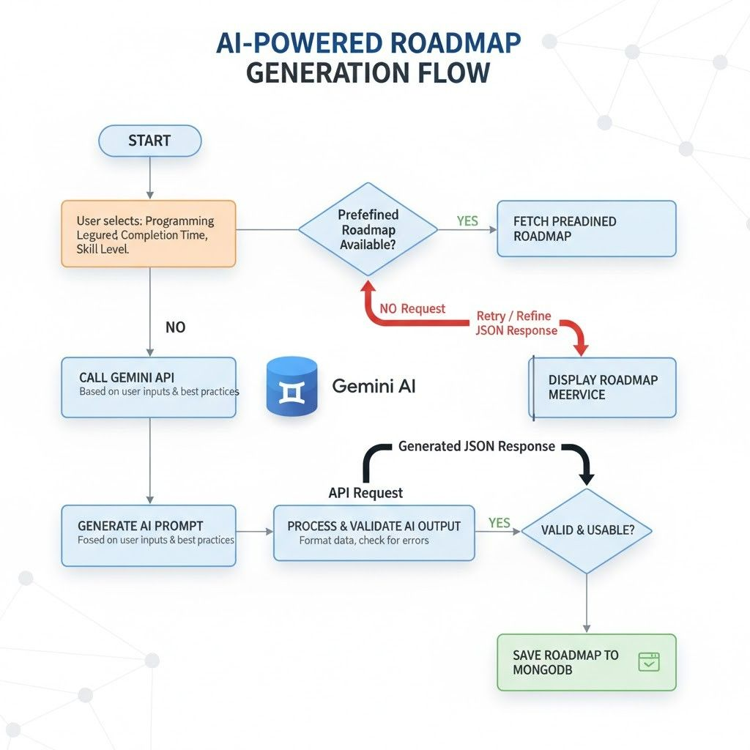
- Progression: Upon success, the next day's content is unlocked; otherwise, the AI Mentor provides remediation.

3.4 Technology Stack & Tools Studied
Category | Technology | Purpose
Framework | Next.js 15.5.9 | Full-stack framework for React 19.
AI Model | Gemini 2.5-flash | High-speed generative AI for content & code.
Styling | Tailwind CSS v4 | High-performance, utility-first CSS design.
Editor | Code Mirror 6 | Providing a robust in-browser code editing experience.
Visuals | Recharts | Generating dynamic progress charts and analytics.
Icons/UI | Lucida & Radix UI | Accessible components and consistent iconography.

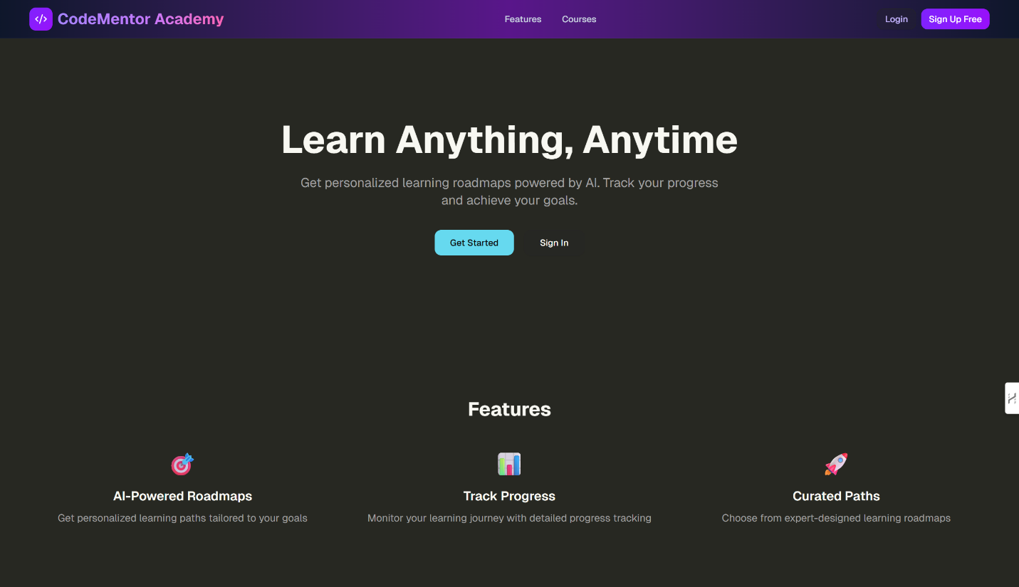
3.5 Frontend Design

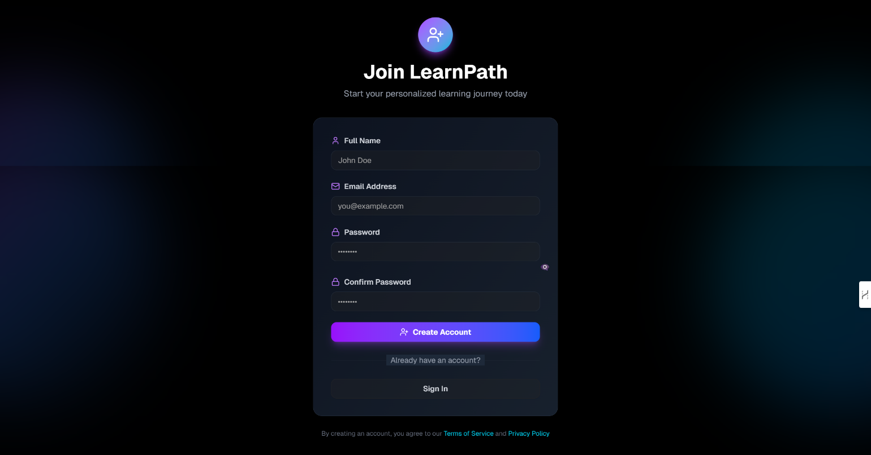

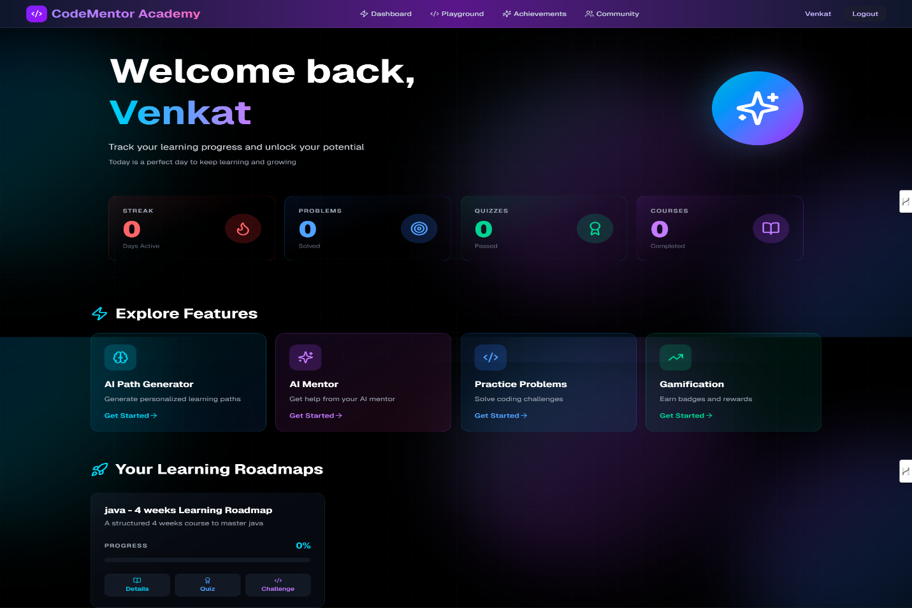

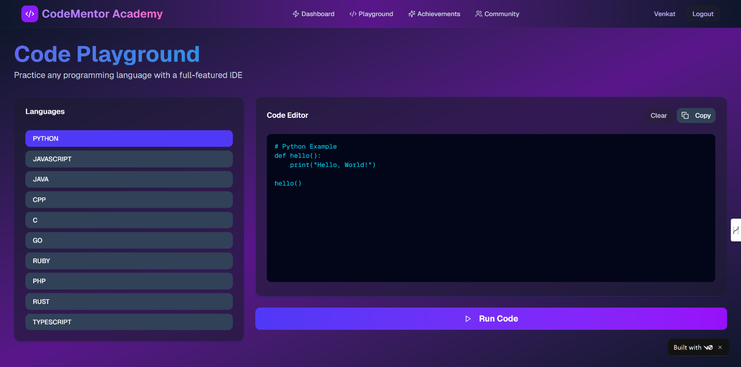

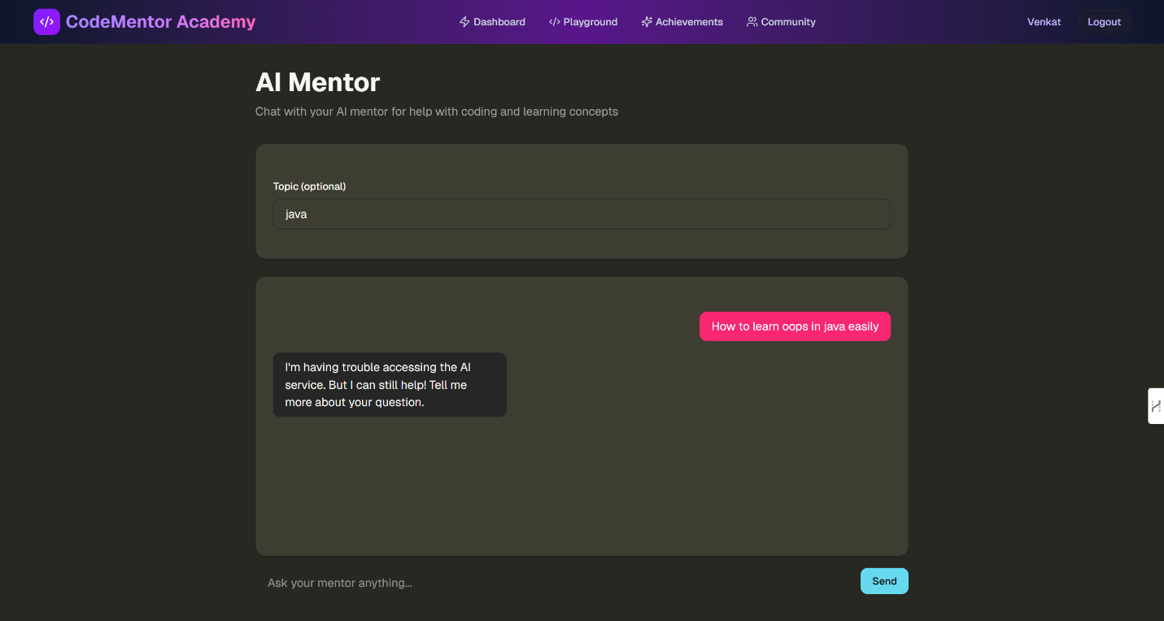

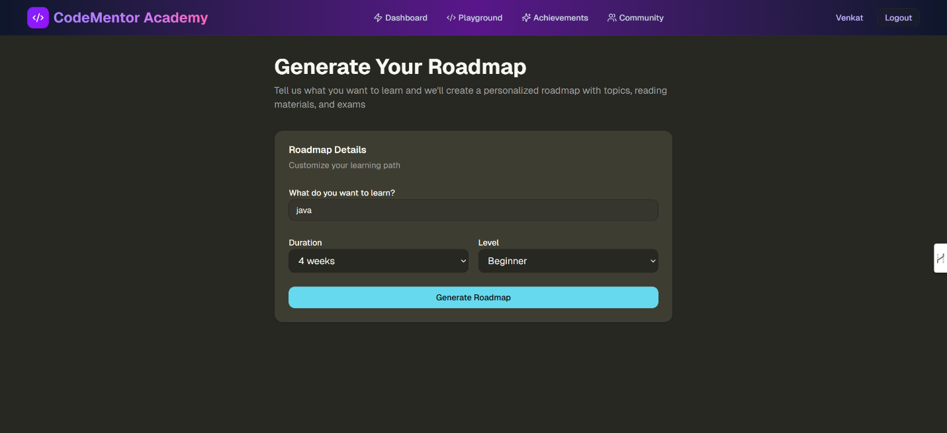

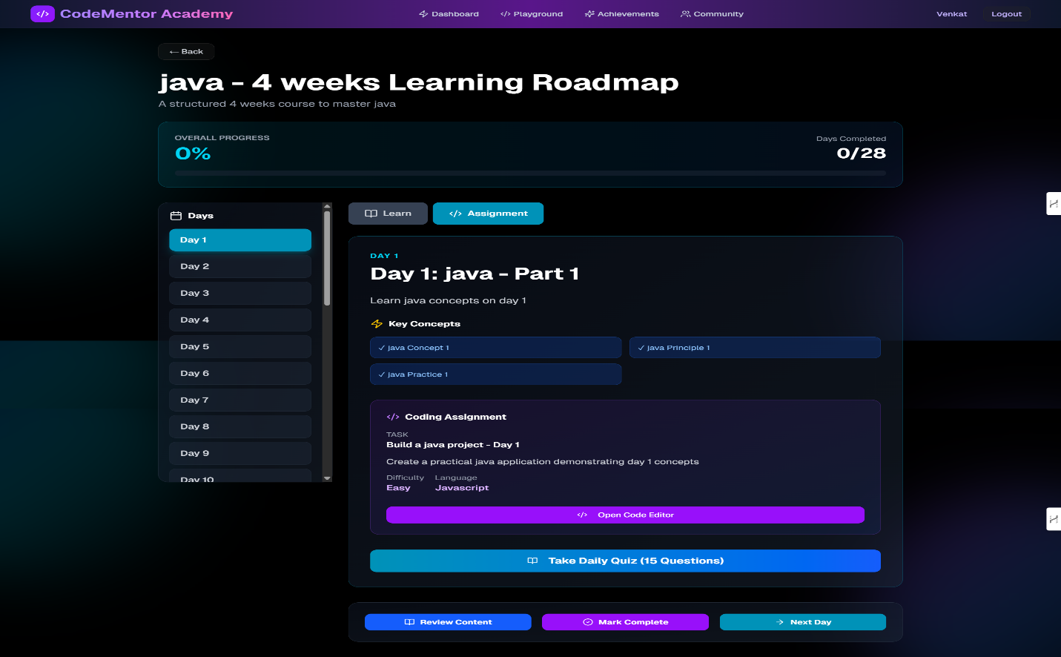

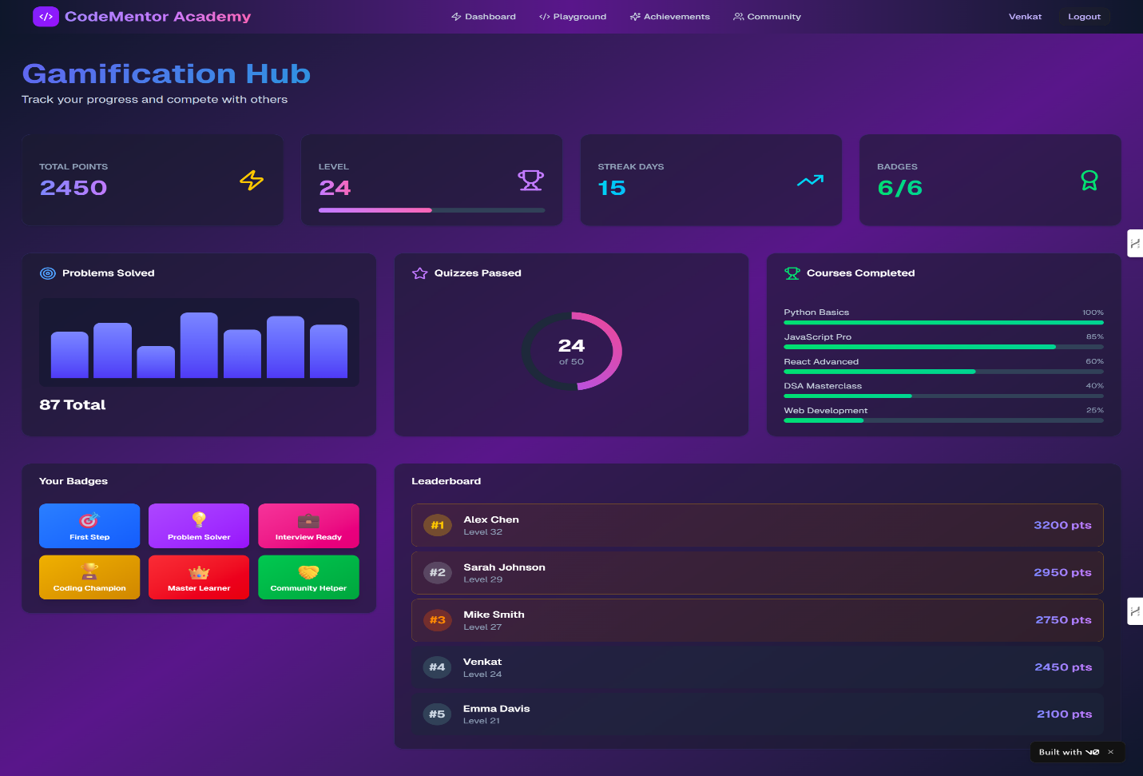

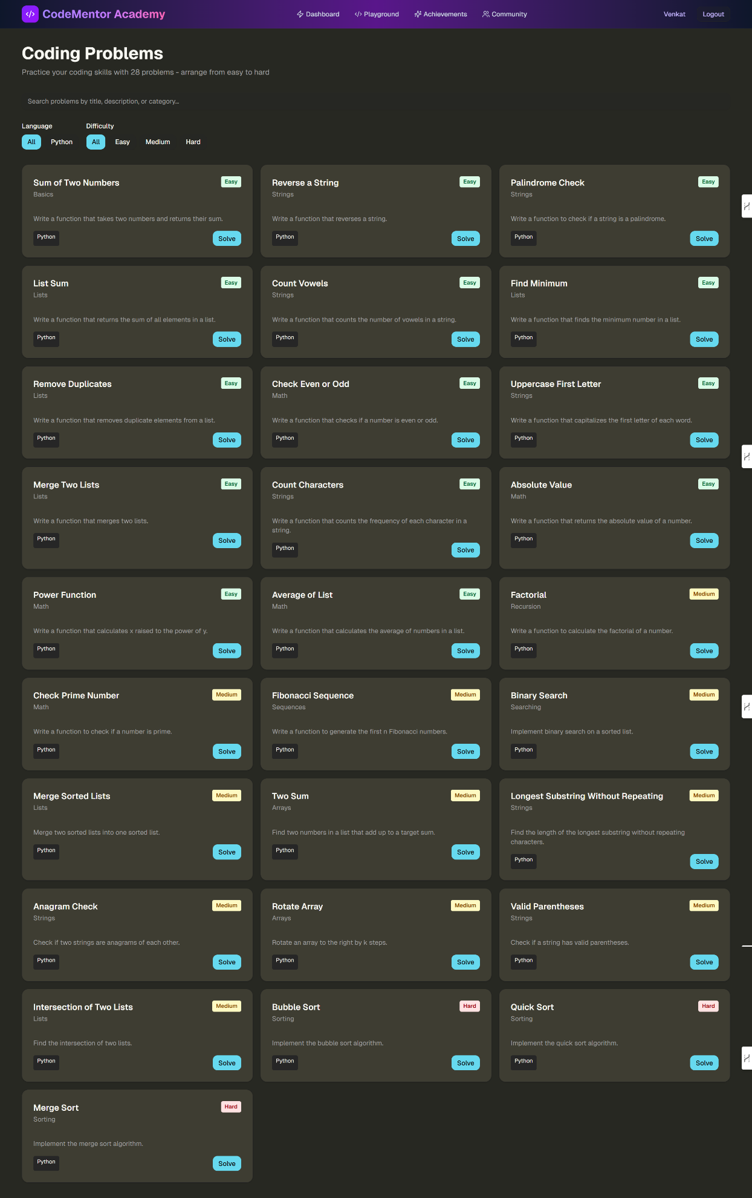

CHAPTER 4: RESULTS AND DISCUSSION
4.1 Key Observations
Through the implementation of the AI-Powered Personalized Learning Platform, several critical observations were recorded:
- Dynamic Response Quality: The Gemini 2.5-flash model demonstrated a high degree of "instruction following," successfully generating valid JSON structures for 95% of initial requests.
- Engagement Levels: The integration of a daily streak counter and badge system created a "nudge" effect, increasing user return rates compared to static PDF-based roadmaps.
- Latency vs. Accuracy: The "flash" model provided a optimal balance between response speed (latency) and the depth of educational content, making it suitable for real-time roadmap generation.

4.2 Conceptual Comparison
To validate the system, it was compared against traditional learning methods:
Feature | Traditional MOOCs | AI-Powered Platform (This Project)
Curriculum | Fixed / Static | Dynamic / Generative
Pacing | Fixed by Instructor | Fully Adaptive to User
Feedback | Delayed / Peer-based | Instant (AI Mentor & Quizzes)
Practicality | External IDE required | Integrated CodeMirror Editor

4.3 Interpretation of System Performance
The system's efficiency is measured by the Successful Completion Rate (SCR). By mandating a 60% quiz score, the platform ensures that progression is earned. Data visualization through Recharts allows users to see their growth, where a rising trend in "Problems Solved" correlates directly with the mastery of the selected topic.
4.4 Advantages, Limitations, and Insights
Advantages
- Scalability: Thousands of unique roadmaps can be generated simultaneously without manual intervention.
- Accessibility: The use of Radix UI and Tailwind CSS ensures the platform is fully responsive across mobile and desktop devices.
Limitations
- Context Window: Long-term mentoring sessions may occasionally lose context if the conversation history exceeds the model's token limit.
- Persistence: Relying on local Storage means progress is tied to a specific browser/device unless a cloud database is integrated.
Insights Gained
The project proved that AI is most effective when constrained by Structured Outputs. Simply asking an AI to "teach me Python" is less effective than forcing it to provide a specific JSON schema containing theory, a quiz, and a challenge.

CHAPTER 5: CONCLUSION AND FUTURE SCOPE
5.1 Summary of the Seminar Work
The seminar successfully demonstrated the architecture and viability of an AI-Powered Personalized Learning Platform. By combining Next.js 15 with the Gemini 2.5-flash API, the project moved beyond traditional static learning to create an intelligent, responsive ecosystem. The platform successfully automates curriculum design, provides real-time feedback, and uses gamification to sustain learner interest.
5.2 Major Learning Outcomes
- Full-Stack AI Integration: Gained expertise in connecting generative models to a modern React-based frontend.
- Schema Validation: Learned the importance of using Zod to bridge the gap between unpredictable AI text and predictable UI components.
- Behavioural Design: Understood how gamification elements (badges/streaks) impact digital learning retention.

5.3 Conclusions
The study concludes that the future of EdTech lies in Hyper-Personalization. Generative AI removes the barrier of "content curation," allowing students to focus entirely on "content consumption and practice." While AI cannot replace a human teacher entirely, it serves as a highly efficient 1-on-1 tutor that is available 24/7.

5.4 Future Scope
To evolve the platform from a seminar project to a production-level application, the following enhancements are proposed:
- Database Integration: Moving from local Storage to Superbase/PostgreSQL for cloud-syncing progress across all devices.
- Spaced Repetition: Implementing an algorithm (like Anki/SuperMemo) to re-introduce quiz questions for concepts the user struggled with previously.
- Multi-Modal Content: Expanding the roadmap to include AI-curated YouTube video links and documentation snippets for a richer learning experience.
- Collaborative Learning: Adding "Peer Review" rooms where students can share and discuss their AI-generated coding challenges.

Professional Profiles
- LinkedIn Profile: https://www.linkedin.com/in/venkat-naidu-neelapu/
- GitHub Profile: https://github.com/venkatneelapu
- YouTube: https://youtu.be/7hsqGzPxqBY?si=WtewzjsGpewZqpG9
- Live App: https://v0-ai-learning-platform-tau-steel.vercel.app/dashboard

DECLARATION

I hereby declare that the seminar report titled “AI POWERED LEARNING PLATFORM” submitted in partial fulfilment of the requirements for the award of the degree of Bachelor of Technology in Computer Science and Engineering is a record of my own work carried out during the academic session 2025-2026.
I further declare that this report has not been submitted, either in part or in full, to any other institution or university for the award of any degree or diploma.
I confirm that the content of this report is original and prepared by me. Any references used have been duly acknowledged. I also declare that the use of Artificial Intelligence (AI) tools, if any, has been minimal and the AI-generated content in this report is less than 10%, ensuring that the majority of the work reflects my own understanding and effort.
I take full responsibility for the authenticity and originality of the work presented in this report.

Name of the Student: Neelapu Venkata Naidu
Registration Number: 12213327
Course: Computer Science and Engineering
Signature of the Student: venkata naidu
Date: 03/04/2026

