Annexure-I
Road Map’s Website Using MERN Stack and Generative AI

Submitted in partial fulfilment of the requirements for the award of degree of
Computer Science and Engineering
Submitted to
Dr. Alok Misra
LOVELY PROFESSIONAL UNIVERSITY

PHAGWARA, PUNJAB


SUBMITTED BY

S.NO | Reg. No | NAME
1 | 12213327 | Neelapu Venkata Naidu
2 | 12207107 | Vaishnavi Kumari Batchu
3 | 12212545 | Bilva Sri
4 | 12205244 | Nithin Yalakala
5 | 12212650 | Akhil Mudadla
6 | 12204945 | Dileep Lopinti

INTRODUCTION OF THE PROJECT UNDERTAKEN
1.Introduction
1.1 Objectives of the project
The project's main goal is to provide a user-friendly online learning environment.This project's technology stack will be built using the MERN stack, which includes AI features like MongoDB, Express.js, React, and Node.js. The goal here is to revolutionize the self-guided learning experience in programming and technology by devising a learning platform that can solve common pain points in learner engagement, resource usage, and guidance. The idea is to have customized, flexible, and engaging learning paths. Its main purpose is to provide seamless and engaging learning activities that help users build skills and grow in confidence.
The idea here is to provide learners with their own individual roadmaps, generated using AI. These roadmaps will be adjusted according to an individual's goals, current skill levels, available time, and preferred learning styles. An integrated suite of AI capabilities will introduce a chatbot and a resource recommendation engine as virtual tutors. They will be able to answer questions fast, show examples in code, and suggest targeted content thus mimicking a real instructor. Having default roadmaps for the most popular frameworks and technologies will also be convenient for those who are just beginning with coding and for advanced users who would like to get more in-depth knowledge of some particular areas.
1.2 Description of the project
In order to transform the way that programming and technical skills are learnt and mastered, this project includes an advanced web-based learning platform built on the MERN stack, which consists of MongoDB, Express.js, React, and Node.js. This would use advanced AI (Gemini AI) to provide personalised and dynamic learning paths that automatically adjust to each user's knowledge level, goals, and available time, in contrast to the typically static online tutorials. The major objective is to get rid of common issues that students encounter, like lack of motivation, ineffective resource use, and uncertainty about learning paths.
The platform emphasises simplicity without sacrificing power, with a focus on user-friendly design. With the help of React in the interface, students can easily follow along with carefully chosen courses or make a personalised plan to accomplish their objectives. The platform will accommodate a range of goals, from learning JavaScript in 30 days to becoming proficient in full stack MERN development in a few months. The back end, which was constructed using Express.js and Node.js, enables smooth and instantaneous communication between the data processing and the client's request. MongoDB manages data effectively and efficiently.
This implies that learning is engaging and enjoyable thanks to gamified progress tracking, mini-projects, quizzes, and an AI mentor chatbot. It practically develops the skill and results in gradual improvement. In addition to AI mentoring, the community facilitates peer-to-peer cooperation, dialogue, and mentoring. Future updates will offer even more customisation, including an AI-powered resource recommendation engine to find high-quality external tutorials and documentation and adaptive learning that can update roadmaps based on performance analytics.
This method offers a disciplined, well-organised, and inspiring learning environment that seamlessly blends with people's personal objectives and schedules. It minimises needless effort on the part of the learner while enabling them to attain better results. By combining intelligent guidance, rich interactivity, and flexibility in self-paced learning, the project seeks to elevate online programming education to a new level that is appropriate for both beginning and experienced developers.
Introduction to Web Development
Frontend vs Backend
- Frontend Development: This is the field that concerns the visual parts of a website, including designing layouts, adding styles, and making sure sites work on multiple devices. The main technologies are HTML, CSS, and JavaScript. Frontend developers give much priority to user experience and interface design.
- Backend Development: It involves the server side. It takes care of data storage, security, and business logic. This usually involves dealing with databases, server-side languages, and frameworks such as Node.js, Python, and Java. A backend developer ensures that the front-end has everything it needs-data and features-to perform well.
Introduction to MERN Stack
The MERN stack is one of the popular tech stacks today for full-stack development. It comprises:
- MongoDB: A NoSQL database that stores data in JSON-like documents.
- Express.js: A web application framework for Node.js, which is used in building web applications and APIs.
- React.js: A JS library for building user interfaces, in particular for SPAs.
- Node.js: This is a Chrome V8-powered JavaScript runtime that allows developers to create scalable server-side network applications.
MERN is chosen because it is efficient and easy to use. It allows developers to code on both frontend and backend in JavaScript, which makes their work easier.
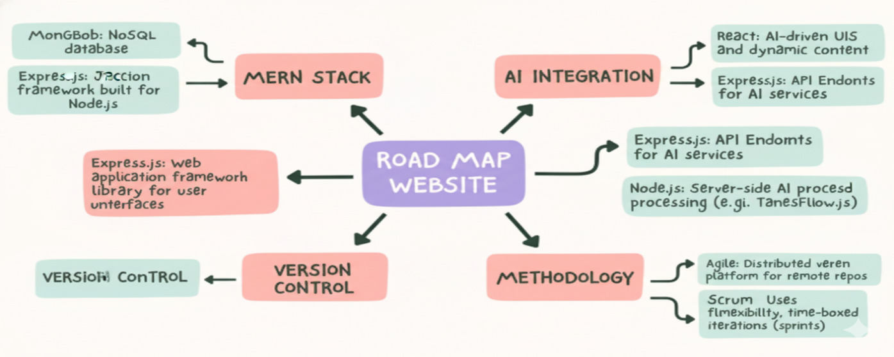

Introduction to Git and GitHub
Git is a free, open-source, distributed version control system that can deal efficiently with small and very large projects. It permits multiple developers to be working on the same project at the same time without interfering in each other's work. Key Concepts:
- Repository (Repo): It is a directory or storage space where your project files along with their history are stored.
- Commit: The snapshot of a repository at one point in time.
- Branch: A parallel copy of your repository. It allows you to work on different features or fixes independently.
- Merge: Integrating changes from multiple branches into a single one.
- GitHub: A web-based platform using Git for version control. It is a developer space where all people can share and manage their code. Key features include:
- Remote Repositories: These are Git repositories that are hosted online, so they can be accessed from anywhere.
- Pull Requests: Proposing changes to a repository and discussing with collaborators before incorporating.
- Issues: Tracking bugs, enhancements, and other project tasks.

Introduction to JavaScript
- Client-Side Scripting: JavaScript generally runs in web browsers, generating dynamic page content, controlling multimedia, animating images, and much more.
- Server-Side Scripting: JavaScript is also applied on the server in environments such as Node.js to create scalable network applications.

Functions: Blocks of reusable code that execute some functionality which may take parameters to operate on.
Objects: Sets of key-value pairs employed in the storage and manipulation of data, containing properties and methods that describe and interact with the data.
Introduction to React
React is one of the most well-known JavaScript libraries, popular for creating user interfaces, preferably SPAs (Single Page Applications). React was developed by Facebook to help developers break down complex UIs into smaller, reusable components.
Key Features of React
1. Component-Based Architecture: React applications are built around the concept of components, which are the building blocks containing their own state and logic. You can nest, reuse, and compose components with each other to build complex UIs.
2. Declarative Syntax: React lets you describe how the UI should look for a specific state. It then takes care of updating the UI when the state changes. This helps you understand and manage the application state more easily.

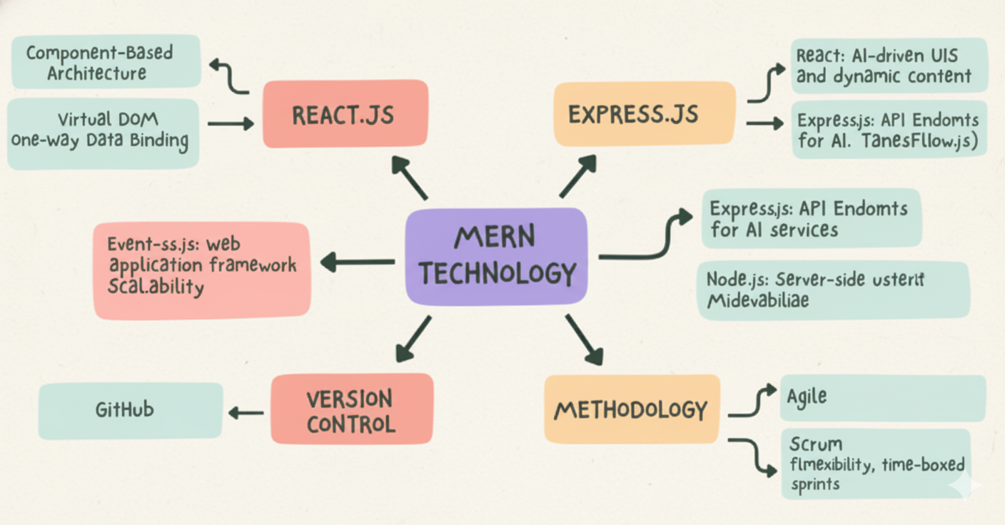

File System
1. Reading Files: One can read the contents of a file either asynchronously or synchronously. Asynchronous reads allow your program to continue running while the file is being read, while synchronous reads block the program until the file is read.
2. Writing Files: You can write data to files in asynchronous and synchronous manners. Writing in an asynchronous manner will let the program continue running while writing to the file, while synchronous writing blocks execution of the thread until the write is completed.
3. Appending Data: You can add new data at the end of an existing file either asynchronously or synchronously. This lets you increase content without overwriting what's already there.
4. File Deletion: You can delete files from the file system. This operation can be asynchronous, meaning the program keeps executing while the file gets deleted, or synchronous, in which case the execution blocks until the file is deleted.
5. Managing Directories: You can create, list, and delete directories. Creating a directory can be done asynchronously or synchronously. You can read a directory to list the files and folders in a directory.

Best Practices for Bug Fixing
- Bug Prioritization: Bugs need to be categorized in order of their seriousness and impact. Critical functionality bugs must take precedence over minor cosmetic issues.
- Document Fixes: Keep track of changes made in the bug-fixing process. Documenting fixes maintains a record of what was done and why.
- Test Thoroughly: After applying the fix, test the whole application to ensure that the bug is fixed and that no new issues have been introduced.
- Team Communication: Update your team members about bugs and their fixes. All this collaboration and communication increase efficiency towards resolving problems.
- Learn from Bugs: Study root causes of bugs so similar ones do not happen in the future. Every bug-fixing session is an occasion to learn and improve development practices.

1.3 Scope of the Project
As an Intern for MERN Stack, your typical role involves gaining practical experience and contributing to the many aspects of web development within the MERN stack, inclusive of MongoDB, Express.js, React, Node.js. Here is a summary of the usual responsibilities and tasks:

1. Development Tasks
- Frontend Development: Construct and maintain the user interface in React, which includes building reusable components, handling state changes using Redux or Context API, ensuring responsive design.
- Backend Development: Developing server-side logic using Express.js and Node.js by creating and managing RESTful APIs, handling authentication on the server-side, and implementing business logic.
- Database Management: Work with MongoDB to design and optimize schemas, perform CRUD operations, and ensure data integrity. This includes writing queries and understanding data modelling.
2. Code Integration and Testing
- API Integration: Link the front-end to back-end services via API endpoints, ensuring a continuous, well-structured flow of information between the client and server with proper error handling.
- Testing: Writing and running unit tests, integration tests, and end-to-end tests in order to ensure the code quality and reliability. This would typically leverage libraries and frameworks for testing, including Jest or Mocha.
3. Documentation and Reporting
- Documentation: Documentation involves commenting your code, APIs, and development processes. This will help in maintaining the project and providing clarity to other team members.
- Reporting: Regularly update your progress and any issues you encounter to your mentor or project lead. Participate in team meetings and contribute to sprint reviews or stand-ups.

4. Collaboration and Learning
- Team Collaboration: Close cooperation with other developers, designers, and stakeholders. Participate in code reviews, pair programming, and collaborative problem-solving sessions.
- Learn and Develop: Create opportunities to learn about new technologies, tools, and best practices applicable in the MERN stack. Ask for feedback and put it into action for personal development.

1.3.1 Use Case Model
This platform's use case model is a description of the main interactions between users and the system. It helps to make requirements clear and guides the priorities in development.
1. User Registration and Authentication: New learners sign up with the system using an email and password or social logins. They set initial preferences like learning goals and schedules. Secure methods handle login sessions and password recovery.
2. AI-Based Personalized Roadmap Generation: The user has to input his technology of choice, current skill level, preferred timeline, and daily study hours through the system. The Gemini AI then processes this input to produce a personalised learning path. Well-organised topics and milestones with resources attached make up the learning path.
3. Previously established roadmaps Access: Teachers or other authorised content providers have developed a number of carefully designed static learning paths from which the user can select. This cover widely used technologies and produce a definite progression devoid of AI-driven personalisation.
4. Progress Tracking: As they complete topics, students record their progress. Their dashboards, which show metrics like completion percentage, streak days, and skill levels for every topic, are updated as a result. Based on user activity, the system also makes recommendations for modifications and subsequent actions.
5. AI Mentor Chatbot Interaction: Students can have a conversation with an AI assistant who provides real-time answers to questions, demonstrates code, explains concepts, and offers debugging advice. This mimics what it would be like to have a private tutor.
6. Community Engagement: Members engage in discussion boards to exchange resources, pose and respond to queries, and work on challenges or side projects. This encourages sharing and social learning.

7. Gamification and Motivation: Based on learning accomplishments, the system provides leaderboards, badges, and points. This promotes consistent learning and advancement, which raises user involvement.
8. Administration and Content Moderation: In order to maintain platform health and user satisfaction, admin users manage user permissions, moderate the community, and oversee roadmaps.

This use case model guarantees that all user journeys are addressed and permits the addition of new features based on admin and user feedback.
2. System Description
The learning platform's architecture is guided by contemporary web development best practices, which place a strong emphasis on scalability, flexibility, and performance. Using React on the frontend, the application functions as an SPA and offers a quick, dynamic, and interactive user interface. React components display community forums, chatbots, user dashboards, and instructional content. Redux and other state management tools facilitate interactive and seamless data flow.
The Express.js framework powers the Node.js backend. It has RESTful APIs for community posts, roadmaps, progress logs, and user management. This backend controls AI features, such as the AI Mentor Chatbot's natural language processing and personalized roadmapping driven by Gemini AI. One of the main non-relational databases is MongoDB. Because MongoDB can store a variety of data, including user profiles, learning materials, progress logs, and even forum posts, it has been used in this application. Under heavy traffic, it scales well.
Multiple levels of security are implemented, including role-based access control, which restricts sensitive actions to administrators, JSON Web Tokens, which enable authentication and session management, and HTTPS, which enables encrypted communication between clients and servers. To increase dependability and maintainability, the platform makes use of middleware for request logging, error handling, and input validation. Scalability: The backend services' ability to distribute load horizontally. This also takes into account cloud-based MongoDB Atlas for managed database operations and containerization for consistent environments. Additionally, it anticipates growing it with microservices in the event that future gamification features or AI analytics become necessary.
Because the platform is client-side responsive, learning can take place at any time and from any location on PCs, tablets, and smartphones. Lazy loading, code splitting, and caching strategies are examples of performance optimizations.
This architecture works together to provide a safe, effective, and intuitive setting for AI-powered personalized learning.
2.1 Customer/User Profiles
The platform caters to various user groups with distinct requirements and levels of access:
Learners: Primary users include, but are not restricted to, novices in need of organized programming lessons and intermediate developers seeking to advance their knowledge or switch to a new technology. Learners value interactive assistance, personalized pacing, interesting gamification, and clear instructions. They gain from community support, AI-generated roadmaps customized to their objectives and timetables, and a progress dashboard that promotes motivation and accountability.
Educators and Mentors (Secondary Users): Teachers and Mentors By creating predetermined roadmaps, facilitating forums, and occasionally providing mentoring, they add value. They would place a strong emphasis on user engagement, system usability, and content quality in order to deliver effective training and support.
Administrators: Admins oversee the system, managing user rights, regulating content, ensuring data integrity, and examining platform metrics. They require tools for moderating forum discussions, managing disagreements or feedback, and dashboards showing user activity and system health.
Technical Support Team (Optional Future Role): A team that will manage AI service integrations, handle user technical issues, guarantee seamless operation, and safely apply updates is known as the Technical Support Team (Optional Future Role). Based on their roles, each user profile has a unique interface and unique access control. As a result, the entire platform is data-secure and maintainable.

2.2 Assumptions and Dependencies
The following assumptions provide grounds for the feasibility and delivery of the project:
- These days, users have access to modern web browsers and reliable internet connections that can support SPA technologies.
- Learners have basic computer skills and are able to work with web interfaces and chatbots.
- As a service to generate custom roadmaps and chatbot dialog, Gemini is accessible via stable API endpoints that return responses with decent latency.
- MongoDB Atlas or any other cloud-managed database service can be used to manage scalable, redundant backend data storage.
- Most importantly, this basis rests on the MERN stack libraries and frameworks-React, Express, Node.js, and MongoDB-which continue to receive security and performance updates and community support.
- The AI algorithms and roadmap content are fine-tuned over time, with adequate feedback from users.
- Integration with third-party tutorials and certification vendors depends upon the APIs available with those partners.
Dependencies include cloud hosting platforms like AWS or Azure, SSL certificate providers for HTTPS, and possible third-party authentication services like OAuth or Google/Facebook login. The project assumes cooperation from educational content creators in ensuring roadmap quality.
2.3 Functional Requirements
The following key functions must be implemented in the system:
- User Management: User registration, login/logout, password reset, profile update, and role-based access.
- Roadmap Management: AI-based creation of customized roadmaps given user input; display and navigation of AI-generated and predefined roadmaps.
- Progress Tracking: The user can mark a topic as complete, track time spent, and see a progress dashboard highlighting strengths and weaknesses.
- Interactive AI Mentor: A natural language interface for questions, explanations, code snippets, and debugging tips.
- Community Features: Posting questions, answering them, forum subscriptions, and moderation tools.
- Gamification: Awarding of points, badges, and leaderboards for user achievements.
- Resource Management: backend CRUD for tutorial links, documentation, quizzes, and code challenges.
- Notifications: Events from roadmap milestones, replies in the forum, and quiz results.
- Security: Enforced authentication in all relevant routes, encrypted data handling, session management, and input validation.
- Admin Tools: User role assignment, content moderation dashboards, and analytics reporting.
2.4 Non-Functional Requirements
- PERFORMANCE: Application response time below 2 seconds for every important user action; should be able to handle 500 or more concurrent users.
- Usability: Clean, intuitive UI with accessibility features meeting WCAG guidelines.
- Scalability: Easy horizontal scaling of back-end services and database loads with minimal down times.
  - Reliability: backup plans, automated failover, and 99.9% uptime.
  - Security: Adhering to OWASP best practices, protecting data in accordance with GDPR guidelines, and optionally using multi-factor authentication.
  - Maintainability: A well-documented, modular codebase that enables quick and simple feature and bug additions.
  - Portability: responsive to mobile devices and compatible with the most recent versions of Chrome, Firefox, Safari, and Edge.
  - Extensibility: The architecture permits the addition of feature toggles, third-party integrations, and microservices.
3. Design

3.1 System Design

3.1.1 E-R Diagram
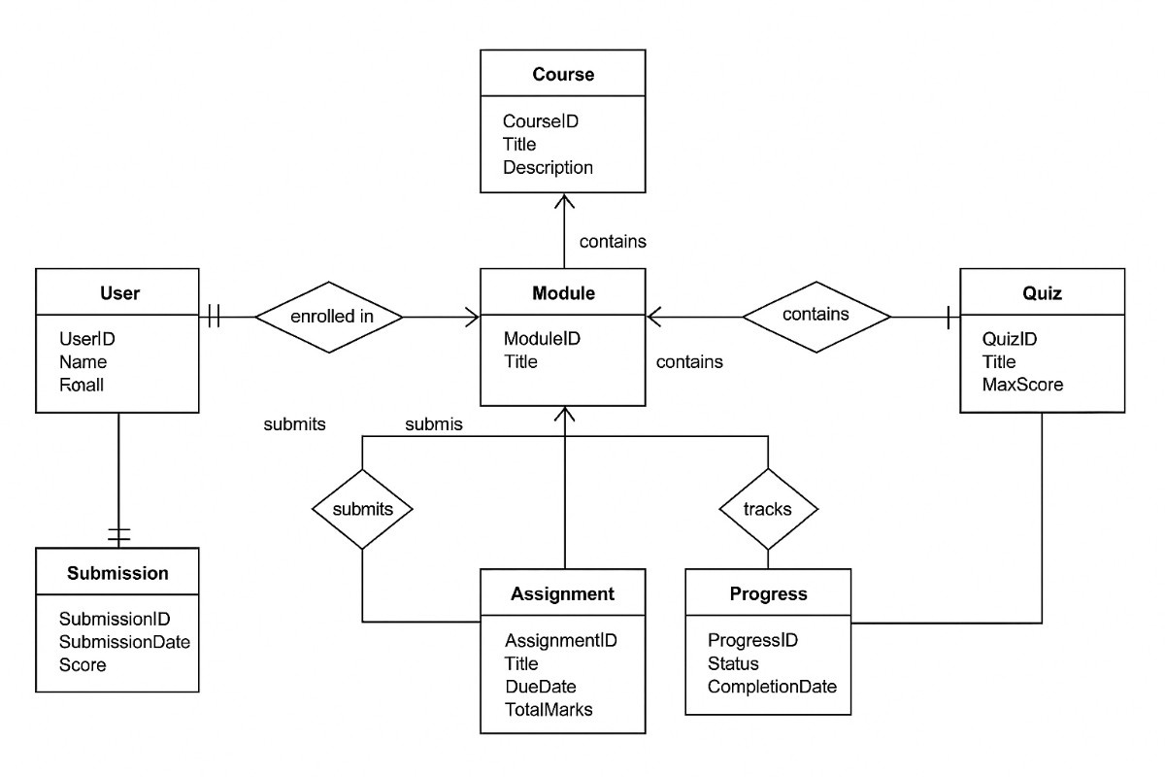

3.1.2 DFD
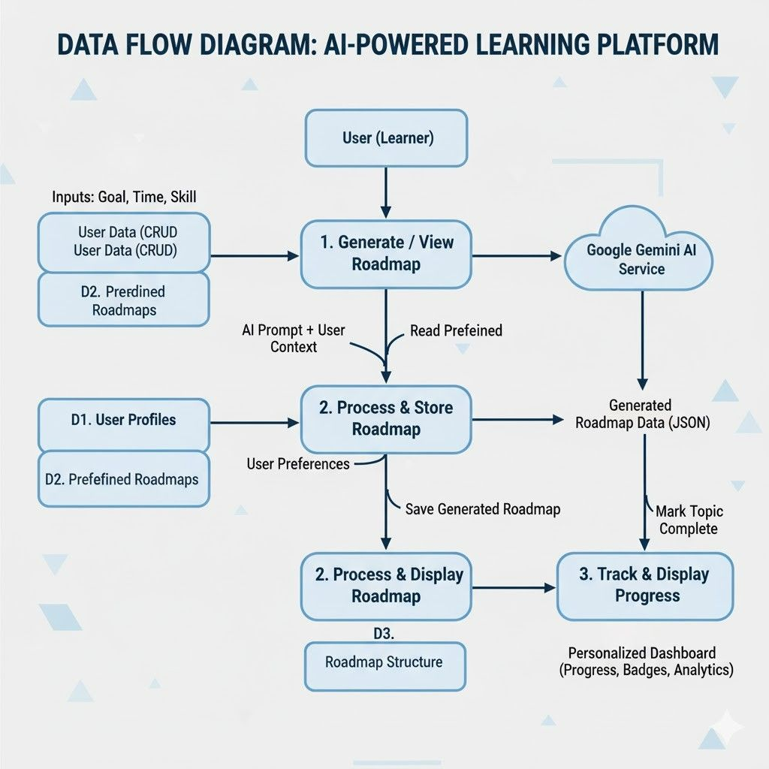
3.2 Database Design
MongoDB was selected as the database for the MERN stack-based AI learning platform because of its adaptable document-oriented model, scalability, and performance benefits. In addition to improving query performance and preserving data consistency, the suggested schema is made to handle different data types that are connected within an educational platform.
Among the principal entities are:
- Users This stores the user profile, roles (learner, educator, admin), preferences, login details, and security information: hashed passwords, tokens.
- ROADMAPS: These represent both AI-generated and predefined learning paths. The attributes are metadata such as technology name, total duration, embedded list of topics, milestones, and difficulty levels.
- Topics: These are detailed documents for each learning unit and include descriptions, linked resources (videos, PDFs, quizzes), estimated times to complete, and prerequisites.
- Progress Records: These are associated with users to track topic completion status, timestamps, quiz scores, and streaks.
- Community Posts: These are discussion threads, comments, and user interaction in general, along with moderation flags, timestamps, and user references. Quizzes and Mini-Projects: This includes questions, answers, scoring rubrics, and submission records.
- AI interactions: These record chatbot conversations, AI suggestions, and system-generated changes to learning paths.
Relationships use both embedding and referencing, depending on the case. For example, topics will be embedded into roadmaps for easy retrieval as a user navigates through it, while user progress will reference topic documents, so data is not duplicated in many places. Community posts and AI interaction logs will use references since there can be a high volume of either and agility is required. Indexes on user IDs, roadmap names, and topic status fields speed up queries. The schema design follows MongoDB best practices by balancing normalization to gain consistency with denormalization to achieve performance. Other design considerations: schema versioning, to handle future changes in the structure of roadmaps; archiving of old content; and securing access controls at document and field levels.
4. Scheduling and Estimates
Scheduling and estimation are indispensable activities in the planning and delivery of the MERN stack-based AI-powered learning platform. Scheduling and estimation help in resource allocation, timely completion, and risk management throughout the project. This section presents a practical approach to project scheduling and realistic effort and cost estimates based on the technical needs and complexity of the platform.
The project schedule breaks down into distinct phases: using Agile methods for incremental delivery of value with stakeholder feedback in regular cycles. Typically, the timeline goes up to 10 to 12 weeks, which covers feature completion and substantial testing.
- Requirement Gathering and Planning: 2 weeks. This phase will involve detailed discussions with stakeholders to finalize the functional and non-functional specifications, database schema design, AI integration points, and wireframes for UI/UX. Time is set aside for the feasibility study on AI roadmap generation and chatbot capabilities.
- Backend and Database Development, 3 weeks: This includes development related to building the Express.js API layer, defining MongoDB schemas with mongoose, authentication implementation, integration of services provided by Gemini AI, and admin functionality. In parallel, setting up of cloud infrastructure is included, complete with CI/CD pipelines for seamlessly deploying these applications.
- Front-end Development, 4 weeks: This phase will involve creating React components for dashboards, customized roadmaps, progress tracking, gamification features, and community forums. Careful attention to responsive design and optimization of performance will be performed in order to improve user experience across devices.
- Testing and Quality Assurance: 2 weeks Rigorous unit, integration, and end-to-end testing checks both back-end APIs and front-end interactions. Security audits and load testing confirm that the application meets standards of performance, reliability, and protection of data.
- Deployment and Final Adjustments (1 week): The team deploys the application to production environments, sets up monitoring tools, finalizes the documentation, and conducts training sessions for admins. Resource allocation estimates and costs are based on the project's scope and complexity:
- Effort: Approximately 480-600 person-hours, assuming a team of 4-6 developers, including frontend engineers, backend specialists, UI/UX designers, and QA testers. In this total, buffer time for unexpected issues has been assumed.
- Budget: Based on labour rates and third-party service fees, such as AI API usage and cloud hosting, estimates are between $40,000 and $60,000. Prices for MongoDB Atlas managed database and scalable resources in the cloud scale according to user traffic.
- Risk Mitigation: Scheduling buffers, regular sprint reviews, and continuous integration reduce delays. Early testing of AI components during planning reduces technical uncertainties.
- Tools: Project management tools such as Jira or Trello will help track the tasks and deadlines, while version control using Git and automated deployment pipelines speed up the iteration cycles.
This structured approach to scheduling and estimation reduces risks in development, provides clarity, and keeps project delivery in sync with business objectives while setting up a solid foundation for a scalable and maintainable AI-driven learning platform.
Brief Description of the Work Done
Position of Internship and Roles
Position: MERN Stack Intern with GenAI Focus Roles:
• Development and maintenance of web applications with the MERN stack, including MongoDB, Express.js, React.js, and Node.js.
• Integrate Generative AI models into web applications and extend their functionality.
• Collaborate with various teams in designing, developing, and releasing new features.
• Write clean, maintainable, and efficient code.
• Participate in code reviews and provide constructive feedback.
Activities/Equipment Handled
Activities:
• Front-end Development: User interfaces should be made using React.js and Tailwind CSS.
• Back-end Development: RESTful API creation using Node.js and Express.js.
• Database Management: Design and manage databases using MongoDB.
• AI Integration: Use Generative AI models through APIs like OpenAI.
• Version Control: Use Git and GitHub will be used for source code management.
• Deployment: Deploy applications on cloud platforms like Vercel or Heroku.
Equipment Handled:
• Development tools including Visual Studio Code.
• Version control systems, such as Git.
• Cloud services for deployment and database management.
Challenges Faced and How They Were Tackled
Challenges:
• Integrating AI Models: There have been challenges with integrating models with the current stack.
o Solution: Worked with AI experts and used detailed documentation and tutorials to understand the integration process.
• Performance Optimization: This was necessary for making the application work seamlessly with AI features.
o Solution: Caching strategies were used, and database queries were optimized to enhance performance.
• Debugging Complex Issues: Faced some challenging-to-trace bugs.
o Solution: Applied debugging tools and conducted thorough code reviews in order to find and fix problems.
Learning Outcomes
• Technical Skills: Acquired proficiency in MERN stack development with AI integration.
• Problem-Solving: Better ability to troubleshoot and resolve complex technical problems.
• Collaboration: This involves enhanced teamwork and communication skills in projects.
• Project Management: Learned how to manage and deliver projects on time. Data Analysis
• User Interaction Data: Analyzed user interaction data to improve UI/UX.
• Performance Metrics: Application performance metrics were monitored to understand where improvements are needed.
AI Model Performance: Analyzed the performance of AI models and fine-tuned them to improve accuracy and efficiency.

CONCLUSION

1.Full-Stack Conceptual Understanding: Developed a sound understanding of how MongoDB, Express.js, React, and Node.js will interact in the proposed system. Identified how the front-end, back-end, and database will interact to solve the problem.

2. Problem Identification & Solution Planning: Identified the problem statement well, studied the existing gaps or challenges. Designing the solution by using modern web technologies and AI integration that would facilitate addressing these issues.

3. Requirement Gathering & Feature Mapping: Listed all key features that will be included in the project; these include dashboards, prediction modules, and user management. Prepared initial workflow diagrams, data flow, and user flow to show how the system will operate.

4. Architecture & Tech Stack Planning: Studied various technologies and chose the MERN stack for scalability, flexibility, and ease of development. Planned how APIs, UI components, database schemas, and AI services will be structured.

5. Integration of AI / ML Components: Identified AI/ML models or APIs, such as Gemini API, that would enhance automation or intelligence in the system. Planned how these models would be applied in text generation, predictions, recommendations, and classification.

6. Research & Feasibility Analysis: Researched similar systems, the feasibility of implementation, and possible limitations. Identifying tools, resources, libraries, and frameworks that may be needed in order to successfully build the project.

7. Team Collaboration & Role Division: Alloted different roles to team members for frontend, backend, database, documentation, and AI integration. Coordinated to make flowcharts, architecture diagrams, and presentation slides.

8. Project Planning & Timeline Creation: Outlined the development phases: analysis, design, development, testing, and deployment. Prepared a realistic timeline for building the working prototype.

9. Presentation & Documentation Preparation: The project proposal, architecture explanation, and slide deck were completed. Visual representations such as flowcharts and block diagrams were made to illustrate the idea in a clear manner.

10. Readiness to Start Development: Completion of all pre-development steps such as finalization of requirements, technology selection, and workflow planning, and then moving into coding upon approval of the idea.
REFERENCES
- FreeCodeCamp’s MERN Stack Roadmap:
This tutorial covers everything from the basics of HTML, JavaScript, and CSS to some advanced topics in React, Express, Node.js, and MongoDB, hence providing project ideas to help you practice and showcase your skills. Read more here.
- MongoDB’sMERNStackTutorial:
This tutorial shows how to create a full-stack MERN application step by step, with practical examples and insight into each component of the stack. Explore the tutorial.
- MirrorFolio’s Comprehensive Guide:
This tutorial presents a detailed explanation of the MERN stack, providing resources for further learning and links to official documentation for MongoDB, Express.js, React.js, and Node.js. Check it out here.
- tedX MERN Stack Courses:
edX has a variety of courses that will continue building your skills in web development, specifically with the MERN stack. Take these courses to learn the knowledge required to start a career as a JavaScript developer Browse courses on edX.
- MongoDB’s Complete Guide:
This tutorial goes in-depth into using the MERN stack by leveraging a MongoDB Atlas
database for hands-on learning. Learn more here.

