Annexure-I
Road Map’s Website Using MERN Stack and Generative AI

Submitted in partial fulfilment of the requirements for the award of degree of
Computer Science and Engineering
Submitted to
Dr. Alok Misra
LOVELY PROFESSIONAL UNIVERSITY

PHAGWARA, PUNJAB


SUBMITTED BY

S.NO | Reg. No | NAME
1 | 12213327 | Neelapu Venkata Naidu
2 | 12207107 | Vaishnavi Kumari Batchu
3 | 12212545 | Bilva Sri
4 | 12205244 | Nithin Yalakala
5 | 12212650 | Akhil Mudadla
6 | 12204945 | Dileep Lopinti

ACKNOWLEDGEMENT

we want to sincerely thank everyone for their contributions, which made it possible to successfully complete the " Road Map’s Website Using MERN Stack and Generative AI”
For all the guidance, ongoing assistance, and insightful recommendations during the research and development, we sincerely thank Dr Alok Misra. The help of Dr Misra was crucial in developing the basic ideas and then enhancing the methodology of this study.
We are grateful to the Department of Computer Science and Engineering, Lovely Professional University, for providing the infrastructure, research environment, and resources that helped in the effective execution of this project.
Finally, I would like to thank my family and friends for their constant encouragement, patience, and faith in our undertaking; it is always a source of strength to me.
Name: Neelapu Venkata Naidu(12213327)
Name :Vaishnavi Kumari Batchu(12207107)
Name :MR Bilva Sri(12212545)
Name : Nithin Yalakala(12205244)
Name : Akhil Mudadla(12212650)
Name : Dileep Lopinti(12204945)

TABLE OF CONTENT
S.No | Content Title
1 | Annexure – I
2 | Acknowledgement
3 | Introduction of the Project Undertaken
3.1 | Introduction
3.2 | Objectives of the Project
3.3 | Description of the Project
3.4 | Introduction to Web Development
3.5 | Introduction to MERN Stack
3.6 | Introduction to Git and GitHub
3.7 | Introduction to JavaScript
3.8 | Introduction to React
3.9 | File System
3.10 | Best Practices for Bug Fixing
3.11 | Scope of the Project
3.11.1 | Use Case Model
4 | System Description
4.1 | Customer/User Profiles
4.2 | Assumptions and Dependencies
4.3 | Functional Requirements
4.4 | Non-Functional Requirements
5 | Design
5.1 | System Design
5.1.1 | E-R Diagram
5.1.2 | Data Flow Diagram (DFD)
5.2 | Database Design
6 | Scheduling and Estimates
7 | Brief Description of Work Done
7.1 | Position of Internship and Roles
7.2 | Activities/Equipment Handled
7.3 | Challenges Faced and Solutions
7.4 | Learning Outcomes
7.5 | Analysis of Data
8 | Conclusion
9 | References

INTRODUCTION OF THE PROJECT UNDERTAKEN
1.Introduction
1.1 Objectives of the project
The primary objective of the project is to create an online learning environment that is easy to use. The MERN stack, which consists of AI features like MongoDB, Express.js, React, and Node.js, will be used to build the technology stack for this project. By creating a learning platform that can address common issues with learner engagement, resource usage, and guidance, the aim is to completely transform the self-guided learning process in programming and technology. The idea is to have customized, flexible, and engaging learning paths. Its main purpose is to provide seamless and engaging learning activities that help users build skills and grow in confidence.
The idea here is to provide learners with their own individual roadmaps, generated using AI. These roadmaps will be adjusted according to an individual's goals, current skill levels, available time, and preferred learning styles. An integrated suite of AI capabilities will introduce a chatbot and a resource recommendation engine as virtual tutors. They will be able to answer questions fast, show examples in code, and suggest targeted content thus mimicking a real instructor. Having default roadmaps for the most popular frameworks and technologies will also be convenient for those who are just beginning with coding and for advanced users who would like to get more in-depth knowledge of some particular areas.
1.2 Description of the project
In order to transform the way that programming and technical skills are learnt and mastered, this project includes an advanced web-based learning platform built on the MERN stack, which consists of MongoDB, Express.js, React, and Node.js. This would use advanced AI (Gemini AI) to provide personalised and dynamic learning paths that automatically adjust to each user's knowledge level, goals, and available time, in contrast to the typically static online tutorials. The major objective is to get rid of common issues that students encounter, like lack of motivation, ineffective resource use, and uncertainty about learning paths.
The platform emphasises simplicity without sacrificing power, with a focus on user-friendly design. With the help of React in the interface, students can easily follow along with carefully chosen courses or make a personalised plan to accomplish their objectives. The platform will accommodate a range of goals, from learning JavaScript in 30 days to becoming proficient in full stack MERN development in a few months. The back end, which was constructed using Express.js and Node.js, enables smooth and instantaneous communication between the data processing and the client's request. MongoDB manages data effectively and efficiently.
This implies that learning is engaging and enjoyable thanks to gamified progress tracking, mini-projects, quizzes, and an AI mentor chatbot. It practically develops the skill and results in gradual improvement. In addition to AI mentoring, the community facilitates peer-to-peer cooperation, dialogue, and mentoring. Future updates will offer even more customisation, including an AI-powered resource recommendation engine to find high-quality external tutorials and documentation and adaptive learning that can update roadmaps based on performance analytics.
This method offers a disciplined, well-organised, and inspiring learning environment that seamlessly blends with people's personal objectives and schedules. It minimises needless effort on the part of the learner while enabling them to attain better results. By combining intelligent guidance, rich interactivity, and flexibility in self-paced learning, the project seeks to elevate online programming education to a new level that is appropriate for both beginning and experienced developers.
Introduction to Web Development
Frontend vs Backend
- Frontend Development: This is the field that concerns the visual parts of a website, including designing layouts, adding styles, and making sure sites work on multiple devices. The main technologies are HTML, CSS, and JavaScript. Frontend developers give much priority to user experience and interface design.
- Backend Development: It involves the server side. It takes care of data storage, security, and business logic. This usually involves dealing with databases, server-side languages, and frameworks such as Node.js, Python, and Java. A backend developer ensures that the front-end has everything it needs-data and features-to perform well.
Introduction to MERN Stack
The MERN stack is one of the popular tech stacks today for full-stack development. It comprises:
- MongoDB: A NoSQL database that stores data in JSON-like documents.
- Express.js: A web application framework for Node.js, which is used in building web applications and APIs.
- React.js: A JS library for building user interfaces, in particular for SPAs.
- Node.js: This is a Chrome V8-powered JavaScript runtime that allows developers to create scalable server-side network applications.
MERN is chosen because it is efficient and easy to use. It allows developers to code on both frontend and backend in JavaScript, which makes their work easier.
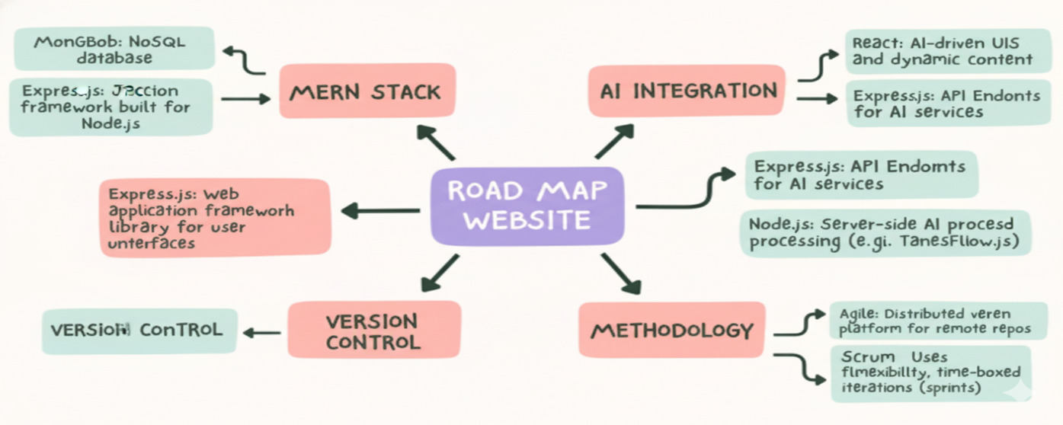

Introduction to Git and GitHub
Git is a free, open-source, distributed version control system that can deal efficiently with small and very large projects. It permits multiple developers to be working on the same project at the same time without interfering in each other's work. Key Concepts:
- Repository (Repo): It is a directory or storage space where your project files along with their history are stored.
- Commit: The snapshot of a repository at one point in time.
- Branch: A parallel copy of your repository. It allows you to work on different features or fixes independently.
- Merge: Integrating changes from multiple branches into a single one.
- GitHub: A web-based platform using Git for version control. It is a developer space where all people can share and manage their code. Key features include:
- Remote Repositories: These are Git repositories that are hosted online, so they can be accessed from anywhere.
- Pull Requests: Proposing changes to a repository and discussing with collaborators before incorporating.
- Issues: Tracking bugs, enhancements, and other project tasks.

Introduction to JavaScript
- Client-Side Scripting: JavaScript generally runs in web browsers, generating dynamic page content, controlling multimedia, animating images, and much more.
- Server-Side Scripting: JavaScript is also applied on the server in environments such as Node.js to create scalable network applications.

Functions: Blocks of reusable code that execute some functionality which may take parameters to operate on.
Objects: Sets of key-value pairs employed in the storage and manipulation of data, containing properties and methods that describe and interact with the data.
Introduction to React
React is one of the most well-known JavaScript libraries, popular for creating user interfaces, preferably SPAs (Single Page Applications). React was developed by Facebook to help developers break down complex UIs into smaller, reusable components.
Key Features of React
1. Component-Based Architecture: React applications are built around the concept of components, which are the building blocks containing their own state and logic. You can nest, reuse, and compose components with each other to build complex UIs.
2. Declarative Syntax: React lets you describe how the UI should look for a specific state. It then takes care of updating the UI when the state changes. This helps you understand and manage the application state more easily.

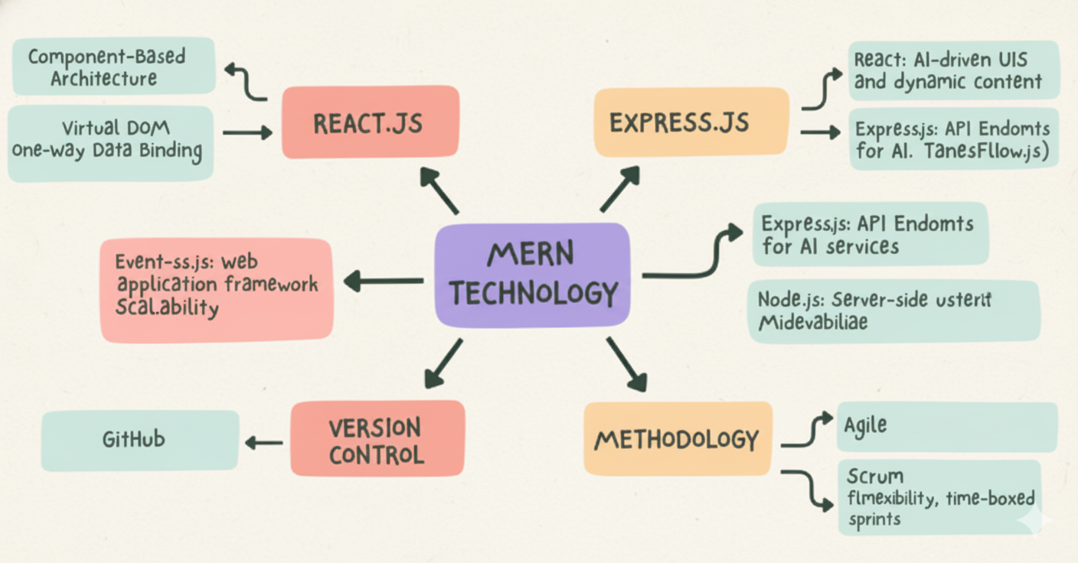

File System
1. Reading Files: One can read the contents of a file either asynchronously or synchronously. Asynchronous reads allow your program to continue running while the file is being read, while synchronous reads block the program until the file is read.
2. Writing Files: You can write data to files in asynchronous and synchronous manners. Writing in an asynchronous manner will let the program continue running while writing to the file, while synchronous writing blocks execution of the thread until the write is completed.
3. Appending Data: You can add new data at the end of an existing file either asynchronously or synchronously. This lets you increase content without overwriting what's already there.
4. File Deletion: You can delete files from the file system. This operation can be asynchronous, meaning the program keeps executing while the file gets deleted, or synchronous, in which case the execution blocks until the file is deleted.
5. Managing Directories: You can create, list, and delete directories. Creating a directory can be done asynchronously or synchronously. You can read a directory to list the files and folders in a directory.

Best Practices for Bug Fixing
- Bug Prioritization: Bugs need to be categorized in order of their seriousness and impact. Critical functionality bugs must take precedence over minor cosmetic issues.
- Document Fixes: Keep track of changes made in the bug-fixing process. Documenting fixes maintains a record of what was done and why.
- Test Thoroughly: After applying the fix, test the whole application to ensure that the bug is fixed and that no new issues have been introduced.
- Team Communication: Update your team members about bugs and their fixes. All this collaboration and communication increase efficiency towards resolving problems.
- Learn from Bugs: Study root causes of bugs so similar ones do not happen in the future. Every bug-fixing session is an occasion to learn and improve development practices.

1.3 Scope of the Project
As an Intern for MERN Stack, your typical role involves gaining practical experience and contributing to the many aspects of web development within the MERN stack, inclusive of MongoDB, Express.js, React, Node.js. Here is a summary of the usual responsibilities and tasks:

1. Development Tasks
- Frontend Development: Construct and maintain the user interface in React, which includes building reusable components, handling state changes using Redux or Context API, ensuring responsive design.
- Backend Development: Developing server-side logic using Express.js and Node.js by creating and managing RESTful APIs, handling authentication on the server-side, and implementing business logic.
- Database Management: Work with MongoDB to design and optimize schemas, perform CRUD operations, and ensure data integrity. This includes writing queries and understanding data modelling.
2. Code Integration and Testing
- API Integration: Link the front-end to back-end services via API endpoints, ensuring a continuous, well-structured flow of information between the client and server with proper error handling.
- Testing: Writing and running unit tests, integration tests, and end-to-end tests in order to ensure the code quality and reliability. This would typically leverage libraries and frameworks for testing, including Jest or Mocha.
3. Documentation and Reporting
- Documentation: Documentation involves commenting your code, APIs, and development processes. This will help in maintaining the project and providing clarity to other team members.
- Reporting: Regularly update your progress and any issues you encounter to your mentor or project lead. Participate in team meetings and contribute to sprint reviews or stand-ups.

4. Collaboration and Learning
- Team Collaboration: Close cooperation with other developers, designers, and stakeholders. Participate in code reviews, pair programming, and collaborative problem-solving sessions.
- Learn and Develop: Create opportunities to learn about new technologies, tools, and best practices applicable in the MERN stack. Ask for feedback and put it into action for personal development.

1.3.1 Use Case Model
This platform's use case model is a description of the main interactions between users and the system. It helps to make requirements clear and guides the priorities in development.
1. User Registration and Authentication: New learners sign up with the system using an email and password or social logins. They set initial preferences like learning goals and schedules. Secure methods handle login sessions and password recovery.
2. AI-Based Personalized Roadmap Generation: The user has to input his technology of choice, current skill level, preferred timeline, and daily study hours through the system. The Gemini AI then processes this input to produce a personalised learning path. Well-organised topics and milestones with resources attached make up the learning path.
3. Previously established roadmaps Access: Teachers or other authorised content providers have developed a number of carefully designed static learning paths from which the user can select. This covers popular technologies and creates a clear progression without personalization powered by AI.
4. Progress Tracking: Students keep track of their progress as they finish subjects. As a result, their dashboards are updated to display metrics such as streak days, completion percentage, and skill levels for each topic. The system also suggests changes and next steps based on user behavior.
5. AI Mentor Chatbot Interaction: Students can chat with an AI assistant that answers questions in real time, shows them how to write code, explains concepts, and gives them debugging tips. This simulates the experience of having a private tutor.
6. Community Engagement: Participants use discussion boards to share resources, ask and answer questions, and work on side projects or challenges. This promotes social learning and sharing.
7. Gamification and Motivation: The system offers leaderboards, badges, and points based on learning achievements. This encourages continuous improvement and learning, which increases user engagement.
8. Administration and Content Moderation: Admin users oversee roadmaps, manage user permissions, and moderate the community to preserve platform health and user satisfaction.
This use case model allows for the addition of new features based on admin and user feedback, and it ensures that all user journeys are covered.
2. System Description
The learning platform's architecture is guided by contemporary web development best practices, which place a strong emphasis on scalability, flexibility, and performance. The application serves as an SPA and provides a fast, dynamic, and interactive user interface through the use of React on the frontend. Community forums, chatbots, user dashboards, and educational materials are all displayed by React components. Data flow is made interactive and smooth by Redux and other state management tools. The Node.js backend is powered by the Express.js framework. It has RESTful APIs for community posts, roadmaps, progress logs, and user management. This backend controls AI features, such as the AI Mentor Chatbot's natural language processing and personalized road mapping driven by Gemini AI. One of the main non-relational databases is MongoDB.
MongoDB has been used in this application because it can store a wide range of data, such as user profiles, learning resources, progress logs, and even forum posts. It scales well under high traffic.
Role-based access control limits sensitive actions to administrators, JSON Web Tokens facilitate session management and authentication, and HTTPS allows encrypted communication between clients and servers, among other security measures. The platform uses middleware for input validation, error handling, and request logging to improve reliability and maintainability. Scalability: The backend services' ability to distribute load horizontally. This also considers containerization for consistent environments and cloud-based MongoDB Atlas for managed database operations. It also plans for expansion with microservices if, in the future, more gamification features or AI analytics are required.
Since the platform is client-side responsive, learning can take place at any time and from any location on PCs, tablets, and smartphones. Examples of performance optimizations include lazy loading, code splitting, and caching strategies.
The architecture works together to provide a safe, effective, and intuitive setting for AI-powered personalized learning.
2.1 Customer/User Profiles
It serves several user groups with different needs and different levels of access:
Learners: Primary users include, but are not limited to, beginners who want structured programming tutorials and intermediate developers looking to expand their skillset or change to a new technology. Learners appreciate interactive support, customized tempo, engaging gamification, and step-by-step instructions. They benefit from community support, AI roadmaps personalized to objectives and timelines, and a progress dashboard to foster motivation and accountability.
Educators and Mentors-Secondary Users: Teachers and Mentors Their added value comes from creating predetermined roadmaps, facilitating forums, and occasionally providing mentoring. They would strongly emphasize user engagement, system usability, and content quality in order to provide effective training and support.
Administrators: Admins oversee the system, managing user rights, regulating content, ensuring data integrity, and examining platform metrics. They require tools for moderating forum discussions, managing disagreements or feedback, and dashboards showing user activity and system health.
Technical Support Team (Optional Future Role): A team that will manage AI service integrations, handle user technical issues, guarantee seamless operation, and safely apply updates is known as the Technical Support Team (Optional Future Role). Based on their roles, each user profile has a unique interface and unique access control. As a result, the entire platform is data-secure and maintainable.

2.2 Assumptions and Dependencies
The following assumptions provide grounds for the feasibility and delivery of the project:
- These days, users have access to modern web browsers and reliable internet connections that can support SPA technologies.
- Learners have basic computer skills and are able to work with web interfaces and chatbots.
- As a service to generate custom roadmaps and chatbot dialog, Gemini is accessible via stable API endpoints that return responses with decent latency.
- MongoDB Atlas or any other cloud-managed database service can be used to manage scalable, redundant backend data storage.
- Most importantly, this basis rests on the MERN stack libraries and frameworks-React, Express, Node.js, and MongoDB-which continue to receive security and performance updates and community support.
- The AI algorithms and roadmap content are fine-tuned over time, with adequate feedback from users.
- Integration with third-party tutorials and certification vendors depends upon the APIs available with those partners.
Dependencies include cloud hosting platforms like AWS or Azure, SSL certificate providers for HTTPS, and possible third-party authentication services like OAuth or Google/Facebook login. The project assumes cooperation from educational content creators in ensuring roadmap quality.
2.3 Functional Requirements
The following key functions must be implemented in the system:
- User Management: User registration, login/logout, password reset, profile update, and role-based access.
- Roadmap Management: AI-based creation of customized roadmaps given user input; display and navigation of AI-generated and predefined roadmaps.
- Progress Tracking: The user can mark a topic as complete, track time spent, and see a progress dashboard highlighting strengths and weaknesses.
- Interactive AI Mentor: A natural language interface for questions, explanations, code snippets, and debugging tips.
- Community Features: Posting questions, answering them, forum subscriptions, and moderation tools.
- Gamification: Awarding of points, badges, and leaderboards for user achievements.
- Resource Management: backend CRUD for tutorial links, documentation, quizzes, and code challenges.
- Notifications: Events from roadmap milestones, replies in the forum, and quiz results.
- Security: Enforced authentication in all relevant routes, encrypted data handling, session management, and input validation.
- Admin Tools: User role assignment, content moderation dashboards, and analytics reporting.
2.4 Non-Functional Requirements
- PERFORMANCE: Application response time below 2 seconds for every important user action; should be able to handle 500 or more concurrent users.
- Usability: Clean, intuitive UI with accessibility features meeting WCAG guidelines.
- Scalability: Easy horizontal scaling of back-end services and database loads with minimal down times.
  - Reliability: backup plans, automated failover, and 99.9% uptime.
  - Security: Adhering to OWASP best practices, protecting data in accordance with GDPR guidelines, and optionally using multi-factor authentication.
  - Maintainability: A well-documented, modular codebase that enables quick and simple feature and bug additions.
  - Portability: responsive to mobile devices and compatible with the most recent versions of Chrome, Firefox, Safari, and Edge.
  - Extensibility: The architecture permits the addition of feature toggles, third-party integrations, and microservices.
3. Design

3.1 System Design

3.1.1 E-R Diagram
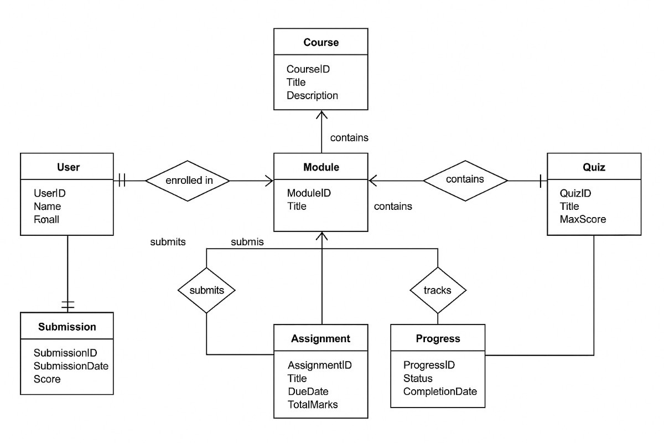

3.1.2 DFD
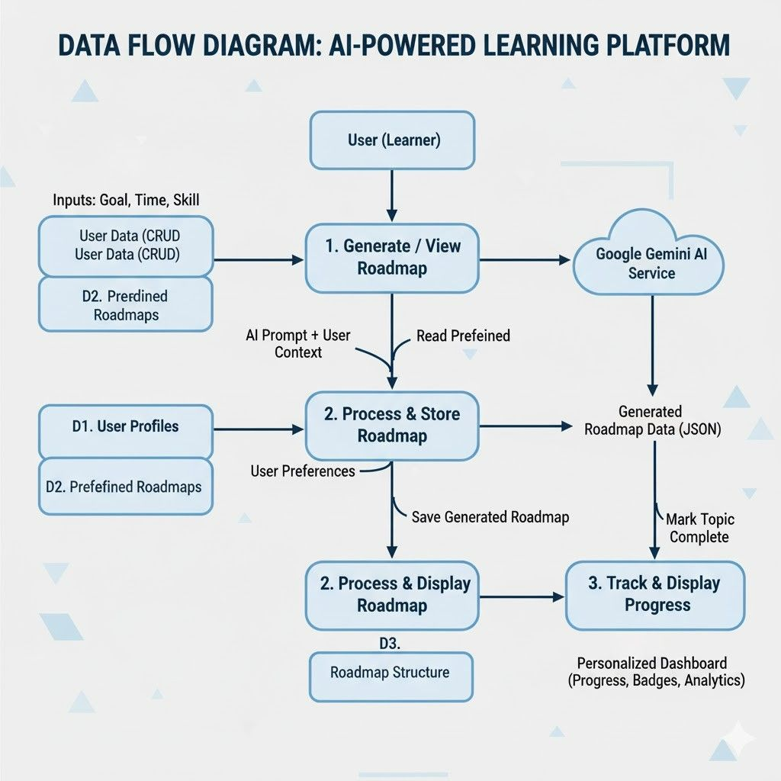
3.2 Database Design
MongoDB was selected as the database for the MERN stack-based AI learning platform because of its adaptable document-oriented model, scalability, and performance benefits. In addition to improving query performance and preserving data consistency, the suggested schema is made to handle different data types that are connected within an educational platform.
Among the principal entities are:
- Users This stores the user profile, roles (learner, educator, admin), preferences, login details, and security information: hashed passwords, tokens.
- ROADMAPS: These represent both AI-generated and predefined learning paths. The attributes are metadata such as technology name, total duration, embedded list of topics, milestones, and difficulty levels.
- Topics: These are detailed documents for each learning unit and include descriptions, linked resources (videos, PDFs, quizzes), estimated times to complete, and prerequisites.
- Progress Records: These are associated with users to track topic completion status, timestamps, quiz scores, and streaks.
- Community Posts: These are discussion threads, comments, and user interaction in general, along with moderation flags, timestamps, and user references. Quizzes and Mini-Projects: This includes questions, answers, scoring rubrics, and submission records.
- AI interactions: These record chatbot conversations, AI suggestions, and system-generated changes to learning paths.
Relationships use both embedding and referencing, depending on the case. For example, topics will be embedded into roadmaps for easy retrieval as a user navigates through it, while user progress will reference topic documents, so data is not duplicated in many places. Community posts and AI interaction logs will use references since there can be a high volume of either and agility is required. Indexes on user IDs, roadmap names, and topic status fields speed up queries. The schema design follows MongoDB best practices by balancing normalization to gain consistency with denormalization to achieve performance. Other design considerations: schema versioning, to handle future changes in the structure of roadmaps; archiving of old content; and securing access controls at document and field levels.
4. Scheduling and Estimates
Planning and delivering an AI-powered learning platform based on the MERN stack requires scheduling and estimation. Scheduling and estimation throughout the project will facilitate risk management and timely completion by properly allocating resources. This section provides realistic effort and cost estimates and a practical approach to project scheduling based on the complexity and technical requirements of the platform.
Using Agile techniques for incremental value delivery with regular cycles of stakeholder feedback, the project schedule is divided into discrete phases. The timeline is usually about 10 to 12 weeks, with extensive testing and completion of features.
• Requirement Gathering and Planning: The duration of this entire process would be two weeks, including requirement gathering and planning. To accomplish the functional and non-functional specifications, database schema design, AI integration points, and UI/UX wireframes, extensive stakeholder discussions are required in this phase. Time is also available for the feasibility study of chatbot and AI roadmap creation.
• Backend and Database Development: Three weeks of backend and database development This covers Express.js API layer development, the definition of MongoDB schemas with Mongoose, the implementation of authentication, integration of Gemini AI services, and administrative features. Meanwhile, cloud infrastructure setup will be covered, along with the development of CI/CD pipelines for smooth deployment of these applications.
• Front-end Development, 4 weeks: It will focus on developing React components for dashboards, customized roadmaps, progress tracking, gamification features, and community forums. This phase will consider responsive design while making sure that performance optimization for a great user experience on a vast array of devices is catered for.
• Testing and Quality Assurance: two weeks of testing and quality assurance Thorough unit, integration, and end-to-end testing covers front-end interactions as well as back-end APIs. Security audits and load testing verify that the application meets the requirements for data protection, performance, and dependability.
Deployment and Final Adjustments: This is where the team spends a week completing the documentation, setting up monitoring tools, deploying the application to production environments, and training administrators. Estimates of resource allocation costs depend on the project size and complexity.
• Estimated effort: Given the development team composition of four to six developers, including frontend engineers, backend specialists, UI/UX designers, and QA testers, the effort would span from 480 to 600 person-hours. A buffer time for unforeseen problems has been factored into the given estimate.
• Budget: Budgets can vary between $40,000 to $60,000, depending on labor rates and third-party service fees for things like cloud hosting and AI API usage. Prices for cloud scalable resources and MongoDB Atlas managed databases vary based on user traffic.
• Risk Mitigation: Continuous integration, frequent sprint reviews, and buffer scheduling minimize delays. Technical uncertainties are decreased through the early testing of AI components during the planning process.
• Tools: Git version control and automated deployment pipelines will speed up the iteration cycles. Project management tools, such as Jira or Trello, will help with tracking tasks and due dates.
This structured approach to estimation and planning reduces development risks, provides transparency, and ensures that the delivery of the project aligns with business objectives while building the foundation for a scalable and maintainable AI-driven learning platform.
Brief Description of the Work Done
Position of Internship and Roles
Position: MERN Stack Intern with GenAI Focus Roles:
• Design and maintain web applications using the MERN (Node.js, Express.js, React.js, MongoDB) technology stack.
• Promote web application functionality by embedding generative AI models.
• Collaborate with teams to build and release new features.
• Understand and write clear, efficient, and maintainable code.
• Participate in code reviews and provide constructive feedback.
Activities/Equipment Handled
Activities:
• Front-end Development: In developing user interfaces, it is recommended that Tailwind CSS and React.js be adopted.
• Back-end Development: RESTful APIs are developed using Node.js with Express.js.
• Database Management: Use MongoDB for database design and administration.
• AI Integration: Utilize OpenAI and other generative AI models through APIs.
• Version Control: GitHub and Git will be used for source code management.
• Deployment: Deploy applications to cloud computing platforms like Heroku or Vercel
Equipment Handled:
• Visual Studio Code is one of the development tools.
• Git and other version control systems.
• Database management and deployment cloud services.
Challenges Faced and How They Were Tackled
Challenges:
• Integrating AI Models: The integration of models with the existing stack has presented difficulties.
o Solution: To comprehend the integration process, I worked with AI specialists and consulted thorough documentation and tutorials.
• Performance Optimization: This was required in order for the AI features of the application to function flawlessly.
o Solution: Debugging tools were used, and extensive code reviews were conducted to identify and fix any problems.• Debugging Complex Issues: Several difficult-to-debug bugs were encountered.
o Solution: To identify and address issues, debugging tools were used and extensive code reviews were carried out.
Learning Outcomes
• Technical Skills: Gained expertise in developing MERN stacks with AI integration.
• Problem-Solving: Improved capacity to identify and fix intricate technical issues.
• Collaboration: This means enhanced communication and cooperation skills in projects.
• Project Management: Gained the skill of managing and delivering projects on time. Data Analysis
• User interaction data: Collected and analyzed to improve UI/UX.

CONCLUSION

1.Full-Stack Conceptual Understanding: Developed a sound understanding of how MongoDB, Express.js, React, and Node.js will interact in the proposed system. determined how the database, front-end, and back-end will work together to address the issue.

2. Problem Identification & Solution Planning: Identified the problem statement well, studied the existing gaps or challenges. Designing the solution by using modern web technologies and AI integration that would facilitate addressing these issues.

3. Requirement Gathering & Feature Mapping: List of all the essential features that will be part of the project, such as user management, dashboards, and prediction modules. created preliminary data flow, user flow, and workflow diagrams to illustrate how the system will function.

4. Architecture & Tech Stack Planning: After researching a number of technologies, the MERN stack was selected due to its scalability, flexibility, and ease of development. planned the structure of database schemas, AI services, UI elements, and APIs.

5. Integration of AI / ML Components: Found AI/ML models or APIs, like the Gemini API, that would improve the system's intelligence or automation. planned the use of these models for classification, recommendations, predictions, and text generation.

6. Research & Feasibility Analysis: Investigated comparable systems, implementation viability, and potential drawbacks. determining which tools, resources, libraries, and frameworks might be required to complete the project successfully.

7. Team Collaboration & Role Division: Allotted different roles to team members for frontend, backend, database, documentation, and AI integration. Coordinated to make flowcharts, architecture diagrams, and presentation slides.

8. Project Planning & Timeline Creation: Outlined the development phases: analysis, design, development, testing, and deployment. Prepared a realistic timeline for building the working prototype.

9. Presentation & Documentation Preparation: The project proposal, architecture explanation, and slide deck were completed. Visual representations such as flowcharts and block diagrams were made to illustrate the idea in a clear manner.

10. Readiness to Start Development: Completion of all pre-development steps such as finalization of requirements, technology selection, and workflow planning, and then moving into coding upon approval of the idea.
REFERENCES
- Free Code Camp’s MERN Stack Roadmap:
This tutorial covers everything from the basics of HTML, JavaScript, and CSS to some advanced topics in React, Express, Node.js, and MongoDB, hence providing project ideas to help you practice and showcase your skills. Read more here.
- MongoDB’s MERN Stack Tutorial:
This tutorial shows how to create a full-stack MERN application step by step, with practical examples and insight into each component of the stack. Explore the tutorial.
- Mirror Folio’s Comprehensive Guide:
This tutorial presents a detailed explanation of the MERN stack, providing resources for further learning and links to official documentation for MongoDB, Express.js, React.js, and Node.js. Check it out here.
- Ted X MERN Stack Courses:
edX has a variety of courses that will continue building your skills in web development, specifically with the MERN stack. Take these courses to learn the knowledge required to start a career as a JavaScript developer Browse courses on edX.
- MongoDB’s Complete Guide:
This tutorial goes in-depth into using the MERN stack by leveraging a MongoDB Atlas
database for hands-on learning. Learn more here.

