**1. Host a Ubuntu Virtual Machine using Oracle VM Virtual Box. (5 marks)**

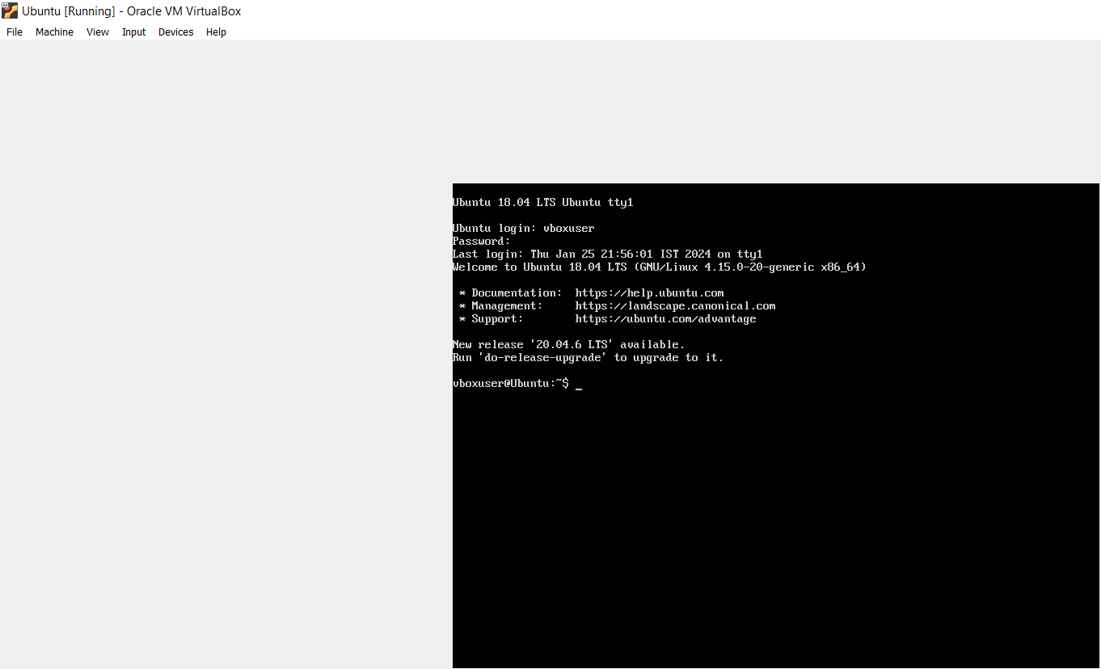

**2. Set up Visual Studio code on Ubuntu VM. (5 marks)**

sudo apt update

sudo apt upgrade

sudo snap install --classic code



**3. . Set up Python. (5 marks)**

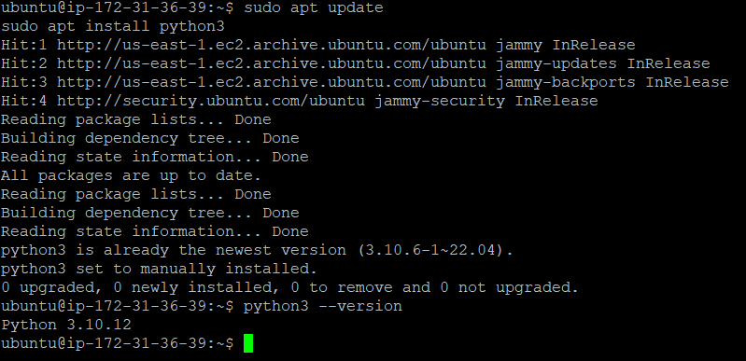

**4. Clone this Github repository https://github.com/Vikas098766/Microservices.git (1 mark)**

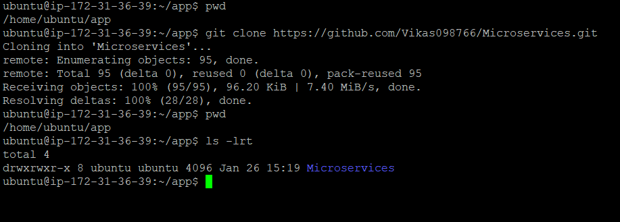

**5. Create a Virtual Environment. (1 mark)**



**6. Install the dependencies from requirements.txt file. ( 1 mark)**

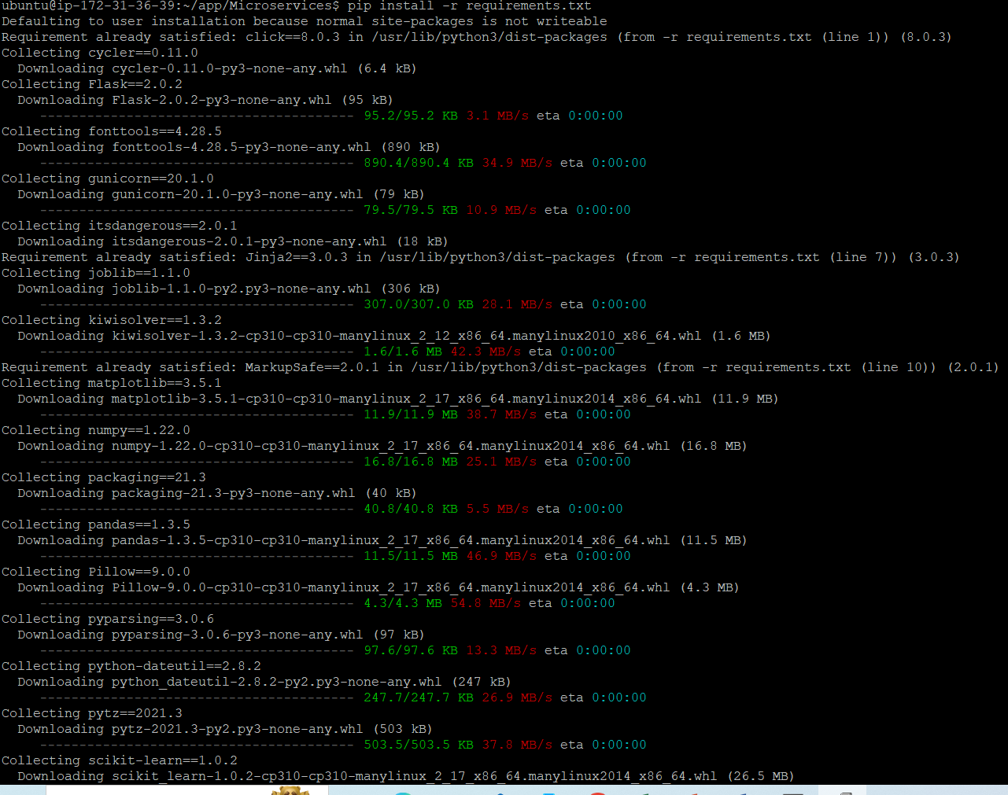

**7. Train and save the model. (2 marks)**

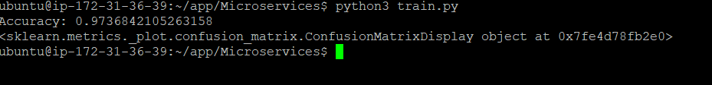

**8. Test the Flask web application. (5 marks)**

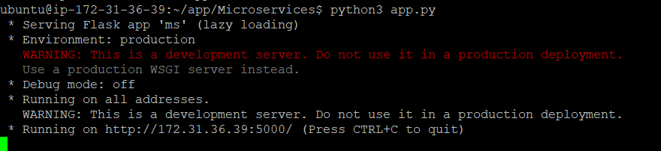



**9. Test the application and make predictions using the example calls available in the folder /tests. (5 marks)**

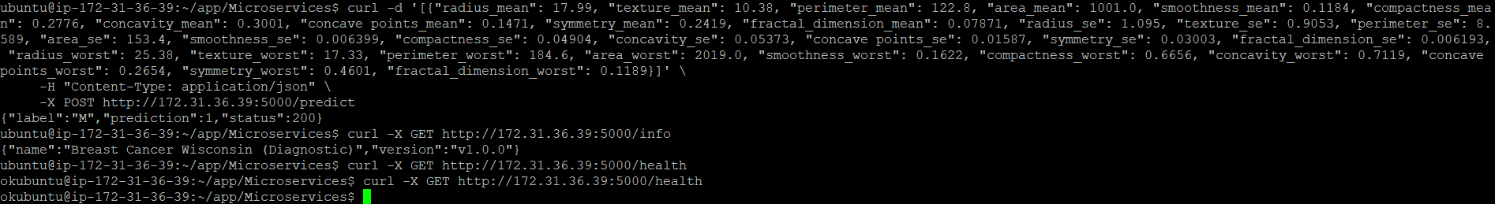

**10.Create a docker image containing everything needed to run the application.(10 marks)**

**docker build -t flask-prediction-app .**

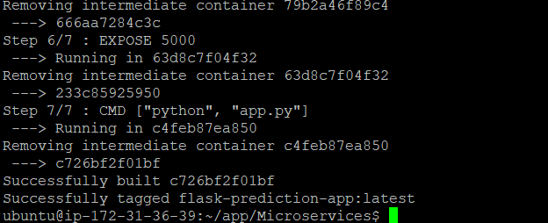

**ubuntu@ip-172-31-36-39:~/app/Microservices$ docker build -t flask-prediction-app .**

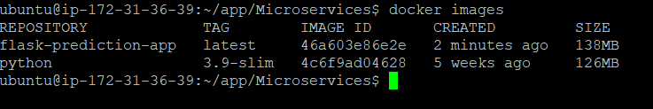

**11.Run the containerized application as a prediction service and test it locally by passing some example calls and get the prediction. (10 marks)**

docker build -t flask-prediction-app .

docker run -p 5000:5000 flask-prediction-app