REWEAR · PRODUCT DESIGN CASE STUDY
Final report
Create more outfits from clothes you already own.
Portfolio concept. Prototype implemented 22 October 2026. Not validated with participants. No business impact is claimed.
Folder: 02-DigitalWarderobe. Source PRD: 02-rewear-digital-wardrobe.md. This report summarizes existing files. It does not add product scope.

1. Executive summary
Rewear is a mobile-first digital wardrobe and outfit planner. The unique value proposition is to create more outfits from clothes the person already owns. The designed response is a private catalogue: add an item with or without a photo, find it, save an outfit for a chosen occasion and weather preference, and turn outfits into one packing list.
The case study is implemented as documentation plus a local TypeScript prototype. It is not a commercial app. Interviews and usability tests are planned and have not been run. The differentiator is a private closet whose suggestions explain their tags, with a finished manual path and no social feed, body score, shop, or location.

2. Product brief and objectives

Target users and jobs
Target users are hypotheses. The primary job is getting dressed or packing with workable combinations from clothes already owned, so the decision is faster and an extra purchase is less necessary. The secondary job is a short trip. Proto-personas Maya (weekday) and Sam (short trip) are labeled as hypotheses in 02-ux-research/personas.md. They are not research participants.

Problem, goals, and constraints
The problem statement is also a hypothesis: clothes are hard to remember and coordinate, so buying can feel easier than using what is owned. The PRD candidate goals, unmeasured, are that 70 percent of prototype participants add at least five items, 80 percent find or generate an outfit for a named occasion, and the median time to a first usable outfit is under three minutes. The guardrail is that manual entry still works if a photo fails.
Constraints that shaped the design: no shaming about consumption or body shape; no exact location; photos are not scanned; the prototype has no server or account; small screens, scalable text, and screen-reader semantics are the accessibility target (WCAG 2.2 AA), not a completed audit.

3. Product analysis and rationale

Positioning
Rewear is a digital wardrobe and outfit planner. It is not positioned as a stylist, a sustainability tracker, or a closet social network. The supporting line on the first screen says photos are optional and that Rewear does not comment on the body or tell the person to buy more.

Alternatives reviewed
Public pages for Whering, Stylebook, Acloset, Indyx, and Cladwell were read on 22 October 2026, plus the camera-roll and notes substitute. The apps were not installed, and no screen-reader comparison of competitor apps was made. Publisher user counts are their claims. Dollar prices are cited only where a reviewed page printed them. Detail and sources are in 01-product-analysis/competitive-analysis.md.
Product | Documented on the pages reviewed | What Rewear does not copy
Whering | Free social wardrobe, packing, cost per wear, weather and location planner in the 5 Oct 2026 Play update. | Friend wardrobes and location.
Stylebook | iOS, $4.99 once in the US FAQ, non-photo add methods, pack-by-outfit. | A collage canvas. Manual entry is treated as finished, not secondary.
Acloset | Free to 100 items, then subscription. AI stylist, weather, personal color. 4M users is their claim. | Body or color analysis, feed, marketplace.
Indyx | Free catalogue, packing, cost per wear. Lookbooks from $150. Insider price unverified. | Human stylists and resale.
Cladwell | Free closet. Web stylist $9.99/mo or $79.99/yr after trial. Catalog add. Weather on the paid plan. | Portrait color analysis and virtual try-on.
Packing, cost per wear, and outfit suggestions are not unmet features. The opening Rewear is designed for is a private closet, a suggestion the person can read, and a photo that is never a scan.

Decisions and trade-offs
- Suggestions are deterministic tag rules with written factors. A generative stylist was declined so a bad match can be seen and dismissed.
- Weather is Mild, Warm, Cold, or Rain. A forecast API and GPS were declined.
- Packing is in the prototype. The scope list marks it Must. The requirements table marks FR-06 Should. The conflict is documented. If scope is cut later, packing is the first Should to remove.
- A dress may be saved alone. Otherwise an outfit needs at least two items. This is an explicit reading of FR-04.
- Cost per wear is hidden until both a price and a wear exist. Currency changes the symbol only.
- The sample wardrobe is 12 labeled illustrative items so the outfit can be tried before personal cataloguing. Loading it does not count as five items added.

Highest-risk assumptions
Ranked in 01-product-analysis/assumptions-and-risks.md. Confidence is about the brief, not about users. The top risks are that people will not tag color, season, and dressiness; that those tags are too thin to judge an outfit; and that manual entry under-tests the capture path people would actually use. The manual builder still works if suggestions fail. No participant has confirmed these assumptions.

4. UX research and evidence
Completed work is a desk review of competitor pages and a design of the research instruments. No interviews were conducted. No quotations in the folder are participant data. 02-ux-research/research-findings.md separates desk evidence from hypotheses H1–H6. An example synthesis row is marked as not data.
Planned method: six interviews (floor five, cap eight), recent-behavior questions about the last morning and a packing episode, and a screener that stops under 18 and avoids body, income, and style questions. The prototype is not opened in that round. Proto-personas and the journey map are hypothetical current states for Maya’s morning and Sam’s packing. They must not be presented as “our users.”
Outstanding questions, still open: which attributes people already use when they match clothes; whether manual tagging is acceptable; whether explained rules are trusted; whether packing should start from outfits; and what minimum wardrobe size is useful. The working answers in the prototype are design choices, not findings.

5. Information architecture and user flows
After welcome, four destinations: Wardrobe, Outfits, Trips, and You (settings). Welcome has no tab bar. Routes are hash URLs from #/welcome through #/settings, documented in 03-information-architecture/sitemap.md. The outfit builder does not hide clothes that fall outside the chosen occasion. People can override their own tags.

Primary journey
Open Rewear. Choose the sample wardrobe or an empty one. Add an item if needed. Search or filter. Create an outfit with an occasion and a weather preference. Save at least two items, or one dress. Reopen the outfit. The diagram is assets/diagrams/primary-flow.svg.

Alternate and recovery paths
- Photo read can fail. The same form explains retry or save without a photo. There is no second “advanced” manual product.
- Suggestions recompute when occasion or weather changes. Dismiss hides that combination. Editing a saved suggestion’s items clears the factors and marks the outfit manual.
- Delete confirms and names affected outfits, then removes the item from them. Archive hides an item from the wardrobe and from new outfits. It stays in outfits already saved.
- Packing is the union of items across selected outfits, one line per item, with “In N outfits” when shared. Offline is a banner. Wardrobe data is already on the device.

6. Wireframes and UI design
Low-fidelity frames are grayscale phones at 390 by 844 pixels in assets/wireframes/wireframes.html, with annotations beside each frame. A print is assets/wireframes/wireframes.pdf. Drawn screens: welcome, wardrobe, empty wardrobe, add item, photo failure, outfit builder, suggestions, packing list, delete confirmation, and offline. Filters, item detail, saved outfits, outfit detail, new trip, and settings are specified in 04-wireframes/ and implemented in the prototype. They are not extra phone drawings. No Figma file exists.
Layout decisions: the value proposition is the first screen; category chips sit on the wardrobe rather than only inside a dialog; garment cards use words plus flat silhouettes, not photographs of people; photo failure stays on the add form; packing states the dedupe in a sentence; destructive confirmation names the outfits that will change.

Visual direction and system
The direction is called Morning paper. Paper #F4EFE8, surface #FFFCF8, ink #1C1916, accent #8C3B16. Fraunces for titles, Figtree for UI, with Georgia and Segoe UI as fallbacks. Olive is reserved and is not a sustainability badge. Contrast was computed on 22 October 2026 from prototype/src/tokens.ts. Ink on paper is 15.30:1. Accent ink on accent is 7.46:1. Muted on paper is 6.58:1. The pairs recorded in 05-ui-design-system/design-tokens.md clear 4.5:1. A unit test checks that the CSS hex values match.
Breakpoints: under 720px, one column and bottom navigation; 720–959px, a centered column and three wardrobe columns; 960px and up, a left navigation and four columns. Text size is 100, 120, or 140 percent. Focus is a 3px ink outline. Dialogs do not dismiss on a scrim click. Components are documented in 05-ui-design-system/components.md: buttons, fields, chips, cards, banners, toasts, dialogs, and garment silhouettes.
Known accessibility gaps, documented rather than certified: search announces every keystroke; focus does not return to the control that opened a dialog; packing groups were not tested with a screen reader; Google Fonts may be missing on a first offline visit; forced colors were not tested.
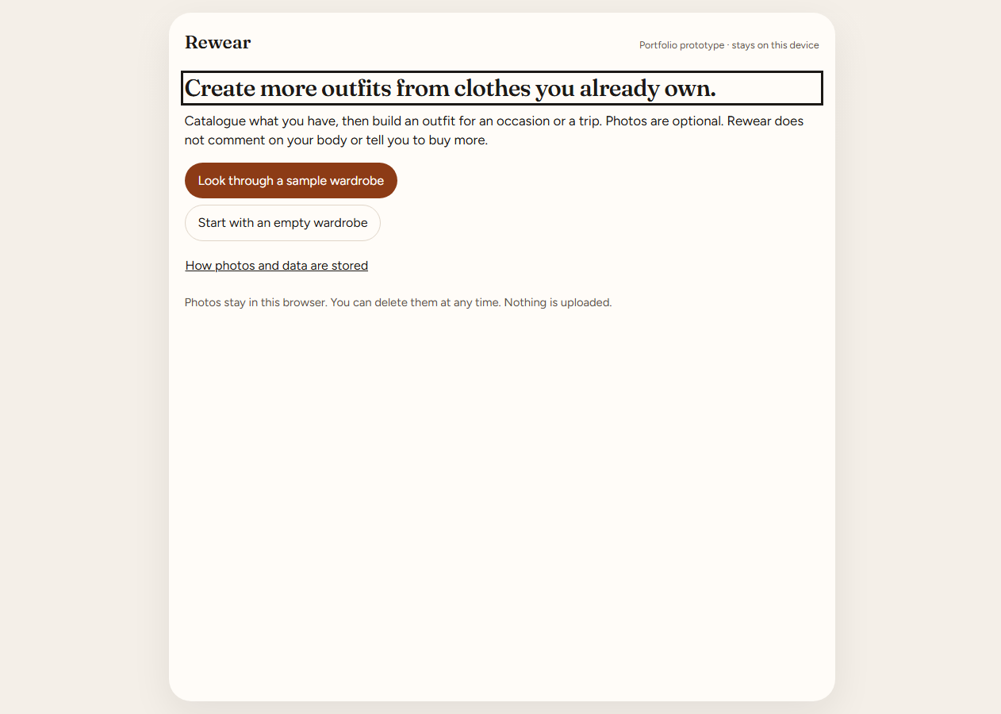
Figure 1. Welcome. The UVP is the title. Sample and empty starts are equal choices. Screenshot from the 22 October 2026 browser pass.
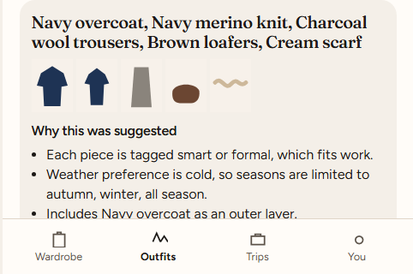
Figure 2. A suggestion names the clothes and lists why they matched. Factors are rules, not a model.
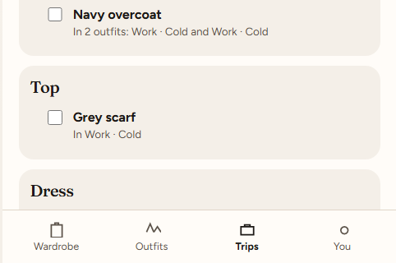
Figure 3. Packing. The navy overcoat is one line: In 2 outfits. Both saved suggestions used the same generated name.

7. Implementation and prototype
The app is prototype/: Vite 6, TypeScript, Vitest, and a small DOM client. No React. Dev server port 5174. Preview port 4174. Production build on 22 October 2026: dist/assets/index-CGitU9fw.js. State that lasts is items, outfits, trips, preferences, dismissed suggestions, and filters, under localStorage key rewear.v1. Drafts, toasts, upload progress, dialogs, and undo are not stored.

Implemented behavior
- Add, edit, archive, and delete items. Required tags are name, category, color, season, and dressiness. Notes and price are optional.
- Photos: jpeg, png, webp, or gif, up to 8 MB, compressed in the browser. Progress, error, retry, and save without a photo. Delete photo has a one-step undo.
- Search and filters. AND across groups, OR within a group. Clear filters.
- Manual outfits and up to three explained suggestions. Save, dismiss, mark worn, cost per wear when the inputs exist.
- Trips of 1 to 21 nights. Packing consolidates by item id.

Simulated or prototype-only behavior
- The 12-item wardrobe is sample data. Prices are illustrative GBP figures. Changing currency does not convert them.
- Reviewer tools on the add form preview a failed upload. That button is not a production control. A real file was not used in the browser pass.
- Suggestions are rules in prototype/src/suggest.ts. There is no model call.
- The offline banner listens for the browser offline event. Nothing is synced, so there is no queue to replay.
Not built, matching the PRD non-goals and Could list: weather API, image-assisted tagging, care and repair, sharing, social feed, resale, body scoring, purchase recommendations, and environmental-impact claims. There is no laundry state. Archived items can remain on a packing list and are not labeled archived there.

8. Testing and validation
Recorded in VALIDATION.md. On 22 October 2026, npm test passed 18 tests (17 domain, 1 journey). The journey test loads the sample, filters navy, saves an outfit, renames an item, deletes it from the outfit, and checks a shared packing line. npm run build typechecked and wrote the bundle above.
Headless Edge then opened http://127.0.0.1:4174 with storage cleared. The click-through covered welcome, the sample wardrobe at 390px width, a navy search whose live region said “2 items match,” an item saved with no photo, two suggestions with factors, a Lisbon trip of 4 nights whose shared coat read “In 2 outfits,” the photo-failure sentence, the offline banner, and the settings privacy copy. Screenshots are in assets/screenshots/. The log failed count is 0.
That pass is an engineering check. It is not a usability study. Filters, archive, delete confirmation, mark worn, text size, and currency were not clicked in the browser. Domain tests cover several of those rules. No VoiceOver, NVDA, TalkBack, or phone keyboard pass was run. No real image file was attached.
Usability testing is planned for five people and five tasks in 08-usability-testing/. The findings template contains one example row marked as not a finding. The iteration log records pre-test design decisions dated 22 October 2026, not results. The PRD percentages were not observed.

9. Outcomes, limitations, and next steps

Verified deliverables
The folder contains the documentation set, a screen inventory, a design system with computed contrast, a working core journey, and an honest evidence status. Strengths a reviewer can inspect: the manual path is on the same form as the photo; suggestions say why; packing dedupes in the interface, not only in a spec; sample data cannot pretend to be a person’s closet; non-goals are absent rather than stubbed.

Limitations
- No user evidence for the problem, the personas, or the success targets.
- localStorage is one origin. Two tabs last-write-wins. Quota and private browsing are fragile. This is not a production deletion architecture.
- Two suggestions for the same occasion and weather can share one generated name.
- HEIC is unsupported. Concurrent editing is unsupported. There is no import or export.
Dependencies for a reviewer: Node.js to run the prototype, a browser, and the fonts from Google Fonts when online. The wardrobe itself does not need a network after the page has loaded.

Highest-priority next work
- Run the interview guide. Replace the proto-personas only with what people describe.
- Run the five usability tasks on a fresh profile. Report counts such as “3 of 5,” not the PRD rates, unless the study is powered to estimate them.
- Change the design for severity found in that test. Do not add laundry or a weather API first.
- If a hosted product is ever specified, design deletion and sync before accounts. Do not treat this prototype’s storage as that design.

10. Project artifact index
00-project-brief/ does not exist. The brief is the PRD at the repository root and 01-product-analysis/product-brief.md.
Path | Contents
01-product-analysis/ | Brief, problem, competitors, positioning, assumptions, metrics.
02-ux-research/ | Plan, screener, interview guide, desk findings, hypothesis personas, jobs, journey.
03-information-architecture/ | Sitemap, flows, task analysis, prioritization and traceability.
04-wireframes/ | Inventory, specifications, annotations, edge cases.
05-ui-design-system/ | Principles, visual direction, tokens, components, accessibility.
06-high-fidelity-ui/ | Screen specs, microcopy, interactions. The hi-fi UI is the prototype.
07-prototype/ | Demo script, state matrix, designer-engineer review.
08-usability-testing/ | Plan, tasks, empty findings template, pre-test iteration log.
09-case-study/ | Narrative, eight-slide outline, portfolio card.
assets/diagrams/ | primary-flow.svg and packing-flow.svg.
assets/wireframes/ | wireframes.html and wireframes.pdf.
assets/screenshots/ | Seven PNGs from the browser pass, plus smoke-log.json.
prototype/ | Vite + TypeScript app, tests, and dist. Separate from the docs.
README.md, VALIDATION.md | How to run the prototype, and the PRD trace.

11. Final status and evidence checklist
Deliverable | Evidence | Status | Remaining action
Product brief and UVP | 01-product-analysis/ | Complete | Keep hypotheses labeled.
Competitor review | competitive-analysis.md | Complete | Re-check prices before any update. Apps were not installed.
Interviews | 02-ux-research/research-plan.md | Missing | Run the guide. Do not fill findings in advance.
Personas and journey | personas.md, journey-map.md | Partial | Hypotheses only.
Information architecture | 03-information-architecture/ | Complete | None for the prototype scope.
Wireframes | assets/wireframes/ | Complete | Six screens are specified and built, not drawn as extra frames.
Design system | 05-ui-design-system/ | Complete | Contrast is calculated, not certified.
High-fidelity UI | prototype/ | Complete | No Figma file. Do not claim one.
Must requirements FR-01 to FR-05 | prototype/ and tests | Complete | Delete dialog was unit-tested, not clicked in the browser.
Packing FR-06 | packing.ts, browser Lisbon list | Complete | Priority conflict remains documented. Archived items are unlabeled on the list.
Suggestions FR-07 | suggest.ts, Figure 2 | Complete | Rules can pair two statement colors and explain them.
Automated tests | VALIDATION.md | Complete | 18 passed on 22 October 2026.
Browser click-through | assets/screenshots/ | Complete | Engineering pass. Real photo file not used.
Usability test | 08-usability-testing/ | Missing | Plan only. No participant results.
Success metrics | success-metrics.md | Needs validation | 70%, 80%, and under 3 minutes are targets, not results.
Screen-reader audit | accessibility.md | Needs validation | Semantics are implemented. Assistive tech was not used.
00-project-brief/ | Not in this folder | Missing | Use the root PRD. Not applicable as a separate folder.
Status language: Complete means the artifact or behavior exists and was checked against the files. Partial means it exists but is explicitly hypothetical or narrower than the heading. Missing means it was not done. Needs validation means a target or quality bar is stated and has not been measured with the intended method.

