**Azure ML(Azure Machine Learning) :** Microsoft Azure is a [cloud computing](https://en.wikipedia.org/wiki/Cloud_computing) platform and infrastructure created by [Microsoft](https://en.wikipedia.org/wiki/Microsoft) for building, deploying, and managing applications and services through a global network of Microsoft-managed [data centers](https://en.wikipedia.org/wiki/Data_center).

Depending Packages: Xml, Rtools

It gives the option to build machine learning model by importing data sets, write and execute r, python scripts to train and validate models. It also has some inbuilt modules to explore

R has a package AzureML that gives the option to to work with Azure ML Studio datasets and experiments directly from R. Once you create an account with AzureML you get a workspace id and work space authorization code. With these two attributes you could access your cloud based workspace offered in AzureML from R.

Various things that one can do with AzureML package:

1. Upload your datasets to cloud and then analyze
2. Download the sample datasets
3. Publish the model as a web service.

Our main focus is on how to publish a model as a web service. The ultimate aim of any model is to sell it and provide it as a service to the client. Once you train and test the model it should be delivered to the client either in the form of an application or as a web service.

Let us build a simple model and publish it as a web service.

Model: A simple model to predict the probability of a personal injury in an accident depending on whether the driver wore a seat belt is built. A logistic regression algorithm has been employed.

The below code build the above required model.

model<-glm(Personal.Injury~ Belts,data = Tfv_data1,family = "binomial")

This is a function to predict the data based on the above model.

Pred<-function(new)

{

Predict(model,new,type = "response")

}

**Publish as a web service:**

First and fore most thing in publishing the model as a web service is to have an AzureML account and then to use the authorization token and Workspace id.

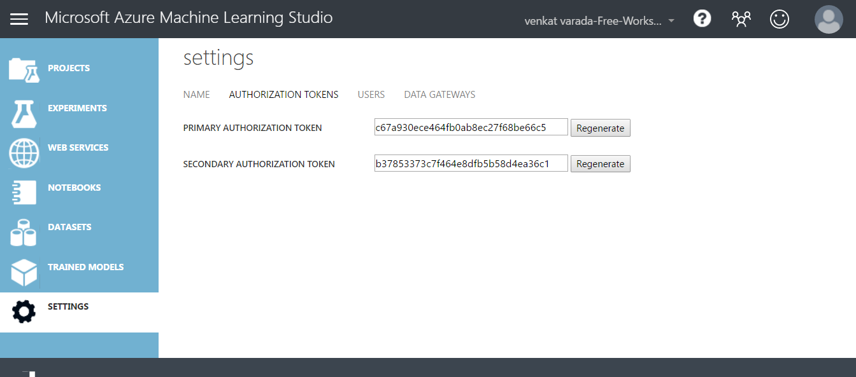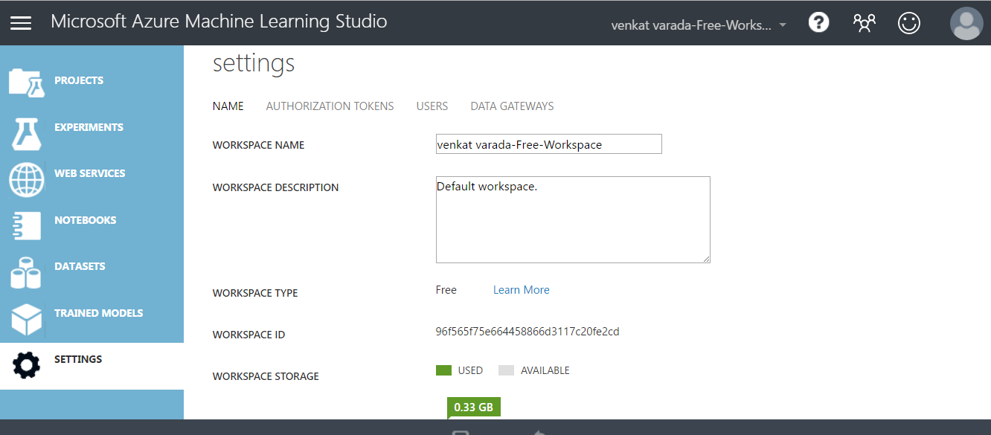

Storing the workspace id and authorization in variables to be able to connect to Azure from R.

wsid<-"96f565f75e664458866d3117c20fe2cd"

wsauth<-"c67a930ece464fb0ab8ec27f68be66c5"

Workspace is a function that is used to define the workspace in Azureml so that it could place the corresponding model in the work space.

ws<-**workspace**(wsid,wsauth)

The Most important step is to define the inputs that should be passed so as to determine the probability of a personal injury.

Here , it is a simple binomial problem with input as belts.

inputs<-as.data.frame(Tfv_data1[,10])

names(inputs)<-c("Belts")

Publish as a web service: The function PublishWebservice is used to publish as a web service. It takes the arguments as workspace, the function which was created to predict and the name of the workspace along with input schema.

accidentwebservice<-publishWebService(ws,fun = Pred,name = "Accident",inputSchema = inputs)

Publishing a model as a model as a web service is not going to be such easy. Let us try and understand how this internally works. The model created is zipped and then placed in the workspace authenticated by a workspace id and token. One needs to have a zip installed in the system else this doesn’t work.This can be achieved by installing rtools.

Once we execute this program its published as a web service in the cloud.

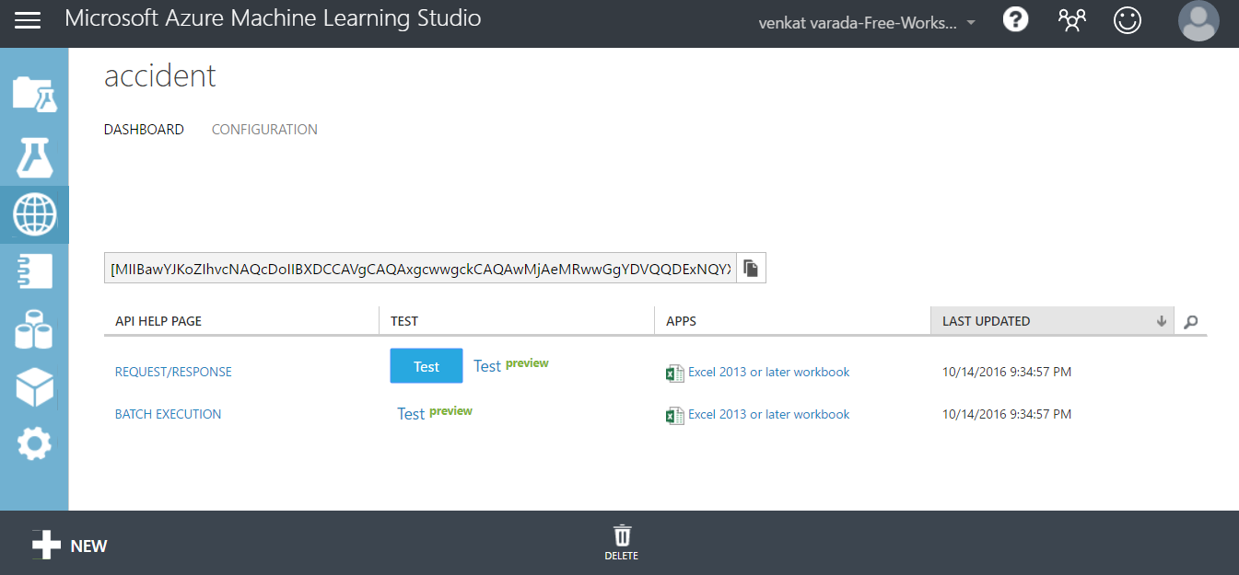

Fig: Published Web service in Azure Ml

Click in Test to see the probability of a personal injury based on belts.

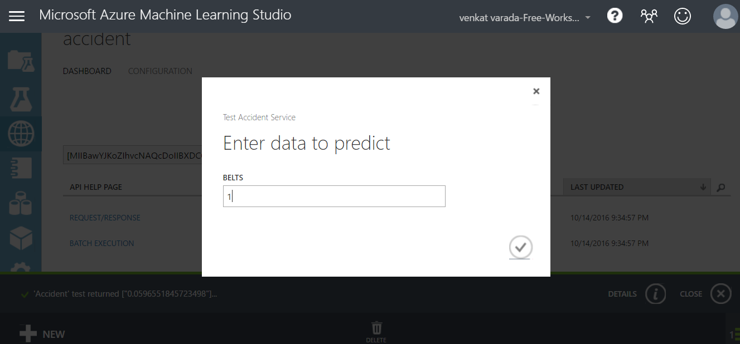

Fig: To provide the inputs to predict.

Resultant Probability:

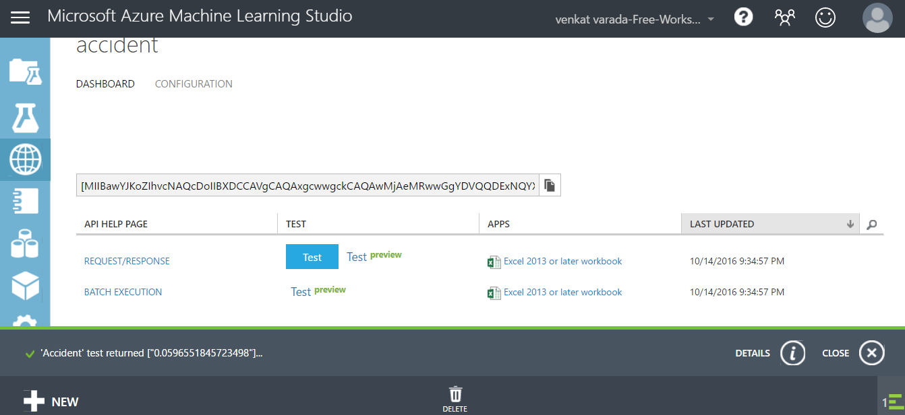

Fig: Showing the outcome.

If one wants to predict a bunch of incidents, then there is an option of batch mode execution.

Not only this it also gives the privilege to update an existing web service by using updateWebservice