DEPARTMENT OF

ELECTRONICS AND COMMUNICATION ENGINEERING
Faculty of Engineering and Technology, SRM University

DESIGN PROJECT PROPOSAL FORM

Project Title : Design and Analysis of 2.4Ghz clock generating Spur
Reduced Fractional-N PLL using 28nm

Supervisor/Guide : Mrs. J.K.KASTHURI BHA
Assistant professor(Sr.G)
Electronics and Communication Department

Team Members : 1.Y .NAGARJUNA REDDY(Reg No.- RA1411004010345)
2. K.NIKHIL SAI(Reg No.- RA1411004010334)
3. S.V.SITA RAMAIAH (Reg No.- RA1411004010351)

Background/Literature Review:

This paper presents the Design and Analysis of 2.4Ghz clock generating Spur Reduced Fractional-N PLL using 28nm

References:

- [1] S. Callegari, F. Bizzarri, and A. Brambilla, “Optimal quantization noise management in wideband fractional-N PLLs,” in Proc. IEEE Int. Symp3. Circuits Syst. (ISCAS), Lisbon, Portugal, May 2015, pp. 561–564.
- [2] S. B. Sleiman and M. Ismail, “Multimode reconfigurable digital modulator architecture for fractional-N PLLs,” IEEE Trans. Circuits Syst. II, Exp. Briefs, vol. 57, no. 8, pp. 592–596, Aug. 2010.
- [3] D. Gaied and E. Hegazi, “Charge-pump folded noise cancelation in fractional-N phase-locked loops,” IEEE Trans. Circuits Syst. II, Exp. Briefs, vol. 61, no. 6, pp. 378–382, Jun. 2014.
- [4] H. Mo and M. P. Kennedy, “Masked dithering of MASH digital deltasigma modulators with constant inputs using linear feedback shift registers,” IEEE Trans. Circuits Syst. I, Reg. Papers, vol. 63, no. 8, pp. 1131–1141, Aug. 2016

Objective:
To design a fractional N-PLL using 28nm :
- To provide high speed frequency sources that can be accurately set with very high resolution.
- To get an accurate value we are using fractional N-PLL instead of integer PLL.
- This is closed loop system which helps to be resistant against external factors which is in a phase locked loop with VCO.

Requirements:

Language : SPICE
Simulator : HSPICE, Waveview
Technology : 28nm

Abstract:

The spurious tones in the output of a fractional-N PLL can be reduced by replacing the ΔΣ modulator with a new type of digital quantizer and adding a charge pump offset combined with a sampled loop filter. It describes the underlying mechanisms of the spurious tones, proposes techniques that mitigate the effects of the mechanisms, and presents a phase noise cancelling 2.4GHz ISM-band CMOS PLL that demonstrates the techniques.

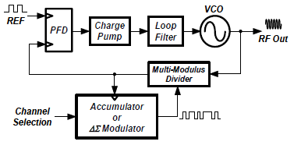

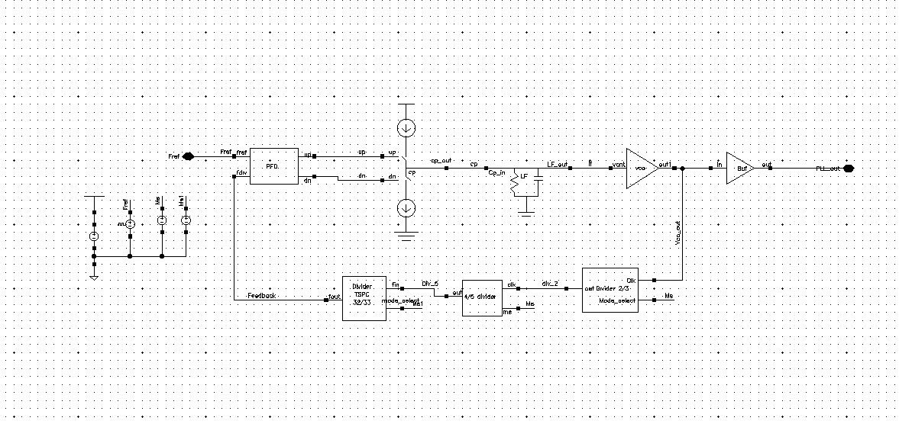
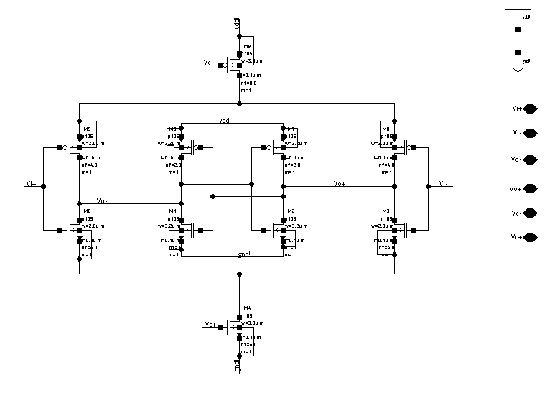

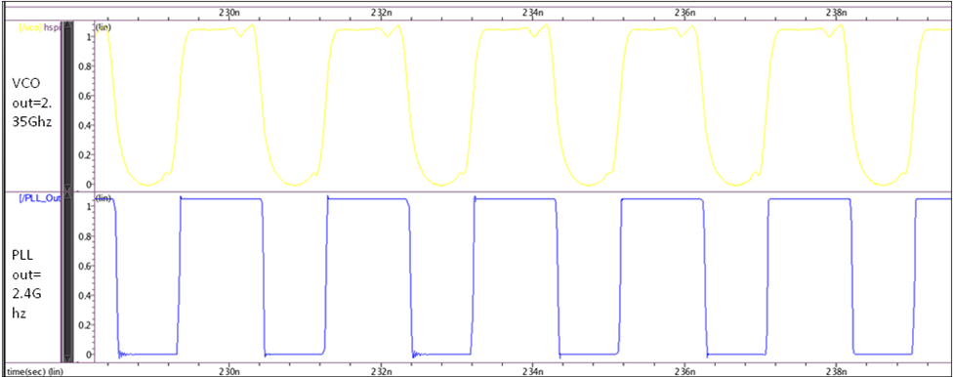
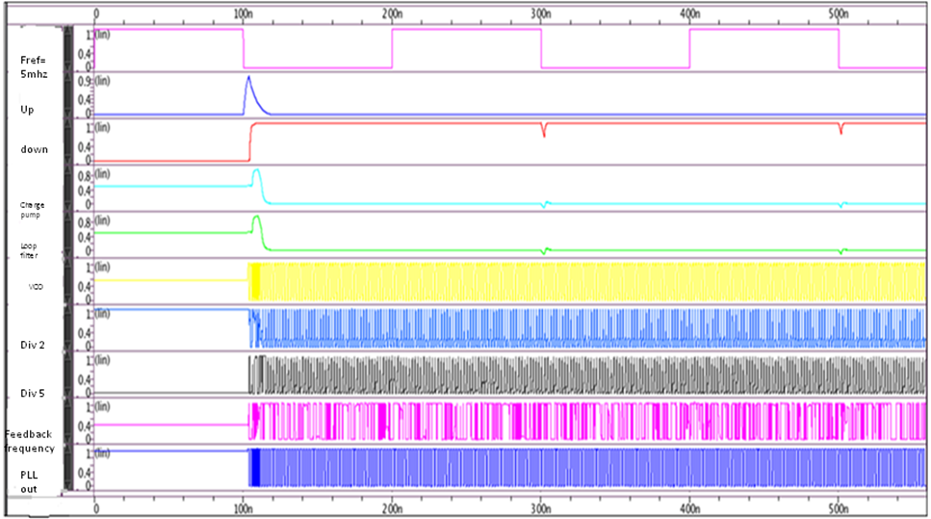

TABULATION RESULT

TERMS | VOLTAGE | INPUT | OUTPUT
Voltage controlled oscillator | 0.65 | 10MHz | 2.387GHz
VCO with PLL | 1.6 | 5MHz | 2.4GHz
PLL locking range | 1.1 | 10MHz | 100ns
PLL locking range | 1.6 | 5MHz | 0.82ns

CONCLUSION:

- Voltage controlled oscillator connected with P.L.L will provide a constant output without effected by external factors
- At 1.1V and 10Mhz reference frequency we get constant output of 2.387Ghz
- Phase locked time is 100ns which can be reduced by modifying the V.C.O which required 1.6V then the phase locked time is reduced to 0.82ns
- In 28nm transistor time will be vary even with the slight change in the current with less consumption of energy

Schedule of Review:

Review 1:24/01/2018
Review 2:26/02/2018
Review 3:22/03/2018

Team Members Signature Signature of Project Guide

Y NAGARJUNA REDDY (Reg No.- RA1411004010345)

K NIKHIL SAI (Reg No.- RA1411004010334)

S V SITA RAMAIH (Reg No.- RA1411004010351)

