1. AIM: Design NFA using simulator to accept the string the start with a and end with b over set {a,b} and check W= abaab is accepted or not.

INPUT:

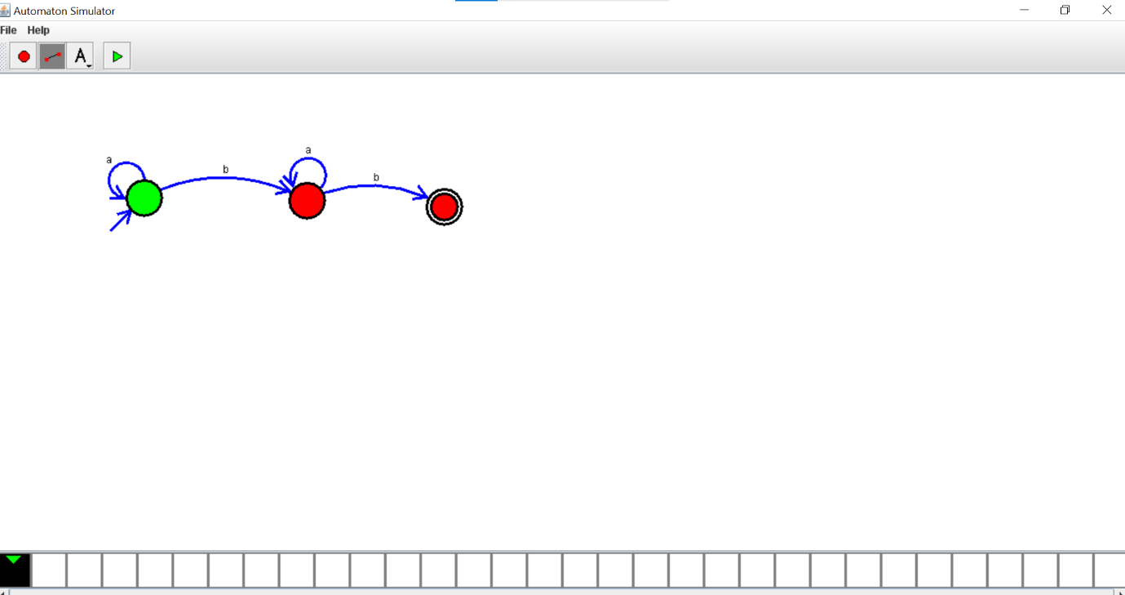

OUTPUT:

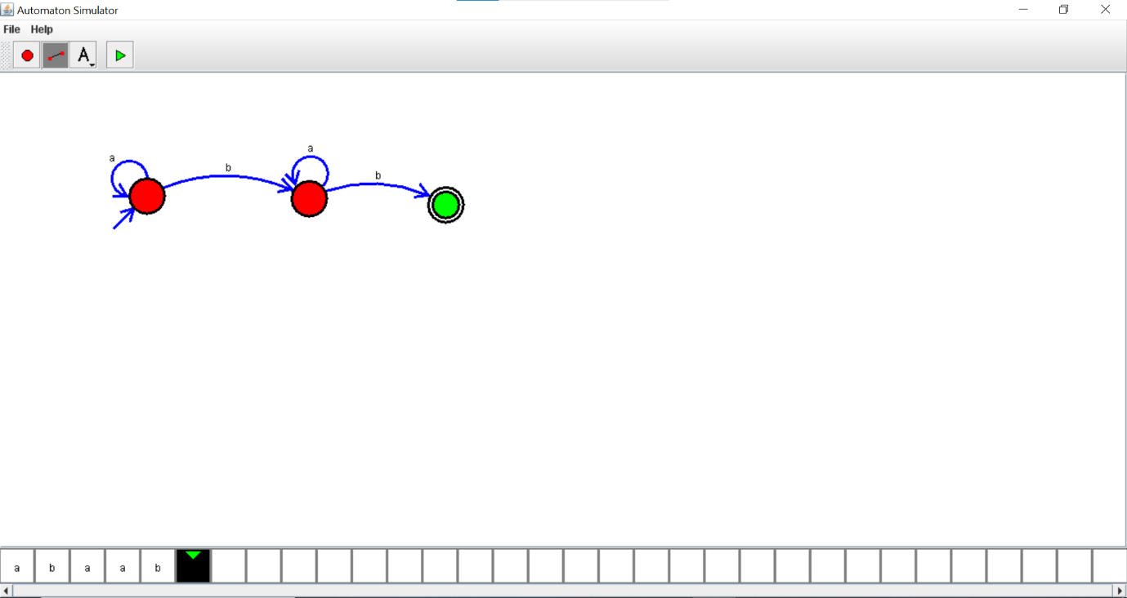

RESULTS: thus designed NFA using simulator to accept the string that start with a and end with b over set {a,b} and check W= abaab is accepted