AIM: Design NFA using simulator to accept the input string “bbc” ,”c”,and ”bcaaa”.

INPUT:

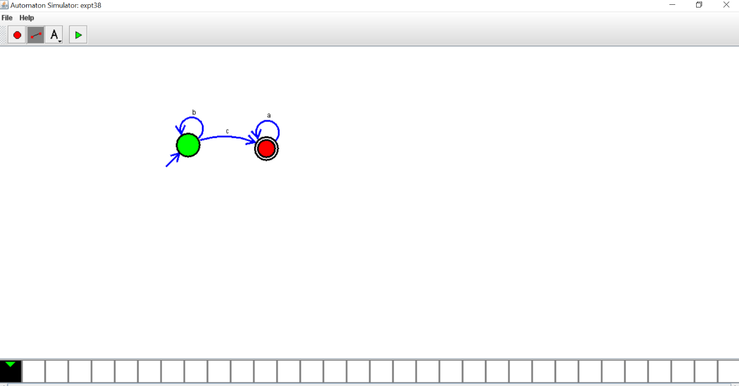

OUTPUT:

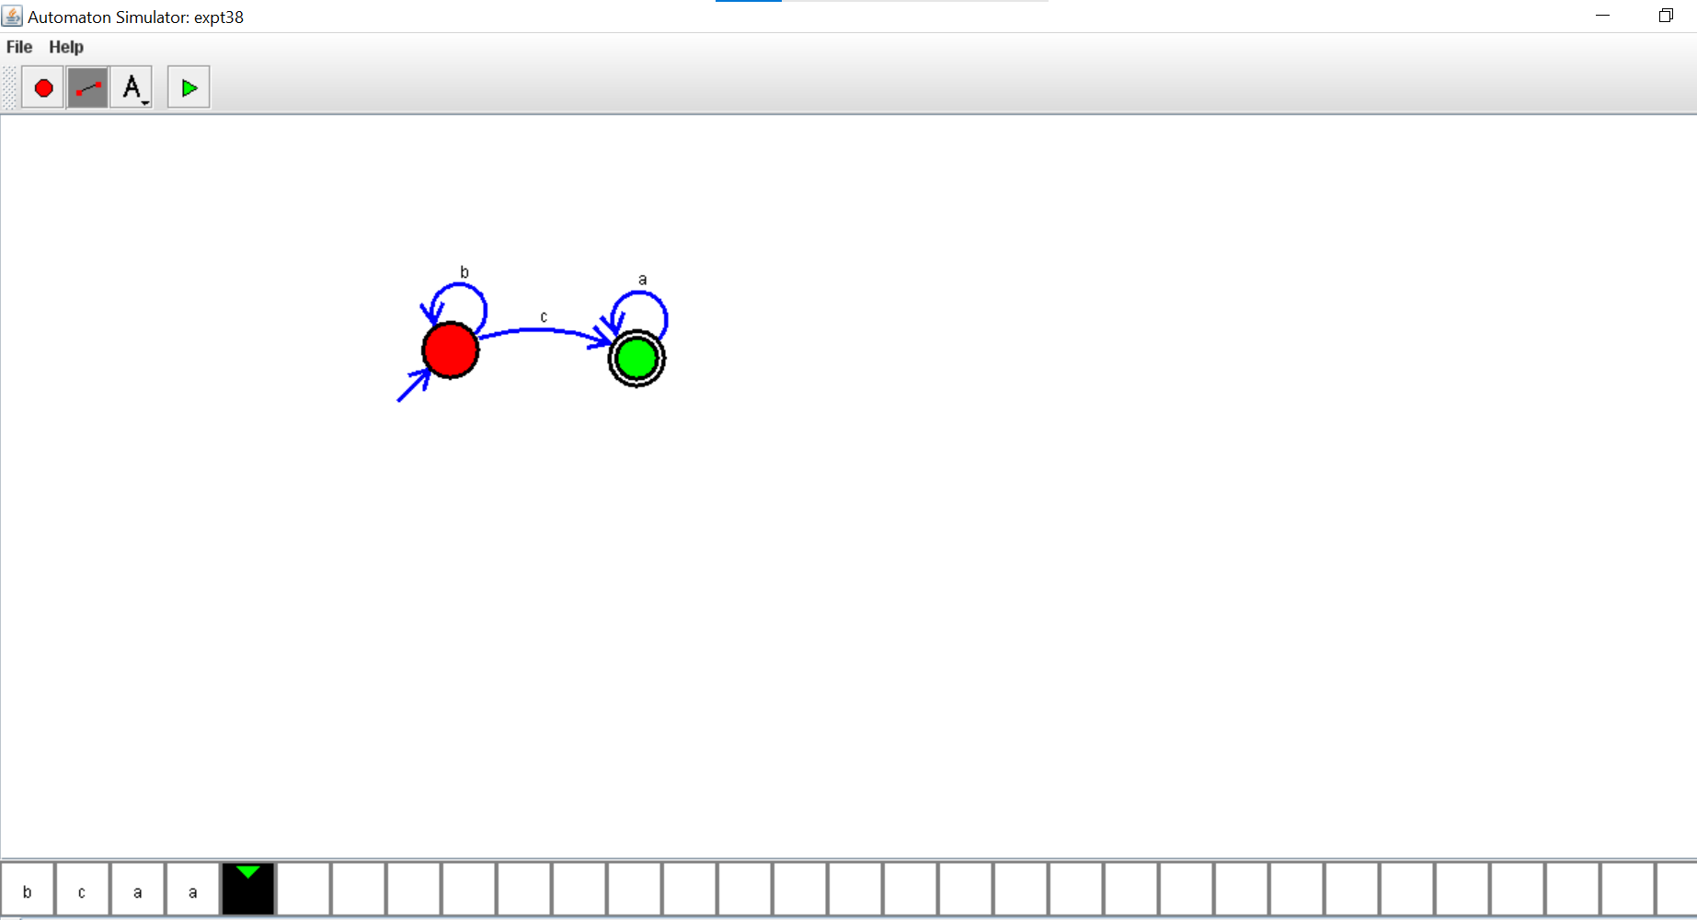

RESULTS: thus designed NFA using simulator to accept the input string “bbc” ,”c”,and ”bcaaa”.