AIM :

To write a C program to simulate a Turing Machine for the language L={ 0n 1n2n | n>=1 } in which n number of 0’s are followed by 2n number of 1’s

ALGORTIHM :

1. Get the input string from the user.

2. Find the length of the string.

3. Read a ‘0’, change it to ‘A’ and move one position to the right

4. Skip all 0’s and B’s if any and move in the right

5. Read a ‘1’, change it to ‘B’ and move one position to the right

6. Skip all 1’s and B’s if any and move in the right

7. Read a ‘2’, change it to ‘C’ and move one position to the left

8. Skip all C’s, 1’s, B’s and 0’s and move left

9. When we read a ‘A’ move one position to the right. a. If the next symbol is 0, goto step 3. b. Otherwise, if the next symbol is B, then skip all B’s and move right. After skipping all B’s i. If there is a C, then skip all C’s and move in the right. After skipping all C’s, if we reach the end of the input, print “String Accepted”, otherwise print “String not accepted” ii. If there is a symbol other than C, print “String not accepted”

10. End the program

PROGRAM:

#include<stdio.h>

#include<string.h>

int main()

{

int i,j,le,flag,flag1,flag2;

char str[20];

printf("Program to show how a turing machine will process 0n1n2n\n");

printf("Enter a string : ");

scanf("%s",str);

le=strlen(str);

j=0;

while(1)

{

flag=0;flag1=0;flag2=0;i=0;

while(i<le)

{

if((str[i]=='0')&&(flag==0))

{

str[i] = 'A';

printf("%s\n",str);

flag=1; //To mark that a 0 is changed to A

i=i+1;

}

else if((str[i]=='0')&&(flag==1))

{

i=i+1; //Skip 0

}

else if(str[i]=='A')

{

i=i+1; //Skip A

}

else if((str[i]=='1')&&(flag1==0))

{

str[i] = 'B';

printf("%s\n",str);

flag1=1; //To mark that a 1 is changed to B

i=i+1;

}

else if((str[i]=='1')&&(flag1==1))

{

i=i+1; //Skip 1

}

else if(str[i]=='B')

{

i=i+1; //Skip B

}

else if((str[i]=='2')&&(flag2==0))

{

str[i] ='C';

printf("%s\n",str);

flag2=1; //To mark that a 2 is changed to C

i=i+1;

}

else if((str[i]=='2')&&(flag2==1))

{

i=i+1; //Skip 2

}

else if(str[i]=='C')

{

i=i+1; //Skip C

}

}

j=j+1;

if(j==le)

{

break;

return 0;

}

}

}

OUTPUT:

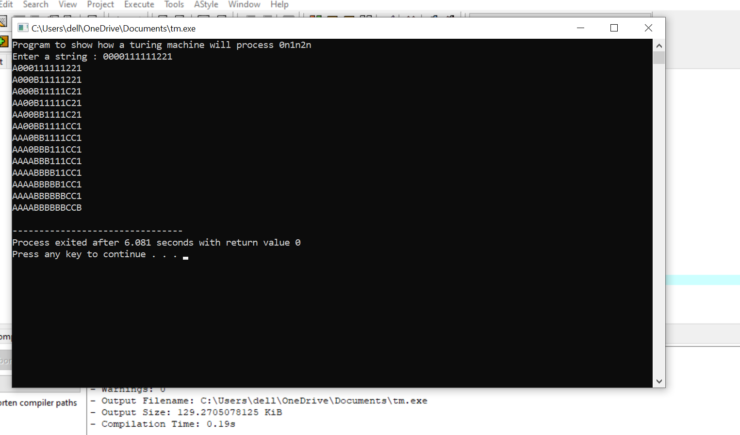

RESULT:

Thus ,executed successfully.