PROJECT REPORT
3D MODELING AND ASSEMBLY OF A UNIVERSAL JOINT (U-JOINT)
Mechanical Engineering – AutoCAD 3D Modeling Project
Software Used: AutoCAD
Model Type: 3D Solid Assembly
Number of Major Parts: 4

1. Introduction
A Universal Joint, commonly called a U-joint, is a mechanical device used to transmit rotary motion and torque between two shafts whose axes are inclined to each other. It is widely used in automobile drive shafts, steering systems, industrial machinery, and other power-transmission applications.
The objective of this project is to design and assemble a three-dimensional Universal Joint using AutoCAD. The model is developed as separate mechanical components and then positioned and aligned to form the final assembly. The project demonstrates the use of 3D solid modeling, Boolean operations, transformations, and assembly techniques.

2. Objectives
- To understand the construction and working principle of a Universal Joint.
- To create individual mechanical parts using AutoCAD 3D modeling tools.
- To use accurate and consistent dimensions for the components.
- To assemble four major components into a complete U-joint.
- To practice commands such as EXTRUDE, PRESSPULL, UNION, SUBTRACT, FILLETEDGE, MOVE, ROTATE3D and ALIGN.
- To produce an isometric/shaded representation suitable for a mechanical CAD submission.

3. Components of the Assembly
Component | Function | Main Dimensions
Input Yoke | Connects the U-joint to the input shaft. | 55 × 45 × 12 mm
Output Yoke | Connects the U-joint to the output shaft. | 55 × 45 × 12 mm
Central Cross / Spider | Central cross that connects the two yokes. | 60 mm overall; Ø16 mm arms
Connecting Shaft | Represents the shaft connected to the yoke. | Ø25 × 80 mm

4. Design Dimensions
The following dimensions were selected as project/design dimensions and are intended to be used consistently in the AutoCAD model and assembly drawing.
Parameter | Dimension
Overall U-joint length | 110 mm
Yoke length | 55 mm
Yoke width | 45 mm
Yoke thickness | 12 mm
Yoke fork gap | 25 mm
Yoke hole diameter | Ø16 mm
Central cross overall length | 60 mm
Cross shaft diameter | Ø16 mm
Cross center diameter | Ø25 mm
Connecting shaft diameter | Ø25 mm
Connecting shaft length | 80 mm
Fillet radius | R3 mm
Assembly operating angle | 30°

5. Modeling Procedure

5.1 Creation of the Yokes
The yoke profile was first created using basic 2D geometry such as lines, circles and arcs. The profile was converted into a 3D solid using EXTRUDE or PRESSPULL. The fork gap was maintained at 25 mm and the pin-hole diameter was set to Ø16 mm. Unwanted material was removed using SUBTRACT. A fillet of approximately R3 mm was applied to suitable edges to improve the mechanical appearance.

5.2 Creation of the Central Cross
The central cross (spider) was created using cylindrical and supporting solid geometry. The four arms were arranged at right angles. The arm diameter was set to Ø16 mm and the overall cross dimension was approximately 60 mm. The individual solids were combined using the UNION command.

5.3 Creation of the Connecting Shaft
The connecting shaft was modeled as a cylindrical solid with a diameter of Ø25 mm and a length of 80 mm. The shaft was positioned along the required axis and aligned with the yoke connection.

5.4 Assembly of Components
After completing the individual parts, the components were assembled using MOVE, ROTATE3D and ALIGN. The central cross was placed between the two yokes. The yokes were positioned relative to each other to represent an operating angle of approximately 30°. The connecting shaft was then aligned with the corresponding yoke. The complete assembly was checked for proper alignment and visible interference.

6. AutoCAD Commands Used
- LINE – creation of straight geometry
- CIRCLE – creation of circular profiles
- ARC – creation of curved profiles
- OFFSET – creation of parallel geometry
- TRIM – removal of unwanted geometry
- EXTRUDE – conversion of 2D profiles into 3D solids
- PRESSPULL – creation and modification of solids
- UNION – combining solids
- SUBTRACT – creating holes and removing material
- FILLETEDGE – rounding selected edges
- MOVE – positioning components
- ROTATE3D – rotating parts about a 3D axis
- ALIGN – accurate positioning of components
- 3DORBIT – inspecting the model from different directions

7. Assembly Drawing and Output
The completed U-joint assembly was inspected in an isometric view and can be presented using a shaded visual style. The final drawing should show the relationship between the two yokes, the central cross, and the connecting shaft.
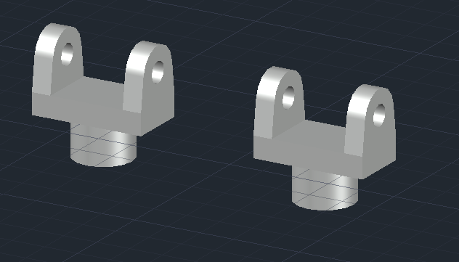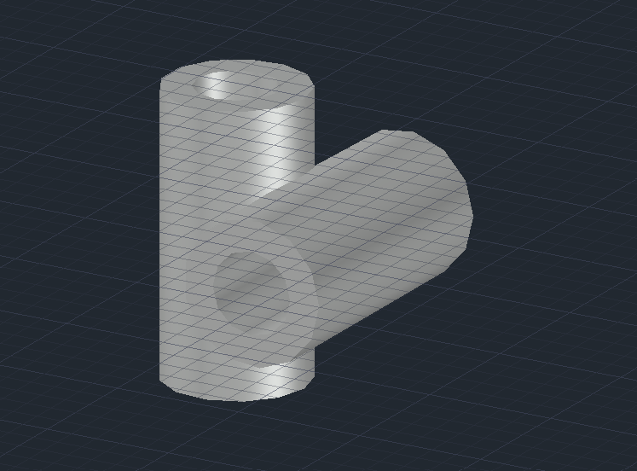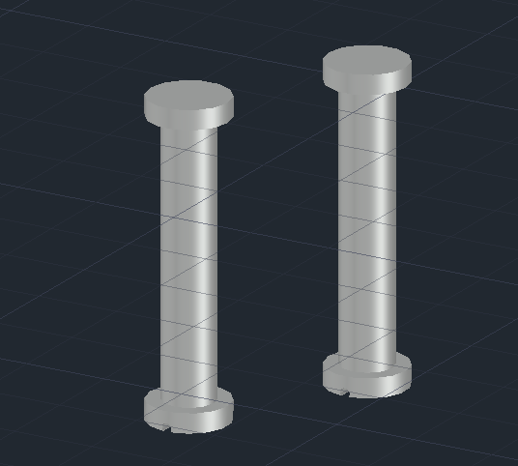

8. Applications
- Automobile propeller and drive shafts
- Steering and mechanical transmission systems
- Industrial power transmission equipment
- Agricultural machinery
- Machine tools and mechanical mechanisms
- Robotics and other systems requiring angular torque transmission

9. Advantages of a Universal Joint
- Allows torque transmission between shafts at an angle.
- Provides flexibility in shaft alignment.
- Has a compact and relatively simple construction.
- Can accommodate changes in operating angle during motion.

10. Conclusion
The Universal Joint 3D assembly was successfully designed as a mechanical CAD project using AutoCAD. The individual components were modeled with defined project dimensions and then assembled using 3D transformation and alignment commands. The project provided practical experience in solid modeling, Boolean operations, dimensional control, and mechanical assembly.
The final U-joint model demonstrates the basic construction of a practical power-transmission component and shows how CAD software can be used to visualize and communicate a mechanical design before manufacturing.

11. Final Project Specifications
Specification | Value
Project | 3D Universal Joint (U-joint) Assembly
Software | AutoCAD
Modeling method | 3D Solid Modeling
Major parts | 4
Overall assembly length | 110 mm
Yoke hole | Ø16 mm
Cross arm | Ø16 mm
Connecting shaft | Ø25 × 80 mm
Fillet | R3 mm
Operating angle | 30°

