🔹 Best Architecture for Your Node.js App

Model architecture for the dynamic links of the KPMPP
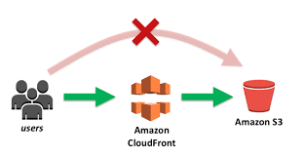 | 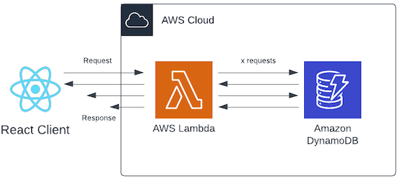
/media | /users /admin /complaint

- /admin → For admin dashboard & management
- /users → For authentication & authorization
- /media → To serve video content

✅ Optimized Setup
Endpoint | Best Service | Reason
/admin | AWS Lambda + API Gateway | Scalable, serverless, cost-effective
/users | AWS Lambda + DynamoDB | Handles authentication with JWT, serverless
/media | CloudFront + S3 | Best for streaming videos, global CDN

🔹 How It Works
1️⃣ Admin & User Authentication (/admin & /users)
- Run Node.js on AWS Lambda (auto-scales).
- Use API Gateway to expose routes (/admin, /users).
- Store user data in DynamoDB or RDS.
- Use JWT authentication for secure login.

2️⃣ Media Streaming (/media)
- Store videos in S3 (private or public).
- Use AWS CloudFront (or Cloudflare CDN if preferred) to serve videos.
- Enable range requests for smooth video buffering.
- (Optional) Use signed URLs if videos are restricted.

🔹 Should You Use Cloudflare for Videos?
✔ CloudFront is better for large-scale video streaming and integrates well with S3.
✔ Cloudflare is good for general static content caching, but not great for large videos.
If your videos are small, Cloudflare works. But for high-quality or long videos, CloudFront + S3 is better.

🔹 Final Optimized Setup
Component | Best Choice
Admin & User API | AWS Lambda + API Gateway
Auth & Data Storage | DynamoDB / RDS
Video Hosting | S3 (CloudFront for delivery)
Video CDN | CloudFront (better than Cloudflare for streaming)
React App Hosting | S3 + CloudFront

🚀 Your Optimized Node.js App Flow
1️⃣ Admin & User Auth → AWS Lambda (Node.js) + API Gateway
2️⃣ Video Storage → S3 Bucket
3️⃣ Fast Video Streaming → CloudFront (better than Cloudflare for large videos)
4️⃣ React Frontend Hosting → S3 + CloudFront
Would you like help with setting this up? 🚀

💰 Why This is Cost-Effective?
Component | Why It's Cost-Efficient?
AWS Lambda | Pay only for execution time (no need to run a full server 24/7).
API Gateway | Low-cost request handling (free tier includes 1M requests/month).
DynamoDB | Free tier includes 25 GB storage & 25M requests/month.
S3 for Videos | Cheaper than running a dedicated media server. Pay per GB stored & transferred.
CloudFront | Caches videos globally, reducing direct S3 costs.
React App on S3 + CloudFront | No server costs, just storage and bandwidth.

💡 Expected Costs (Rough Estimate)
Service | Free Tier | Low Usage Cost | High Traffic Cost
AWS Lambda | 1M requests free | ~$5/month | Scales with traffic
API Gateway | 1M requests free | ~$3/month | Scales with traffic
DynamoDB | Free 25 GB | ~$5/month | More for high writes
S3 Storage | 5 GB free | ~$0.023/GB | ~$20 for 1TB storage
CloudFront | 1 TB free | ~$0.08/GB | ~$80 for 1TB traffic

📌 If your videos are highly accessed, CloudFront reduces the cost by caching. 📌 If you have low traffic, your monthly cost could be below $10!

🚀 Is This the Best Cost-Effective Setup?
✅ Yes, for scalable, pay-as-you-go architecture.
✅ No need to pay for unused servers.
✅ Auto-scales with traffic (low cost when traffic is low).
✅ Faster video delivery with CloudFront caching.
For VERY high video traffic, using CloudFront Signed URLs to charge users or limit access, avoiding unnecessary costs.

🌍 Architecture Flow
User → React Navbar → Routes (Node.js API + CloudFront for Media)

🖼️ Diagram Explanation
- The React App serves the front end (hosted on S3 + CloudFront).
- The /media page serves videos via CloudFront (backed by S3).
- The rest (/about, /complaints, /adminauth, etc.) communicate with AWS Lambda (Node.js) via API Gateway.

🖼️ Architecture Diagram
┌───────────────────────────┐
| React Navbar UI |
| (Hosted on S3 + CloudFront) |
└───────────┬───────────────┘
/users /admin │ /media
┌───────────────────┴───────────────────┐
│ │
┌────▼────┐ ┌────▼────┐
| API GW | | CloudFront |
| (Lambda)| | (S3 Videos)|
└────┬────┘ └────┬────┘
│ │
┌────▼────┐ ┌────▼────-┐
| Node.js | | S3 |
| Lambda | | (Videos) |
└─────────┘ └──────────┘

🔗 Route Connections
Route | Connects To | Service Used
/about | Static content | React frontend
/organization | Static content | React frontend
/media | CloudFront (S3 videos) | AWS CloudFront + S3
/objectives | Static content | React frontend
/complaints | Node.js API | AWS Lambda (Node.js) + API Gateway + DynamoDB
/missions | Static content | React frontend
/adminauth | Node.js API (Auth) | AWS Lambda (Node.js) + API Gateway + DynamoDB

🚀 Final Setup Summary
- Frontend (React + Navbar) → Hosted on AWS S3 + CloudFront.
- Videos (/media) → Served via AWS CloudFront (backed by S3).
- Dynamic Pages (Complaints, Admin Auth, Users) → Handled by AWS Lambda + API Gateway.

