CSA1519-CLOUD COMPUTING FOR BIG DATA ANALYTICS
LAB EXPERIMENTS
1. Create a simple cloud software application for Flight Reservation System using any Cloud Service Provider to demonstrate SaaS.
AIM
To design, develop, and deploy a cloud-based Flight Reservation System using a cloud service provider to demonstrate the Software as a Service (SaaS) model.
MATERIALS REQUIRED
- Zoho Creator (Cloud Platform)
- Built-in Forms & Workflows
- Web Browser
PROCEDURE
STEP 1: Create Zoho Creator Account (Cloud)
- Open browser
- Go to: https://creator.zoho.com
- Sign up / Login
- Click Create New Application
👉 This is done ONLINE (Cloud)

STEP 2: Create Flight Reservation Application
- Choose From Scratch
- Application Name:
- Flight Reservation System

STEP 3: Create Flight Booking Form
Add a Form with following fields:
Field Name | Type
Passenger Name | Text
Email | Email
Source City | Dropdown
Destination City | Dropdown
Travel Date | Date
Flight Class | Dropdown (Economy/Business)
Number of Seats | Number
Click Save

STEP 4: Create Reservation Database (Automatic)
✔ Zoho Creator automatically creates a cloud database
✔ No manual database installation required

STEP 5: Create Reservation View
- Create Report / View
- Name it:
- Booking Details
- Displays all flight reservations

STEP 6: Deploy Application as SaaS
- Click Access This App
- Choose Public / User Access
- Users can now book flights via browser
✔ No software installation
✔ Hosted on Zoho Cloud

STEP 7: Access the SaaS Application
Users access the system using:
https://creator.zoho.com/yourapp

OUTPUT

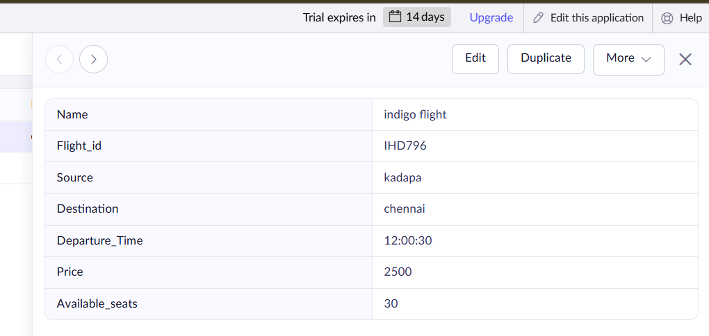
Figure 1: Flight Details

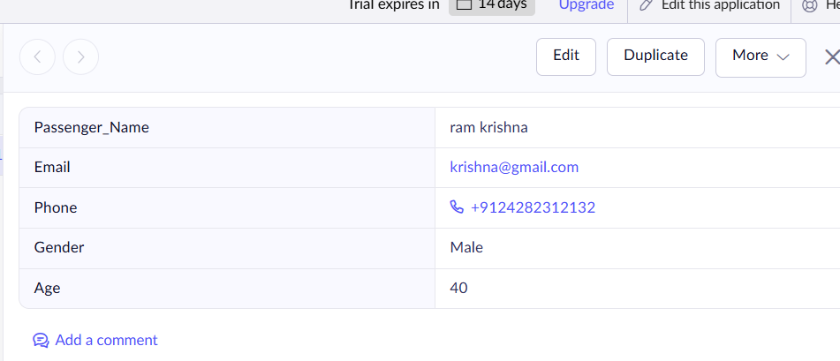
Figure 2: Passenger Details

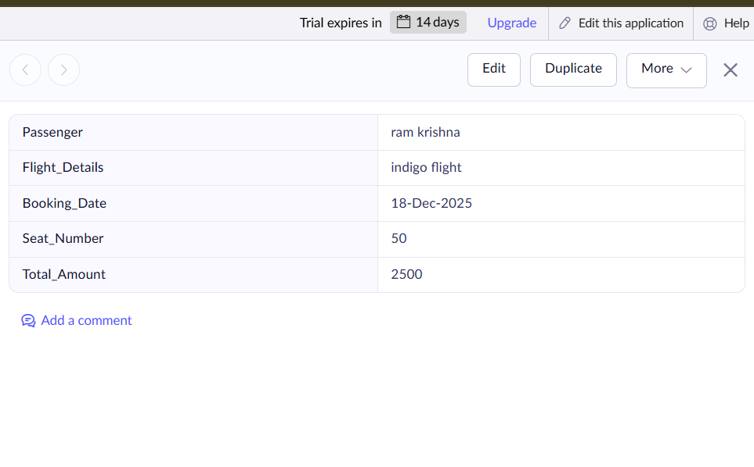

Figure 3: Flight Booking
RESULTS
The cloud-based Flight Reservation System Management System was successfully designed, developed, and deployed using Zoho Creator as a Software as a Service (SaaS) application.

