CSA1519-CLOUD COMPUTING FOR BIG DATA ANALYTICS
LAB EXPERIMENTS
5. Create a simple cloud software application for Library book reservation system for SIMATS library using any Cloud Service Provider to demonstrate SaaS.
AIM
To create a simple cloud software application for a Library Book Reservation System for SIMATS Library using Zoho Creator in order to demonstrate the Software as a Service (SaaS) cloud computing model.
MATERIALS REQUIRED
Hardware Requirements
- Desktop / Laptop Computer
- Minimum 4 GB RAM
Software Requirements
- Web Browser (Google Chrome / Firefox)
- Zoho Account
- Internet Connection
Cloud Platform
- Zoho Creator (Online SaaS Platform)

PROCEDURE
Step 1: Login to Zoho Creator
- Open a web browser and go to https://creator.zoho.com
- Login using Zoho credentials
- Click Create App
- Select Create from Scratch
- App Name:
SIMATS Library Book Reservation System
Step 2: Create Three Forms
Form 1: Book Details
Form Name: Book_Details
Field Name | Field Type
Book_ID | Single Line
Book_Title | Single Line
Author_Name | Single Line
Department | Dropdown (CSE, IT, ECE, EEE, MECH, CIVIL)
ISBN | Single Line
Availability_Status | Dropdown (Available / Issued)

Form 2: Student Details
Form Name: Student_Details
Field Name | Field Type
Student_Name | Single Line
Register_Number | Single Line
Department | Dropdown
Email | Email
Phone_Number | Phone

Form 3: Reservation Details
Form Name: Reservation_Details
Field Name | Field Type
Student | Lookup (Student_Details)
Book | Lookup (Book_Details)
Reservation_Date | Date
Issue_Type | Dropdown (Reference / Home Issue)

Step 4: Create Reports
Create the following reports:
- Book Details
- Student Details
- Reservation Details
Step 8: Create Dashboard Page
Add a page with:
- Button → Book Details
- Button → Student Details
- Report → Reservation Details

OUTPUT

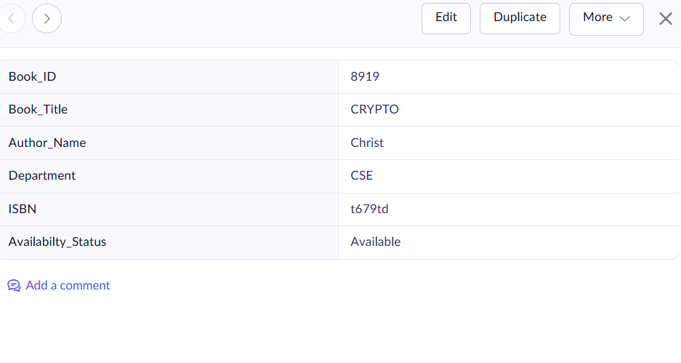
Figure 1: Book Details

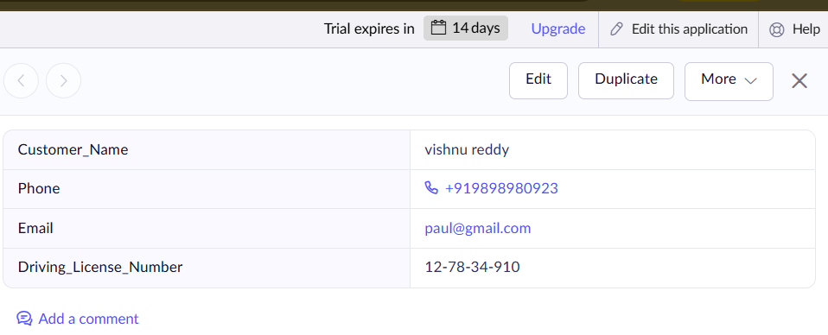
Figure 2: Student Details
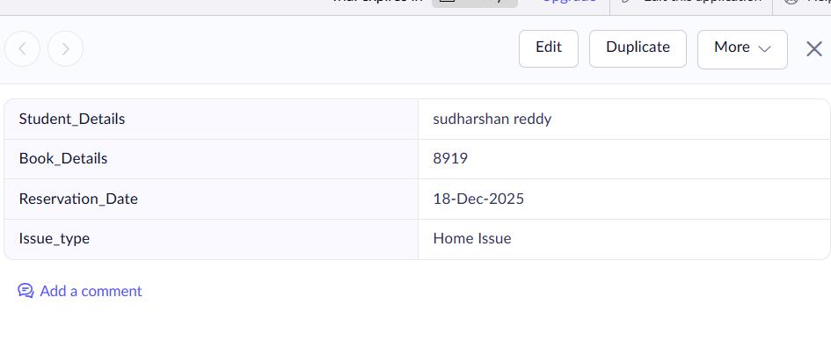

Figure 3: Reservation Details
RESULTS
The cloud-based Library Book Reservation System for SIMATS Library was successfully designed, developed, and deployed using Zoho Creator as a Software as a Service (SaaS) application.

