CSA1519-CLOUD COMPUTING FOR BIG DATA ANALYTICS
LAB EXPERIMENTS
3. Create a simple cloud software application for Property Buying &amp; Rental process (In Chennai city) using any Cloud Service Provider to demonstrate SaaS.
AIM
To create a simple cloud software application for Property Buying and Rental process in Chennai city using Zoho Creator in order to demonstrate the Software as a Service (SaaS) model.
MATERIALS REQUIRED
Hardware Requirements
- Desktop / Laptop Computer
- Minimum 4 GB RAM
Software Requirements
- Web Browser (Google Chrome / Firefox)
- Zoho Account
- Internet Connection
Cloud Platform
- Zoho Creator (Online SaaS Platform)

PROCEDURE
Step 1: Login to Zoho Creator
- Open browser and go to https://creator.zoho.com
- Login using Zoho credentials
- Click on Create App
- Choose Create from Scratch
- App Name: Property Buying & Rental System – Chennai
Step 2: Create Property Details Form
Form Name: Property_Details
Add the following fields:
Field Name | Field Type
Property_ID | Single Line
Property_Type | Dropdown (Flat, Villa, Plot)
Area | Dropdown (T Nagar, Velachery, Anna Nagar, Adyar, Tambaram)
Address | Multi Line
Price | Number
Rental_Price | Number
Property_Status | Dropdown (Available, Sold, Rented)
Step 3: Create Owner Details Form
Form Name: Owner_Details
Field Name | Field Type
Owner_Name | Single Line
Email | Email
Phone | Phone
Property | Lookup (Property_Details)

Step 4: Create Buyer / Tenant Details Form
Form Name: Customer_Details
Field Name | Field Type
Customer_Name | Single Line
Email | Email
Phone | Phone
Requirement | Dropdown (Buy, Rent)
Preferred_Area | Dropdown (Chennai Areas)

Step 5: Create Booking Form
Form Name: Property_Booking
Field Name | Field Type
Customer | Lookup (Customer_Details)
Property | Lookup (Property_Details)
Booking_Type | Dropdown (Buy, Rent)
Booking_Date | Date
Final_Amount | Number

Step 6: Add Workflow Automation
Auto Update Property Status
Go to:
Workflow → Form Actions → On Success
propertyRec = Property_Details[ID == input.Property];
if(input.Booking_Type == "Buy")
{
propertyRec.Property_Status = "Sold";
}
else
{
propertyRec.Property_Status = "Rented";
}

Step 7: Create Reports
Create the following reports:
- Available Properties in Chennai
- Booked Properties Report
- Customer Details Report
- Rental Properties Report

Step 8: Create Dashboard Page
Add a page with:
- Button → Add Property
- Button → Book Property
- Report → Available Properties

OUTPUT

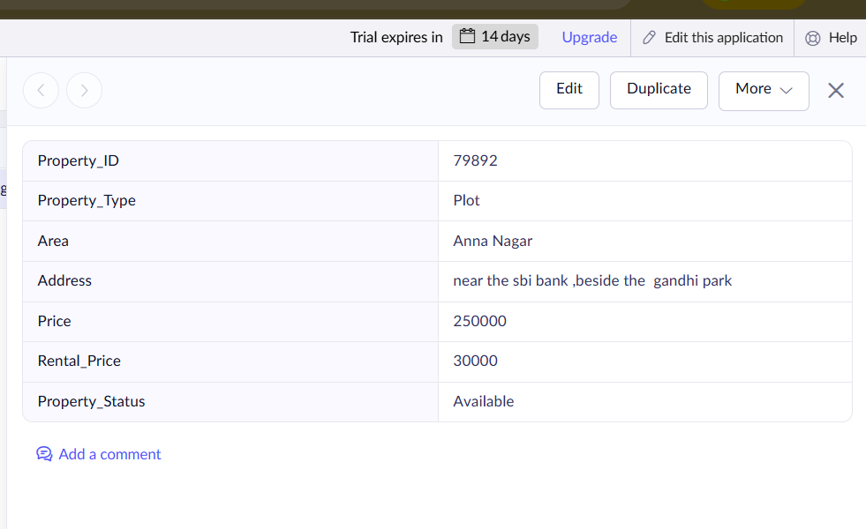
Figure 1: Property Details

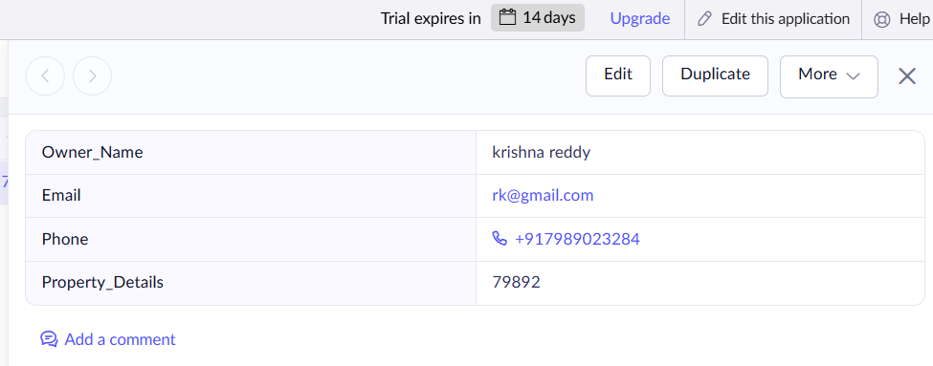
Figure 2: Owner Details

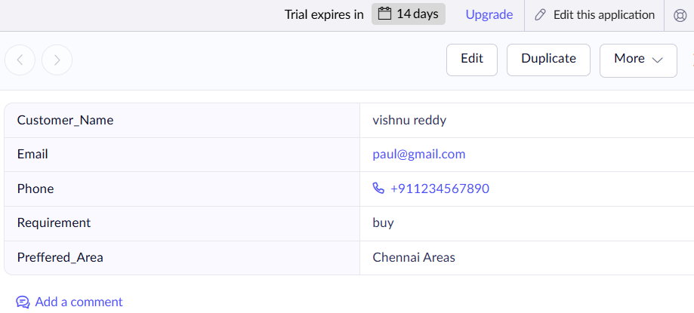

Figure 3: Customer Details
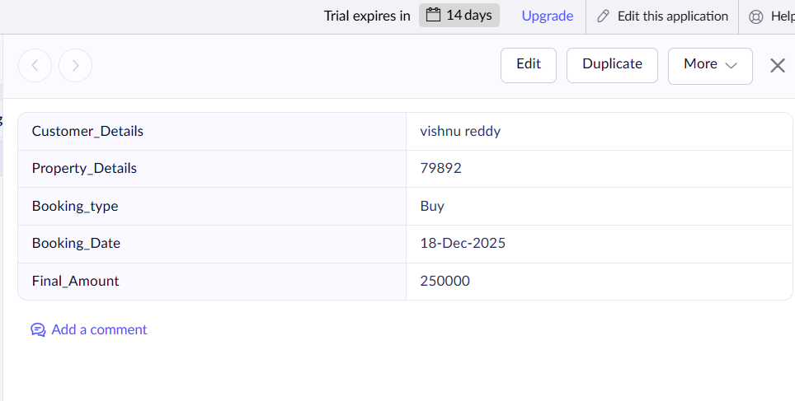
Figure 4: Property Booking

RESULTS
The cloud-based Buying & Rental Property System Management System was successfully designed, developed, and deployed using Zoho Creator as a Software as a Service (SaaS) application.

