**Steps followed to build Batch Process Grails Application:**

1. Created grails app schedule
2. Created three domain classes personA, personB, personC. Which has properties

String firstName

String lastName

Date dateOfBirth

String gender

String addres

1. Records can be created in personA table on clicking personAcontorller. Records will be copied from personA to PresonB on schedule of morningBatch and personA to person on schedule of eveningBatch
2. Created controller for domain personA.

The above controller class will help us to insert/update/ records in table persona

1. Created domain jobInterval which has properties

String batchName

Integer intervalTime

The above class by default contains two records morningBatch and eveningBatch, where we can set time and schedule process. Records in jobinterval can be updated, cannot be created new or delete existing

1. Added default records for domains personA and jobInterval in bootstrap.groovy
2. Included plugin quartz
3. Created service called batchService where I have defined methods to copy records from persona to personb and persona to personc
4. In order to schedule batch after loading application one has to redirect to [schedule.JobIntervalController](http://localhost:8080/schedule/jobInterval/index) where we can edit the record and schedule the job.

Note: on deployment cron will not get scheduled, manually edit the job interval set the time and initiate the batch

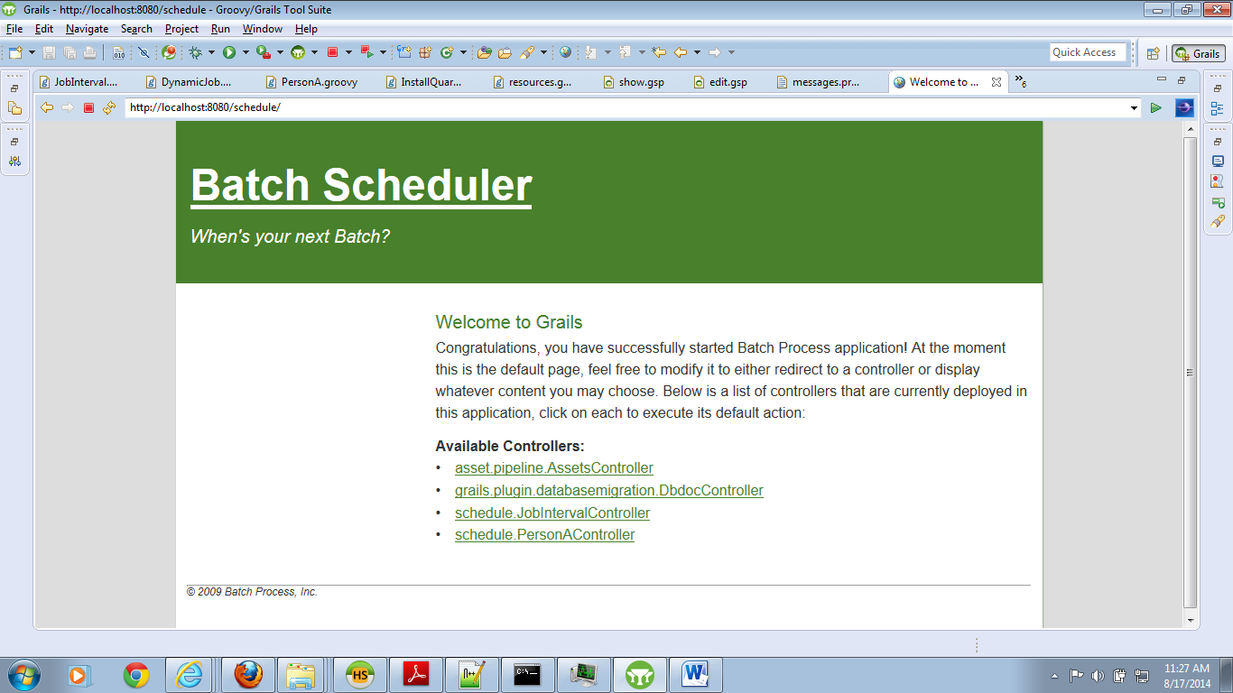

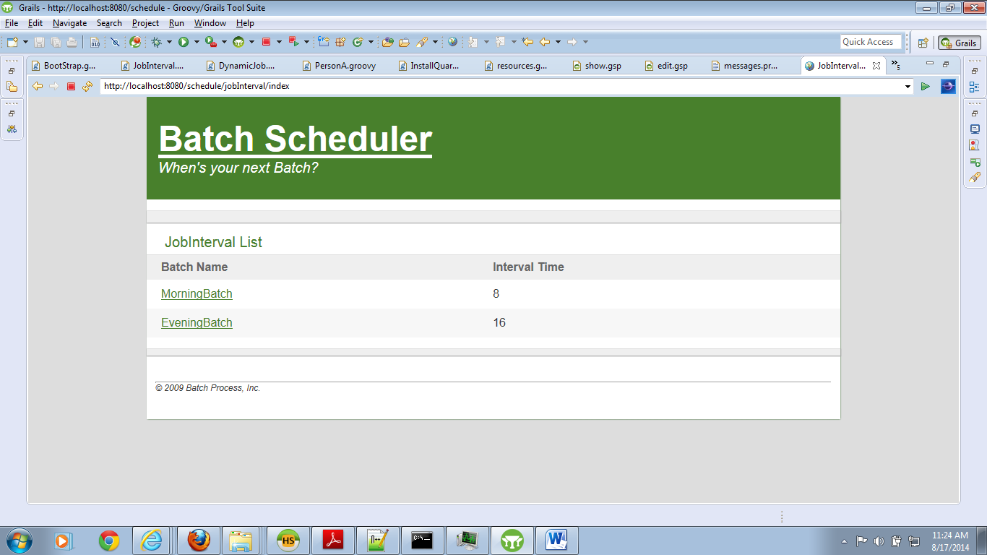

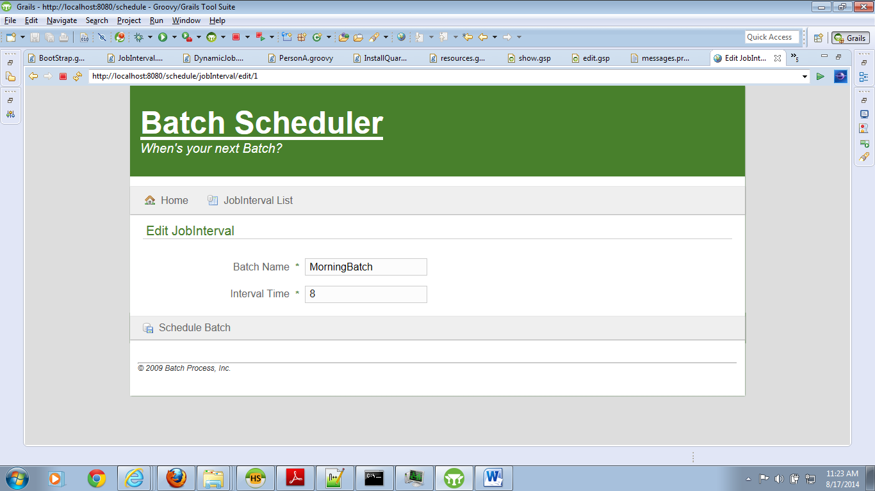

1. After updating the record in job_interval table, job will be scheduled and automatically triggered on scheduled time.
2. The above application is packaged as plugin
3. The plugin schedule is included in schedulerApp.
4. As there are no controllers for personB and person, Please configure mySql in datasource.groovy to see whether the table are updating in DB

Please find the configuration details below:

driverClassName = "com.mysql.jdbc.Driver"

username = "root"

password = "root"

dbCreate = "create-drop" // one of 'create', 'create-drop', 'update', 'validate', ''

url = "jdbc:mysql://localhost:3306/scheduler_dev?autoreconnect=true"

Note: for testing purpose I have configured Morning batch scheduler in seconds, on entering interval time (constraint max allowed value is 23) runs after each nth second.

**Below are the Steps for Achieving plugin and including in main Application:**

* Grails application can be migrated to plugin by running the following command:
  + >grails create-plugin <plugin-name>

Here if plugin name and grails application name are same, the plugin configuration will

Automatically placed in same in grails app, otherwise manually we have to copy the changes made for app to plugin

* After migrating to plugin project we can package the plugin using the below command which creates a zip file with plugin source.
  + >grails package-plugin
* The above generated plugin we can include in main application using the below snippet of code including in BuildConfig.groovy

> grails.plugin.location.<plugin-name> =

"<path of the packaged plugin location>"

For ex: in main application to include schedule plugin below is the command:

> grails.plugin.location.schedule =

"C:/Users/venkata.siva.maddali/web/schedule/"

* To generate WAR below is the command:

>grails WAR