Aircraft Collision Avoidance Using Priority Technique for increased Optimization
Venkataramana Nagarajan
Computer Engineering Department, Vanderbilt University, Nashville, TN,37203 USA
Venkataramana.nagarajan@vanderbilt.edu

Abstract—This electronic document describes my experience on how to design an aircraft controller which navigates the aircraft from source to destination in a 2-D plane while ensuring that it does not collide with the other aircraft in its path. The software used is MATLAB.

Introduction

This document is a final report for the class project “Aircraft Collision Avoidance” prescribed as per the curriculum in CS 6376: Foundations of Hybrid and Embedded Systems. The problem given here is that we have to design an aircraft controller which guides two aircraft to their respective destinations without collision[1].

Input/Output

The controller gets information about the current location and the target location of the aircraft. Further, it also receives messages from aircraft in its vicinity and uses this information to navigate the aircraft and avoid collision with other aircraft.
Data structure containing the above-mentioned information is a variable called ‘in’ with the following fields in it
- (x,y) - They denote the current position of the aircraft.
- (xd,yd) - They denote the destination position of the current aircraft.
- Theta - It denotes the direction of movement of the aircraft.
- m – Incoming message from the other aircraft which contains (x,y,xd,yd,theta) of the other aircraft in its vicinity.

The controller generates an output value which indicates if the aircraft should move forward, move right or move left.

Playing field and assumptions

1. The aircraft can fly in a 2-D plane. Its source and destination are integer-valued points in the plane.
2. The aircraft flies with a constant velocity v = 1 km/minute along either X-axis or Y-axis.
3. The aircraft controller can update direction of flight every
k = 1 minutes. Note that, it can decide to either fly straight or rotate left or right by 90 degrees but not turn back.
4. At the beginning of every k = 1 minutes
- The controller can exchange messages with any aircraft in a square region with side length 2q = 4 km (communication zone) in the vicinity of the aircraft as shown in figure below
- Based on the messages received and the current state of the aircraft, the controller can update the direction of flight.
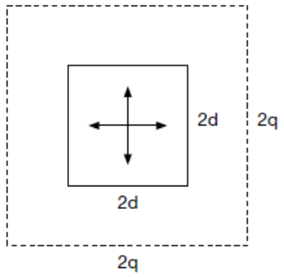
Fig. 1.

5. Collision Avoidance: Each aircraft has a square region with side length 2d = 1 km (danger zone) around it such that no aircraft should enter this region at any time during the flight as
shown in figure 1 above.
6. The source locations are distinct locations for different aircraft.
7. Once an aircraft reaches its destination, it is no longer a threat and collision avoidance is not required for this aircraft. Also, the aircraft stops sending messages to the other aircraft in its vicinity.
8. Further, we assume that the airspace consists only of two aircraft that start at time t = 0.

Requirements

The controller should guide the aircraft from source to destination with the following 2 requirements:

- Liveness - (The aircraft eventually reaches its destination)
- At all times, the controller should bring the aircraft closer to the destination using the shortest path algorithm implemented.
- Once the aircraft reaches its destination the controller should not move the aircraft.

- Safety - (The controller should avoid collision between the aircraft)
- The controller should check for incoming messages from the other aircraft.
- The controller should use the above message to predict the next positon of the other aircraft.
- The controller should intelligently avoid navigating the aircraft to the predicted position of the other aircraft of in their vicinity.
- At each step there must exist one valid move for both the aircraft based on our collision avoidance algorithm.

Design of simple controller[1]

The simple controller guides the aircraft from source to destination as quickly as possible. To ensure this we use the shortest path algorithm, which makes the aircraft choose the right direction that is at a minimum step-distance from its destination. Total number of steps required by the aircraft to reach the destination is called step-distance. The algorithm for SimpleController to choose the right direction for movement is shown in the flowchart below.

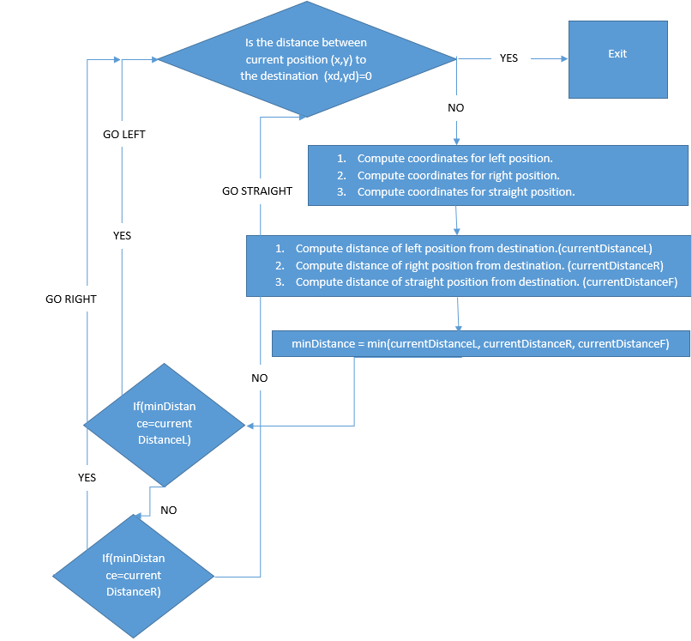

Fig.2

This is the algorithm being used in my code to determine the left, right and straight step-distances

if( in.theta == 0 || in.theta == 360)
currentDistanceF = abs(in.xd-(in.x+1))+abs(in.yd-in.y);
currentDistanceR = abs(in.xd-in.x)+abs(in.yd-(in.y-1));
currentDistanceL = abs(in.xd-in.x)+abs(in.yd-(in.y+1));

elseif(in.theta == 90)
currentDistanceF = abs(in.xd-in.x)+abs(in.yd-(in.y+1));
currentDistanceR = abs(in.xd-(in.x+1))+abs(in.yd-in.y);
currentDistanceL = abs(in.xd-(in.x-1))+abs(in.yd-in.y);

elseif(in.theta == 180)
currentDistanceF = abs(in.xd-(in.x-1))+abs(in.yd-in.y);
currentDistanceR = abs(in.xd-in.x)+abs(in.yd-(in.y+1));
currentDistanceL = abs(in.xd-in.x)+abs(in.yd-(in.y-1));

elseif(in.theta == 270)
currentDistanceF = abs(in.xd-in.x)+abs(in.yd-(in.y-1));
currentDistanceR = abs(in.xd-(in.x-1))+abs(in.yd-in.y);
currentDistanceL = abs(in.xd-(in.x+1))+abs(in.yd-in.y);
end

Further, I used a 2-d array called ‘ASorted’ with dimensions 3x2 to store and sort these distances. Here the 1st column contains the distance and the second column has the id which tells whether that distance is left, right or straight distance.
1 - denotes left
-1 - denotes right
0 - denotes straight

The code used to initialize the matrix is

ASorted(1,1) = currentDistanceL;
ASorted(2,1) = currentDistanceR;
ASorted(3,1) = currentDistanceF;

ASorted(1,2) = 1 ;
ASorted(2,2) = -1 ;
ASorted(3,2) = 0;

So the matrix looks like this initially when it is not sorted(just a random example just to make the data structure clear)

10 | 1
5 | -1
2 | 0

For sorting, I used the following code in my project

for i=1:3
for j=(i+1):3
if ( ASorted(i,1) > ASorted(j,1))
temp=ASorted(i,1);
ASorted(i,1)=ASorted(j,1);
ASorted(j,1) = temp;

temp=ASorted(i,2);
ASorted(i,2)=ASorted(j,2);
ASorted(j,2) = temp;
end
end
end

After sorting the matrix looks like this

2 | 0
5 | -1
10 | 1

So, the value at index (1,2) of the matrix gives us the right direction which in this case is 0. This means the right direction for the aircraft to go is straight.

Complete Controller with collision avoidance

The complete controller has to guide the aircraft from source to destination using the shortest path algorithm without any collision.

Here I have given the 1st priority to aircraft 1 if the 1st preferences of both the aircraft result in a collision. For example, for aircraft-1 taking a left is the shortest path and after taking left assume it would come to (5,2) , for aircraft-2 taking a right is the shortest path and assume it would come to (5,2) as well. In this case, I have given priority to aircraft-1, so aircraft-1 gets its first choice of turn while aircraft-2 has to change its choice to the 2nd shortest path. This has been facilitated by using a persistent variable ‘count’ in controller.m. It is initialized to 1. Whenever controller.m is called ‘count’ is incremented after a call to path_finder, which means that whenever count is odd the decision for aircraft-1 is being made by the controller and whenever count is even the decision for aircraft-2 is being made by the controller. Code snippet for the same is as below

persistent count;
if isempty(count)
count = 1;
end
out.val = path_finder(in,in.m,count);
count = count + 1 ;

Since we know that aircraft-1 is always given its first choice, we only need to change the course of aircraft-2 whenever it is in vicinity of aircraft-1. This is facilitated by the following code, where we check if message is not empty and if aircraft_no is even.(which means the aircraft being controlled is aircraft-2)

if( ~isempty(message) && mod(aircraft_no,2)==0)

if( message.theta == 0 || message.theta == 360)

oppDistanceF = abs(message.xd-(message.x+1))+abs(message.yd - message.y);
oppDistanceR = abs(message.xd - message.x)+abs(message.yd-(message.y-1));
oppDistanceL = abs(message.xd - message.x)+abs(message.yd-(message.y+1));

elseif(message.theta == 90)
oppDistanceF = abs(message.xd - message.x)+abs(message.yd-(message.y+1));
oppDistanceR = abs(message.xd-(message.x+1))+abs(message.yd-message.y);
oppDistanceL = abs(message.xd-(message.x-1))+abs(message.yd-message.y);

elseif(message.theta == 180)

oppDistanceF = abs(message.xd-(message.x-1))+abs(message.yd - message.y);
oppDistanceR = abs(message.xd - message.x)+abs(message.yd-(message.y+1));
oppDistanceL = abs(message.xd - message.x)+abs(message.yd-(message.y-1));

elseif(message.theta == 270)

oppDistanceF = abs(message.xd - message.x)+abs(message.yd-(message.y-1));
oppDistanceR = abs(message.xd-(message.x-1))+abs(message.yd - message.y);
oppDistanceL = abs(message.xd-(message.x+1))+abs(message.yd - message.y);

end

As shown in the simple controller, we go ahead and make a 2- array called ASortedOpposite which contains the sorted distances to the destination.

ASortedOpposite(1,1) = oppDistanceL;
ASortedOpposite(2,1) = oppDistanceR;
ASortedOpposite(3,1) = oppDistanceF;

ASortedOpposite(1,2) = 1 ;
ASortedOpposite(2,2) = -1 ;
ASortedOpposite(3,2) = 0;

for i=1:3
for j=(i+1):3
if ( ASortedOpposite(i,1) > ASortedOpposite(j,1))
temp=ASortedOpposite(i,1);
ASortedOpposite(i,1)=ASortedOpposite(j,1);
ASortedOpposite(j,1) = temp;

temp=ASortedOpposite(i,2);
ASortedOpposite(i,2)=ASortedOpposite(j,2);
ASortedOpposite(j,2) = temp;
end
end
end

Now we have the sorted distances in the array ASortedOpposite. Further, we go ahead and check if the “to be taken first choice” of aircraft-2 collides with the “already taken first choice” aircraft-1.

This is facilitated by the following code

for i=1:3
if(find_possible_path(ASorted(i,2),in,ASortedOpposite(i,2),in.m))
selected_value = ASorted(i,2);
break;
end

end

So, in the above code we make a call to a new function “find_possible_path.m” which basically loops through the array and returns an option for aircraft-2 that does not collide with the aircraft-1. This decision is then returned to the controller which guides the planes left/right/straight accordingly.

Proof Of Correctness

I will show the proof of correctness by addressing the requirements of Liveness and Safety.

- Liveness
- At each step both the aircraft make progress towards their respective destinations. This is ensured by the shortest-path algorithm explained in the simple controller part. In each call to controller this algorithm returns a direction for the aircraft to take.
- The aircraft never enter a state of deadlock where they move around in circles. This is ensured because I have given priority to aircraft-1 in case when the shortest path of both the aircraft causes collision. So, this makes sure that aircraft-1 takes its shortest path while aircraft-2 alters is path to the next shortest path. This way the algorithm is also optimized because both the aircraft do not avoid the shortest path, only aircraft-2 changes its path to the next shortest one. So, this is the proof of correctness for liveness.

- Safety
- At each step if there are incoming messages from the aircraft in vicinity we check it in our code to avoid collision. In case of aircraft-2 we go and check if the shortest path for aircraft-2 collides with the shortest path of aircraft-1, and since I have given priority to aircraft-1 , aircraft-2 alters its path thus avoiding collision. So, this is the proof of correctness for safety.

Results

Below I will provide screenshots of matlab simulations of some of the test cases

- runSimulation([0, 0], [0, 10], [5, 10], [10, 5], 40)

Here both the aircraft reach their final destinations following their respective shortest paths. Here there is no collision avoidance as their paths do not cross.

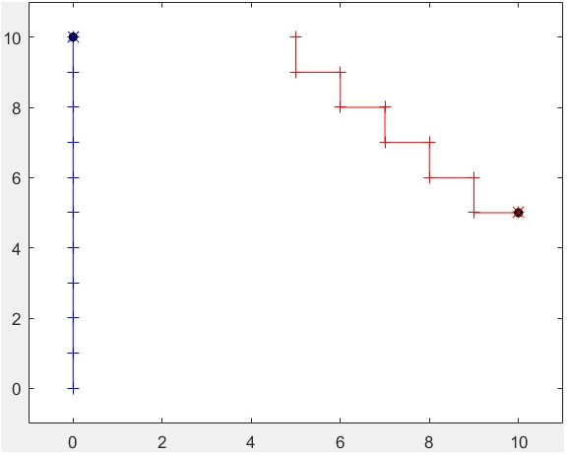
Fig.3

- runSimulation([0, 0], [0, 10], [-5, 5], [5, 5], 40)

Here we can see that since aircraft-1(blue line) has the highest priority it follows its shortest path while aircraft-2(red line) changes its path at (-1,5) to go to
(-1,4) instead of (0,5) and thus avoids collision.

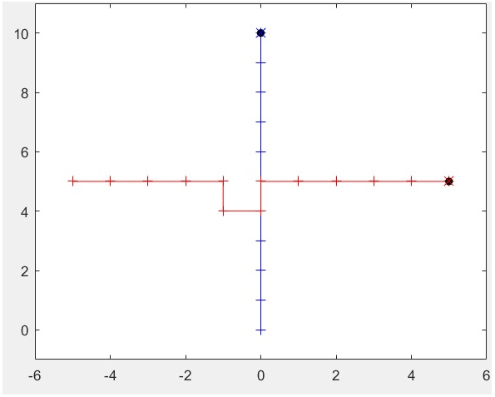

Fig.4

- runSimulation([0, 0], [0, 10], [10, 0], [0, 0], 40)

Here both the aircraft reach their final destinations following their respective shortest paths. Here there is no collision avoidance as their paths do not cross.

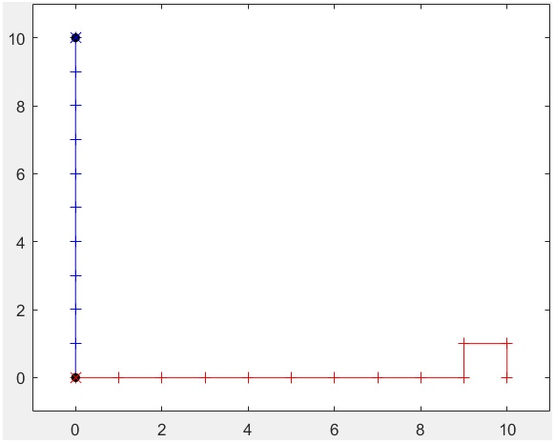

Fig.5

- runSimulation([0, 0], [10, 10], [10, 0], [0, 10], 40)

Here we can see that since aircraft-1(blue line) has the highest priority it follows its shortest path while aircraft-2(red line) changes its path at (6,5) to go to
(6,6) instead of (5,5) and thus avoids collision.

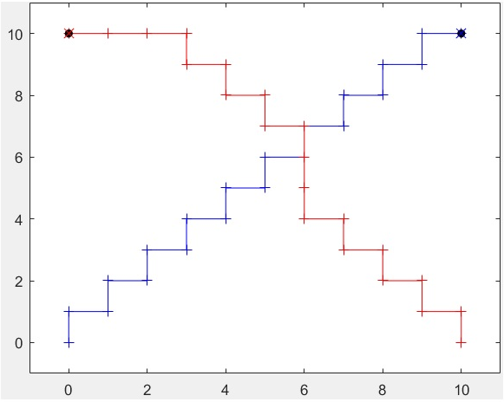
Fig.6

- runSimulation([0, 5], [15, 5], [5, 10], [15, 0], 40)

Here we can see that since aircraft-1(blue line) has the highest priority it follows its shortest path while aircraft-2(red line) changes its path at (15,6) to go to
(15,7) instead of (15,5) and thus avoids collision.

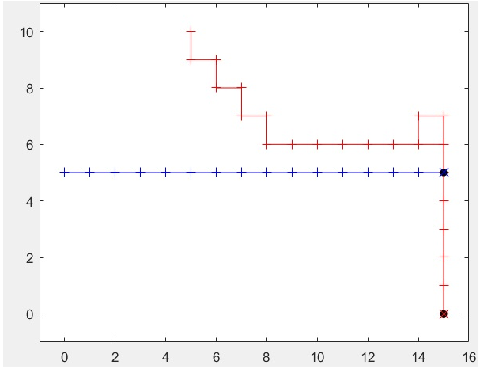

Fig.7

I would also like to present to you the results of the 3 different test benches I ran. The 1st test bench is the one given in Readme.txt[2]

>> [numPassed, numFailed, log] = testbench(3, 100)

numPassed = 22174
numFailed = 0
log = []

>> [numPassed, numFailed, log] = testbench(4, 40)

numPassed = 116859
numFailed = 0
log = []

>> [numPassed, numFailed, log] = testbench(3, 25)

numPassed = 22174
numFailed = 0
log = []

Acknowledgment
The author would like to thank Dr.Xenofon D. Koutsoukos and Xingyu Zhou for their help.

References
- https://blackboard.vanderbilt.edu/bbcswebdav/pid-1269534-dt-content-rid-3588686_1/courses/2016.08.FALL.ENG.CS.6376.01/aircraftcollisionavolidance.pdf
- https://blackboard.vanderbilt.edu/bbcswebdav/pid-1281738-dt-content-rid-3686859_1/courses/2016.08.FALL.ENG.CS.6376.01/Readme.txt

