

**T1: Data Science Inventory**

**Team Project Final Report**

INFO 5717– Fall 2017

By,

Venkat Varun Madarapu – [venkatvarunmadarapu@my.unt.edu](mailto:venkatvarunmadarapu@my.unt.edu)

Swathi Kosuna – [Swathikosuna@my.unt.edu](mailto:Swathikosuna@my.unt.edu)

Venkata Santhosh Danduru- [venkatasanthoshdanduru@my.unt.edu](mailto:venkatasanthoshdanduru@my.unt.edu)

Akhil Tammina -[AkhilTammina@my.unt.edu](mailto:AkhilTammina@my.unt.edu)

**Objective of the Project:**

The objective and use of the system is as an online catalog which are field of data science. Along with the titles of the books, the database also has information like publisher details, author details and price. Website provides details of contains data science related books which includes data analytics, visualization, machine learning, data mining, text mining.

The system also has admin panel where user with valid credentials can login and view the statistics of the data in the database like adding the record to database and checking the stats of existing data.

**Objectives and Scope of the database:**

The main objective of our database it stores the information of books related field of data science. Along with the titles of the books, the database also has information like publisher details, author details and price.

The database contains data science related books which includes data analytics, visualization, machine learning, data mining, text mining. The database is designed to create record, edit and also delete with required authentication.

The scope of the database is it is restricted to records only related to field of data science. It doesn’t support to other books. It can only store limited number of fields like title, number of pages, price, author and publisher information etc.

**User Requirements:**

There are three types of users who can access the website and the records in the database.

1. End User: who access to database with ‘read’ permission only through web application.
2. Staff User: Users who can insert new records into the database and can search for the old records which were stored in the database.
3. Admin User: Admin user can search for the existing records, can insert new records and can manage and maintain the webpage and the database.

**Business Rules:**

1. A book can have one or more authors.

2. An author can have one or more books.

3. M:N relationship exists between Books and Authors.

4. A publisher can have one or more books. Each book can have only one publisher.

5. A book can only have one set of ISBN values which has a combination of ISBN-10 and ISBN-13. Each ISBN set can have only one book.

6. A book can have one or more subject terms.

7. A subject can have one or more books.

8. M:N relationship exists between Subjects and Books

9. USER_CREDS table is the unique table having combination of User-Id and Password and which doesn’t have any relationship with other tables in the database.

**Data Dictionary:**

|  |  |  |  |  |  |  |
| --- | --- | --- | --- | --- | --- | --- |
| Table Name | Column Name | Data Type | Field Size(bytes) | Data Format | Description | Example |
| DSI_Publishers | Pub_ID | int | 10 | NNNNNNNNNN | Unique number for all publishers | 5 |
| DSI_Publishers | Pub_Name | Varchar | 64 |  | Name of the publisher | Analytics Press |
| DSI_ISBN | Book_ID | int | 10 | NNNNNNNNNN | Unique number for all ISBN numbers | 15 |
| DSI_ISBN | ISBN-10 | Bigint | 10 | NNNNNNNNNN | 10 digit ISBN number | 1466585269 |
| DSI_ISBN | ISBN-13 | Char | 14 | NNNNNNNNNNNNN | 13 digit ISBN number | 978-1466585263 |
| DSI_Books | Book_ID | int | 10 | NNNNNNNNNN | Unique number for all books | 1000000001 |
| DSI_Books | Title | Varchar | 225 |  | Title of the book | Now You See It: Simple Visualization Techniques for Quantitative Analysis |
| DSI_Books | Pub_ID | int | 10 | NNNNNNNNNN | Unique number for all publishers | 5 |
| DSI_Books | Pub_Year | int | 4 | YYYY | Year of publication of the book | 7/9/1905 |
| DSI_Books | Price | Char | 10 | NNNNNNNNNN | Price of the Book | $15 |
| DSI_Books | Abstract | Varchar | 500 |  | Abstract of the book | Now You See It: Simple Visualization Techniques for Quantitative Analysis teaches simple, practical means to explore and analyze quantitative data--techniques that rely primarily on using your eyes. This book features graphical techniques that can be applied to a broad range of software tools, including Microsoft Excel, because so many people have nothing else, but also more powerful visual analysis tools that can dramatically extend your analytical reach. |
| DSI_Books | No_of_pages | Int | 10 |  | Number of Pages in Book |  |
| DSI_Authors | Auth_ID | int | 10 | NNNNNNNNNN | Unique number for all authors | 10 |
| DSI_Authors | Auth_Name | Varchar | 64 |  | Name of the author | Stephen Few |
| DSI_Books_Authors | Book_ID | int | 10 | NNNNNNNNNN | Unique number for Book table |  |
| DSI_Books_Authors | Auth_ID | int | 10 | NNNNNNNNNN | Unique number for all authors |  |
| DSI_Subjects | Sub_ID | Int | 10 | NNNNNNNNN | Unique Number for each subject |  |
| DSI_Subjects | Sub_Term | Varchar | 255 |  | Name of the Subject | Data Mining |
| DSI_Subjects | Description | Varchar | 500 |  | Description of the Subject |  |
| DSI_Subject_Books | Book_ID | Int | 10 |  | Unique Number for each book |  |
| DSI_Subject_Books | Sub_ID | int | 10 |  | Unique Number for each subject |  |

**Major Entities:**

The below entities are the mandatory entities for a record entered into database:

Title: Title of each book which is entered as separate record in the database.

Author: Name of author/authors are recorded in author table and each record for each author when book has multiple authors.

Publisher: Name of the publisher

Subject: Name of the field the book belongs

ISBN 10 and ISBN 13: unique value for each record from library of congress.

**Entity Relation Diagram**

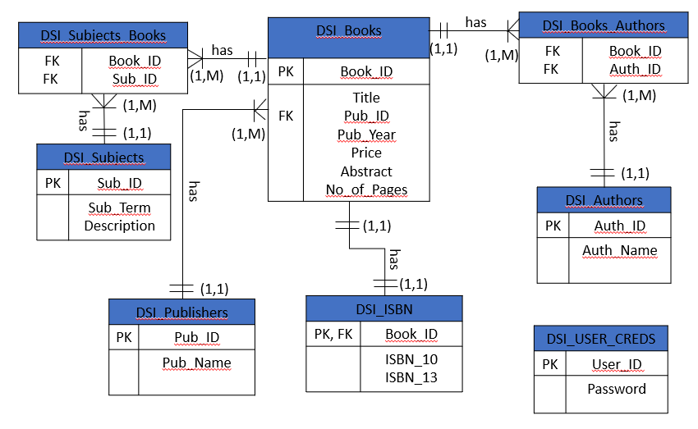

**SQL Statements:**

CREATE TABLE IF NOT EXISTS `DSI_Publishers` (

`Pub_ID` int(10) NOT NULL AUTO_INCREMENT,

`Pub_Name` varchar(255) NOT NULL,

PRIMARY KEY (`Pub_ID`),

UNIQUE KEY `Pub_ID` (`Pub_ID`),

UNIQUE KEY `Pub_Name` (`Pub_Name`)

) ENGINE=InnoDB DEFAULT CHARSET=latin1 AUTO_INCREMENT=10019 ;

CREATE TABLE IF NOT EXISTS `DSI_Authors` (

`Auth_ID` int(10) NOT NULL AUTO_INCREMENT,

`Auth_Name` varchar(255) NOT NULL,

PRIMARY KEY (`Auth_ID`),

UNIQUE KEY `Auth_ID` (`Auth_ID`),

UNIQUE KEY `Auth_Name` (`Auth_Name`)

) ENGINE=InnoDB DEFAULT CHARSET=latin1 AUTO_INCREMENT=30110 ;

CREATE TABLE IF NOT EXISTS `DSI_Books` (

`Book_ID` int(10) NOT NULL AUTO_INCREMENT,

`Title` varchar(255) NOT NULL,

`Pub_ID` int(10) NOT NULL,

`Pub_Year` int(10) DEFAULT NULL,

`Price` varchar(255) DEFAULT NULL,

`Abstract` longtext,

`No_of_Pages` int(10) DEFAULT NULL,

PRIMARY KEY (`Book_ID`),

UNIQUE KEY `Book_ID` (`Book_ID`),

UNIQUE KEY `No_of_Pages` (`No_of_Pages`),

KEY `Pub_ID` (`Pub_ID`)

) ENGINE=InnoDB DEFAULT CHARSET=latin1 AUTO_INCREMENT=20077 ;

CREATE TABLE IF NOT EXISTS `DSI_Books_Authors` (

`Book_ID` int(10) NOT NULL,

`Auth_ID` int(10) NOT NULL,

KEY `Book_ID` (`Book_ID`),

KEY `Auth_ID` (`Auth_ID`)

) ENGINE=InnoDB DEFAULT CHARSET=latin1;

CREATE TABLE IF NOT EXISTS `DSI_ISBN` (

`Book_ID` int(10) NOT NULL,

`ISBN_10` varchar(255) DEFAULT NULL,

`ISBN_13` varchar(255) NOT NULL,

PRIMARY KEY (`Book_ID`),

UNIQUE KEY `Book_ID` (`Book_ID`),

UNIQUE KEY `ISBN_13` (`ISBN_13`)

) ENGINE=InnoDB DEFAULT CHARSET=latin1;

CREATE TABLE IF NOT EXISTS `DSI_Subjects` (

`Sub_ID` int(10) NOT NULL AUTO_INCREMENT,

`Sub_Term` varchar(255) NOT NULL,

`Description` longtext,

PRIMARY KEY (`Sub_ID`),

UNIQUE KEY `Sub_ID` (`Sub_ID`),

UNIQUE KEY `Sub_Term` (`Sub_Term`)

) ENGINE=InnoDB DEFAULT CHARSET=latin1 AUTO_INCREMENT=7 ;

CREATE TABLE IF NOT EXISTS `DSI_Subjects_Books` (

`Book_ID` int(10) NOT NULL,

`Sub_ID` int(10) NOT NULL,

KEY `Book_ID` (`Book_ID`),

KEY `Sub_ID` (`Sub_ID`)

) ENGINE=InnoDB DEFAULT CHARSET=latin1;

CREATE TABLE IF NOT EXISTS `USER` (

`UserID` int(11) NOT NULL AUTO_INCREMENT,

`LoginName` varchar(255) NOT NULL,

`PasswordHash` varchar(64) NOT NULL,

`FirstName` varchar(255) DEFAULT NULL,

`LastName` varchar(255) DEFAULT NULL,

PRIMARY KEY (`UserID`)

) ENGINE=InnoDB DEFAULT CHARSET=latin1 AUTO_INCREMENT=4 ;

**SiteMap:**

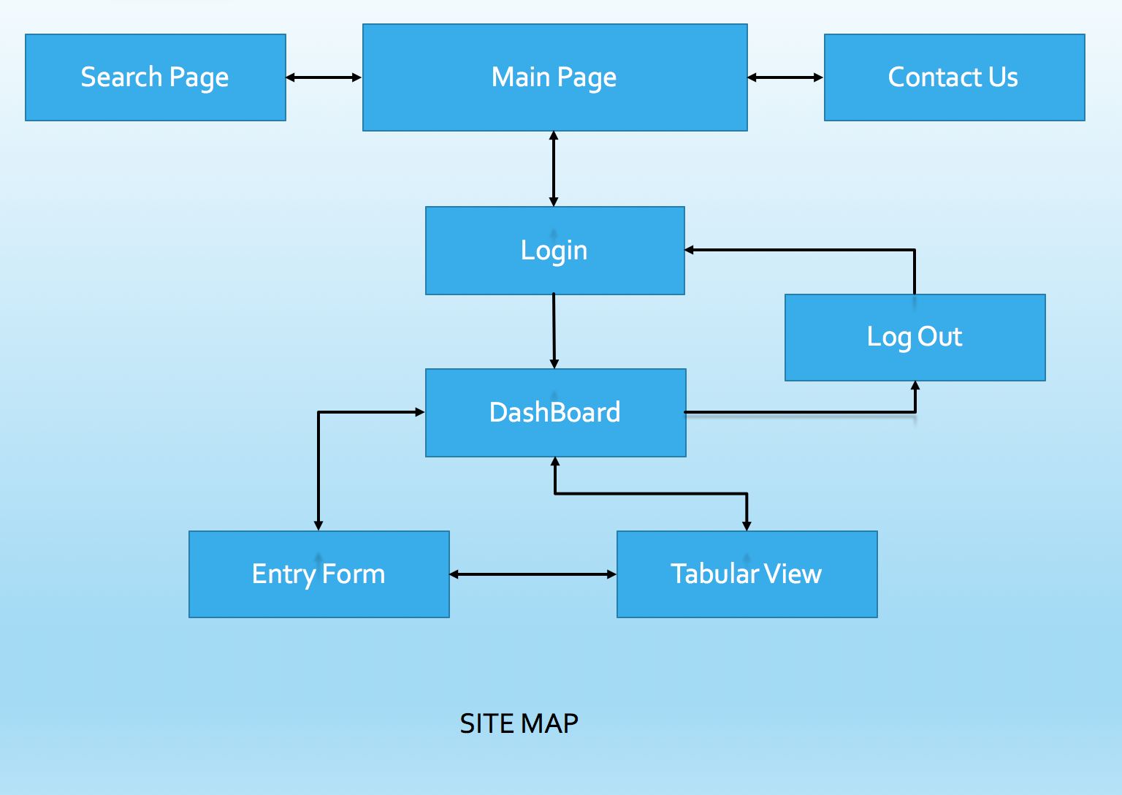

**Usability considerations in your Website design:**

**Design:** The website has been designed using HTML, CSS, Bootstrap and JavaScript with PHP as backend code. The design has been made with simple features and colors visible clear on any time on resolution and visible font size. Different background colors have been used for different pages to differentiate the functionalities and variations during redirect of pages.

**Ease of webpage:** Each the home page, the system has been designed with optimization where less data retrieve from the database so the pages will be displayed fast.

Web pages has been designed with less navigation options and more options on a single page. So, user doesn’t need to have lot of clicks.

**Security:** The system has been designed where no user can directly access to webpages with valid credentials. Admin or any user can route to dashboard panel through login page.

**URL and Credentials:**

**Home Page:**

<http://iia02.ci.unt.edu/5717/group6/Home.php>

**Login Page:**

<http://iia02.ci.unt.edu/5717/group6/Login.php>

**Search Page:**

<http://iia02.ci.unt.edu/5717/group6/AtoZ.php>

**Dashboard:**

<http://iia02.ci.unt.edu/5717/group6/adminwelcome.php>

**Credentials:**

Username: admin

Password: admin

**---- END ---**