Happy Marriages

Software Requirements Specification

Version 1.0

4/1/2015

NOVAK

For

M. Tech Sem End Project, DSU 2015

Revision History

Date | Description | Author | Comments
<date> | <Version 1> | <Your Name> | <First Revision>

Document Approval

The following Software Requirements Specification has been accepted and approved by the following:
Signature | Printed Name | Title | Date
 | <Your Name> | Lead Software Eng.
 |  | Instructor, CptS 322

Table of Contents

Revision History ii
Document Approval ii
1. Introduction 1
1.1 Purpose 1
1.2 Scope 1
1.3 Definitions, Acronyms, and Abbreviations 1
1.4 References 1
1.5 Overview 1
2. General Description 2
2.1 User Characteristics 2
2.2 General Constraints 2
2.3 Assumptions and Dependencies 2
3. Specific Requirements 2
3.1 External Interface Requirements 2
3.1.1 User Interfaces 2
3.1.2 Hardware Interfaces 2
3.1.3 Software Interfaces 3
3.2 Functional Requirements 3
3.3 Non-Functional Requirements 4
3.5.1 Performance 4
3.5.2 Reliability 4
3.5.5 Maintainability 4
4. Analysis Models 5
4.1 USE CASE Diagram 5
4.2 sequence diagram 5
4.2.1 Sequence Diagram for Registration 6
4.2.2 Sequence Diagram for Edit profile 7
4.2.3 Sequence Diagram for Search 8
4.3 data flow diagram(DFD) 9
4.4 CLASS DIAGRAM………………………….....……………….…………………………………….……………………10

1. Introduction
The main objective of our Web Application is to provide the users with excellent matchmaking experience by exploring the opportunities and resources to meet true potential partner. Keeping our objective in mind, we are creating a matchmaking service that will touch the souls of millions of people all over the globe. In this Project we basically focus on all the people in the world who want to find their life partner. Adults of all age can access this application. People are also given suggestions for Event Managers, parlors, catering and Wedding Halls.

1.1 Purpose
The main purpose of this application is to facilitate matchmaking business. It helps the user by providing profiles of perspective “Bride” or “Groom” and other information regarding them online. The purpose of this project is to provide a platform for people to connect around the globe. The user can view the best community halls, beauty parlors, catering services, photography and video coverage services and event organizers. The admin can also view the analytic details and make decisions based on it. Since internet is a pivot for modern business, our project which is based on internet paves a path for modernization in trade.

1.2 Scope
Our website will provide platform to a lot of Bride/Groom for finding perfect match. There are different sectors like Registration, My Profile, Matching Preferences, Send Interest, Search, etc. The Matching Preferences gives suggestions to send interest who have similar expectations. This makes people convenient in finding their pairs. Bride/Groom can directly search Partner according to their required criteria. The Bride/Groom can also send personal messages and contact each other.
.

1.3 Definitions, Acronyms, and Abbreviations

1.4 References

1.5 Overview

The document is composed of different sections including functional requirements and nonfunctional requirements like Security, Reliability, Performance, and Maintainability.

2. General Description

2.1 User Characteristics
This software is going to be used by people who browse the net and have
registered themselves. There are going to be two types of users. They are Administrator, and basic user. The various functions that can be performed by these users are indicated in section - functional requirements.
Each of the users will have access to the system only through user-id and password mechanism.

2.2 General Constraints
Following are the constraints of the system.
- An active internet connection is required to access system.
- Participants need to have a valid email address.
- Participants shall not be allowed to modify other users details data.
- The user can login only with a user id and a valid password.

2.3 Assumptions and Dependencies
- Happy Marriages, being a web based application, can be used anytime and from anywhere where there is internet access.
- The system assumes that the users shall be conversant with basic web applications.
- The system assumes that the user enters valid, relevant and correct details in the system.

3. Specific Requirements
All data inputs are validated before accepting for action. In case of violation, suitable error messages must be produced.

3.1 External Interface Requirements

3.1.1 User Interfaces
Happy Marriages shall be a web based system; hence the user shall be interacting with the system through a web browser.

3.1.2 Hardware Interfaces
The Happy Marriages shall not require any hardware interfaces.

3.1.3 Software Interfaces
Except from initial installations at the server and presence of a web browser at each client machine, the system shall not have any software dependencies and interfaces.

3.2 Functional Requirements

1. The Authenticity of the user is checked.

- If the user is a new user, then the user has to sign up or register the details and login.
- The user should enter valid email id and password if he is registered with the system.
- If the email id and password are valid, then the user should be able to login to the system.
- If the email id and password are invalid, then proper error message should be displayed.
- If the user forgets the password, forget password link should be clicked. The user should enter the email-id. The password should be sent to the mail.

2. The User page.

- Once registered, the user can :

1. View or update the profile : The user should be able to edit/update his/her details.
2. Search for profiles : The user should be able to search profiles based on the preferred criteria.
3. Change the settings : The user should be able to change the settings w.r.t privacy.
4. View the matching profiles : The matching profiles should be available to the user based on his/her preferences.
5. Send interest or view profiles who have sent an interest : By clicking on send interest , mail will be sent to the preferred user and also a message will appear in that users request page.
6. Check notifications

- The site details should be available in About us and Contact us pages.

- The user can view the best community halls, beauty parlors, catering services, photography and video coverage services and event organizers in third party services category.

3. The Admin page

The Admin can do analysis about the following :

- How many users are there in each religion, caste or language and location.
- How many users are first, second marriage or divorced users
- How many users have uploaded their photos or not in their profiles
- How many users are regularly logging in
- How many users have incomplete details in their profile
- How many users have duplicate profiles
- What kind of feedback users are regularly giving – positive/negative
- How many users’ marriage is fixed through this site?

3.3 Non-Functional Requirements

Peformance
- Convenience: The system shall be convenient to use in terms of accessing and using the interface.
  - Ease of Learning: The system shall be user friendly and easy to learn. The user interface of the Happy Marriages shall be appropriate for a computer-literate user community with no additional training on the system.

3.3.2 Reliability
- Accuracy: The system shall store information accurately in terms of user details, preferences etc.
- Availability: System shall be accessible via internet. It should be available 24 hours a day 7 days a week with minimal downtime.

3.3.3 Maintainability
- Modifiable: It shall be able to customize according to users needs.
- Scalable: The system shall be built in such a way that new functionalities can be added easily in future.

4. Analysis Models

4.1 Use Case Diagram

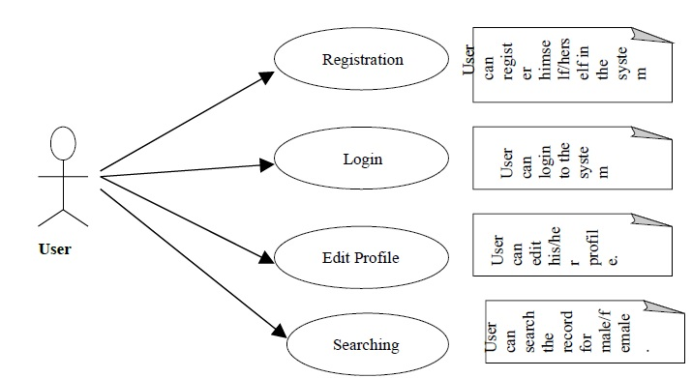

4.2 Sequence Diagram

4.2.1 Sequence diagram for Registration

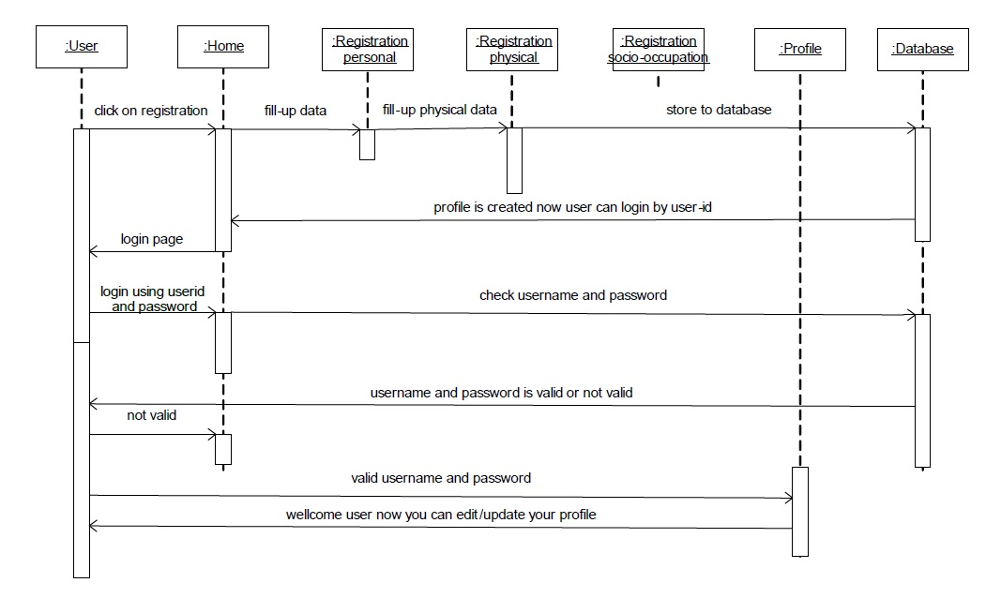

4.2.2 Sequence Diagram for Edit Profile

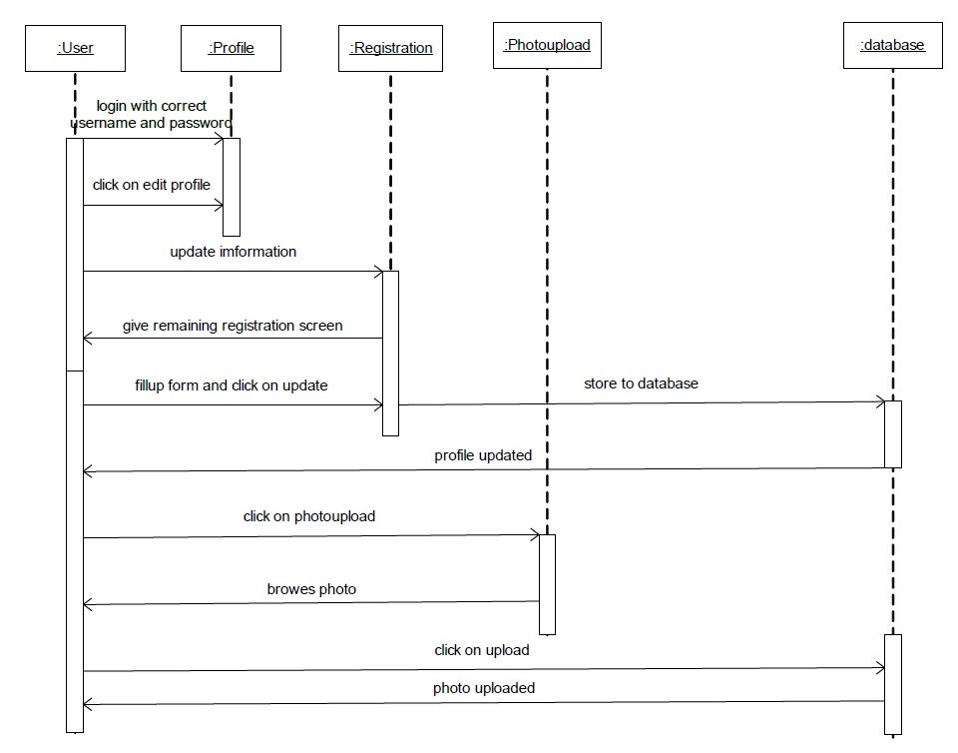

4.2.3 Sequence Diagram for Search

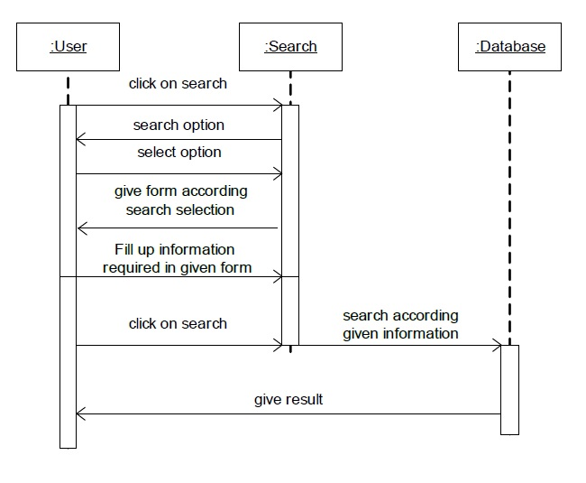

4.3 Data Flow Diagram (DFD)

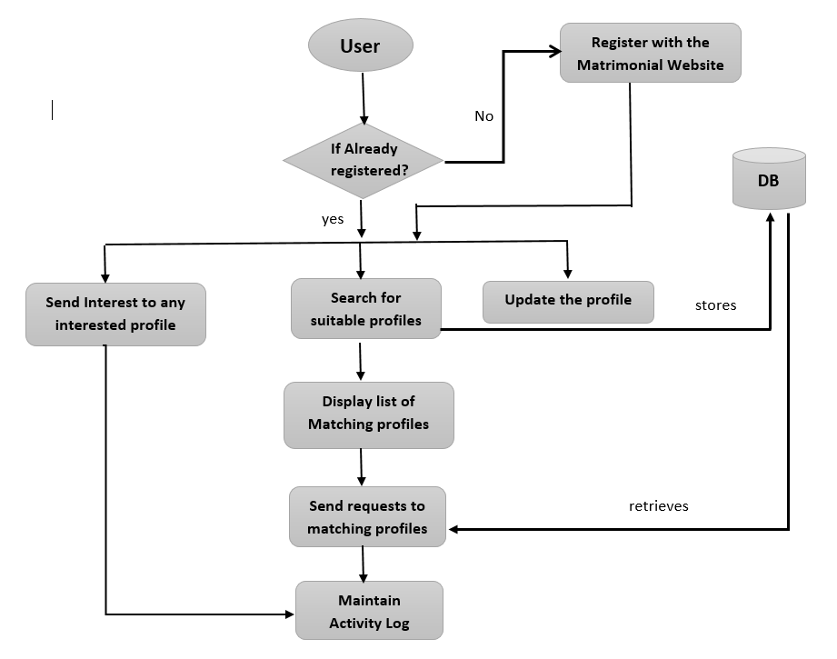

4.4 Class Diagram

