CatSight — Business & Domain Guide
A Plain-English Explanation of Reinsurance Math, Catastrophe Claims, and AI Contract Intelligence
Team Techno Crackers: Venket Raj S · Malik Chandra Pandian · Arun Veerappan · Nagaraj
Live URL: https://catsight-api-342162443546.us-central1.run.app | Code: https://github.com/venketraj/catsight-ai-buildercup-2026
Demo Video (< 3 min): https://drive.google.com/file/d/14Yv-A-KtVksOgRxOxafZcEKFBUvFumQi/view?usp=sharing
[DOCUMENT PURPOSE] This guide translates the entire CatSight project (synced to the final submission build, 870+ offline tests + 13 opt-in live tests, and 14-slide official AI Builder Cup submission deck) into everyday business language. It demystifies every reinsurance formula, explains why primary insurers and reinsurers argue over millions of dollars after natural disasters, and shows how CatSight delivers a verified portfolio view in 0.7 seconds (math) and 11.3 seconds p50 (full AI wording check).

1. The Real-World Problem: The Morning After a Disaster
Imagine a Category 5 typhoon—like Typhoon Jebi in September 2018—slams into Osaka, Japan. In reality, Jebi produced 857,284 insurance claims and ¥1,067.8bn paid out (the largest ever for a Japanese typhoon, per GIAJ). Early modelled estimates 10 days after landfall were $3–5.5bn (Moody's RMS), but the final insured loss grew to ~$13bn (Swiss Re).
Who pays for all of this? Local primary insurance companies (in our app, fictional insurers like "Sakura General Insurance" and "Yamabiko Casualty") sell property insurance to households and factories. When a typhoon strikes, thousands of customers file claims simultaneously. If a local insurer had to pay hundreds of millions of dollars from its own bank account, it would go bankrupt.
To protect themselves, primary insurers buy "Insurance for Insurance Companies"—called REINSURANCE—from global reinsurers (like Swiss Re, Munich Re, or in our app, our fictional company "Lion Re").
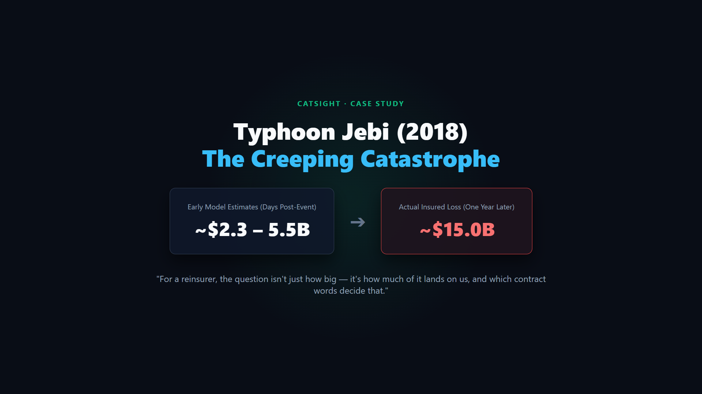
Figure 1: The morning after a typhoon — why reinsurers need a fast, defensible view of their own book.
The Bottleneck Today: The morning after a typhoon, the CFO of Lion Re asks: "Which of our treaties are hit, how much do we owe, and which contract clauses could change that number?"
Source / Workflow | When It Arrives | Why It Falls Short for One Reinsurer
Modeller event response (Moody's RMS) | 4 to 20 days | Describes the overall market or pre-coded terms, not your PDF wording
PERILS (Japan typhoon & flood) | 6 weeks | Market-wide industry loss report, not treaty-specific
Verisk PCS Japan (events >= $2bn) | Up to 90 days | Market-wide catastrophe index
In-house manual analyst workflow | 2 to 4 business days (30–60 analyst-hours) | Spreadsheets + re-reading 25+ exposed PDF contracts by hand
CatSight (on the reinsurer's own book) | 0.7s (math) · 11.3s p50 (verified AI flags) | Joins event × exposure × layers × verified PDF wording

Industry context (sourced): 48% of insurers do not license catastrophe models, and nearly 60% run cat teams of five or fewer people (Aon 2025). Moody's notes that outward reinsurance treaty structures often "only exist in their capital model, a homegrown tool, or even in a spreadsheet." Meanwhile, Singapore writes S$27.6bn of reinsurance premium (hosting 16 of the top 25 global reinsurers' regional hubs), yet 91% of Asia-Pacific's 2023 catastrophe losses ($65bn) were uninsured (MAS).
[POSITIONING] Where CatSight Fits (Complementary, Not a Replacement): CatSight is NOT a catastrophe model and does not compete with Moody's RMS or Verisk. Cat models estimate HOW BIG the loss is. CatSight is the layer after that: it joins an event footprint (public NOAA/USGS data today, or a licensed vendor footprint via the same typed interface) to the reinsurer's own treaties and reads their PDF wording.

2. Demystifying the Reinsurance Jargon (In Plain English)
You do not need an actuarial background to understand CatSight. Here are the six core terms:
A. Cedent vs. Reinsurer
- The Cedent (Primary Insurer): The primary insurance company that sells policies to homeowners and businesses (e.g., Sakura General Insurance, Yamabiko Casualty, Kogane Fire & Marine). They are called the 'Cedent' because they 'cede' (pass on) part of their disaster risk.
- The Reinsurer (Lion Re — "Us"): The company that accepts that ceded risk in exchange for an annual premium. In CatSight, we are Lion Re, holding a book of 24 treaties across 8 cedents in Japan, the Philippines, and Taiwan.
B. What is a "Treaty"? (Cat XL vs. Quota Share)
A Treaty is simply a formal 1-year contract PDF between a Cedent and its Reinsurers. CatSight handles two types of treaties:
- 1. Catastrophe Excess of Loss (CAT_XL): Works like stacked deductibles (layers). Reinsurers only pay when losses exceed a set threshold (Retention), up to a cap (Limit).
- 2. Quota Share (QS): A simpler proportional split: the reinsurer takes a fixed percentage (e.g., 40% cession_pct) of every dollar of loss from the very first dollar, sometimes up to an event_limit (e.g., Treaty T-006, T-021, T-022, T-023).
C. Layers, Retention, and Limit ("$20M xs $10M")
In a Cat XL treaty, coverage is sliced into horizontal tiers called Layers. When you see "$20M xs $10M", read it as "$20 Million limit in excess of a $10 Million retention (deductible)":
Tier / Layer | Contract Shorthand | Plain-English Meaning | Who Pays?
Cedent Retention | First $10M ($0 to $10M) | The insurer's deductible. The primary insurer pays the first $10M. | Cedent (100%)
Layer 1 (L1) | $20M xs $10M | Covers losses above $10M, up to a max payout of $20M (i.e., $10M to $30M). | Reinsurers on L1
Layer 2 (L2) | $30M xs $30M | Covers losses above $30M, up to a max payout of $30M (i.e., $30M to $60M). | Reinsurers on L2
Layer 3 (L3) | $40M xs $60M | Covers losses above $60M, up to a max payout of $40M (i.e., $60M to $100M). | Reinsurers on L3

D. "Our Share" vs. "All Reinsurers"
A single reinsurer rarely takes 100% of a layer. Instead, a syndicate of reinsurers each subscribes to a percentage share. For example, on Sakura's Layer 1 ($20M limit), Lion Re has a 25% share ($5M max payout), and on Layer 2 ($30M limit), Lion Re has a 10% share. That is why CatSight always shows three party views: What the Insurer Keeps, What All Reinsurers Pay, and Lion Re's Net ("Our Net").
E. Burn (Layer Erosion)
"Burn" is simply the percentage of a layer's limit used up by the disaster. If Layer 1 has a $20M limit and pays $20M, Burn = 100% (EXHAUSTED). If Layer 2 has a $30M limit and pays $24.3M, Burn = 81.0% ($24.3M / $30M).
F. Reinstatements & Reinstatement Premium (RIP) — Reloading the Shield
Think of a reinsurance layer as a protective shield. When Typhoon Jebi burns 100% of Layer 1 in September, that shield is used up. If another typhoon (like Typhoon Trami) hits three weeks later, the primary insurer would have zero Layer 1 protection left!
To prevent this, treaties include a REINSTATEMENT clause: the reinsurers automatically reload the burned portion of the layer for the rest of the contract year. However, reloading is not free—the primary insurer must pay a reload fee called a REINSTATEMENT PREMIUM (RIP):
[HOW RIP AFFECTS THE MONEY] Exact Reinstatement Premium (RIP) Rule (Per Occurrence):
RIP = (Limit Eroded in Occurrence / Layer Limit) × Layer Premium × Reinstatement Rate
Key Financial Effect:
• Insurer's Net Cost = Retention + RIP Payable (+ any Excluded Loss)
• Reinsurers' Net Cost = Claims Paid (Ceded) - RIP Received
Because the cedent pays RIP to the reinsurer, RIP increases the insurer's cost and reduces the reinsurer's net loss!

3. Step-by-Step Numerical Examples (How the Engine Calculates)
Every money figure in CatSight comes from deterministic Python using exact Decimal math (870+ offline tests + 13 opt-in live tests). Here are the two core worked examples from our documentation (`docs/DOMAIN_PRIMER.md` and `docs/MONEY_MOMENT.md`):
Example 1: One Event vs. Two Events Under an Hours Clause ($54.4M Gross Loss)
Suppose Sakura General Insurance suffers $54.4M in gross losses. Its treaty has Layer 1 ($20M xs $10M, premium $2.0M, Lion Re share 25%, 1 reinstatement @ 100%) and Layer 2 ($30M xs $30M, premium $1.5M, Lion Re share 10%).
- Reading A — Treated as ONE Event ($54.4M): First $10.0M is Cedent Retention. Layer 1 pays its full $20.0M limit (100% burn). Layer 2 pays $24.4M ($54.4M - $30M, 81.3% burn). Total Ceded = $44.4M. Lion Re gross loss = (25% × $20M) + (10% × $24.4M) = $5.00M + $2.44M = $7.44M. Lion Re RIP received = (20/20 × $2.0M × 25%) + (24.4/30 × $1.5M × 10%) = $0.500M + $0.122M = $0.622M. Lion Re Net = $7.44M - $0.622M = $6.82M.
- Reading B — Split into TWO Events ($35.0M + $19.4M): If the hours clause splits the storm into two separate occurrences, the insurer must pay its $10M deductible TWICE ($20.0M total retention)! Occurrence 1 ($35.0M) burns $20.0M of L1 and $5.0M of L2. Occurrence 2 ($19.4M) burns $9.4M of the reinstated L1 and $0 of L2. Total Ceded drops from $44.4M to $34.4M (-$10.0M / -22.5%). Layer 2 drops by -80% ($24.4M -> $5.0M). Wait—what happens to Lion Re? Because Lion Re holds 25% of L1 (which now pays $29.4M instead of $20.0M) and only 10% of L2, Lion Re's net loss actually INCREASES from $6.82M to $7.33M (+$0.51M / +7.4%)!
[THE ASYMMETRY INSIGHT] Why This Matters: In Example 1, splitting the storm into two events saves the overall reinsurance market $9.03M net, but COSTS Lion Re $0.51M more because Lion Re's share is concentrated in Layer 1! A single headline number would hide that.

Example 2: The Live Jebi Clause Courtroom — Storm-Surge Exclusion (Treaty T-004)
On Jebi's real 9-hour timeline, all wind damage occurs within 9 hours (so no 72-hour clause is breached in reality; hours-clause splits are explored in the What-if panel, clearly labelled HYPOTHETICAL). For Jebi, the real live dispute is on Treaty T-004 (Yamabiko Casualty): JMA recorded a 329 cm storm surge in Osaka Bay that flooded Kansai Airport, and T-004 (Page 2, Clause 8) excludes Storm Surge!
Party / Metric | Base (0% Excluded) | 20% Surge Share (Recorded Live Run) | 30% Surge Share (Reference) | Direction
Gross Loss to Treaty T-004 | $58.18M | $46.54M (-$11.64M) | $40.72M (-$17.46M) | Excluded loss leaves the treaty
Total Ceded (Gross Recoveries) | $39.58M | $27.94M (-$11.64M) | $22.12M (-$17.46M) | Less loss reaches Layer 1 & Layer 2
Insurer's Net Cost (Retention + RIP + Excluded) | $22.79M | $33.10M (+$10.31M) | $38.30M (+$15.51M) | Insurer carries the excluded surge loss
All Reinsurers Pay (Recoveries - RIP) | $35.39M | $25.08M (-$10.31M) | $19.88M (-$15.51M) | Reinsurers save exactly what insurer loses
Lion Re Net ("Our Net") | $7.61M | $6.27M (-$1.34M) | $5.17M (-$2.44M) | Lion Re saves money under exclusion

4. The CatSight 5-Step Analyst Walkthrough (With Screenshots)
The live application (https://catsight-api-342162443546.us-central1.run.app) is laid out for a judge or analyst in five clear steps under a sticky summary bar. Visitors can click 'Instant replay' (~6s recorded real run) or 'Run live' (~15s live Gemini agents):
Step 1: Event — The Disaster Facts
Loads the historical catastrophe track (NOAA IBTrACS for typhoons or USGS ShakeMap for earthquakes), event window (start, end, duration_h), and verified JMA facts (e.g., Kansai Airport 58.1 m/s gust; Osaka 329 cm record storm-surge tide).
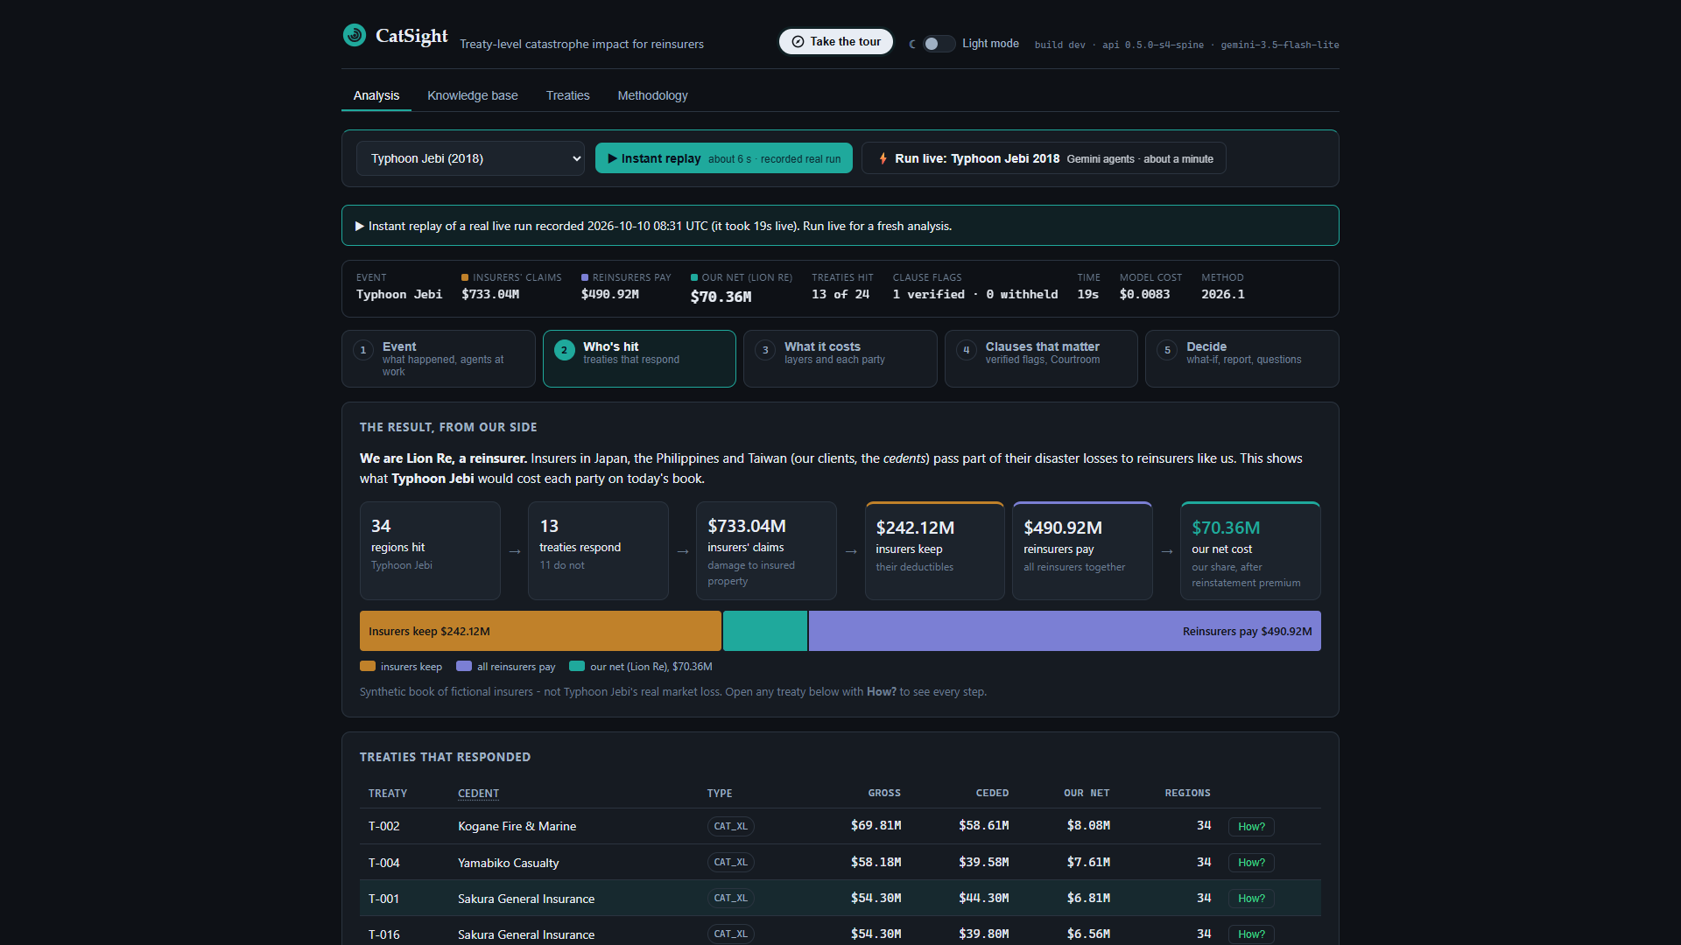
Figure 2: Step 1 (Event) — Selecting Typhoon Jebi (2018) and viewing its storm track and JMA facts.
Step 2: Who's Hit — Regional Exposure Overlay
Colours all 34 affected Japanese prefectures by peak wind or shaking intensity. Clicking any region reveals the insured property value by insurer, alongside a full accessible table alternative.
Figure 3: Step 2 (Who's Hit) — Choropleth map of peak winds and regional insured values.
Step 3: What It Costs — Deterministic Layer Waterfall
Within 0.7 seconds (p50), the deterministic loss engine matches all 24 treaties (13 matched, 11 excluded with reasons—e.g., PHL or TWN territory) and computes gross loss ($733.04M), insurer retention ($242.12M), all reinsurers ($490.92M), and Lion Re's net ($70.36M). Clicking 'How was this calculated?' shows every treaty's region-by-region damage and layer formulas.
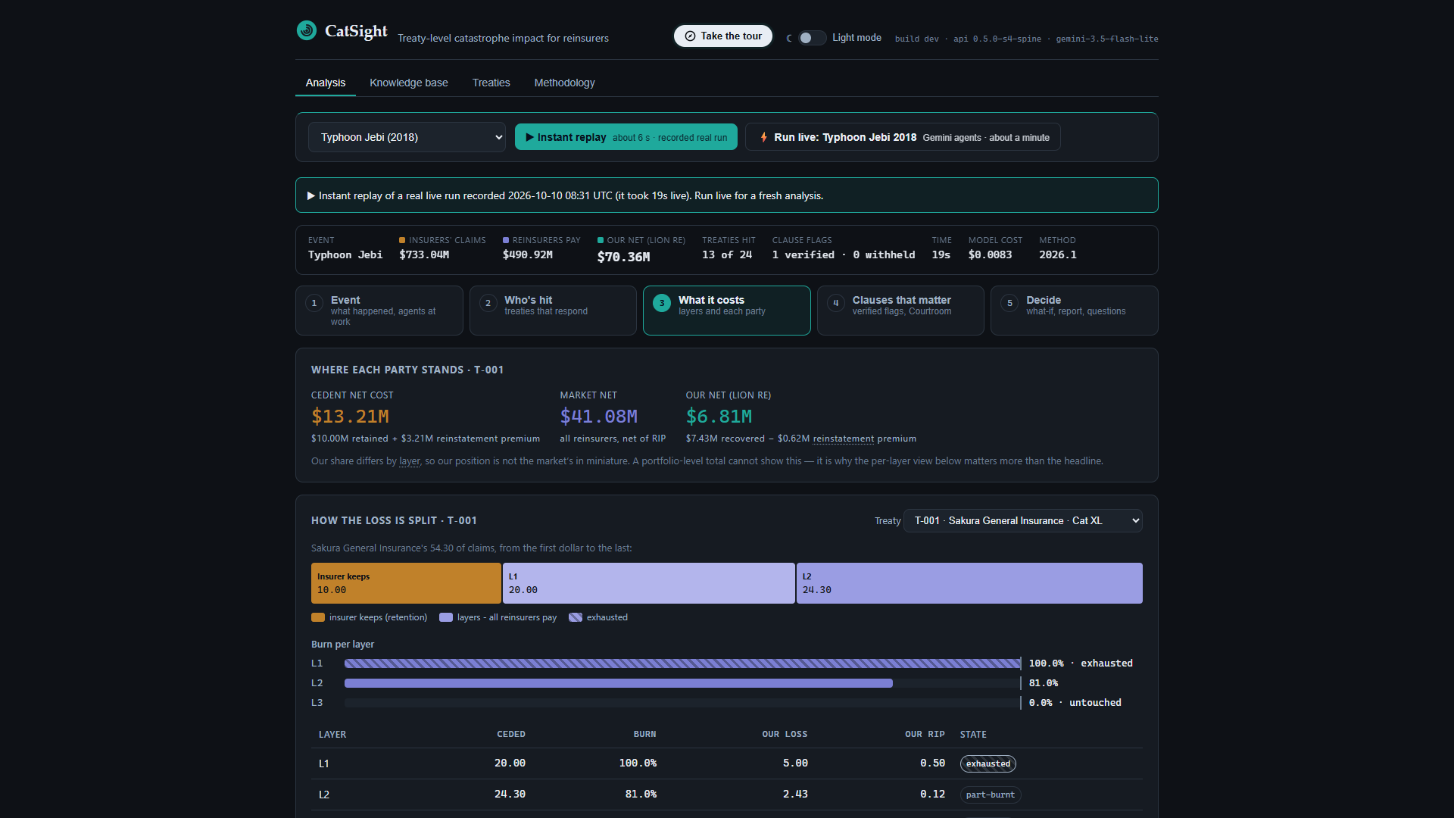
Figure 4: Step 3 (What It Costs) — Three-party financial bar and treaty-by-treaty layer breakdown.
Step 4: Clauses That Matter — Verified Citations & The Endorsement Detective
While the analyst views the numbers, Gemini 3.5 Flash-Lite searches the 252 clause vectors in Firestore and raises wording flags. Every candidate flag passes through our Verifier Loop: (1) deterministic normalized & word-aligned '...' fragment match against the stored clause text, and (2) a semantic support check on Gemini 3.8 Flash. Failed flags get one revision retry; if they still fail, they are WITHHELD and counted in the header ('n of n displayed citations verified · k withheld').
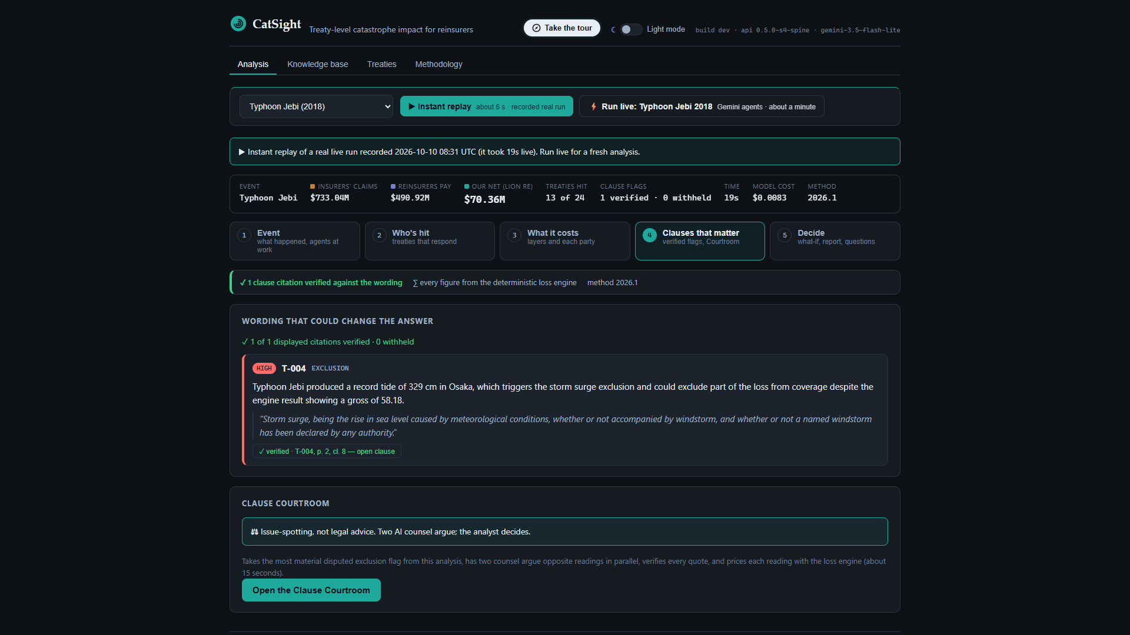
Figure 5: Step 4 (Clauses That Matter) — Machine-verified wording flags and the bounded What-if tool.
The Endorsement Detective: Treaty T-004 has a 72-hour windstorm clause on Page 2, but Page 7 is a scanned, stamped image endorsement with no text layer that amends Windstorm to 168 consecutive hours. Gemini transcribes the image once at ingest, flags the override, and badges citations to it distinctly as 'transcribed' rather than 'verified'.
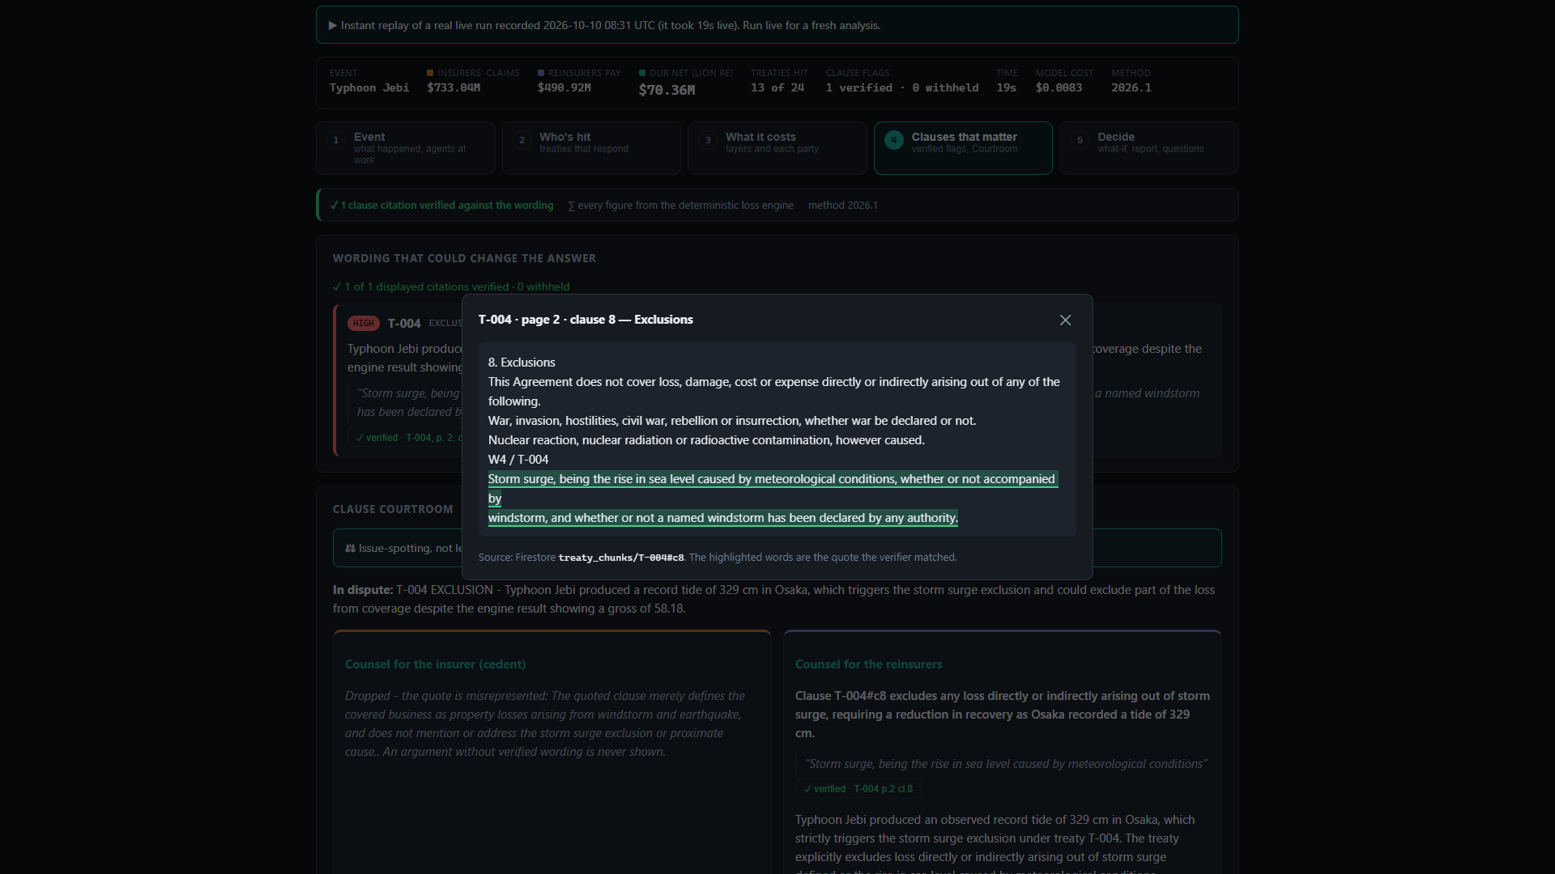
Figure 6: The Treaty Clause Viewer showing T-004's transcribed scanned endorsement overriding the base contract.
Step 4b: The Clause Courtroom (Adversarial Multi-Agent Fan-Out)
When a verified HIGH or MEDIUM exclusion flag is present (like T-004's storm-surge exclusion), the analyst can open the Clause Courtroom. Two ADK agents (cedent_counsel and reinsurer_counsel) run in parallel, blind to each other, arguing opposing readings from verified quotes (with 1 revision retry and '...' fragment matching). Each states an excluded surge share assumption (bounded 0–50%), the Python engine prices both sides, and an Arbiter (on Gemini 3.8 Flash) summarises the dispute without deciding it.
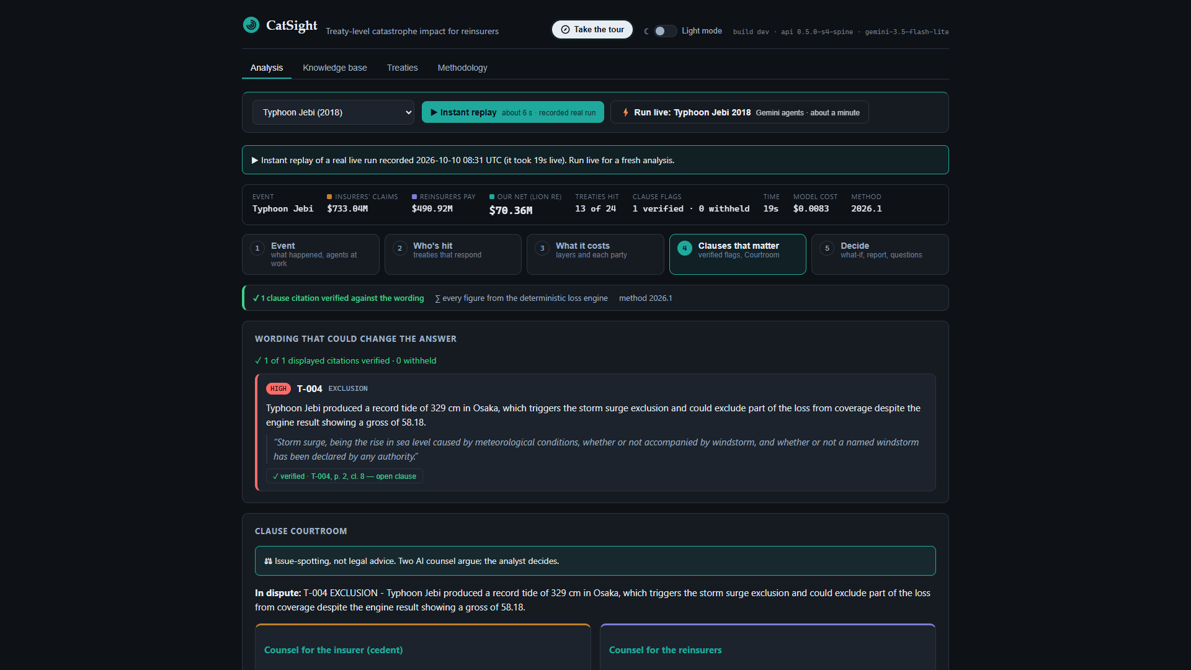
Figure 7: The Clause Courtroom — Parallel AI counsel, engine-priced outcomes, and analyst position recording.
Step 5: Decide & Export
The analyst records their position on the dispute (Insurer's reading, Reinsurers' reading, or Unresolved) with an audit timestamp, reviews the AI-generated report (where every single number is checked in Python against the engine's output), and downloads a formatted Word (.docx) or Markdown underwriting memo.
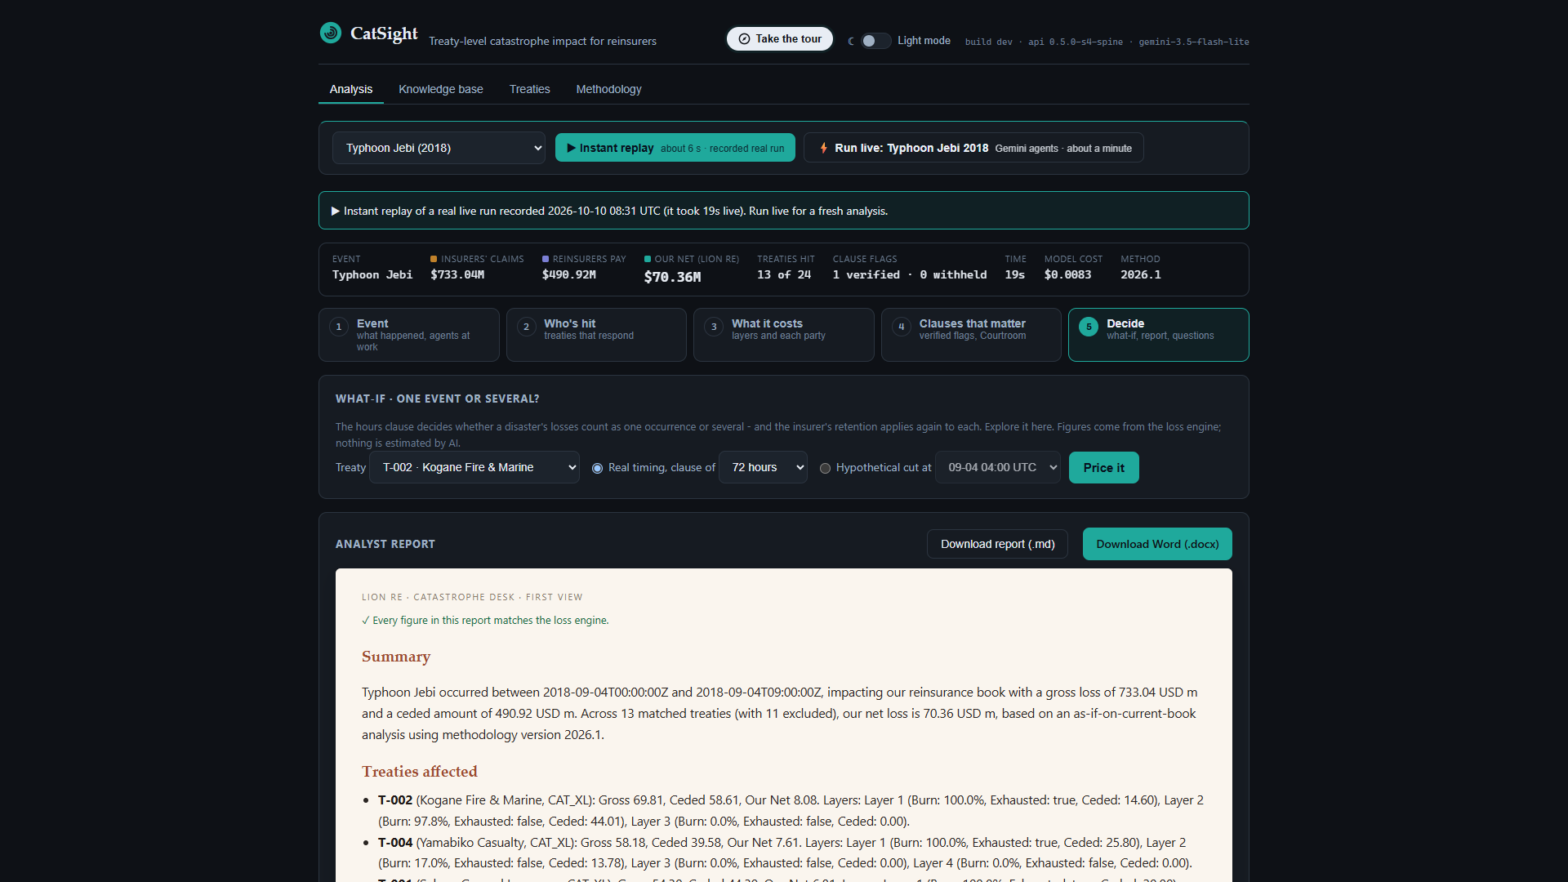
Figure 8: Step 5 (Decide) — Traceable executive report and one-click Word (.docx) / Markdown export.
5. Google Cloud Architecture & Measured Proof Pack
CatSight runs as a single Cloud Run service serving both the FastAPI SSE backend and the React UI from the same origin, backed by two Google ADK 2.11 Workflow graphs, Gemini Enterprise Agent Platform (formerly Vertex AI) global endpoints, Firestore Native vector search, and Cloud Trace/Monitoring.
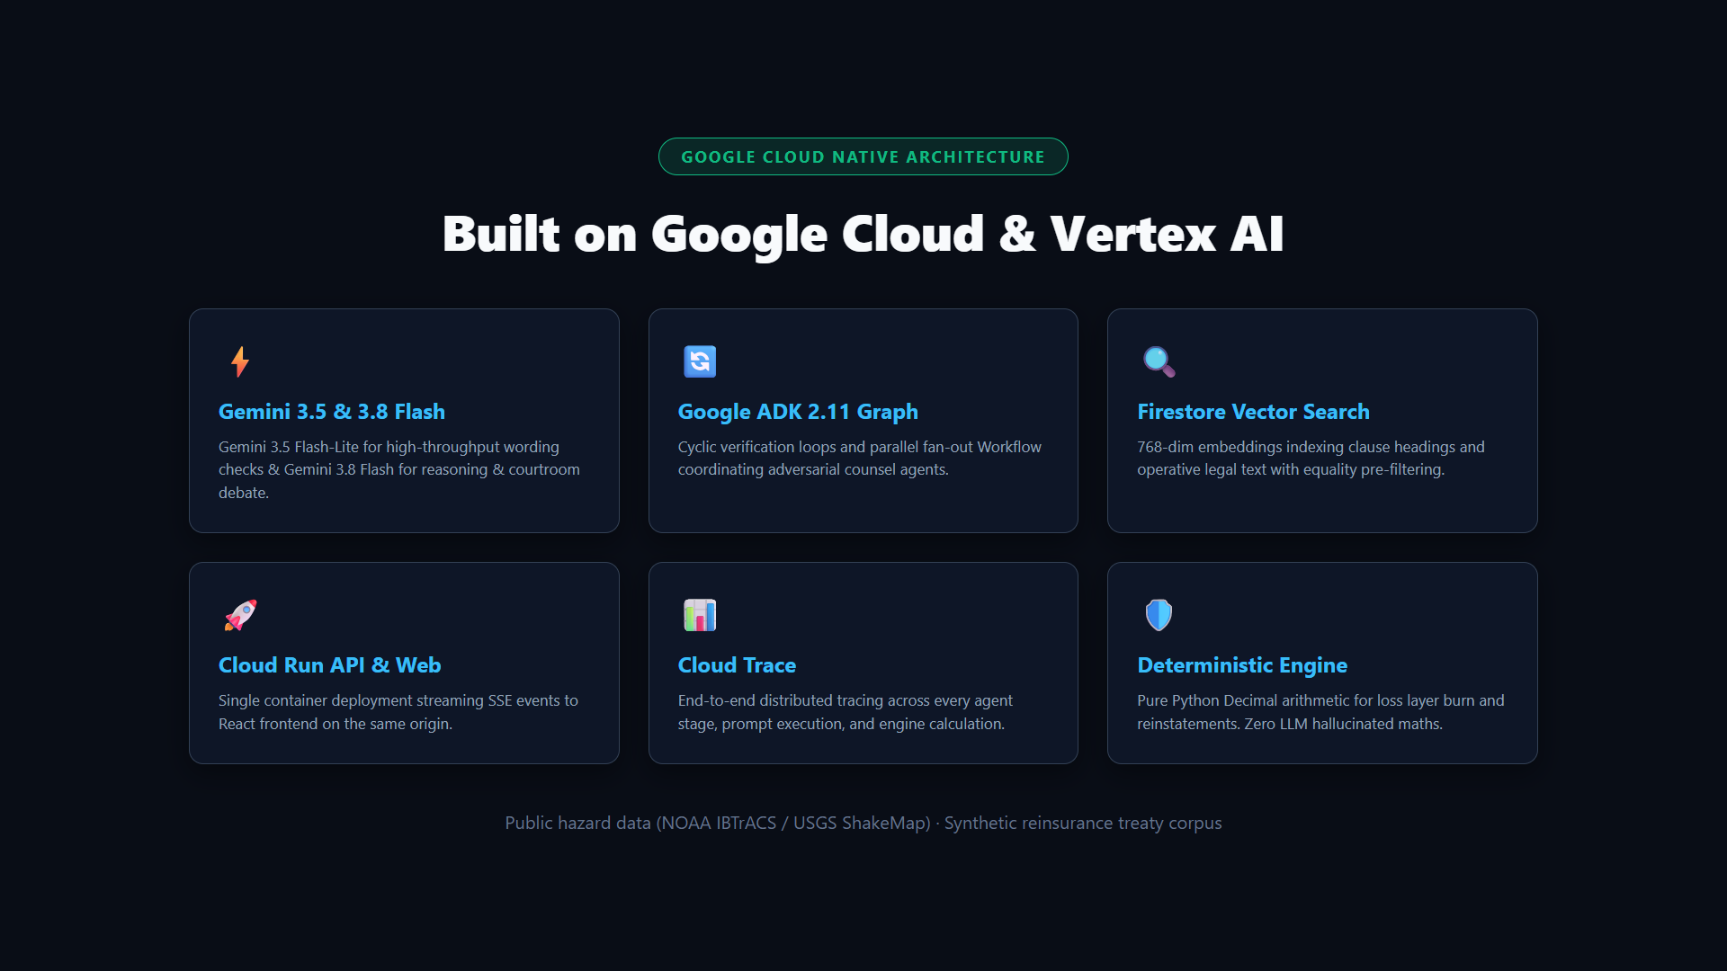
Figure 9: Google Cloud Architecture — ADK 2.11 Workflows, Gemini Enterprise Agent Platform (Vertex AI), Firestore Vector Search, and Cloud Run.
Benchmark / Metric | Measured Result | Notes & Audit Trail (`docs/RESULTS.md`)
Loss engine vs. hand-checked worked example | Exact (100%) | 870+ offline tests + 13 opt-in live tests (`Decimal` half-up)
Time to money on screen (10-run live benchmark) | 0.7 s p50 (0.5–1.1 s) | Engine runs before LLM agents
Complete live analysis with verified flags | 11.3 s p50 (7.8–19.3 s) | Warm Cloud Run service, SSE with 15s heartbeat
Model cost per live analysis | $0.0097 p50 ($0.0081–$0.0140) | Measured from Gemini token usage
Clause Courtroom latency & cost | 8.0 s p50 · $0.0052 p50 | Ran in 8 of 10 live analyses (skipped in 2 when the verifier withheld the T-004 flag); both sides verified in all 8.
Treaty-term extraction (RAG-first, 8 wordings) | 99.5% (185/186 fields) in 57 s | Upper bound on tuned set (vs ~25 min whole-doc)
Governing clause retrieved | 186/186 (100%) | Firestore 768-dim vector search with treaty_id pre-filter
Per-field citation audit | 186/188 cited · 185/186 verified | 184 verified + 1 transcribed; 1 unverified withheld
Untraceable figures in AI reports | 0 across all live runs | Every number checked against engine output in code

