DATA FOR THE MODEL
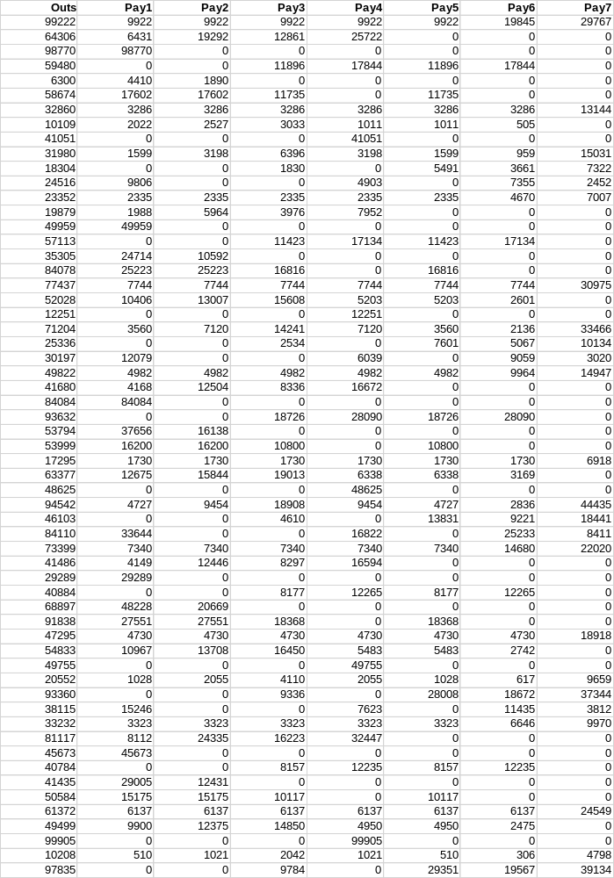
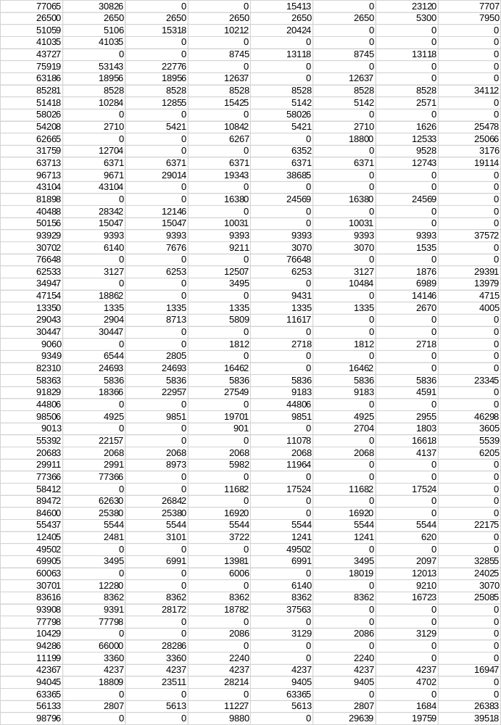
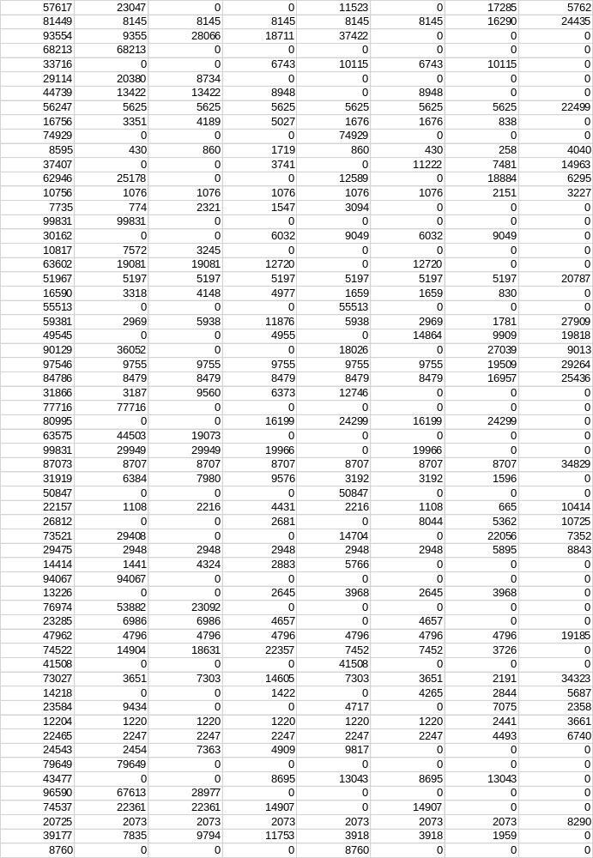
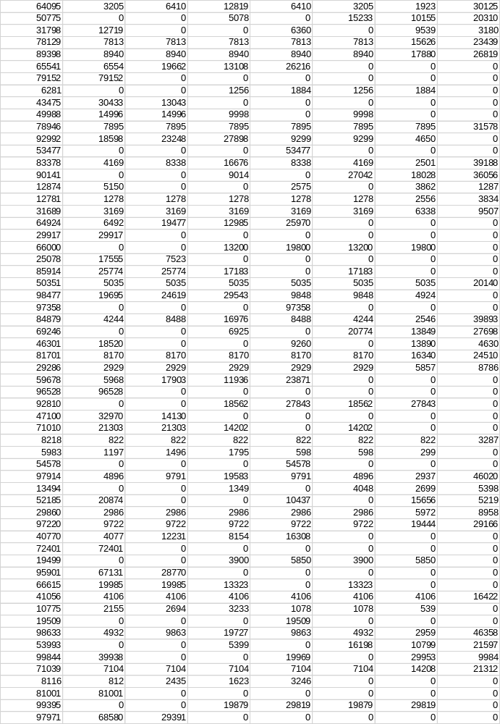
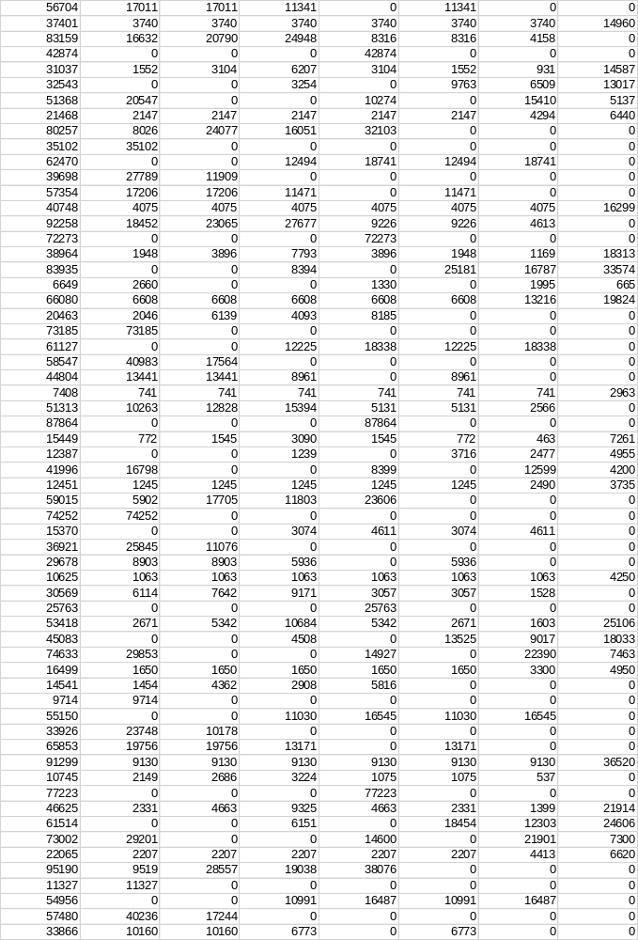

MODEL
from google.colab import drive
import pandas as pd
import numpy as np
import csv
import matplotlib.pyplot as plt
drive.mount('/content/gdrive')
df=pd.read_csv('/content/gdrive/My Drive/csvdata1.csv',nrows=300)
usecols=["outs","pay1","pay2","pay3","pay4","pay5","pay6","pay7"]
out1=df['Outs']
p1=df['Pay1']
p2=df['Pay2']
p3=df['Pay3']
p4=df['Pay4']
p5=df['Pay5']
p6=df['Pay6']
p7=df['Pay7']
c1=0
c2=0
c3=0
c4=0
c5=0
c6=0
c7=0
c8=0
t1=0
t2=0
t3=0
t4=0
t5=0
t6=0
t7=0
t8=0
x1=p1-out1
x2=p1+p2-out1
x3=p1+p2+p3-out1
x4=p1+p2+p3+p4-out1
x5=p1+p2+p3+p4+p5-out1
x6=p1+p2+p3+p4+p5+p6-out1
x7=p1+p2+p3+p4+p5+p6+p7-out1
c1 = (x1 >=0).sum()
print(c1)
c2=((x2>=0).sum()) - c1
print(c2)
c3=((x3>=0).sum())-c2-c1
print(c3)
c4=((x4>=0).sum())-c3-c2-c1
print(c4)
c5=((x5>=0).sum())-c4-c3-c2-c1
print(c5)
c6=((x6>=0).sum())-c5-c4-c3-c2-c1
print(c6)
c7=((x7>=0).sum())-c6-c5-c4-c3-c2-c1
print(c7)
t1 = out1[x1 >= 0].sum()
print(t1)
t2 = out1[x2 >= 0].sum()
print(t2)
t3 = out1[x3 >= 0].sum()
print(t3)
t4 = out1[x4 >= 0].sum()
print(t4)
t5 = out1[x5 >= 0].sum()
print(t5)
t6 = out1[x6 >= 0].sum()
print(t6)
t7 = out1[x7 >= 0].sum()
print(t7)

