**UART – Hardware communication protocol design**

**KARNATI PARANJAI**

**IEC2021097**

**Final Year Student, B-Tech ECE, IIIT ALLAHABAD**

**SAMPLE OUTPUTS**

1. Sample testbench and the corresponding output for **uart module** :

Testbench :

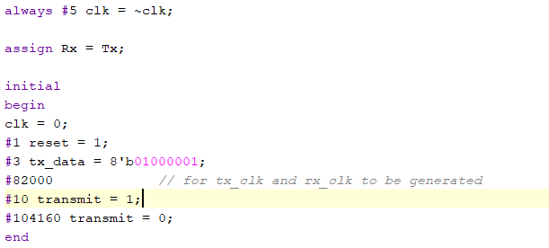

Output :

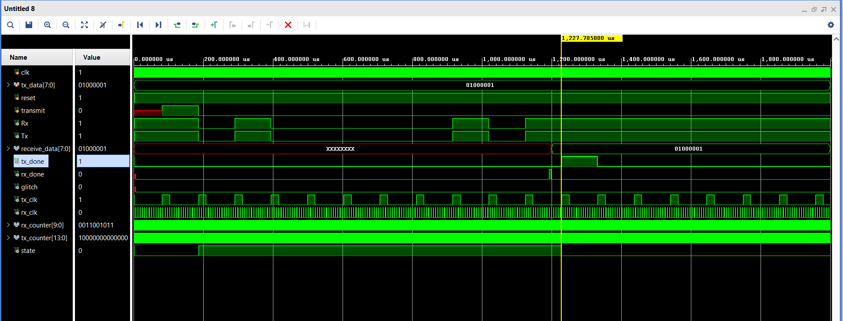

1. Sample Testbench and corresponding output for uart_transmitter (**uart_tx**) module :

Test Bench:

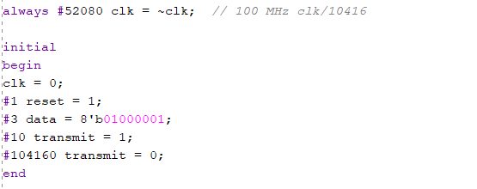

Output:

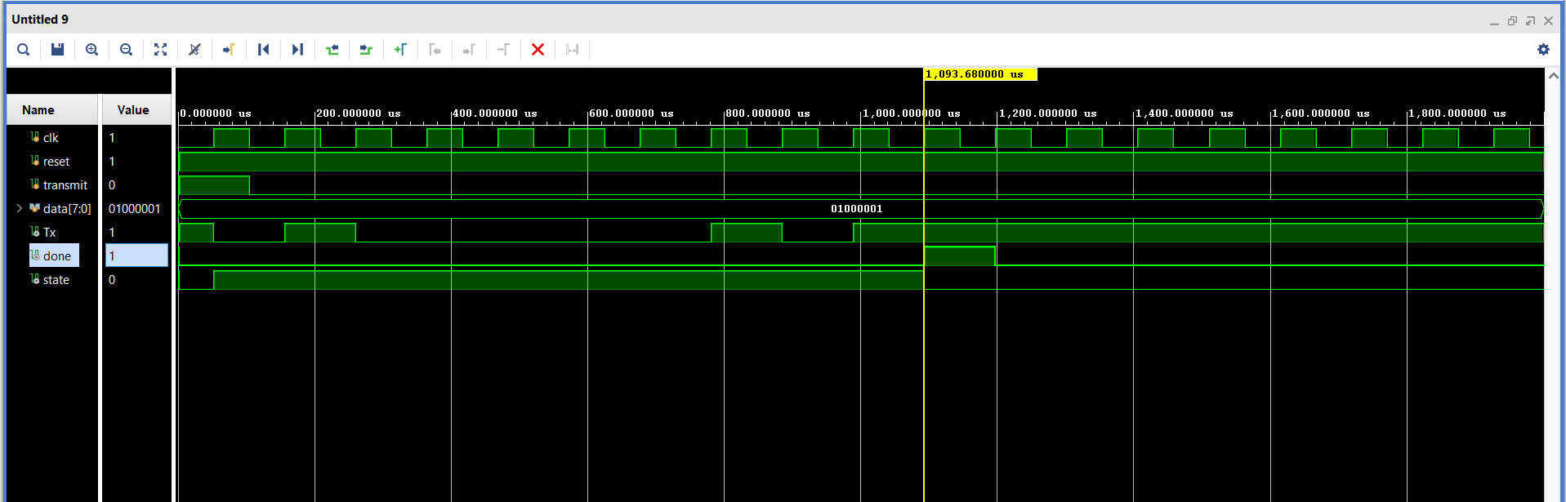

1. Sample Testbench and corresponding output for uart_receiver (**uart_rx**) module: (**without glitch**)

Testbench:

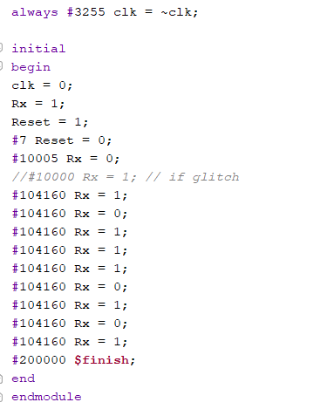

Output :

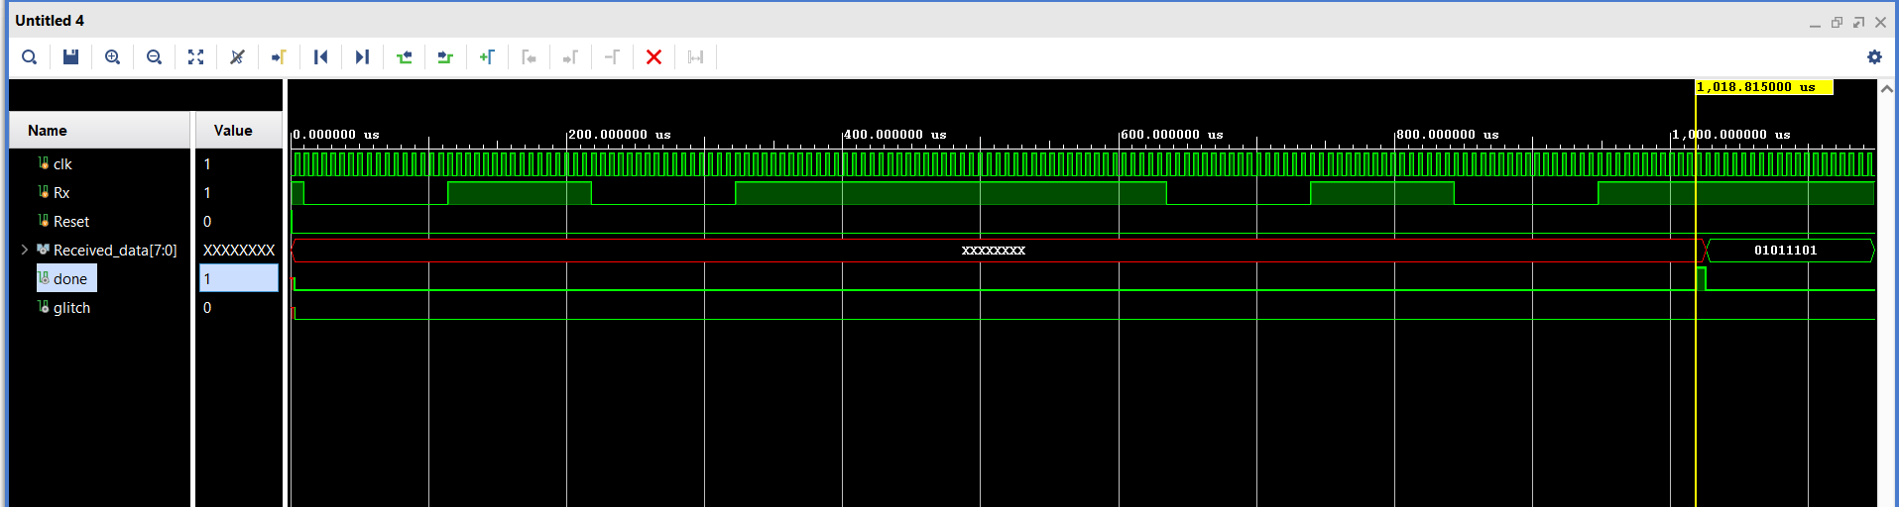

1. Sample Testbench and corresponding output for the **uart_rx** module **with a glitch** :

Test bench:

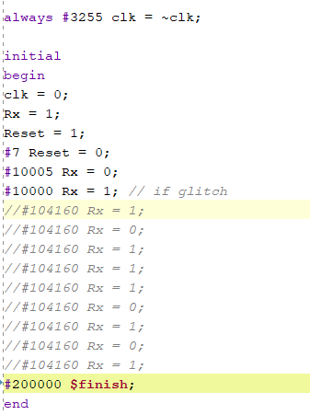

Output :

