Deepfake Images and Fake News Detection: Challenges, Methods, and Future Directions

Abstract--Accessible generative-media tools have increased the need for systems that can screen both manipulated facial images and misleading text. This paper presents a lightweight multimodal framework with an EfficientNet-based binary image classifier, a TF-IDF and logistic-regression news classifier, a Flask API, and Android and web interfaces. The image pipeline uses stratified train, validation, and test partitions, transfer learning, augmentation, fine-tuning, threshold calibration, and uncertainty rejection. The completed V2 image model achieved 80.41% balanced accuracy on a held-out test set, with recalls of 76.09% for fake images and 84.73% for real images. In a source-held-out evaluation, the text model achieved 65.4% accuracy but only 0.481 macro-F1, revealing substantial cross-source distribution shift. The results show that a practical screening tool can run with moderate computing resources, but they also expose the limits of closed-set classification. Low-confidence outputs are therefore marked as uncertain, and all predictions are presented as decision support rather than forensic proof.
Index Terms--deepfake detection, fake news, EfficientNet, transfer learning, uncertainty, Android

I. INTRODUCTION
Synthetic facial imagery and rapidly circulated misinformation undermine trust in digital communication. Modern generation tools can produce convincing faces, while misleading articles may imitate the language of legitimate reporting. Although both problems concern information integrity, they require different representations: spatial artifacts for images and statistical language patterns for text. FaceForensics++ demonstrated the scale of facial-manipulation research and the sensitivity of detectors to manipulation method and compression [1]. FakeNewsNet likewise showed that article text alone does not capture the social context and propagation patterns associated with misinformation [2].
This work develops a practical screening application that accepts either a facial image or news text and returns a calibrated result through web and Android interfaces. It does not claim universal forensic detection. Instead, it combines independently trained visual and textual models behind one service, evaluates them with class-balanced and cross-source protocols, and introduces a manual-review state for uncertain predictions. The main contributions are: (1) a resource-conscious image pipeline based on transfer learning and calibrated binary decisions; (2) a source-aware text evaluation that exposes dataset shift; (3) a Flask REST interface shared by web and mobile clients; and (4) a hard-example-mining design for improving difficult visual cases without changing labels or hard-coding individual samples.

II. RELATED WORK
A. Visual Manipulation Detection
Rossler et al. introduced FaceForensics++, a benchmark containing pristine content and several manipulation families, and showed that face-focused processing and domain knowledge can improve detection [1].
Model architecture also affects whether a detector is practical. MobileNetV2 uses inverted residuals and linear bottlenecks for efficient inference on constrained hardware [3]. EfficientNet jointly scales network depth, width, and resolution [4], whereas EfficientNetV2 uses training-aware architecture search and fused mobile inverted bottlenecks to improve training speed and parameter efficiency [5].
These developments motivated the progression from MobileNetV2 and EfficientNet-B0 baselines to the EfficientNetV2-B0 design proposed for the V3 experiment.
B. Misinformation and Fact Verification
Misinformation datasets capture different aspects of the problem. FakeNewsNet combines article content with social and spatiotemporal context [2]. FEVER contains 185,445 human-written claims labeled as supported, refuted, or not enough information, together with evidence for supported and refuted claims [6]. Fakeddit provides more than one million multimodal samples with fine-grained labels [7].
The text component in this work is a linguistic-pattern classifier, not an evidence-retrieval fact checker. TF-IDF with logistic regression can learn vocabulary and style associated with particular sources, but it cannot determine whether a current factual claim is true. This distinction is important when interpreting its output.

III. SYSTEM ARCHITECTURE
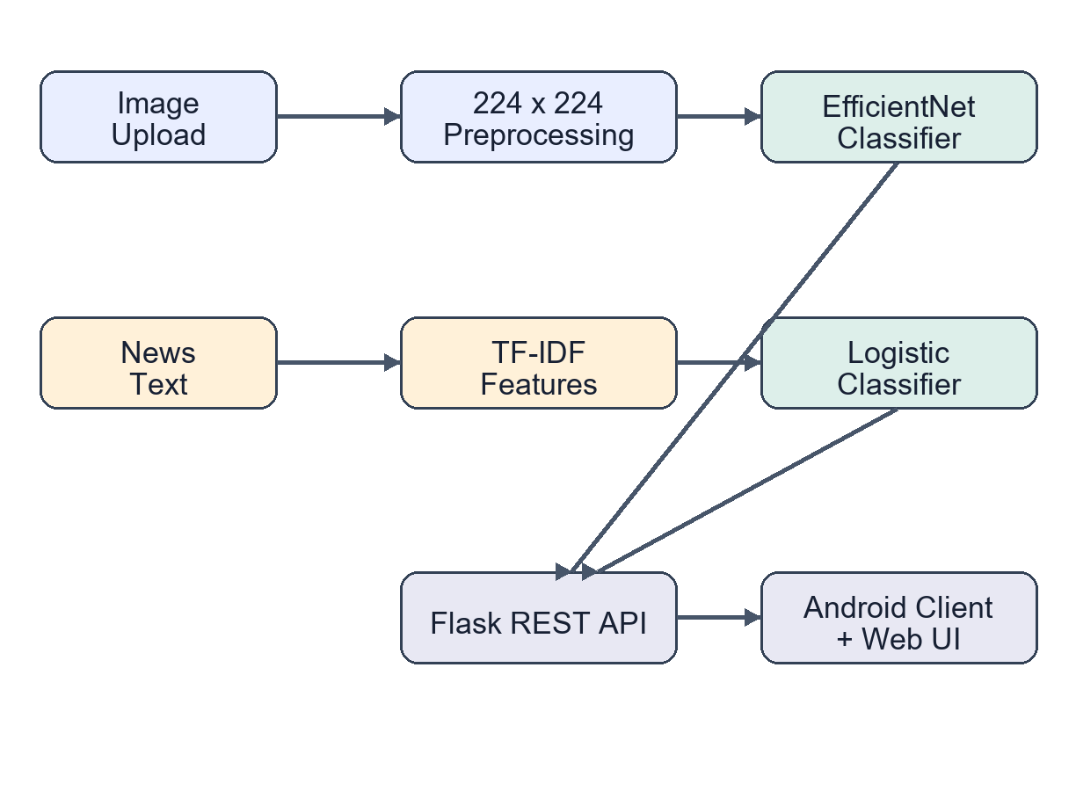Fig. 1. End-to-end architecture of the dual screening system.
Figure 1 shows two independent inference paths. Images are decoded to RGB, resized, and evaluated by the convolutional model. Text is normalized and converted into sparse TF-IDF vectors before classification.
Both branches are exposed through Flask API endpoints. The Android client uploads images as multipart form data and submits news text as JSON. The server can also produce an artifact map that highlights local high-frequency inconsistencies. This visualization is descriptive rather than causal and must not be treated as proof of manipulation.
IV. METHODOLOGY
A. Image Dataset and Partitioning
The local image corpus contains 22,044 facial images: 10,961 labeled fake and 11,083 labeled real. Two stratified splits with a fixed seed of 42 produce approximately 70% training, 15% validation, and 15% test data. Stratification preserves the nearly balanced class distribution and reduces class-order artifacts. V2 resizes images to 160 x 160 pixels and applies horizontal flipping, small rotations, zoom, and contrast variation. Fig. 2. Image-model training and evaluation workflow.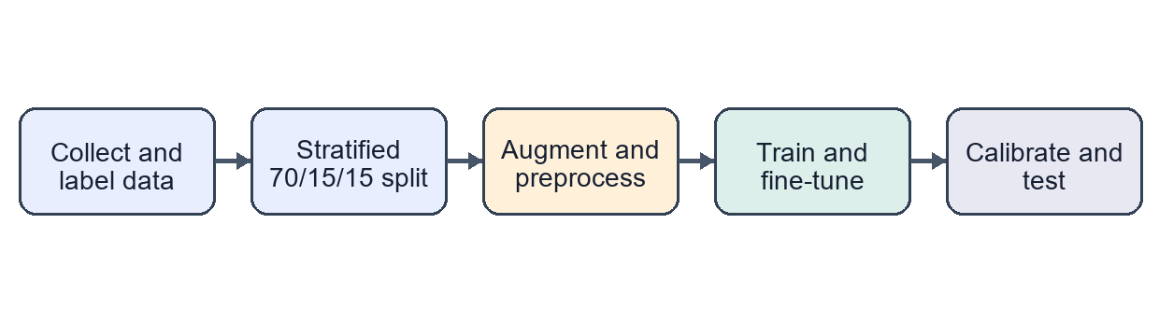
B. Transfer Learning and Calibration
V2 uses an ImageNet-pretrained EfficientNet-B0 backbone. During the first training stage, the backbone is frozen while a global-average-pooling layer, dropout, and sigmoid output are optimized. The final 25 backbone layers are then unfrozen and fine-tuned at a lower learning rate.
Training minimizes binary cross-entropy. Validation ROC-AUC is used for checkpoint selection and early stopping.
The model returns p_r, the estimated probability of the real class. A decision threshold tau is selected on the validation set by maximizing balanced accuracy:$p_{r}τ$
$$BA\left(τ\right)=\frac{1}{2}\left[{\text{Recall}}_{\text{fake}}\left(τ\right)+{\text{Recall}}_{\text{real}}\left(τ\right)\right] \left(1\right)$$
Threshold calibration alone does not make every probability reliable. The system rejects a prediction when the maximum class probability is below 0.65 or when the score is close to the selected threshold. These borderline cases are sent for manual review instead of being reported as definitive decisions.$τ$
C. V3 Hard-Example Design
The V3 design increases input resolution to 224 x 224 pixels, preserves aspect ratio through padding, adopts EfficientNetV2-B0, and uses binary focal loss. Focal loss reduces the influence of easy samples and places more emphasis on difficult examples [8].
After conventional training and fine-tuning, the training set is rescored. Misclassified samples receive four times the standard sample weight during a final low-learning-rate optimization stage. V3 results are not reported because training was still in progress when the manuscript was prepared.
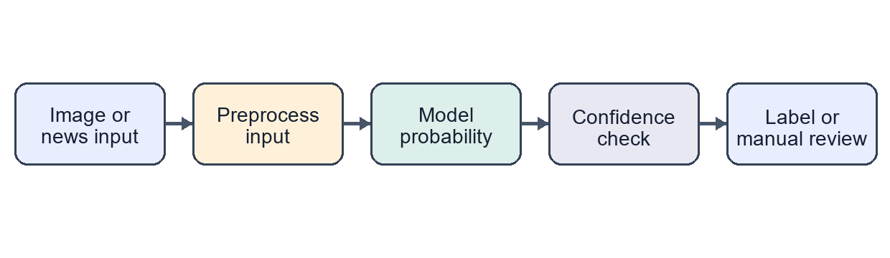
Fig. 3. Runtime prediction and uncertainty-handling workflow.
D. Text Classification
The prepared news corpus contains 186,032 records drawn from WELFake, FakeNewsNet, and FEVER-derived data. Text is normalized, and entries shorter than 20 characters are removed. The remaining documents are represented with lowercase word unigrams and bigrams. TF-IDF uses sublinear term frequency, English stop-word removal, and a vocabulary limit of 100,000 features.
A class-balanced logistic-regression model estimates the probabilities of fake and real news. The weight of feature t in document d is defined as:$td$
$$w\left(t,d\right)=\left[1+\log{\text{tf}}\left(t,d\right)\right]\log\left[\frac{N}{\text{df}\left(t\right)}\right] \left(2\right)$$
Evaluation uses GroupShuffleSplit with dataset source as the grouping variable, so every record from the held-out source remains outside the training data. After evaluation, the production model is fitted on all available records. Scores from 0.35 to 0.65 return a 'needs fact-check' result.
V. EXPERIMENTAL RESULTS
TABLE I
IMAGE MODEL RESULTS (%)
Model | Split | Bal. Acc. | Fake Rec. | Real Rec.
Three-model ensemble | Validation | 77.50 | 70.30 | 84.70
EfficientNet-B0 V2 | Validation | 81.48 | — | —
EfficientNet-B0 V2 | Test | 80.41 | 76.09 | 84.73
Table I summarizes the completed image experiments. V2 obtained higher validation balanced accuracy than the earlier three-model ensemble, although the comparison should be interpreted cautiously because the pipelines used different splitting procedures. On the V2 test set, real-image recall exceeded fake-image recall by 8.64 percentage points, indicating that missed manipulations remain an important weakness.
TABLE II
CROSS-SOURCE TEXT RESULTS
Metric | Fake | Real | Overall
Precision | 0.215 | 0.748 | —
Recall | 0.155 | 0.817 | —
F1-score | 0.180 | 0.781 | 0.481 macro
Accuracy | — | — | 0.654
FakeNewsNet was held out for the source-aware text evaluation. As Table II shows, overall accuracy is influenced by the larger number of real articles. Macro-F1 gives a clearer view of cross-source performance. A fake-class recall of 0.155 means that the lexical model misses most fake articles from the unseen source. The text module should therefore be treated as a pattern-based screener, not as a truth-verification system.
VI. DEPLOYMENT
The Flask backend provides POST /api/predict-image and POST /api/predict-news endpoints. The image endpoint assigns a randomized upload name, runs inference, generates an artifact map, and returns JSON. The news endpoint validates the submitted text before classification. The Android application uses the system image picker, previews the selected file, sends requests on a background thread, displays progress, and stores the configured server address. During emulator testing, 10.0.2.2 maps to the host machine; a physical device must use the host's local-network address.
Model artifacts are separated from interface code, allowing V3 to replace V2 when both the model and metadata files are available. Cleartext HTTP is used only for local development. A production deployment should require HTTPS, authentication, upload-size limits, retention controls, and rate limiting.
VII. LIMITATIONS AND ETHICAL CONSIDERATIONS
The system has four main limitations. First, benchmark accuracy does not guarantee performance on unseen generators, recompressed social-media images, partial faces, or adversarial transformations. Second, dataset labels may contain noise. Third, a content-only news classifier cannot retrieve evidence or reason about current events. Fourth, the artifact map measures local detail energy rather than a validated causal attribution. The predictions must therefore not be used as the sole basis for legal, financial, disciplinary, or journalistic decisions.
A false negative on a known manipulated training image illustrates why hard-coded corrections are inappropriate. Mapping a filename or hash to its stored label might improve a demonstration, but it would not improve generalization. The chosen approach is to mark low-confidence predictions as uncertain and strengthen the training procedure through higher resolution, focal loss, hard-example weighting, and future cross-dataset evaluation.
VIII. CONCLUSION AND FUTURE WORK
This paper presented a lightweight end-to-end framework for screening manipulated facial images and suspicious news text. The completed image model achieved 80.41% balanced accuracy on the test set, whereas the source-held-out text model achieved only 0.481 macro-F1.
The difference between the in-domain image results and the source-shifted text results shows that evaluation design and uncertainty reporting are as important as model selection.
Future work will complete and evaluate V3, add face detection and frequency-domain features, test on external deepfake datasets, incorporate evidence retrieval for textual claims, calibrate probabilities with reliability diagrams, and migrate the service to authenticated HTTPS deployment.

REFERENCES
[1] A. Rossler, D. Cozzolino, L. Verdoliva, C. Riess, J. Thies, and M. Niessner, “FaceForensics++: Learning to detect manipulated facial images,” in Proc. IEEE/CVF Int. Conf. Comput. Vis. (ICCV), 2019, pp. 1–11.
[2] K. Shu, D. Mahudeswaran, S. Wang, D. Lee, and H. Liu, “FakeNewsNet: A data repository with news content, social context and spatiotemporal information for studying fake news on social media,” arXiv:1809.01286, 2018.
[3] M. Sandler, A. Howard, M. Zhu, A. Zhmoginov, and L.-C. Chen, “MobileNetV2: Inverted residuals and linear bottlenecks,” in Proc. IEEE Conf. Comput. Vis. Pattern Recognit. (CVPR), 2018, pp. 4510–4520.
[4] M. Tan and Q. V. Le, “EfficientNet: Rethinking model scaling for convolutional neural networks,” in Proc. 36th Int. Conf. Mach. Learn. (ICML), vol. 97, 2019, pp. 6105–6114.
[5] M. Tan and Q. Le, “EfficientNetV2: Smaller models and faster training,” in Proc. 38th Int. Conf. Mach. Learn. (ICML), vol. 139, 2021, pp. 10096–10106.
[6] J. Thorne, A. Vlachos, C. Christodoulopoulos, and A. Mittal, “FEVER: A large-scale dataset for fact extraction and verification,” in Proc. NAACL-HLT, 2018, pp. 809–819.
[7] K. Nakamura, S. Levy, and W. Y. Wang, “r/Fakeddit: A new multimodal benchmark dataset for fine-grained fake news detection,” in Proc. 12th Lang. Resour. Eval. Conf. (LREC), 2020, pp. 6149–6157.
[8] T.-Y. Lin, P. Goyal, R. Girshick, K. He, and P. Dollar, “Focal loss for dense object detection,” in Proc. IEEE Int. Conf. Comput. Vis. (ICCV), 2017, pp. 2980–2988.

