**Thursday, March 14, 2024**

**Python was created by Guido van Rossum and its development began in the late 1980s.**

**The first official release, Python 0.9.0, was released in February 1991.**

**python name coming from comedy series "Monty Python's Flying Circus," which he enjoyed watching.**

**1.Can you differentiate between a List and a Tuple?**

**Lists and tuples are Python data structures. The list is dynamic and whereas the tuple has static characteristics.**

**List**

**The list is the mutable data type, consumes more memory, and it is better for element insertion and deletion. It is slower compared to Tuple.**

**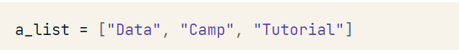**

#### Tuple

**The Tuple is an immutable data type, and it is generally used for accessing the elements. It is faster and consumes less memory because it’s immutability.**

**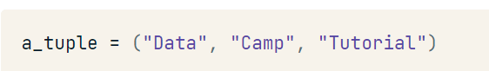**

### 2. What is \_\_init\_\_() in Python?

**\_\_init\_\_() is a constructor, used to initialize objects of a class.**

**class book\_shop:**

**# constructor**

**def \_\_init\_\_(self, title):**

**self.title = title**

**# Sample method**

**def book(self):**

**print('The tile of the book is', self.title)**

**b = book\_shop('Sandman')**

**b.book()**

**# The tile of the book is Sandman**

### 3. What is the difference between a mutable data type and an immutable data type?

**The mutable Python data types can be modified, and they can change at runtime, for example, a List, Dictionary, and Set.**

**The immutable Python data types can not be changed or modified, and they remain unchanged during runtime, for example, a Numeric, String, and Tuple.**

### 4. Explain List, Dictionary, and Tuple comprehension with an example.

### Dictionary and list comprehensions are just another concise way to define dictionaries and lists.

**List comprehension eases the creation of the list based on existing iterable.**

**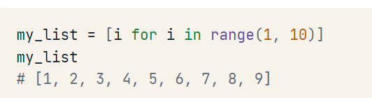**

#### Dictionary

****

#### Tuple

****

**What is interpreted language ?**

**An interpreted language is a type of programming language where the source code is not directly executed by the computer's hardware. Instead, the code is interpreted by another program, called the interpreter, which translates the source code into machine code or intermediate code that the computer can understand and execute.**

**What are python features?**

**Interpreted language:**

**An interpreted language is a type of programming language where the source code is not directly executed by the computer's hardware. Instead, the code is interpreted by another program, called the interpreter, which translates the source code into machine code or intermediate code that the computer can understand and execute.**

**Dynamically typed:**

**In Python, being dynamically typed means that the type of a variable is determined at runtime, not at compile time. This means you don't need to declare the type of a variable when you define it; instead, Python automatically determines the type based on the value assigned to it.**

**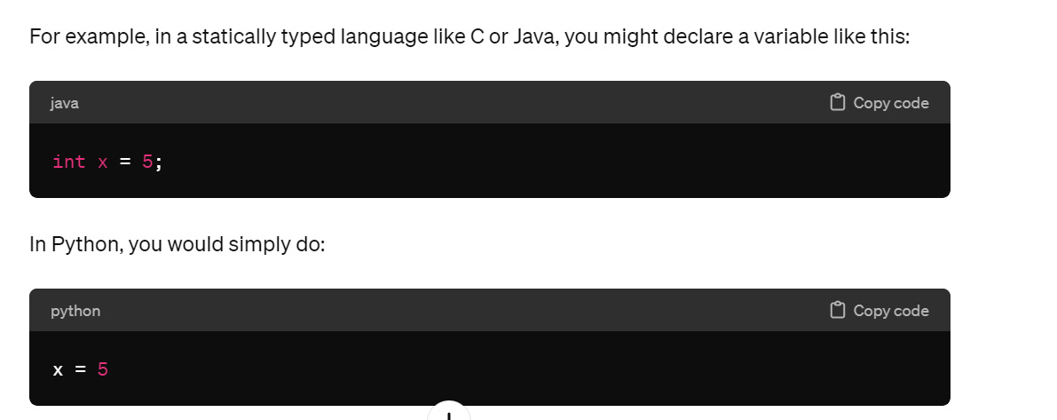**

**Object oriented programming language:**

**Python finds use in many spheres – web applications, automation, scientific modeling, big data applications and many more.**

### ****Q5.What is pep 8?****

***Ans:*PEP stands for Python Enhancement Proposal.****It is a set of rules that specify how to format Python code for maximum readability.**

**Namespaces in python ?**

**Namespaces are important for code organization and encapsulation, as they allow you to control the scope and visibility of variables and functions in your code.**

**A namespace is a naming system used to make sure that names are unique to avoid naming conflicts.**

### ****Q22. Is python case sensitive?****

***Ans:*Yes. Python is a case sensitive language.**

**Q26. What is the difference between Python Arrays and lists?**

***Ans:*Arrays and lists, in Python, have the same way of storing data. But, arrays can hold only a single data type elements whereas lists can hold any data type elements.**

**Example:**

|  |  |
| --- | --- |
| **1**  **2**  **3**  **4**  **5** | **import array as arr**  **My\_Array=arr.array('i',[1,2,3,4]) – i means int type**  **My\_list=[1,'abc',1.20]**  **print(My\_Array)**  **print(My\_list)** |

**Q27. What are functions in Python?**

***Ans:*A function is a block of code which is executed only when it is called. To define a**[**Python function**](https://www.edureka.co/blog/python-functions)**, the def keyword is used.**

**Example:**

|  |  |
| --- | --- |
| **1**  **2**  **3** | **def Newfunc():**  **print("Hi, Welcome to Edureka")**  **Newfunc(); #calling the function** |

**Q29.What is a lambda function?**

***Ans:*An anonymous function is known as a lambda function. This function can have any number of parameters but, can have just one statement.**

**Example:**

|  |  |
| --- | --- |
| **1**  **2** | **a = lambda x,y : x+y**  **print(a(5, 6))** |

### ****Q30. What is self in Python?****

**By using self, you can access instance variables and methods within the class definition. It helps differentiate between instance variables and local variables within the class methods.**

**Friday, March 15, 2024**

**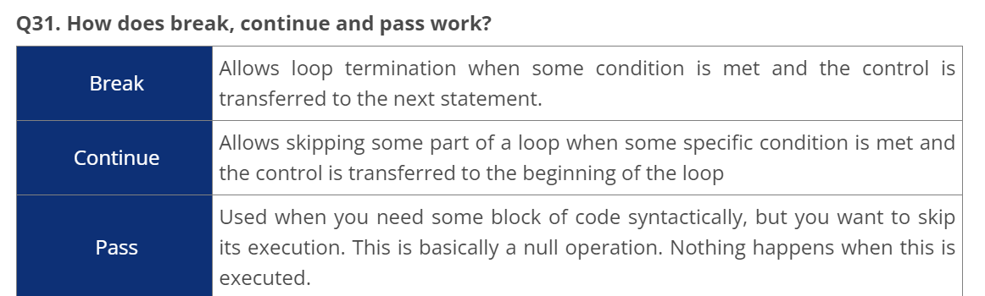**

**Q32. What does [::-1} do?**

***Ans:* [::-1] is used to reverse the order of an array or a sequence.**

***For example:***

|  |  |
| --- | --- |
| **1**  **2**  **3** | **import array as arr**  **My\_Array=arr.array('i',[1,2,3,4,5])**  **My\_Array[::-1]** |

**Output: array(‘i’, [5, 4, 3, 2, 1])**

**Q33. How can you randomize the items of a list in place in Python?**

**Ans: Consider the example shown below:**

|  |  |
| --- | --- |
| **1**  **2**  **3**  **4** | **from random import shuffle**  **x = ['Keep', 'The', 'Blue', 'Flag', 'Flying', 'High']**  **shuffle(x)**  **print(x)** |

**The output of the following code is as below.**

**['Flying', 'Keep', 'Blue', 'High', 'The', 'Flag']**

### ****Q34. What are python iterators?****

### *****an iterator is an object that represents a stream of data.*****

### *****It implements two methods: \_\_iter\_\_() and \_\_next\_\_(). The \_\_iter\_\_() method returns the iterator object itself,*****

### *****and \_\_next\_\_() method returns the next element from the stream.*****

### *****class MyIterator:*****

### *****def \_\_init\_\_(self, data):*****

### *****self.data = data*****

### *****self.index = 0*****

### *****def \_\_iter\_\_(self):*****

### *****return self*****

### *****def \_\_next\_\_(self):*****

### *****if self.index >= len(self.data):*****

### *****raise StopIteration*****

### *****value = self.data[self.index]*****

### *****self.index += 1*****

### *****return value*****

### *****# Example usage:*****

### *****my\_iter = MyIterator([1, 2, 3, 4, 5])*****

### *****for item in my\_iter:*****

### *****print(item)*****

### ****Q37. How do you write comments in python?****

***Ans:*Comments in Python start with a # character. However, alternatively at times, commenting is done using docstrings(strings enclosed within triple quotes).**

### ****Q38. What is pickling and unpickling?****

**Ans: Pickle module accepts any Python object and converts it into a string representation and dumps it into a file by using dump function, this process is called pickling. While the process of retrieving original Python objects from the stored string representation is called unpickling.**

### ****Q39. What are the generators in python?****

**generators are special functions that allow you to generate a sequence of values lazily. They are similar to iterators but are implemented using a special syntax involving the yield keyword.**

**Generators are particularly useful when you need to generate a large sequence of values without consuming a lot of memory.**

**def my\_generator():**

**yield 1**

**yield 2**

**yield 3**

**yield 4**

**yield 5**

**# Example usage:**

**gen = my\_generator()**

**for value in gen:**

**print(value)**

### ****Q40. How will you capitalize the first letter of string?****

***Ans:*In Python, the capitalize() method capitalizes the first letter of a string. If the string already consists of a capital letter at the beginning, then, it returns the original string.**

**mystr='venki'**

**print(mystr.capitalize())**

**Q41. How will you convert a string to all lowercase?**

***Ans:*To convert a string to lowercase, lower() function can be used.**

**Example:**

|  |  |
| --- | --- |
| **1**  **2** | **stg='ABCD'**  **print(stg.lower())** |

**Output: abcd**

**Q43.What are docstrings in Python?**

***Ans:*Docstrings are not actually comments, but, they are *documentation strings*. These docstrings are within triple quotes.**

**Example:**

|  |  |
| --- | --- |
| **1**  **2**  **3**  **4**  **5**  **6**  **7**  **8** | **"""**  **Using docstring as a comment.**  **This code divides 2 numbers**  **"""**  **x=8**  **y=4**  **z=x/y**  **print(z)** |

### ****Q48. How can the ternary operators be used in python?****

### ****Q49. What does this mean: \*args, \*\*kwargs? And why would we use it?****

**Q50. What does len() do?**

***Ans:*It is used to determine the length of a string, a list, an array, etc.**

**Example:**

**Stg =’venkateswarlu’**

**Len(stg)**

**Output: 13**

**Q54.How can files be deleted in Python?**

**To delete a file in Python, you need to import the OS Module. After that, you need to use the os.remove() function.**

**Example:**

**Import os**

**Os.remove(“sample.txt”)**

**Q57. How to add values to a python array?**

**Elements can be added to an array using the append(), extend() and the insert (i,x) functions.**

**Example:**

### arr = [1,2,3,4,5]

### print(arr)

### arr.append(6)#value add end of list

### print(arr)

### arr.insert(3,8)#index,value add anywhere

### print(arr)

### arr.extend([1,3])#add multiple values

### print(arr)

### Output:

### [1, 2, 3, 4, 5]

### [1, 2, 3, 4, 5, 6]

### [1, 2, 3, 8, 4, 5, 6]

### [1, 2, 3, 8, 4, 5, 6, 1, 3]

**Q58. How to remove values to a python array?**

***Ans:*Array elements can be removed using pop() or remove() method. The difference between these two functions is that the former returns the deleted value whereas the latter does not.**

**Example:**

**arr = [1,2,3,4,5]**

**print(arr)**

**print(arr.pop(2))**

**print(arr)**

**print(arr.remove(5))**

|  |  |
| --- | --- |
| **print(arr)** |  |

**Output:**

**[1, 2, 3, 4, 5]**

**3**

**[1, 2, 4, 5]**

**None**

**[1, 2, 4]**

### ****Q63.**** ****What are Python libraries? Name a few of them.**** Python libraries are a collection of Python packages. Some of the majorly used python libraries are – [Numpy](https://www.edureka.co/blog/python-numpy-tutorial/" \t "_blank), [Pandas](https://www.edureka.co/blog/python-pandas-tutorial/), [Matplotlib](https://www.edureka.co/blog/python-matplotlib-tutorial/), [Scikit-learn](https://www.edureka.co/blog/scikit-learn-machine-learning/) and many more.

### ****Q64. What is split used for?****

**The split() method is used to separate a given**[**String in Python**](https://www.edureka.co/blog/what-is-string-in-python/)**.**

**Example:**

|  |  |
| --- | --- |
| **1**  **2** | **a="edureka python"**  **print(a.split())** |

**Output:  [‘edureka’, ‘python’]**

**Q66. Explain Inheritance in Python with an example.**

**Ans: Inheritance allows One class to gain all the members(say attributes and methods) of another class. Inheritance provides code reusability, makes it easier to create and maintain an application. The class from which we are inheriting is called super-class and the class that is inherited is called a derived / child class.**

**They are different types of inheritance supported by Python:**

1. **Single Inheritance – where a derived class acquires the members of a single super class.**
2. **Multi-level inheritance – a derived class d1 in inherited from base class base1, and d2 are inherited from base2.**
3. **Hierarchical inheritance – from one base class you can inherit any number of child classes**
4. **Multiple inheritance – a derived class is inherited from more than one base class.**

### ****Q69. Does python support multiple inheritance?****

**Multiple inheritance means that a class can be derived from more than one parent classes. Python does support multiple inheritance, unlike Java.**

### ****Q70. What is Polymorphism in Python?****

**Polymorphism means the ability to take multiple forms. So, for instance, if the parent class has a method named ABC then the child class also can have a method with the same name ABC having its own parameters and variables. Python allows polymorphism.**

### ****Q71. Define encapsulation in Python?****

**Encapsulation means binding the code and the data together. A Python class in an example of encapsulation.**

### ****Q72. How do you do data abstraction in Python?****

**Data Abstraction is providing only the required details and hiding the implementation from the world. It can be achieved in Python by using interfaces and abstract classes.**