2.1.3 Localization Function

The localization function was built on top of a previous localization project entitled “Lesys”, which provided a structure and became the skeleton of the localization system of this project. “Lesys” was designed according to a client-server model, in which the client and the server interconnected through a wireless network.
The server side program is used directly by users to view the instantaneous location of the PDA client on the map. The client PDA has input and output ports to send and receive messages between the server and the robot.
The client side program is used to receive commands from the server and send the signal strength data to the server for localization. It is also used to get connected with and control the Lego robot, allowing the mobilization of the client.
To complete and refine the localization function, our group has been re-designed and implemented the incomplete location estimation program, the self-guiding function, the user commands and also the program flow of the connections between the Lego robot, the client side program and the server side program.
In this project, K-Nearest Neighbor(KNN) and Bayesian Probability approach were used to implemented the localization function.

2.1.4 Collection of Wireless Signal Strength Data

Wireless signal strength data, together with the MAC addresses, was collected on the 3rd floor of academic building, near the Computer and Engineering Department. Data was collected 50 times on every pre-define 1.5m x 1.5m grid cell on the map.

2.1.5 Analysis of Wireless Signal Strength Data

Wireless signal strength data, together with the MAC addresses, is processed before sending to the server. Processing entails removing duplicated signals, and the duplicated signals are averaged and stored before remove. The signal strength data collected at particular grids to produce sets of centroid signal strength data.

2.1.6 Database Design

The signal strength database is used to store the MAC addresses and the corresponding signal strength RSSI for each grid cell on the map.
Each single record is stored in the database with name “dataset.txt” and defined as follows:
#number of access points #grid number
MAC address of AP 1 RSSI 1
MAC address of AP 2 RSSI 2
MAC address of AP 3 RSSI 3
MAC address of AP 4 RSSI 4
…………
For each grid cell on the map, 50 records are collected and stored.

To facilitate the localization algorithm, the “dataset.txt” is further organized by the system and grouped according to their grid cell number. The format of the formatted dataset is as follows:
#Grid k Record i
#number of access points #grid number
MAC address of AP 1 RSSI 1
MAC address of AP 2 RSSI 2
MAC address of AP 3 RSSI 3
MAC address of AP 4 RSSI 4
…………
Where k is the grid cell number of a record and i is the record number at grid cell number k.
Apart from the signal strength data, the information about connectivity of the grids is also saved into a file named “meta_grid_graph.mph”
This file saves the grid cell numbers of the grid cells adjacent to each specific grid cell in order to facilitate the algorithm used in the guiding system.

The format of this file is as follows:

# Grid: #Grid-North, #Grid-East, #Grid-South, #Grid-West

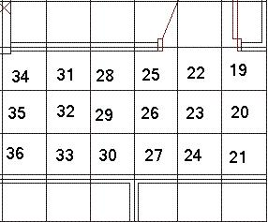
22: -1, 19, 23, 25
Figure 3. The grid cell map.
N
23: 22, 20, 24, 26
30: 29, 27, -1, 33

Note: -1 denotes an infeasible grid cell

2.2 Implementation
Implementation of the robot guiding system began on January 2010, and was completed on April 2010. It included the following parts.

2.2.1 Localization Algorithm

Algorithm 1: K-Nearest Neighbors (KNN)
KNN is a method for classifying objects based on a training dataset. Given an unlabeled object, the algorithm looks for the closest classified objects and classifies the unlabeled object to be the same class. In this project, the training dataset is the signal strength data collected during the offline phrase. Each record in the dataset (Refer to 2.1.6.Database design) is classified to be in a particular grid cell number and the signal strength data collected during online phrase are unclassified record.

The localization of the client is based on the signal strength data received at the client-side and the signal strength data stored in the database. The data sets are compared to find out the most likely grid cell in which the client is located. In order to analyze how close two signal strength records is objectively, Euclidean distance is used.
Euclidean distance
The Euclidean distance is used to score the similarity between the client-side signal strength data and the stored signal strength data. The shorter the Euclidean distance, the more likely the client is located in the corresponding grid.
The Euclidean distance between client-side data and each set of stored data is defined as follows:
distance = distance + abs( RSSIclient-side-i – RSSIdatabase-i)
where RSSIclient-side-i represents all the access points’ RSSI sensed at the client side and RSSIdatabase-I represents the corresponding access points’ RSSI for a set of stored data in the database. This can be demonstrated as follows:

Client-side signal strength data | Database signal strength data |  | Euclidean distance
00:17:DF:AA:C1:61 -90  00:17:DF:AA:9E:63 -85  00:17:DF:AA:9C:D0 -70  Figure 12. Calculating the Euclidean distance between client-side data and each set of stored data | Set 1 | 5 21 (#num APs #grid num)  00:16:B6:B5:30:C4 -91  00:17:DF:AA:9E:62 -70  00:17:DF:AA:C1:61 -85  00:17:DF:AA:9E:63 -70  00:17:DF:AA:9C:D0 -53 | D =  |0-(-91)| +  | 0-(-70)|+  |-90-(-85)|+  |-85-(-70)|+  |-70-(-53)| = 47
 | Set 2 | 3 19 (#num APs #grid num)  00:17:DF:AA:C1:61 -95  00:17:DF:AA:9E:63 -85  00:17:DF:AA:9C:D0 -75 | D =  |-90-(-95)|+  |-85-(-85)|+  |-70-(-75)| = 10

As Set 2 is having a shorter Euclidean distance with the client-side data than that of Set 1, the client’s current location is estimated to be in grid cell 19 instead of 21.
Selecting the best grid number
During the calculation of Euclidean distances, grid cells that have short Euclidean distances are stored in a list for selecting the best localization results.
The corresponding grid cell numbers of the top five shortest Euclidean distances are stored in the list. As there are multiple records stored in the database for each grid cell, grid cells that are closer to the client are more likely to have a shorter Euclidean distance and to be inserted into the list more than once.
To select the best grid cell that the client is closest to, the occurrences of each unique grid cell number in the top-five list are counted. The grid cell that has highest number of occurrences is estimated to be the best localization result.
Algorithm 2: Bayesian Probability
Bayesian probability is a popular interpretation of the concept of probability. It interprets the concept of probability based on the prior knowledge and existing information. In order to apply the Bayesian probability, the Bayesian probability formula is transformed into:
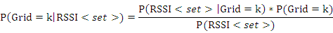
RSSI<set> | A RSSI record collected during online phrase. <set> = <AP₁ = s_{i} , AP₂ = s₂ ...AP_{i} = s_{i}>
 | The probability that grid cell number equals k
 | The probability that the RSSI record occur in database.
 | The probability that grid cell number equals k, given a RSSI record.
 | The probability that the RSSI record occur in database, given a grid number k.

The formula above can be further simplified. is a the probability that a grid cell number equals k, which is uniform for all grid cell. Thus can be eliminated from the formula. Similarly, is the probability that the RSSI record occurs in database. It is a constant and thus can also be eliminated. The formula becomes:
Assuming that the signal strength received from different access points is independent, becomes:
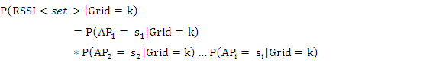
Where is the probability that the RSSI of AP_{i} equals the value of s_{i} for grid cell number k. These numbers can be obtained using the normalized histogram (RSSI profile) of the access point AP_{i} at grid cell number k. Figure 13 below shows an RSSI profile of a grid cell.
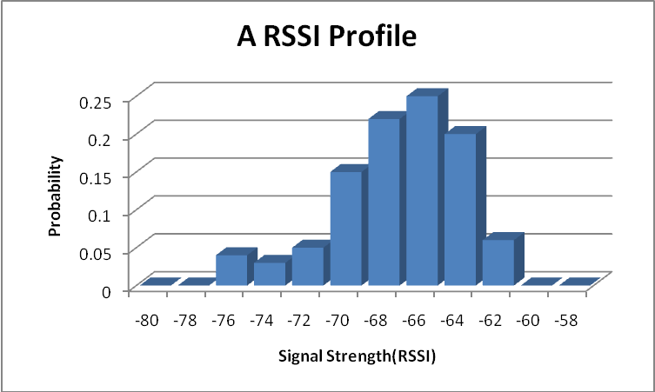
Figure 13. The probability distribution of an access point’s signal strength

Constructing RSSI Profiles for Each Grid Cell
In this project, we used hash map to represent the structure of the RSSI profile.
Key = RSSIValue = Probability
Probability hash map of a mac address
-76
0.04
-74
0.03
-72
0.05
-70
0.22
Key = Mac AddressValue = probability HashMap
00:17:DF:AA:9C:D0
00:17:DF:AA:C1:61
00:17:DF:AA:9E:63
RSSI Profile hash map pointing to its corresponding probability hash map

Thus, the final formula used is :
Selecting the best-grid cell
The formula is used to find out the probability of over the whole map, in total 106 grid cells. Grid cell having the highest is chosen to be the best estimated location.

2.2.2 Collection of Wireless Signal Strength Data
MAC addresses and the corresponding signal strength RSSI of each access point around each grid cell are collected for the localization purpose of localization.
In order to retrieve this data, software named “Place Lab”, is installed on the client PDA. It scans the beacon frames received by the wireless network card and retrieve the access points’ information.
For each 1.5m x 1.5m grid cell defined on the map, the signal strength data is collected using the Java APCollector, which uses the Place Lab library. Each grid cell has 50 sets of signal strength records in the database.

Evaluation

Accuracy in Localization

Accuracy in Finding the Shortest Path

Effectiveness in Bypassing Obstacles and Finding New Path

Ability in Starting the Robot at Any Grid Cell on Map

Ability to Collect and Transmit the Wi-Fi Signal Data from the PDA to the Server.

Discussion

Discussion on the Localization Algorithm
In this project, we have implemented two localization algorithm, which are K-Nearest Neighbor(KNN) and Bayesian Probability approach.

Discussion on the Signal Strength Error
People, devices, Wall

Discussion on the Timeliness of Signal Strength

Discussion on the Devices used to Collect Data

Discussion on the Auto Data Collection
Traveling salesman problem

Discussion on the Mechanical Error

Discussion on the Testing Environment
Carpet, locker

Discussion on the Difficulty in Regarding PDA
Collection of data, Spotter, PlaceLab, PDA problems, WiFi connection

Discussion on the Shortest Path ( Turning )

Conclusion
150Words

Reference

