QYA2
Lego Robot Guided by Wi-Fi Devices
by
Li Chun Kit Eddy and So Hung Wai
QYA2

Advised by
Prof. Qiang YANG

Submitted in partial fulfillment
of the requirements for COMP 397
in the
Department of Computer Science and Engineering
The Hong Kong University of Science and Technology
2009-2010

Date of submission: February 5, 2010

Table of Contents
1. Introduction 5
1.1 Overview 5
1.2 Objectives 6
1.3 Literature Survey 7
1.3.1 Location tracking 7
1.3.2 Obstacle Detection 9
2. Progress 10
2.1 Design 10
2.1.1 Localization System 10
2.1.2 Collection of Wireless Signal Strength Data 11
2.1.3 Analysis of Wireless Signal Strength Data 11
2.1.4 Database Design 11
2.1.5 Guiding System 12
2.1.6 Client-Server Architecture 13
2.1.7 Program Flow 14
2.1.8 Auto Data Collection 14
2.1.9 Graphical User Interface Design 15
2.1.10 Sensors Available for the Lego Robot 18
2.2 Implementation 19
2.2.1 Localization Algorithm 19
2.2.2 Collection of Wireless Signal Strength Data 21
2.2.3 Analysis of Wireless Signal Strength Data 22
2.2.4 Socket Connection 23
2.2.5 Guiding System 23
2.2.6 Auto Data Collection 25
2.2.7 Command System 25
2.3 Testing 26
2.3.1 Localization System 26
2.3.2 Guiding System 27
2.3.3 Auto Data Collection 29
2.3.4 Manual Control of the Robot 29
2.4 Evaluation 30
3. Project Planning 32
3.1 Division of Work 32
3.2 GANTT Chart 34
4. Hardware and Software Requirements 35
4.1 Hardware 35
4.2 Software 35
5. References 36
6. Appendix A: Minutes 37
6.1 Minutes of the 1st Project Meeting 37
6.2 Minutes of the 2nd Project Meeting 39
6.3 Minutes of the 3rd Project Meeting 40
6.4 Minutes of the 4th Project Meeting 41
6.5 Minutes of the 5th Project Meeting 42
6.6 Minutes of the 6th Project Meeting 44
6.7 Minutes of the 7th Project Meeting 46

1. Introduction

1.1 Overview
Wi-Fi (Wireless Fidelity) has become one of the most important technologies that has contributed to urban society in recent years. The Hong Kong government has initiated a Wi-Fi program that aims to provide free wireless Internet access services to all citizens by installing Wi-Fi facilities at designated government premises ^{[2]}. At same time, many people have been setting up their own wireless networks inside their homes as well. These wireless networks have become part of our life for communication and entertainment. Being surrounded by such different kinds of Wi-Fi devices nowadays, people in Hong Kong can now easily access the Internet to obtain almost any kind of information.
Robots have many different types of applications. For example, a security robot can work at night and patrol in the dark. A delivery robot can work inside a laboratory to help transfer instruments around. A rescue robot can search for survivors at the scene of a fire. As long as there are Wi-Fi devices set up in a building, robots can serve in many different ways by using Wi-Fi localization.
In our FYP, we have developed a guiding system that can guide the movement of a LEGO MINDSTORMS NXT Robot by making use of Wi-Fi localization devices and a PDA attached to the robot. We make use of Wi-Fi hotspots that are distributed around the HKUST academic building to pinpoint the location of the robot. Then, we run the guiding system from a remote computer to search for the shortest path for the robot to travel to reach a specified destination. The system runs in client-server mode, where the robot is the client that receives commands from the remote server through the Wi-Fi network and the PDA. The robot collects Wi-Fi signal strength data and sends it back to the remote server or stores it in the PDA. The signal strength data is used to localize the robot as it moves through the building.

1.2 Objectives
Our project mainly focused on developing a successful guiding system that controls a Lego NXT robot in a remote location. The following were the objectives that we aimed to achieve:
- The system should correctly guide the robot to a specified destination using the shortest path.
- The robot should be able to start at any feasible location on the map, provided that it is on the same floor as the destination.
- The robot should be able to bypass small obstacles or find a new path around major blockages.
- The robot should collect Wi-Fi signal data and successfully transfer it to the remote PC via the PDA and the Wi-Fi connection.
Reaching the correct destination is the crucial part of the system, so we carefully developed a search algorithm to find the shortest path on the map.
In order to guide the robot from any feasible starting point to any feasible destination on the map, our system must be able to track the position of the robot anywhere on the floor we choose. This required much initial work to test and record the signal strength of the Wi-Fi hotspots on the floor we chose. Some of this work was done by the robot, and some was done manually.
In order to prevent the robot from colliding with obstacles, we equipped the robot with a few sensors that can notify the robot that it either needs to stop or turn to avoid collision. For small obstacles, the system helps the robot to find a way to bypass them. For large obstacles blocking the robot’s path, the robot should immediately reports them to the remote computer. The system then searches for the best alternate path to reach the destination. In case blockage is on a major path and makes the destination completely inaccessible, the robot returns to the starting point or a default position on the map.
We run the robot in client-server mode, so it can collect Wi-Fi signal data and data received from its sensors and then send this data through Wi-Fi connection to the remote server for further analysis.

1.3 Literature Survey
A group of students at National Taiwan University has built a tour guide robot that has features similar to those of our robot. It uses Global Positioning System (GPS) technology for location tracking and laser light sensors to detect obstacles and people. The robot learned the environment during the initial run inside the room. After that, it was able to make a journey in the same room, bypassing any obstacles. The robot was developed at a cost of NT$300,000 (US$9,100) ^{[4]}.
Compared to the Taiwanese robot, our robot is much cheaper, since it uses a LEGO robot package that costs only about US$300 and only focuses on the guiding system. It also does not require features that provide interaction with users, such as detecting facial expressions. Thus, our hardware specifications are quite different and much more economical.

1.3.1 Location tracking
According to some related work in the area of location tracking, there are three main categories ^{[1]}:

Global Positioning System (GPS)
When we think of tracking the real-time location of a robot, GPS might be the first thing that pops up into our minds. However, GPS relies on navigation satellites located 10,000 to 20,000 km above the earth’s surface and designed for outdoor localization, so its performance is normally not good for indoor environments like ours. Even though we could have bypassed the indoor limitation by using numerous GPS repeaters ^{[3]}, the price of each GPS repeater is over HK $200, and we would have needed more than hundred of them to cover the rooftop of HKUST, so this was not a feasible option for our project.

Indoor IR networks
Infra-red (IR) technology is widely-used for remote control. It can also provide location tracking information. For example, an IR system can track the location of users wearing badges that periodically emit IR signals. IR sensors in the area will receive the IR signals and provide location information. Conversely, other systems use IR transmitters attached to the ceiling inside a building. An optical sensor carried by a user will pick up the IR signals and determine the location for the user. However, both types of these IR-based systems have limitations. Firstly, the limited range of IR transmission may produce inaccurate results. Secondly, the cost of installation and maintenance for these IR transmitters is significant. Finally, the performance will be heavily affected by sunlight ^{[1]}. Thus, our project does not use an indoor IR network.

Wide-area radio frequency networks (Wi-Fi networks)
Our project is based on Wi-Fi due to the advantages of this technology over the others. First of all, radio waves have a significantly longer transmission range compared to IR light. Secondly, the penetration power of Wi-Fi signals is much better than that of GPS. This makes the Wi-Fi technology a good candidate for indoor location tracking. Another main reason for selecting Wi-Fi is that Wi-Fi networks are widely available in many places including schools, homes and offices ^{[1]}.

1.3.2 Obstacle Detection
According to our research, there are two popular obstacle detection technologies for robots:

Laser light sensors
Sending out laser light that bounces back is a very convenient way to find obstacles. It works in a way similar to radar. However, laser light requires a significant amount of energy, so our robot would use up energy very quickly if there were many obstacles in the area. The laser also requires extra calibration and testing with the robot. Thus, we do not use this technology.

Ultrasonic sensors
In our design, we use the ultrasonic sensors that came with the Lego robot package. They were easy to install on the robot and operate perfectly without any significant calibration. The software in the robot package directly supports these sensors, so this approach saved us a lot of time and allowed us to focus on building and testing other parts of the system.

2. Progress

2.1 Design

2.1.1 Client-Server Architecture

In this project, the server, the client and the Lego robot are connected via the Wi-Fi and Bluetooth communication. The server-side program is installed into a laptop computer, and the client-side program is installed on a PDA. See Figure 1 below.
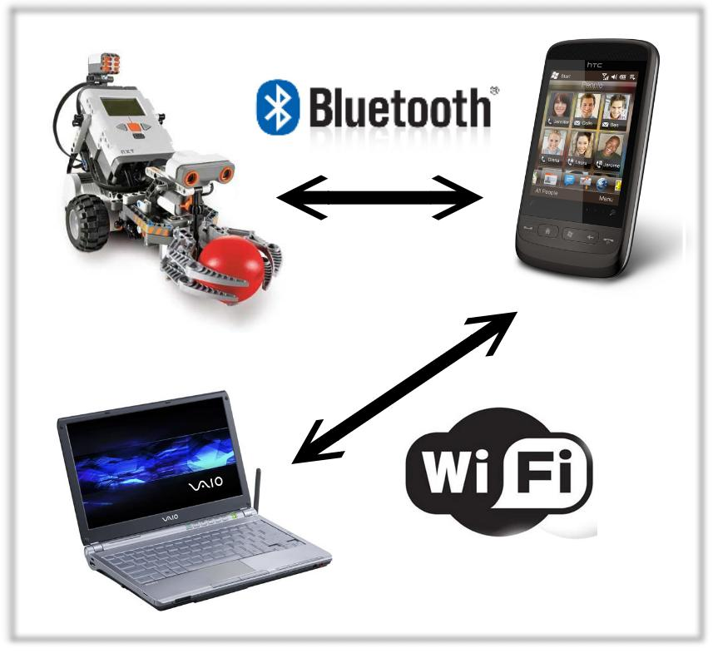

Figure 1. The structure of the client-server connection

The localization function, the self-guiding function and the command system are executed concurrently on both the server and the client. As for the Lego robot, it is used to facilitate the mobilization of the client, which is needed in the self-guiding system. The client PDA rides on top of the Lego robot. The PDA and the robot communicate via Bluetooth.

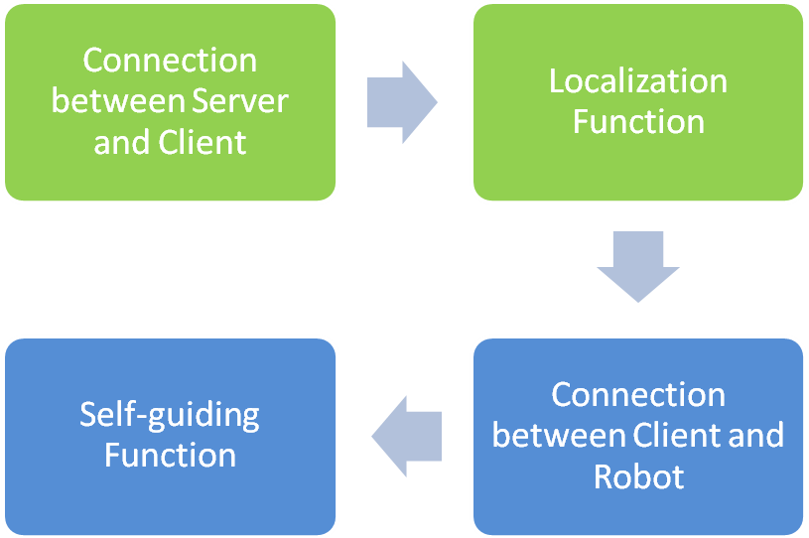
2.1.2 Program Flow
Figure 2. Two-level program flow

The program flow for the whole system is divided into two layers.
The first layer is for the localization function, in which the server and client are first connected before localization.
The second layer is for the self-guiding function, which is dependent on the localization function. In this layer, the client is connected with the Lego robot so as to enable the self-guiding function and manual control of the Lego robot.

2.1.3 Localization Function

The localization function was built on top of a previous localization project entitled “Lesys”, which provided a structure and became the skeleton of the localization system of this project. “Lesys” was designed according to a client-server model, in which the client and the server interconnected through a wireless network.
The server side program is used directly by users to view the instantaneous location of the PDA client on the map. The client PDA has input and output ports to send and receive messages between the server and the robot.
The client side program is used to receive commands from the server and send the signal strength data to the server for localization. It is also used to get connected with and control the Lego robot, allowing the mobilization of the client.
To complete and refine the localization function, our group have been re-designed and implemented the incomplete location estimation program, the self-guiding function, the user commands and also the program flow of the connections between the Lego robot, the client side program and the server side program.

2.1.4 Collection of Wireless Signal Strength Data

Wireless signal strength data, together with the MAC addresses, was collected on the 3rd floor of academic building, near the Computer and Engineering Department. Data was collected fifty times on every pre-define 1.5m x 1.5m grid cell on the map for each time period, i.e. in the morning, during the daytime and during the evening.

2.1.5 Analysis of Wireless Signal Strength Data

Wireless signal strength data, together with the MAC addresses, is sent to the server for further processing. Processing entails averaging and intersecting the signal strength data collected at a particular grids to produce sets of centroid signal strength data.

2.1.6 Database Design

The signal strength database is used to store the MAC addresses and the corresponding signal strength RSSI for each grid cell on the map.
Each single record is stored in the database with name “dataset.txt” and defined as follows:
#number of access points #grid number
MAC address of AP 1 RSSI 1
MAC address of AP 2 RSSI 2
MAC address of AP 3 RSSI 3
MAC address of AP 4 RSSI 4
…………

For each grid on the map, three records are collected and stored, plus an extra estimated record.
Apart from the signal strength data, the information about connectivity of the grids is also saved into a file named “meta_grid_graph.mph”
This file saves the grid cell numbers of the grid cells adjacent to each specific grid cell in order to facilitate the algorithm used in the guiding system.
The format of this file is as follows:

# Grid: #Grid-North, #Grid-East, #Grid-South, #Grid-West

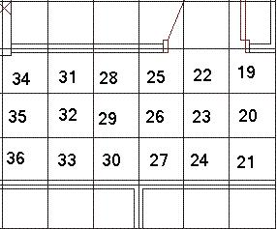
22: -1, 19, 23, 25
Figure 3. The grid cell map.
N
23: 22, 20, 24, 26
30: 29, 27, -1, 33

Note: -1 denotes an infeasible grid cell

2.1.7 Self-Guiding Function

The self-guiding function was designed to guide the client from a starting point along the shortest path to a destination, specified by the server-side user. This function is dependent on the localization function, as it needs instantaneously know the location of the client and also to verify the client’s arrival at the destination point.

When the self-guiding function first estimates the shortest path, it makes assumptions about the predefined routing. However, during the course of movement, if it senses path blockage or a dead end, then it will generate and alternative path for the client.

2.1.8 Auto Data Collection

In order to ensure localization accuracy, mitigate changes caused by dynamic signal strength data and also mitigate infrastructure changes, the system also includes an automatic data collection function. With the help of the localization and self-guiding functions, this function collects up-to-date RSSI data as the robot moves through every cell of the grid and automatically updates the signal strength database accordingly.

2.1.9 Graphical User Interface Design

The robot guiding system includes two graphical user interfaces(GUI). One is for the client PDA, and the other is for the server.
2.1.9.1 Client PDA GUI

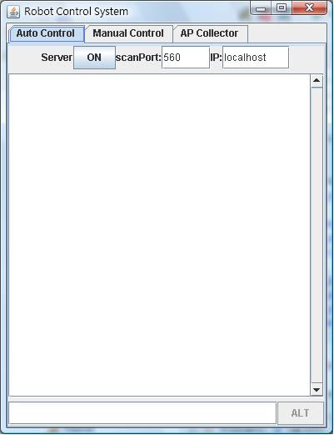  Figure 4. Auto Control Panel of the client PDA GUI | The Auto Control Panel is used to provide the user interface to connect the client side model to the server side model.  It provides two textboxes for users to input the IP address and connection port of the server.  The text field will display the connection status with the Lego-robot and the server and the actions done when commands are received.
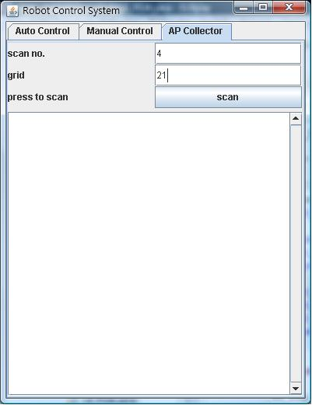 | The AP Collector Panel is used to scan the wireless signal strength data and MAC addresses of the surroundings access points. The data collected will further stored in another structured file.  It provides textboxes for the user to input the current grid number (which is pre-defined by developer) corresponding to a location on the map and the scan number.
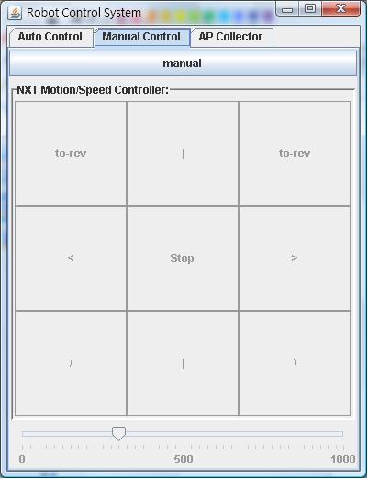 | The manual control panel provides an user interface to control the movements of the Lego-robot manually.  Through the panel, users can move, stop and alter the speed of the Lego-robot.
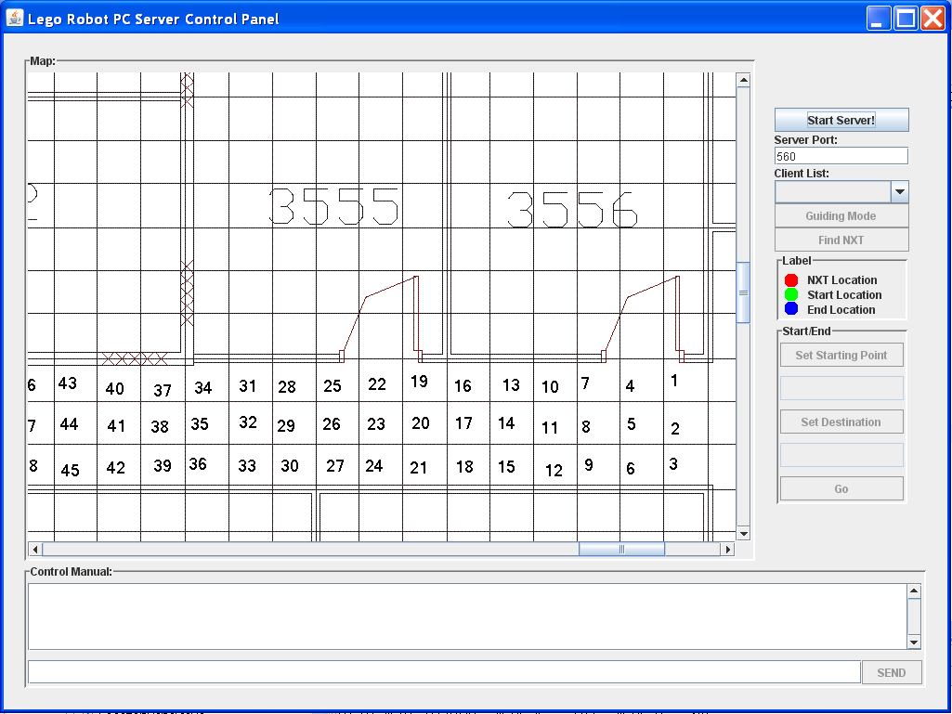

The server-side GUI consists of a few components, the map, the console and the control panel. User is required to specify a server port for connection. By pressing the “Start Server!” button, the server will start running and wait for a client to connect.
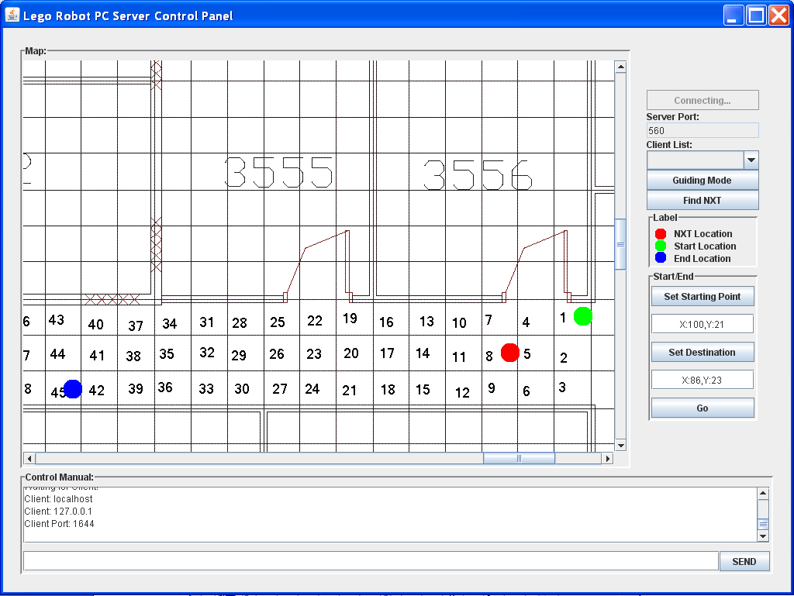

After a client has successfully connected, the control panel will then be available to the user for further operation. The drop down client list will show the list of connected client. The button below the drop down box will indicate the operating mode of the selected client. User can change the mode in between “guiding mode” and the “training mode” by pressing the button. The “Find NXT” button is for estimating the current location of the client. A red dot will appear on the map indicating the estimated location the client. This will help the user to specify the starting point for the guiding system. The “Set Starting Point” and “Set Destination” button will allow the user to place a green dot and a blue dot on the map that represents the stating position and the destination for the guiding system. The guiding system will plot a shortest path between these two points and setup the guiding instruction for the robot. Finally, the “Go” button will initiated the instruction and the robot will start to move toward the destination.
The console at the bottom will show the detail information about the robot. It will report the new location of the robot from time to time as the robot is traveling. It will also display the sensor information if the robot has met with an obstacle. User could use the text field below to send different command to the robot. User may gain manual control over the robot or request more for detailed information by different command. See “Command System” in the “Implementation” section for more details.

2.1.10 Sensors Available for the Lego Robot

Touch Sensor
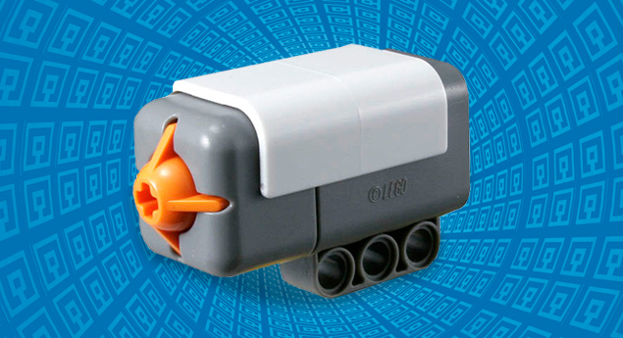
The touch sensor enables the Lego NXT robot to react to contact with various objects. Whenever the Lego robot hits an obstacle, the touch sensor can detect when contact is made and when contact is lost due to reaction force or from manually backing off. (See Figure 9.)
Figure 9. Touch Sensor
The touch sensor can report single or multiple button presses to the NXT Intelligent Brick.

Light Sensor
The light sensor enables the NXT Lego robot to distinguish between light and dark, as well as determine the light intensity in a room or the light intensity of different colors. (See Figure 10.)
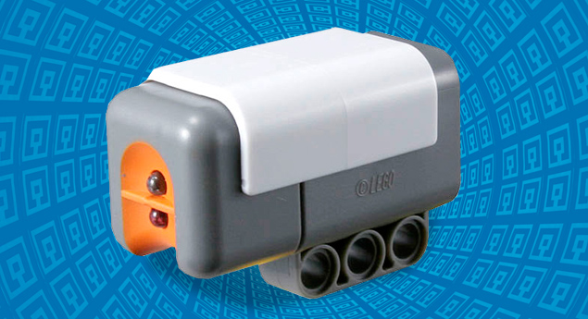
The light sensors are extensively used by developers to guide the Lego robot in a confined space with colored lines.
Figure 10. Light Sensor

Ultrasonic Sensor
The ultrasonic sensor allows the NXT Lego robot to sense and determine the distances from objects. It is able to detect an object and measure its proximity in inches or centimeters. (See Figure 11.)
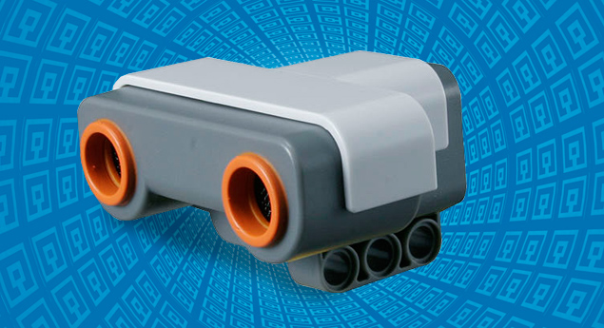
Figure 9. Ultrasonic Sensor

Selection of Sensor(s)
In this project, the touch sensor and light sensor are not used as touch sensing and light sensing are not needed in the implementation of the localization function or the self-guiding function.
In this project, the ultrasonic sensor is used extensively in the guiding system to detect the proximity of objects from the robot. The data is sent to the guiding function in case an alternate path is required.

2.2 Implementation
Implementation of the robot guiding system began on January 2010, and was completed on April 2010. It included the following parts.

2.2.1 Localization Algorithm

The localization of the client is based on the signal strength data received at the client-side and the signal strength data stored in the database. The data sets are compared to find out the most likely grid cell in which the client is located.
Euclidean distance
In order to compare the data sets objectively, the Euclidean distance is used to score the similarity between the client-side signal strength data and the stored signal strength data. The shorter the Euclidean distance, the more likely the client is located in the corresponding grid.
The Euclidean distance between client-side data and each set of stored data is defined as follows:
distance = distance + abs( RSSIclient-side-i – RSSIdatabase-i)
where RSSIclient-side-i represents all the access points’ RSSI sensed at the client side and RSSIdatabase-I represents the corresponding access points’ RSSI for a set of stored data in the database. This can be demonstrated as follows:
Client-side signal strength data | Database signal strength data |  | Euclidean distance
00:17:DF:AA:C1:61 -90  00:17:DF:AA:9E:63 -85  00:17:DF:AA:9C:D0 -70  Figure 12. Calculating the Euclidean distance between client-side data and each set of stored data | Set 1 | 5 21 (#num APs #grid num)  00:16:B6:B5:30:C4 -91  00:17:DF:AA:9E:62 -70  00:17:DF:AA:C1:61 -85  00:17:DF:AA:9E:63 -70  00:17:DF:AA:9C:D0 -53 | D =  |0-(-91)| +  | 0-(-70)|+  |-90-(-85)|+  |-85-(-70)|+  |-70-(-53)| = 47
 | Set 2 | 3 19 (#num APs #grid num)  00:17:DF:AA:C1:61 -95  00:17:DF:AA:9E:63 -85  00:17:DF:AA:9C:D0 -75 | D =  |-90-(-95)|+  |-85-(-85)|+  |-70-(-75)| = 10

As Set 2 is having a shorter Euclidean distance with the client-side data than that of Set 1, the client’s current location is estimated to be in grid cell 19 instead of 21.
Selecting the best grid number
During the calculation of Euclidean distances, grid cells that have short Euclidean distances are stored in a list for selecting the best localization results.
The corresponding grid cell numbers of the top five shortest Euclidean distances are stored in the list. As there are multiple records stored in the database for each grid cell, grid cells that are closer to the client are more likely to have a shorter Euclidean distance and to be inserted into the list more than once.
To select the best grid cell that the client is closest to, the occurrences of each unique grid cell number in the top-five list are counted. The grid cell that has highest number of occurrences is estimated to be the best localization result.

2.2.2 Collection of Wireless Signal Strength Data

MAC addresses and the corresponding signal strength RSSI of each access point around each grid cell are collected for the localization purpose of localization.
In order to retrieve this data, software named “Placelab”, is installed on the client PDA. It scans the beacon frames received by the wireless network card and retrieve the access points’ information.
For each 1.5m x 1.5m grid cell defined on the map, the signal strength data is collected using the Java DataCollector and Java DataReceiver classes. These use the Placelab library.

2.2.3 Analysis of Wireless Signal Strength Data

For each grid cell on the map, we have stored an estimated signal strength record that is generated by analyzing 50 sets of collected records. We processed the actual RSSI values of each Mac address and stored the mean as the estimated RSSI value. This is demonstrated as follows:
Collected record |  |  | Estimated record
 | Mac address | RSSI | Mac address | RSSI
Set 1 | 00:17:DF:AA:C1:61  00:17:DF:AA:9E:63  00:17:DF:AA:9C:D0  00:17:DF:AA:9E:62  00:16:B6:B5:30:C4 | -85  -70  -53  -71  -91 | 00:17:DF:AA:C1:61  00:17:DF:AA:9E:63  00:17:DF:AA:9C:D0  00:17:DF:AA:9E:62  00:16:B6:B5:30:C4 | ((-85)+(-95)+(-82))  /3  = -87.3333  ((-70)+(-85)+(-71))  /3  = -75.3333  ((-53)+(-65)+(-55))  /3  = -57.6667  (-71)/1  = -71  ((-91)+(-93))  /2  = -92
Set 2 | 00:17:DF:AA:C1:61  00:17:DF:AA:9E:63  00:17:DF:AA:9C:D0 | -95  -85  -65
Set 3 | 00:17:DF:AA:C1:61  00:17:DF:AA:9E:63  00:17:DF:AA:9C:D0  00:16:B6:B5:30:C4 | -82  -71  -55  -93
Figure 13. Calculating estimated RSSI values

As the sample size of the collected record increases, the estimated RSSI values should become more and more accurate. The estimated RSSI values are stored in the signal database for localization in the future. This estimation process can help reduce the amount of processing time during localization, since the localization function then only needs to go through one set of estimated records instead of three or more set of collected record.

2.2.4 Socket Connection

Both our client and server applications rely on socket communication. We used the TCP protocol, as it is a very reliable way to transfer data between the processes that run on the client and the server.
On the server side, when the user presses the “Start Server!” button, the system will create a TCP socket on the specific port assigned by the user. The server will then wait for an incoming connection by listening to that port.
On the client side, the user has to specify the server IP address and port number for the connection. When the user press the “On” button, the system will create a TCP socket and try to establish a connection using the specified IP and port.
Every time the server is contacted by a client, it setups a new TCP socket that communicates with the TCP socket on the client. This will allow the server to support multiple clients at the same time by opening more TCP sockets.

2.2.5 Self-Guiding Function

The self-guiding system consisted of two components: The ability to search for the shortest path and the ability to give correct instructions to the robot.
For the ability to search for a shortest path, we first considered using the Breadth First Search (BFS) ^{[5]} algorithm. We transformed each grid cell number to a single node and drew an edge between two nodes if two girds were connected to each other. Part of the transformed graph is shown below:

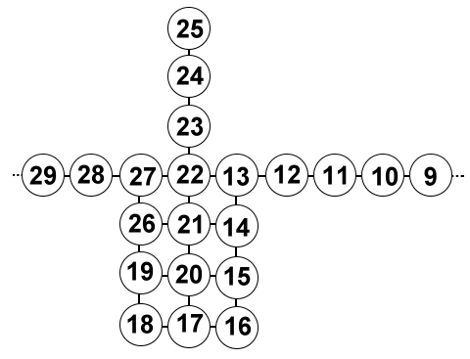
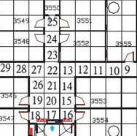
N
Figure 15. Transforming grid cells to a graph for applying BFS

Applying the BFS algorithm on the generated graph, it will exhaustively search the graph until the shortest path is found to the destination.
The BFS algorithm might not be the most efficient way to search for the shortest path due to the complexity of our graph. However, we considered Dijkstra's algorithm and DFS algorithm, but the results were no better.
For the ability to give correct instructions to the robot, the system relied on the correctness of the shortest path returned by the BFS algorithm and the direction data within the database. The major problem of the guiding function is that it is difficult to determine the direction that the robot is facing. We decided to assume the robot would be determined always facing north at the beginning.
We will now consider an example to show how the system works:
Assume the starting position is grid cell 12, and the destination is grid cell 14. (See Figure 15.) The shortest path is clearly to travel through grid cell 13. Since we assume the robot is facing north at grid cell 12, the system checks the database to see whether or not it is facing the correct direction if we want the robot to move to grid cell 13. Obviously, the first instruction is to tell the robot to turn 90 degrees to its left, because grid cell 13 is to the west of grid cell 12. Afterwards, the system guides the robot to move a distance of 1 grid cell to the west, so that it is now on grid cell 13 and facing west. Same as before, the system again looks at the database to see which direction is the correct one for grid cell 14. The system then gives another instruction to turn the robot 90 degrees to its left so that it can reach grid cell 14 by moving forward one cell.
In case of infeasible movements, such as reaching a dead end, the self-guiding function will generate an alternative path for the robot to reach the destination.

2.2.6 Auto Data Collection
In order to facilitate the periodic update of the signal strength database, the system would create a path and guide the robot to visit every grid cell on the map. Upon reaching each grid cells, the robot collects one or more sets of signal strength data and imports them into the database. This process also updates the estimated RSSI records by calculating the new mean values. This helps the system to achieve more accurate estimation due to a larger sample size.

2.2.7 User Commands
When users operate the robot from a remote location, they are probably unable to manually control the robot via the client PDA GUI. In that case, the user can remotely send various commands to the client-side program in order to control the robot’s movement and acquire more information about the current state of the robot. The following are the list of available user commands:
- HELP
Show the command list.
- STOP
Stop the movement of the robot.
- MOVEFOR [Speed] [Duration]
Tell the robot to move forward at a certain speed for a certain number of seconds.
- MOVEBACK [Speed] [Duration]
Tell the robot to move backward at a certain speed for a certain number of seconds.
- TURN RIGHT/LEFT
Tell the robot to do a 90 degree turn to the right/left.
- TURN [Angle]
Tell the robot to turn by the value of [Angle] in the clockwise direction.
- GETAP
Tell the robot to scan for access points and return their RSSI values.
- GETDIRECTION
Get the direction that the robot is facing at the moment.
- GETDATA
Get the speed of the various motors of the robot and all its sensor readings.
- GETLOC
Estimate the location of the robot and return the information on the console. Update the map if necessary.
- ISOBSTACLE
Check to see if the robot is stopped by one or more obstacles around it.

2.3 Testing
We carried out our testing according to the functionalities of our project. Following is what we did:

2.3.1 Localization Function

Test case 1 | The correctness of the localization system on the server.
Setup | Place a client at a particular grid and connect it with the server.
Input | The wireless signal strengths received by the client.
Expected result | The localization system returns the correct grid number of the client’s position.

This test was repeated 3 times for every grid to ensure the correctness.
Results :
2.3.2 Self-Guiding Function

Path finding
Test case 1 | The correctness of finding the shortest path between two points.
Setup | Specify the starting point and the destination on the server.
Input | A case that is short in distance and requires no turning
Expected result | The localization system returns the correct shortest path.

Test case 2 | The correctness of finding the shortest path between two points.
Setup | Specify the starting point and the destination on the server.
Input | A case that is short in distance and requires a few turns in the path.
Expected result | The localization system returns the correct shortest path.

Test case 3 | The correctness of finding the shortest path between two points.
Setup | Specify the starting point and the destination on the server.
Input | A case that is long in distance and requires no turning
Expected result | The localization system returns the correct shortest path.

Test case 4 | The correctness of finding the shortest path between two points.
Setup | Specify the starting point and the destination on the server.
Input | A case that is long in distance and requires a few turns in the path.
Expected result | The localization system returns the correct shortest path.

Each of these test cases was repeated 3 times with different starting points and destinations.
Results:

Translocation
Test case 1 | The correctness of controlling the robot.
Setup | The guiding system successfully generates a shortest path.
Input | The shortest path generated by the guiding system.
Expected result | The robot follows the shortest path and reaches the destination correctly.
This test case was repeated 3 times with different path.
Results:

Test case 2 | The ability to bypass small obstacles
Setup | Place one or more obstacles on the path.
Input | The shortest path generated by the guiding system.
Expected result | The robot follows the shortest path and reports to the server when it encounters the obstacles. Then the robot bypasses the obstacles by going around them or by using another path to reach the destination.
This test case was repeated 3 times with different paths and with obstacles in different locations.
Results:

Test case 3 | Situation of total blockage in the path
Setup | Place an obstacle on the path that creates a complete blockage between the starting point and the destination.
Input | The shortest path generated by the guiding system.
Expected result | The robot follows the shortest path and reports to the server when it encounters the obstacles. Then robot will try to bypass the obstacles before it reports a complete blockage.
This test case was repeated 3 times with different path and with obstacles in different locations.
Results:

2.3.3 Auto Data Collection

Test case 1 | The correctness of updating the database
Setup | Put the robot in “Training Mode” and allow it to start running.
Input | The new set of collected data of each grid.
Expected result | The database has been updated successfully.
This test case was repeated 3 times at different times.
Results:

2.3.4 Manual Control of the Robot

Test case 1 | The correctness of various commands.
Setup | Place the robot at random location and establish a connection between the server and the robot.
Input | All the commands inside the command list.
Expected result | Receive the correct information from the robot or successfully control the movement of the robot.
This test case was repeated 3 times for each command with the robot placed at a different location each time.
Results:

2.4 Evaluation

Lesys Localization System

Flexibility
The localization function of the Lesys localization system requires the Lego robot, the client-side PDA and the server-side laptop to be connected. Without all the connections being established, the localization function will not be done.
These requirements for the execution of the localization function make the Lesys localization system device dependent and limit its functions. It is unable to localize a client without the Lego NXT robot being connected.
In our project, the program flow and structure were redesigned. The localization function can be run once the client and server are connected. The connection to the Lego NXT robot is independent from the localization. This allows our localization system to be used on any devices that support WIFI connection and WIFI signal scanning, and it permits the mobilization of the PDA client not only by a Lego NXT robot, but also by any movable, controllable and blue-tooth supported robot.

Grid Cell Size Defined
The size of each grid cell defined in the Lesys localization system is around 1 foot x 1 foot (33.33cm x 33.33cm) per cell. However, the signal strength difference between adjacent grid cells is not significant enough to fingerprint a grid cell, so neighboring grid cells often have very similar RSSI. This hinders accurate localization.
To improve the accuracy of the localization function, the grid cells used in our system are redefined as 1.5m x 1.5m. This also reduced the complexity of the map, as the number of grid cells are reduced by a factor of 9. The size of the database are also similarly reduced.

Timeliness of the Signal Strength Data
The database for the signal strength data in the Lesys localization system does not consider the time and period of the collection of data. In reality, human activities such as the use of the wireless network, the movement and other use of electronic devices will interfere with the signal strength of the access points. Thus, the signal strength may be significantly different in daytime than in the evening.
To avoid this phenomenon, we stored three separate data sets for data from different time periods, i.e. in the morning, during the daytime and during the evening. We used the man of the three RSSI data sets for estimating RSSI valves.

Analysis of Signal Strength Data
In order to facilitate the localization algorithm and obtain a better RSSI estimation, the signal strength data for each grid was collected 3 times, and the mean of those 3 sets of data was stored as a 4th set after mathematical averaging.
Multiple sets of data for each grid cell accommodate the variations of wireless signals at different times and the mean RSSI values of sets of data incorporate the idea of a centroid of the sets.

Placelab Spotter Library

Number of Access Points Can Be Scanned
The maximum number of access points that can be scanned using the Placelab spotter library is limited to 32. Because of the rapid development of wireless communication these few years, the number of access points deployed in the many environments has increased beyond the limit of 32.
In order to help the localization system to catch up with the growing rate of access point deployment, the spotter library was recompiled and the limit increased to 128.

3. Project Planning

3.1 Division of Work
 | Li Chun Kit | So Hung Wai
Research on the NXT Lego Robot | X | X
Research on the Localization System | X | X
Study of the Lesys Localization System | X | X
Study of the Compatibility of Hardware | X | X
Design of the Localization Function | X | X
Design of the Collection of Wireless Signal Strength Data | X
Design of the Analysis of Wireless Signal Strength Data |  | X
Design of the Database Structure |  | X
Design of the Robot Guiding Function | X
Design of the Client-Server Architecture | X
Design and Refining the Program Flow |  | X
Design of the Auto Data Collection Function | X
Design of the Graphical User Interface | X
Implementation of the Localization Function |  | X
Implementation of the Collection of Wireless Signal Strength Data | X
Implementation of the Analysis of the Wireless Signal Strength Data |  | X
Implementation of the Socket Connection | X
Implementation of the Robot Guiding Function |  | X
Implementation of the Auto Data Collection Function | X
Implementation of the Command Function | X
Testing of the Localization Function |  | X
Testing of the Robot Guiding Function |  | X
Testing of the Auto Data Collection Function | X
Testing of the Manual Control of the Robot | X
Evaluation | X | X
Final Report and Project Poster | X | X
Presentation and Demonstration | X | X

3.2 GANTT Chart
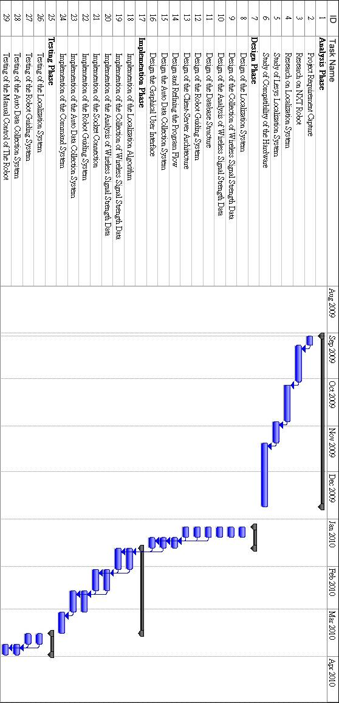

4. Hardware and Software Requirements

4.1 Hardware
- LEGO MINDSTORMS NXT Robot
  - 32-bit ARM7 microprocessor.
  - Support for Bluetooth wireless communication.
  - 1 USB 2.0 port
  - Powered by 6 AA (1.5V ) batteries.
  - NXT Intelligent Brick – controller of the Lego Robot
- PDA – for processing Wi-Fi data and giving instructions to the robot.
  - Running Microsoft Windows Mobile 2003 or above
  - CPU - Intel XScale, 400MHz or above
  - Memory – 128MB or above
- Computer – for acting as the web server and developing the guiding system.
  - Desktop or Notebook running MS Windows XP
  - CPU - Pentium IV, 3 GHz or above
  - Hard Disk Space - 80 GBytes or above
  - Memory - 1GB or above

4.2 Software
- JAVA – programming languages used to develop our FYP
- Placelab – software for scanning the wireless network card
- LEJOS – Java for LEGO NXT
- LESYS – provides the structure for our localization program

5. References

[1] Bahl, Paramvir and Venkata. N. Padmanabhan. 23 November 1999. “RADAR: An In-Building RF-based User Location and Tracking System”. Online. Available from Internet, http://research.microsoft.com/en-us/um/people/padmanab/papers/infocom2000.pdf, Accessed: 17 September 2009.
[2] Hong Kong Government. 3 June 2009. “Government Wi-Fi Programme (GovWiFi)”. Online. Available from Internet, http://www.gov.hk/en/theme/wifi/ program/ index.htm, accessed 17 September 2009.
[3] Murph, Darren. 21 February 2007. “Underground / indoor GPS repeater maintains your position”. Online. Available from Internet, http://www.engadget.com/2007/02/21/ underground-indoor-gps-repeater-maintains-your-position, Accessed: 4 September 2009.
[4] Nystedt, Dan. 20 Aug 2009. “Taiwan University students build tour guide robot”. Online. Available from Internet, http://www.networkworld.com/news/2009/082009-taiwan-university-students-build-tour.html, Accessed: 4 September 2009.
[5] Wikipedia. 1 February 2010. “Breadth-first search”. Online. Available from Internet, http://en.wikipedia.org/wiki/Breadth-first_search, Accessed: 3 February 2010

6. Appendix A: Minutes

6.1 Minutes of the 1st Project Meeting
Date: | September 3, 2009 (Thursday)
Time: | 2:00 AM
Place: | 1/F Library
Present: | Li Chun Kit, So Hung Wai
Absent: | None
Recorder: | So Hung Wai

1. Approval of minutes
This is the first formal group meeting. Thus, there were no minutes to be approved.

2. Report on progress
Both team members have read the project description and some reference information.

3. Discussion items
- The main objectives of the proposed project:
- The system should be able to guide the robot to a correct destination.
- The robot should be able to react to obstacles.
- The major requirement of the projects:
- Collection and analysis of wireless signal data.
- Localization of the robot by using wireless sensors.
- Implementation of the self-guiding system.
- Graphical User Interface.
- The division of work of the project proposal.

4. Goals for the coming week

- Both team members will search for and read related project papers, articles information.
- Li Chun Kit will be responsible for writing the introduction hardware/software requirements and references of the proposal.
- So Hung Wai will be responsible for writing the methodology, project planning and minutes of the proposal.
- Arrange a meeting with professor Qiang to have a short consultation.

5. Meeting adjournment and next meeting
The meeting was adjourned at 3:00 PM.
The next meeting is scheduled on September 8th at 2:00 PM in the Café.

6.2 Minutes of the 2nd Project Meeting
Date: | September 8, 2009 (Tuesday)
Time: | 2:00 PM
Place: | Café
Present: | Li Chun Kit, So Hung Wai
Absent: | None
Recorder: | So Hung Wai

1. Approval of minutes
The minutes of the last meeting were approved without amendment.

2. Report on progress
- Li Chun Kit has finished the draft proposal’s introduction, objectives and literature survey and hardware/software requirements.
- So Hung Wai has finished the drafted proposal’s methodology and project planning.
- Both team members attended the consultation with professor Qiang.
- Li Chun Kit has found information about the Lego-mindstorm robot.
- So Hung Wai has found information about the wireless localization.

3. Discussion items
- The amendment of the draft proposal after consultation with professor:
- Modification of the introduction.
- New ideas for the literature survey.
- The testing of the basic movement of the Lego-robots.

4. Goals for the coming week
- Li Chun Kit will amend the proposal’s introduction.
- So Hung Wai will amend the proposal’s methodology.
- Both team members will test on the basic movement of the robots.
- Both team members will read the reference papers suggested by professor Qiang and decide which information is useful for the project.

5. Meeting adjournment and next meeting
The meeting was adjourned at 2:30 PM.
The next meeting is scheduled on September 22, 2009 at 2:00 PM in the Café.

6.3 Minutes of the 3rd Project Meeting
Date: | October 2, 2009 (Friday)
Time: | 2:00 PM
Place: | Café
Present: | Li Chun Kit, So Hung Wai
Absent: | None
Recorder: | Li Chun Kit

1. Approval of minutes
The minutes of the last meeting were approved without amendment.

2. Report on progress
- So Hung Wai has watched the video lecture of Prof. Qiang Yang
- Li Chun Kit has finished reading the official LEGO robot software development kit.
- So Hung Wai has researched leJOS, the Java-based replacement firmware for the LEGO NXT robot.
- Li Chun Kit has researched the ROBOTC, the C-based programming language for the LEGO NXT robot.

3. Discussion items
- The localization module that we have requested from the Teaching Assistant.
- The PDA that we have requested from the Teaching Assistant.

4. Goals for the coming week
- Both team members will study and test the localization module in order to get familiar with it.
- Li Chun Kit will develop a simple path-finding program.
- So Hung Wai will test the PDA in order to get familiar with it.

5. Meeting adjournment and next meeting
The meeting was adjourned at 2:30 PM.
The next meeting is scheduled on October 31, 2009 at 2:00 PM in the Café.

6.4 Minutes of the 4th Project Meeting
Date: | November 10, 2009 (Tuesday)
Time: | 3:00 PM
Place: | Café
Present: | Li Chun Kit, So Hung Wai
Absent: | None
Recorder: | So Hung Wai

1. Approval of minutes
The minutes of the last meeting were approved without amendment.

2. Report on progress
- Both team members have studied the localization program given.

3. Discussion items
- The programming environment for the Lego Mindstorms Robot
- Migration from the C-based programming environment to the Java programming environment using LeJos NJX due to the fact that the localization program was written in Java.
- The localization program
- The user interface.
- The functionality of the program.

4. Goals for the coming weeks
- Li Chun Kit will study the LeJos NJX codes for the signaling between server and the Lego Mindstorms Robot.
- So Hung Wai will import and test the client side localization program on PDA.
- Both team members will test the localization system on the 3rd floor of the CSE Department.

5. Meeting adjournment and next meeting
The meeting was adjourned at 3:30 PM.
The next meeting is scheduled on December 1, 2009 at 2:00 PM in the Café.

6.5 Minutes of the 5th Project Meeting
Date: | January 6, 2010 (Wednesday)
Time: | 1:15 PM
Place: | Library G/F
Present: | Li Chun Kit, So Hung Wai
Absent: | None
Recorder: | Li Chun Kit

1. Approval of minutes
The minutes of the last meeting were approved without amendment.

2. Report on progress
The meeting on December 1, 2009 was postponed to January 6, 2010. This was due to final examinations and the Christmas holiday.

3. Discussion items
3.1. The difference between J2ME and J2SE/EE.
- The localization program (Lesys) was developed in J2SE/EE and our PDA (htc touch 2 T3333) only supports J2ME applications.
3.2. A Java Virtual Machine (JVM) Mysaifu for Windows mobile has been installed on the PDA.
- The JAVA class for the PDA was unable to run on the JVM.
- This was possibly due to incompatibility of window mobile 6.5 and
Mysaifu.
- An E-mail about the problem described above has been sent to the
author of Mysaifu (freebeans).
3.3. Another JVM jbed was also been tested.
- Test failed due to the requirement of the JAD file.

4. Goals for the coming weeks
- Both team members continue to import the localization program to the PDA.
- Both team members use notebooks for testing the system on the 3rd floor outside the CSE department.

5. Meeting adjournment and next meeting
The meeting was adjourned at 5:00 PM.
The next meeting is scheduled on January 11, 2010 at 2:00 PM in the Library G/F.

6.6 Minutes of the 6th Project Meeting
Date: | January 28, 2010 (Thursday)
Time: | 1:00 PM
Place: | Computer Barn A
Present: | Li Chun Kit, So Hung Wai
Absent: | None
Recorder: | So Hung Wai

1. Approval of minutes
The minutes of the last meeting were approved without amendment.

2. Report on progress
- Both team members have failed to import the localization program to the PDA with Windows Mobile 6.5.
- Li Chun Kit has successfully improved the movement of the robot in a straight line.

3. Discussion items
3.1. Installation of PlaceLab protocol
The DataCollector and DataReceiver classes were implemented with the PlaceLab library, and the PlaceLab library requires the installation of PlaceLab protocol on the wireless network card. The protocol is used to scan a list of APs seen by the wireless network card.
3.2. Collection of APs data with PlaceLab installed using a Laptop computer
Successful collection of a list of APs data, including MAC address and RSSI, near Room 3555. The data collected was recorded to the dataset file.
3.3. Testing of the existing system with PlaceLab installed
The existing localization system was tested outside Room 3555 and it failed due to the incompletion of the system. It seems like the existing system seems has not implemented the function for processing the APs data collected from the surrounding via location estimation.

4. Goals for the coming weeks
- All team members continue to debug and modify the existing localization system to achieve the basic localization function using the APs data.

5. Meeting adjournment and next meeting
The meeting was adjourned at 5:00 PM.
The next meeting is scheduled on January 28, 2010 at 1:00 PM in Library G/F.

6.7 Minutes of the 7th Project Meeting
Date: | January 29, 2010 (Friday)
Time: | 1:00 PM
Place: | Library G/F
Present: | Li Chun Kit, So Hung Wai
Absent: | None
Recorder: | Li Chun Kit

1. Approval of minutes
The minutes of the last meeting were approved without amendment.

2. Report on progress
- Li Chun Kit has successfully installed placelab on the computer.
- So Hung Wai was unable to installed placelab on the computer due to a problem with Windows Vista.
- Both team members have tried to debug the Lesys localization system.

3. Discussion items
3.1. The limitations of the Placelab software.
- Placelab software can only capture a maximum 32 access points at the same time. However due to the development of the Wifi network on the campus, there are far more than 32 access points in most of the areas.
- Placelab will stop working if there are more than 32 access points. The localization program is unable to receive any data if placelab stops.
- Even with the minimum power output of the wireless network card, we still received more than 32 access point in the same time.
- A possible solution is to recompile Placelab with a larger maximum number of access points
3.2. The size of the grid in the localization system.
- The original setting of the grid size was about 3X3 meters big.
- We have discussed reducing the size in order to improve the accuracy of the localization system.
- We agreed to keep the original setting at the moment. We will come back to this point after we successfully run the localization system without problem.
3.3. Working environment
- We have tried to receive WiFi signals in different locations on the 3rd floor.
- Most of the locations can receive more than 32 access point signals, thus making Placelab stop working.

4. Goals for the coming weeks
- Both team members will try to recompile the Placelab software in order to support more access point.
- Li Chun Kit will work on the server structure of the design session of the progress report.
- So Hung Wai will work on the PDA structure of the design session of the progress report.

5. Meeting adjournment and next meeting
The meeting was adjourned at 6:30 PM.
The next meeting is scheduled on February 1, 2010 at 1:00 PM in the Library G/F.

