1. Start
2. Input values of A and B
3. Compute C = A+B
4. Stop

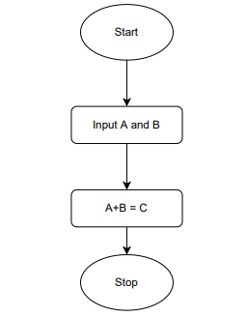

1. Start
2. Input temperature values in celsius as C
3. Convert it to fahrenheit as C(9/5) + 32
4. Stop

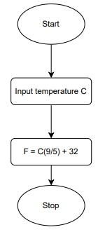

1. Start
2. Input the values for NUM1 and NUM2
3. Compare NUM1 and NUM2
4. If NUM1 smaller print NUM1 is smaller
5. Else NUM2 is smaller
6. Stop

