Karnataka Law Society's   
**GOGTE INSTITUTE OF TECHNOLOGY**

UDYAMBAG, BELAGAVI-590008

**Department of Computer Science and Engineering**



**Software Requirement Specification Document**

**On “Pigmy Management System”**

*Submitted in the partial fulfilment for the 6th Semester Course of*

**SOFTWARE DEVELOPMENT LAB (16CSL67)**

**Submitted By:**

* Venktesh Mutalik 2GI17CS183
* Rohit Topi 2GI17CS108
* Muttugoud Patil 2GI17CS075

**Guide:** Prof. G .C.Deshpande.

**Table of Content**

1. Introduction

1.1 Purpose

1.2 Objective

1.3 References

1.4 Technologies to be Used

2. Overall Description

2.1 Assumption and Dependencies

2.2 Requirement Analysis

2.3 Use case model survey

2.4 Entity Relationship Diagram

2.5 Class Diagram

2.6 State Diagram

2.7 Activity Diagram

2.8 Sequence Diagram

3. Output Snapshots

1. Introduction

1.1 Purpose:

Pigmy collection is the system in which the small shops can save amount

and deposit them in to the banks on a daily basis . A bank person comes to the

door step and collects the amount and issues him a receipt . The receipt contains the details

like the date and time of amount receiving , amount received by , amount received from etc.

This process is carried out using ledger books and paper receipts . Hence the purpose of this project is to give a software solution to this problem.

1.2 Objective

Create a software in which the bank agent can collect the amount , issue a receipt through sms or email to the customer , generate reports for himself , generate reports for the customer .

1.3 References

1. Roger. S. Pressman, Software Engineering – A Practitioners Approach, TataMcGraw Hill 4th Edition 2. IEEE SRS format

1.4 Technologies to be Used

1. Operating System : Windows 10

2. Visual Modelling : Visual Paradigm

3. IDE : NetBeans IDE 8.0.2

# 4. Database : Java DB (Derby) Database

5.Programming Language: Java

2. Overall Description

2.1 Assumption and Dependencies

1.The user must register to the Application.

2. Username and password will be used for Identification and authentication.

3.The bank agents must be verified by the bank

2.2 Requirement Analysis

Software Requirements: Windows 10, Visual Paradigm ,NetBeans IDE

FUNCTIONAL REQUIREMENTS:

1.REGISTRATION: The agent has to register himself . He is provided with a unique agent ID.

2. LOGIN AND LOGOUT :The agents who wish to use the application will have to login into the software . They have to log out upon completion of the work.

3. REGISTER A CUSTOMER : The agent has the power to register new customers by getting their details.

4.COLLECT MONEY:The agent after logging into the system can collect amount form the customers and issue them a e-receipt through sms.

5.GENERATE REPORT : The agent can create reports for i)collection on a particular date ii)total monthly collection of a particular customer etc.

6. The Customer can also login to the system but he can only generate reports of himself.

NON-FUNCTIONAL REQUIREMENTS:

1.No unauthorised login must happen .

2. The system must generate a receipt which exactly as per the information stored in the database .

3.The amount/balance must not be visible to any other persons other than the registered ones.

4. In the event of any software or hardware failure, the system must revert back to previous consistent state .

5. Privacy of the user should be maintained.

2.3 Use case model survey

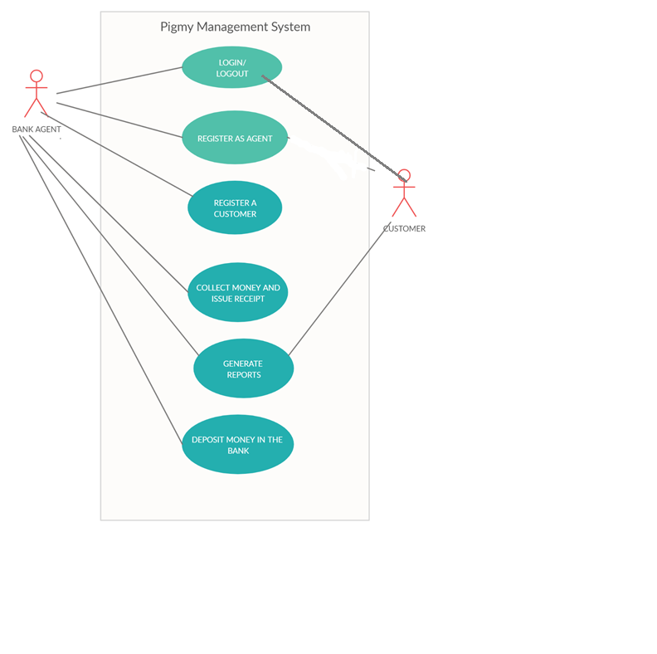

2.4 Entity Relationship Diagram

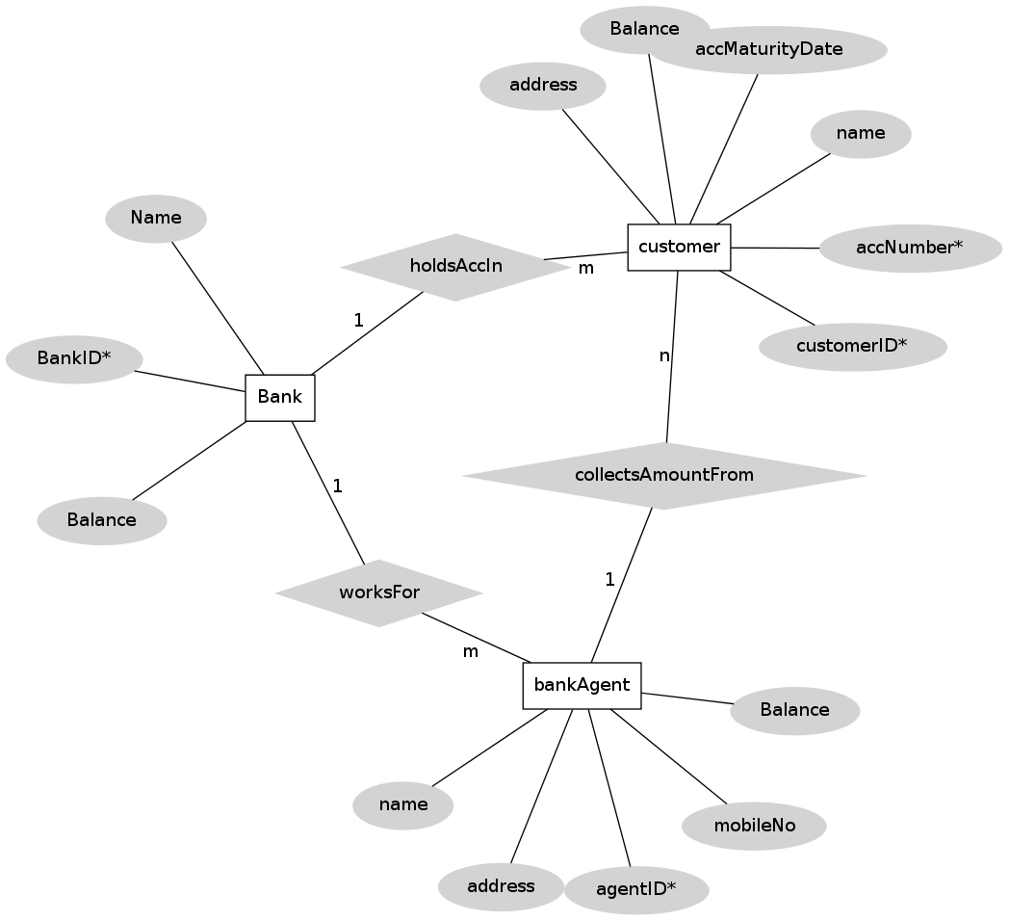

2.5 Class Diagram

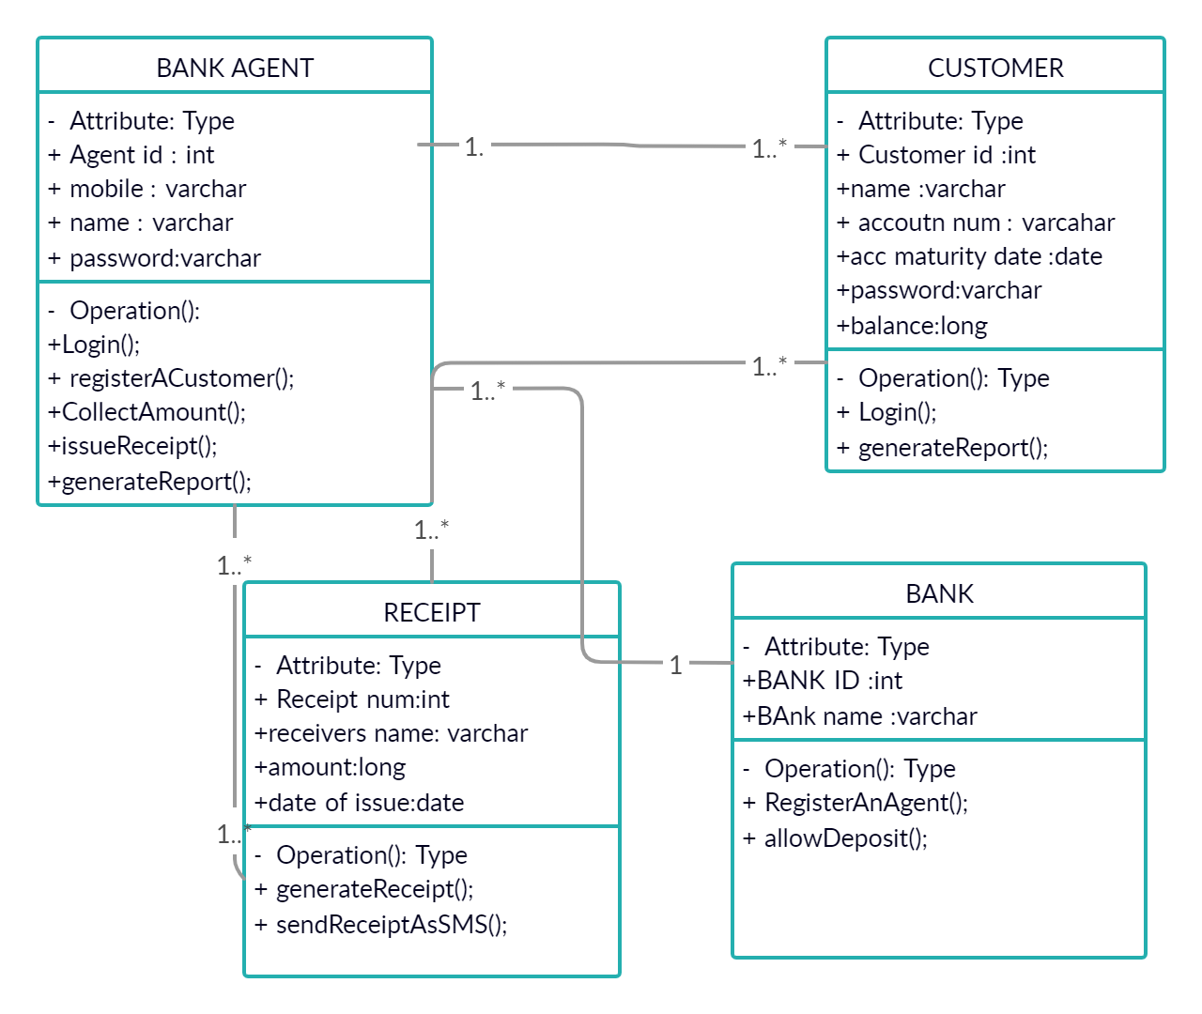

2.6 State Diagram

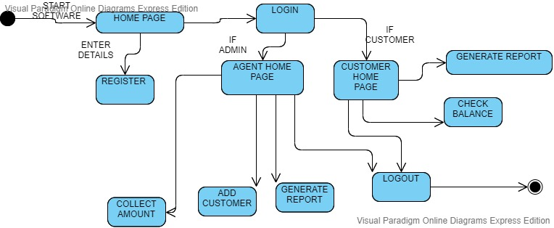

2.7 Activity Diagram

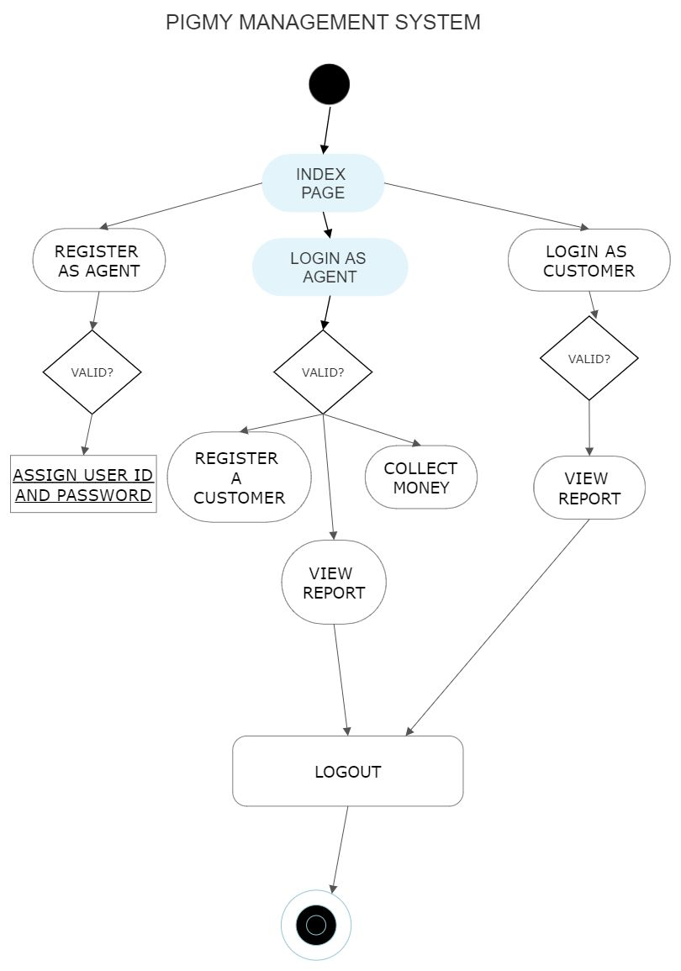

2.8 Sequence Diagram

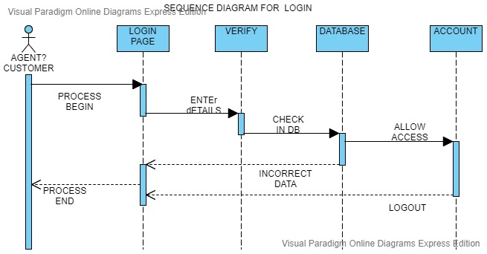

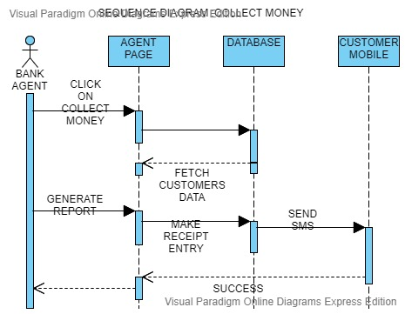

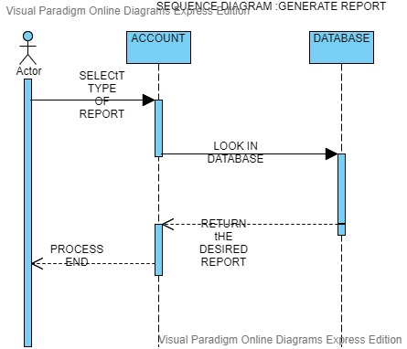

**3. Output Snapshots**

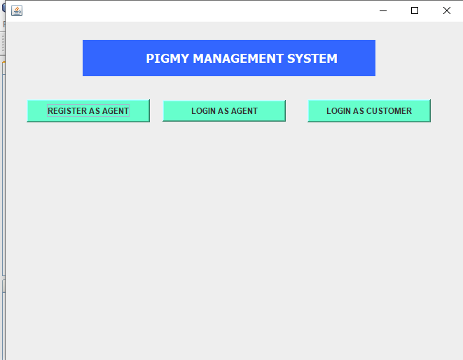

Figure : HOME PAGE

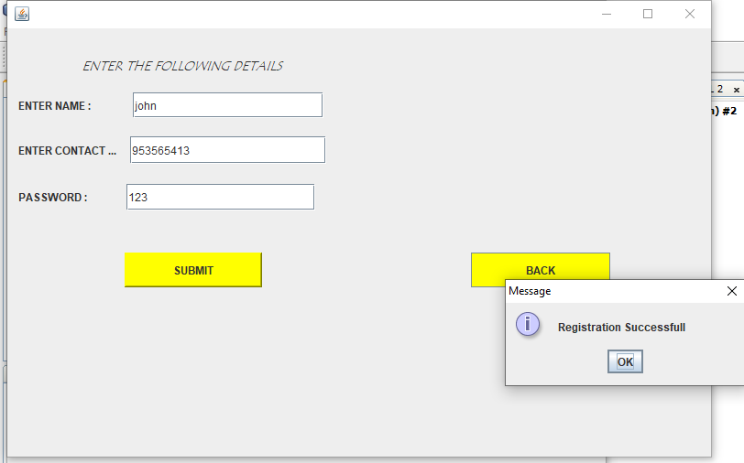

Figure : UPON CLICKING REGISTER AS AGENT

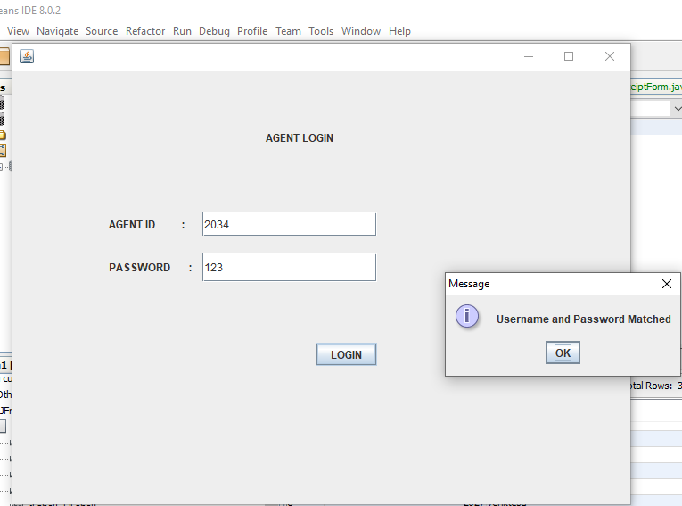

Figure :UPON CLICKING LOGIN AS AGENT

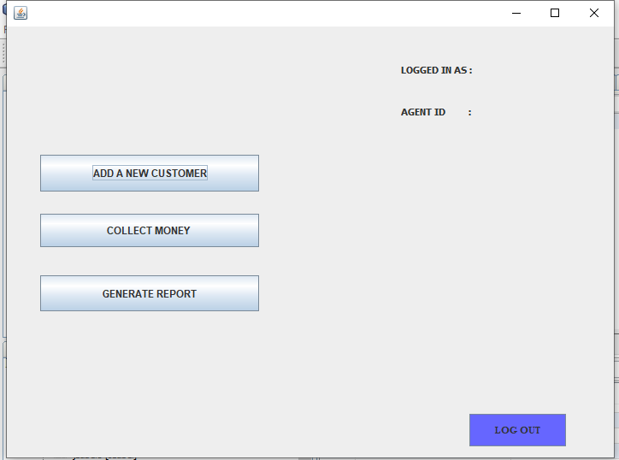

Figure :AGENTS HOME PAGE

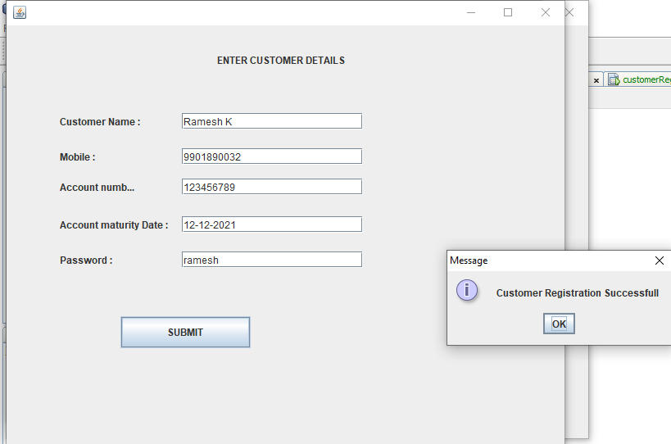

Figure :AFTER CLICKING ADD CUSTOMER

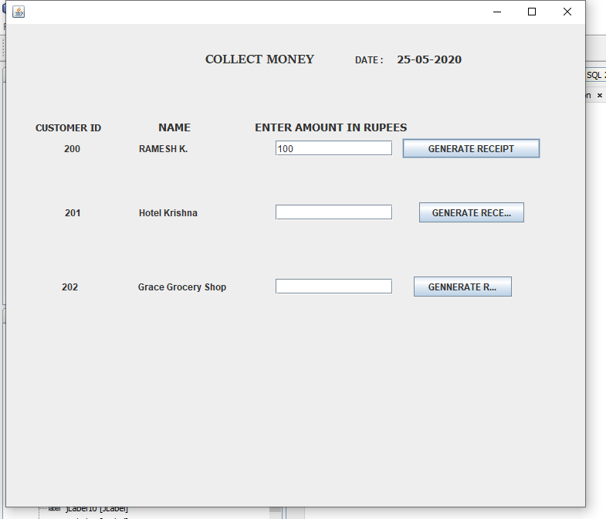

Figure :AFTER CLICKING COLLECT MONEY

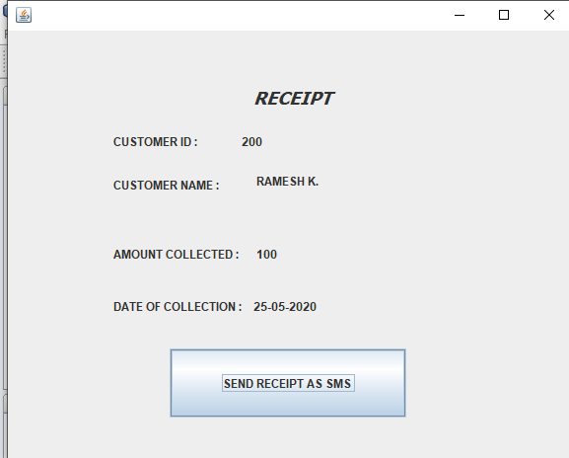

Figure :AFTER CLICKING GENERATE RECEIPT

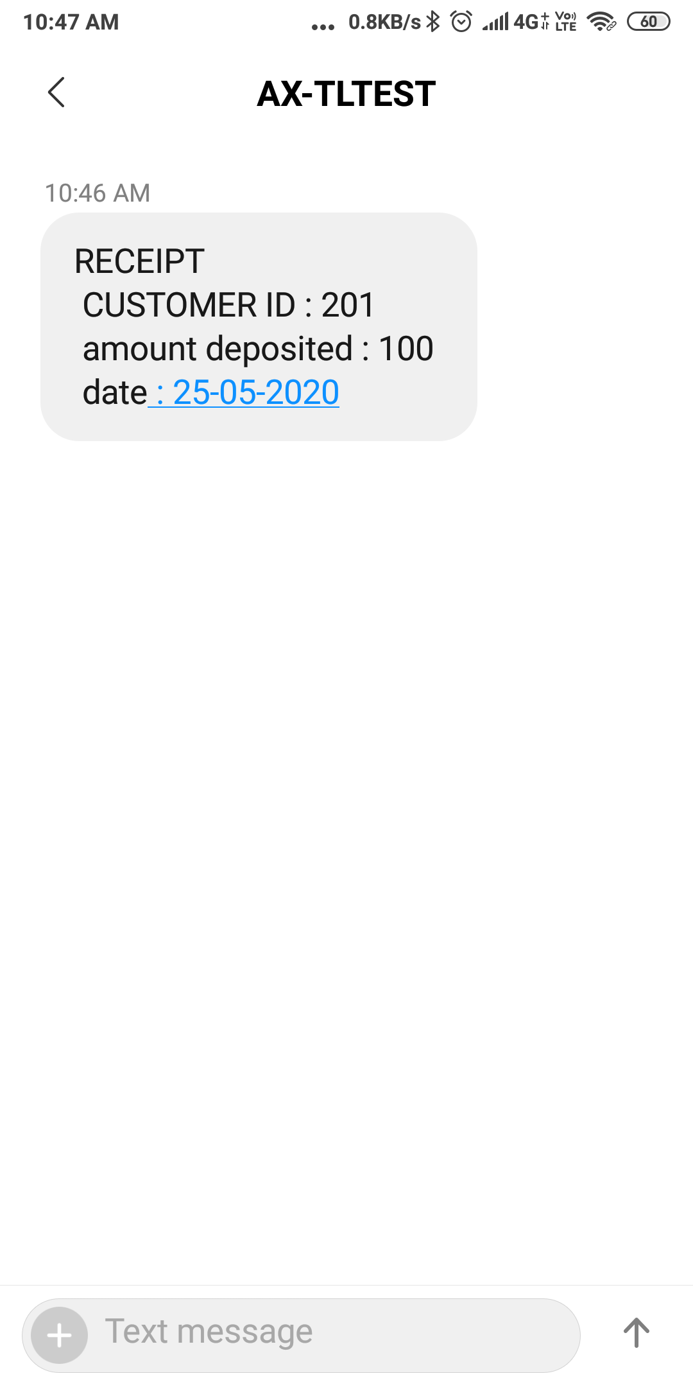

Figure : THE SMS SENT TO THE CUSTOMERS PHONE NUMBER

GIT Hub LINK : <https://github.com/venkteshmutalik/pigmySoftware>