**Model**

**Dataset:**

[**https://onlineacademiccommunity.uvic.ca/isot/2022/11/27/fake-news-detection-datasets/**](https://onlineacademiccommunity.uvic.ca/isot/2022/11/27/fake-news-detection-datasets/)

**Libraries:**

1. pandas
2. seaborn
3. matplotlib
4. tqdm
5. re
6. nltk
7. string
8. Os

**Model selection:**

Logistic regression is one of the most popular Machine Learning algorithms when using the Supervised Learning approach. It is used to forecast the categorical dependent variable using a specified set of independent variables. Logistic regression can be used to forecast a categorical dependent variable's outcome.Because it can categorize new data using continuous and discrete datasets and provide probabilities, logistic regression is a key machine learning algorithm.

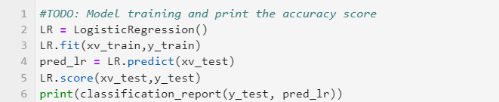

**Model architecture:**

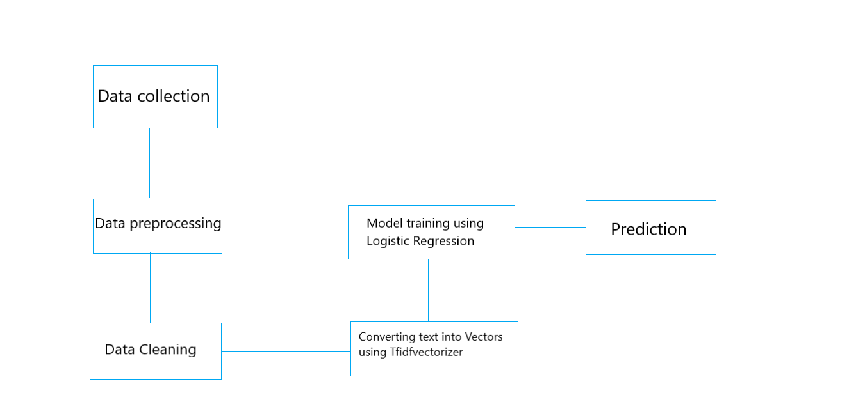

**Evaluation of model:**

