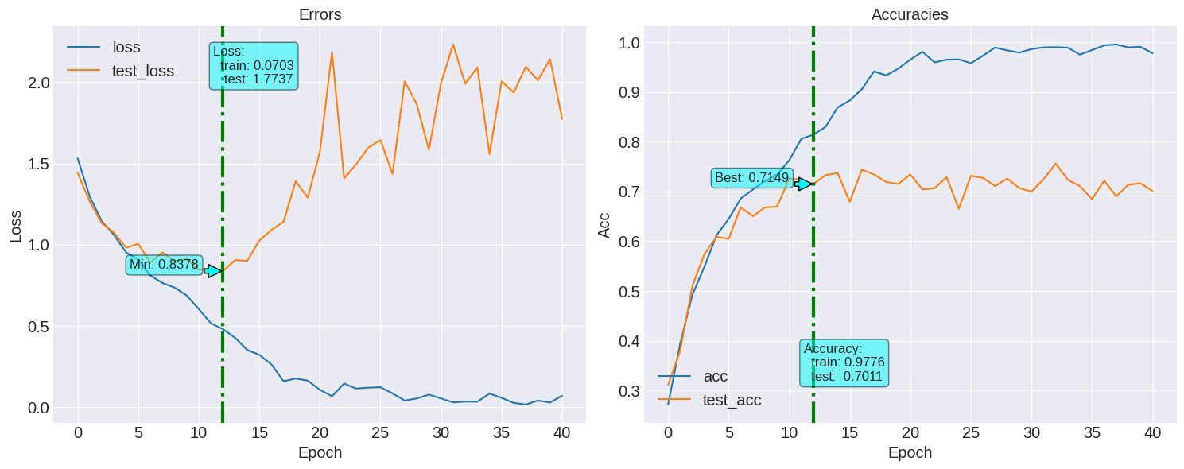
Training accuracy : 0.9895
Testing accuracy : 0.7011

Training accuracy : 0.9895
Testing accuracy : 0.7011

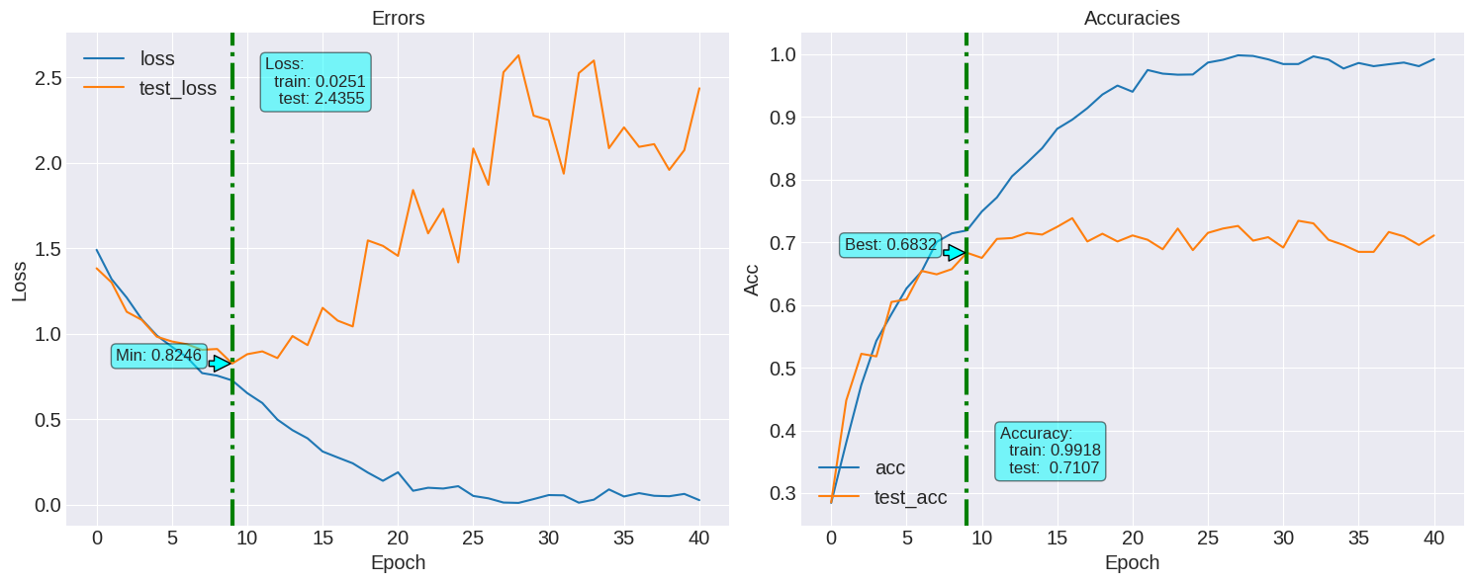
Training accuracy : 0.9983
Testing accuracy : 0.7107
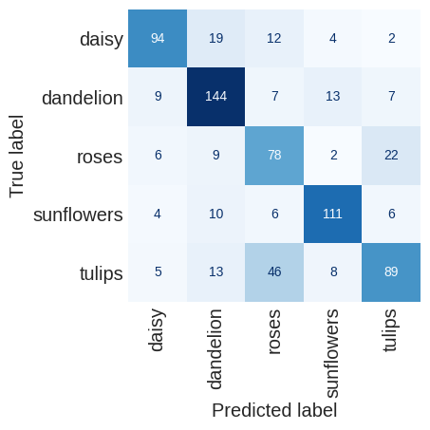
f1 score : 0.7110388347774391 with L2 Regularizer

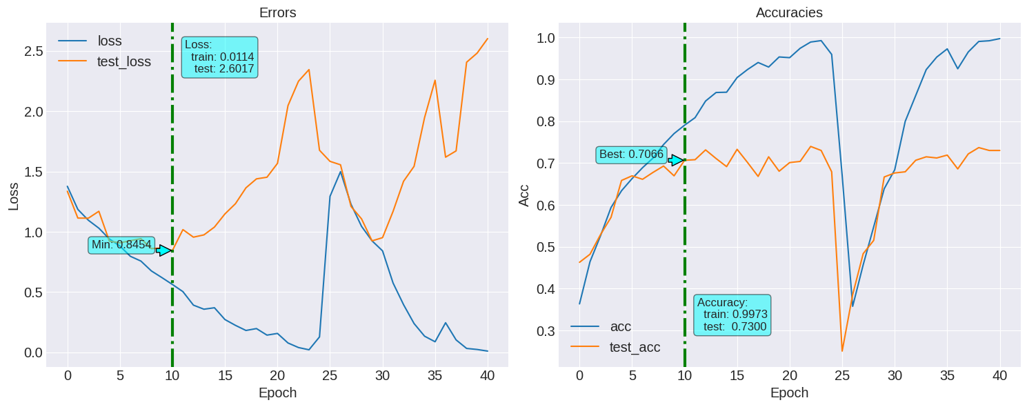
Training accuracy : 0.9969
Testing accuracy : 0.7300

F1 score:0.7282955616957342

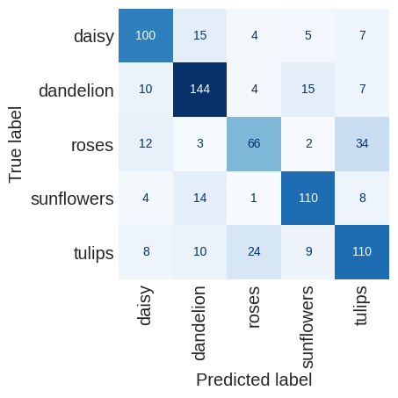

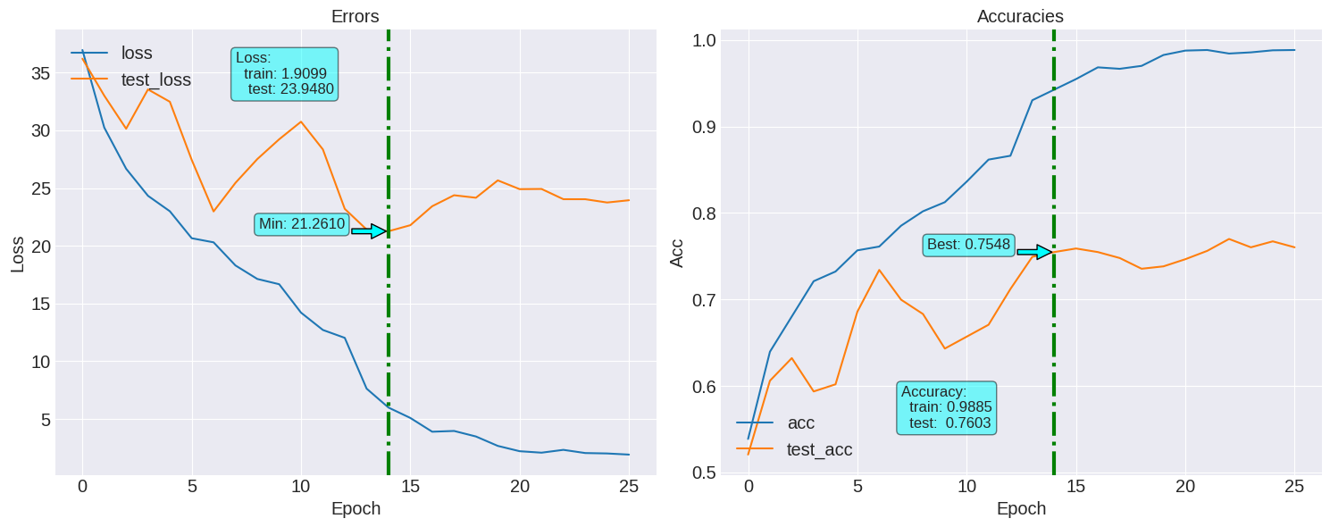

Model : Dropout rate 0.1 flat before maxpool

Training accuracy : 0.9806
Testing accuracy : 0.7603

F1 score:0.7595060800850393
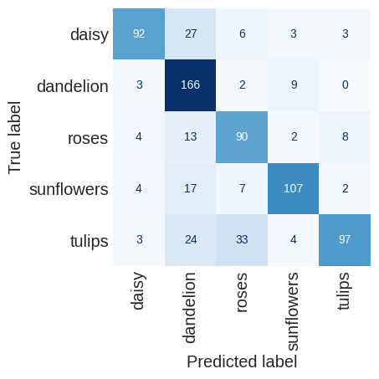

Model : Dropout rate 0.1 flat after maxpool

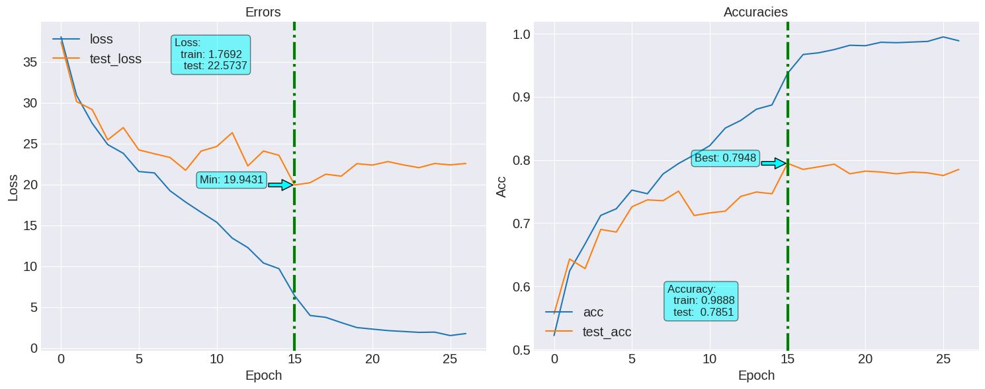
Training accuracy : 0.9990
Testing accuracy : 0.7851

F1 score:0.7856471792052404

Model with incremental dor (0.10 to 0.45) (after maxpool)

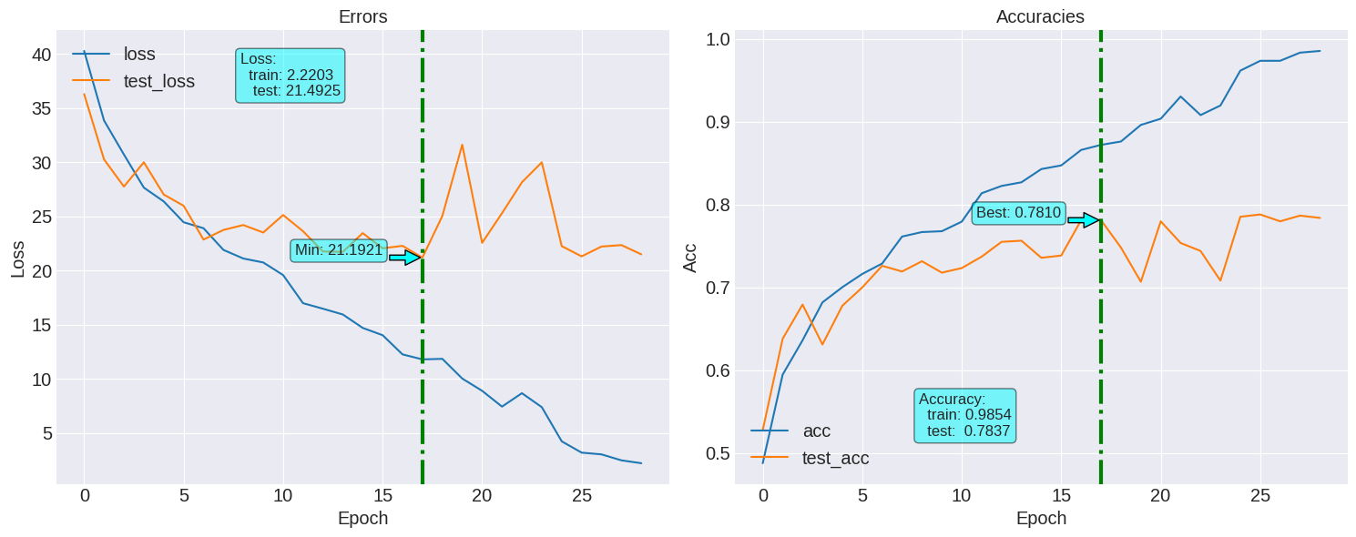
Training accuracy : 0.9997
Testing accuracy : 0.7837

F1 score:0.784124867074639
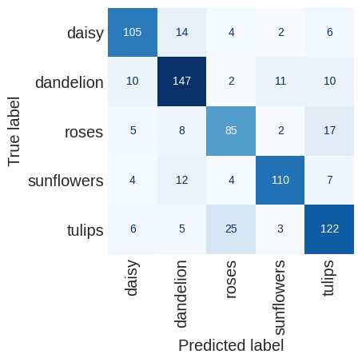

Model with incremental dor (0.1, 0.1, 0.2, 0.2, 0.3, 0.3, 0.5, 0.5) (after maxpool)

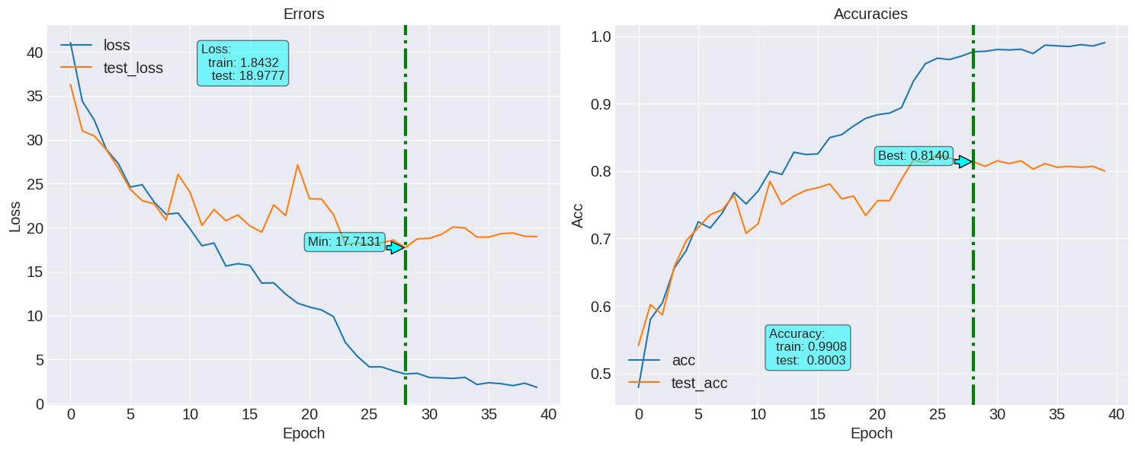
Training accuracy : 0.9997
Testing accuracy : 0.8003

F1 score:0.8004280342762399

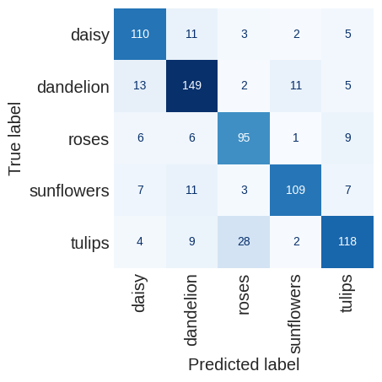

Model with incremental dor (0.1, 0.1, 0.2, 0.2, 0.5, 0.5, 0.5, 0.5) (after maxpool)
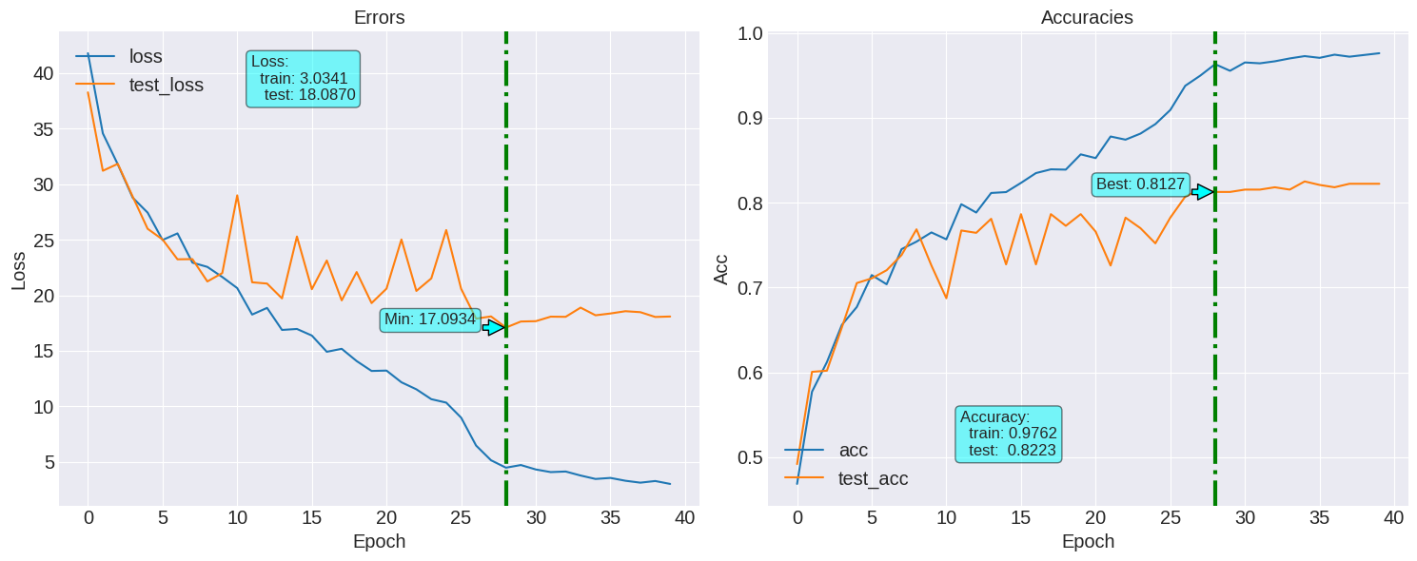

Training accuracy : 0.9986
Testing accuracy : 0.8223

F1 score:0.8229630244915562

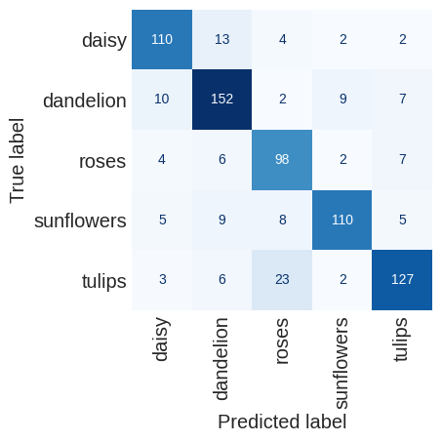

Model with incremental dor (0.1, 0.1, 0.2, 0.2, 0.5, 0.5, 0.6, 0.6) (after maxpool)
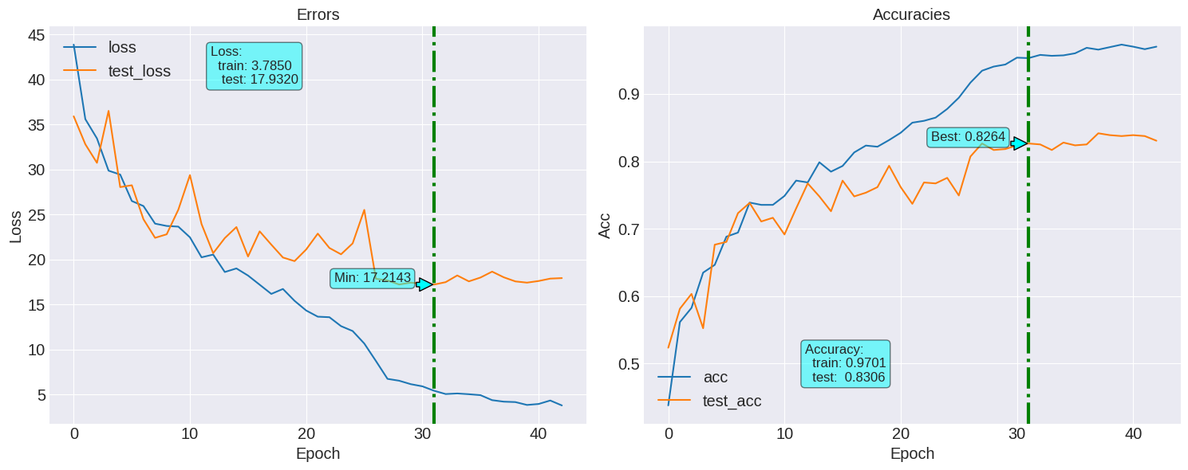
Training accuracy : 0.9973
Testing accuracy : 0.8306

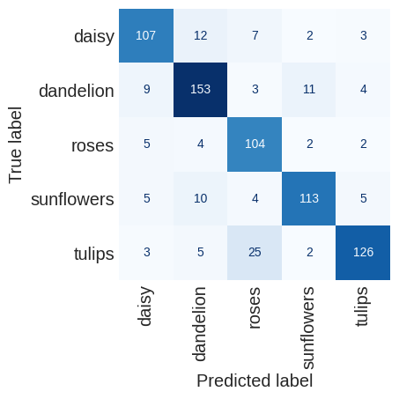
F1 score:0.8312603343425018

Model with dor(0.1, 0.1, 0.1, 0.1, 0.6, 0.6, 0.6, 0.6) with AdamW(1e-2)
After maxpool

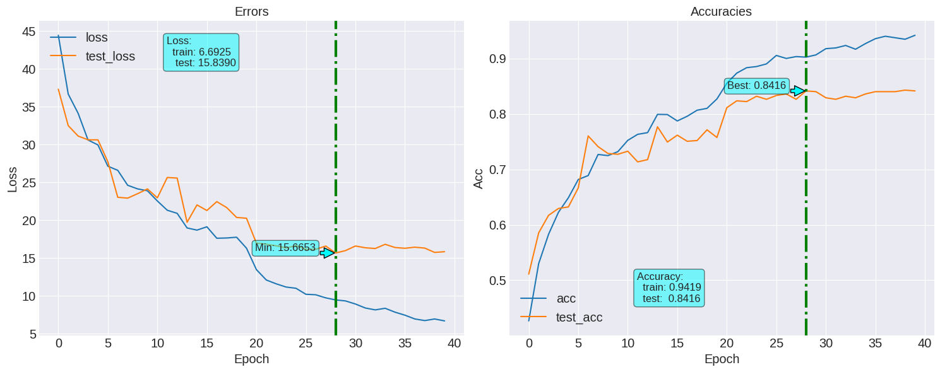
Training accuracy : 0.9857
Testing accuracy : 0.8416

F1 score:0.8428061683322265

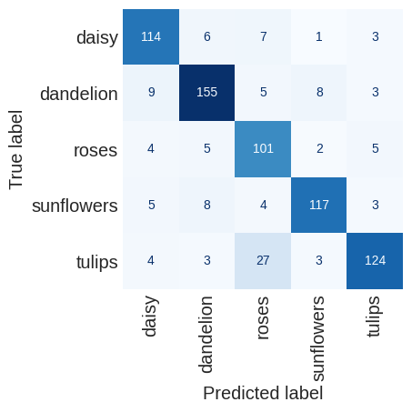

Training accuracy : 0.9925
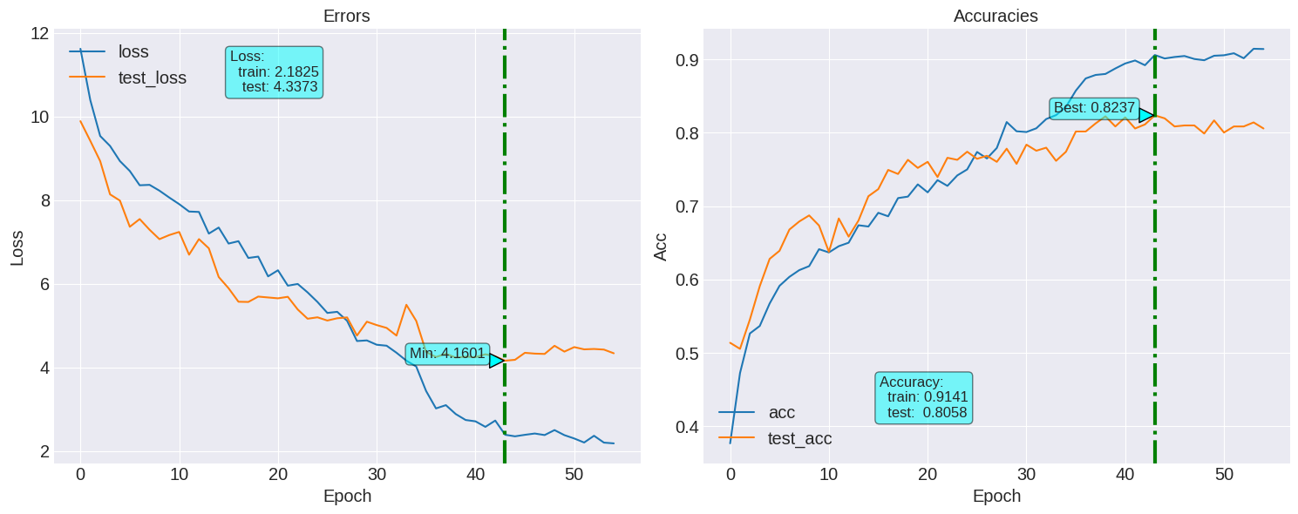
Testing accuracy : 0.8058

F1 score:0.8063610258255933

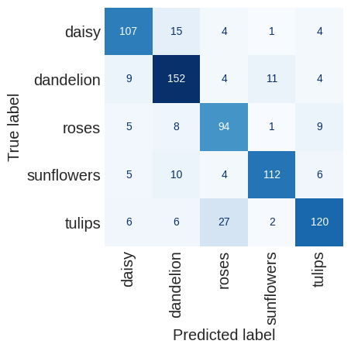
Model with batch size = 8 and weight = 1e-2

