PROPOSAL
PSS/E Modeling, HILL Form & One-Line — Arkansas Data Center Project
SPP | ATTACHMENT AX / HILL SUBMISSION
PREPARED FOR
IntelliQuest Energy Consulting
PREPARED BY
Continuum Associates LLC
12343 Preakness Circle Ln Clarksville, MD 21029
www.continuum-associates.com | (T): 617 756 1499
October 4, 2026
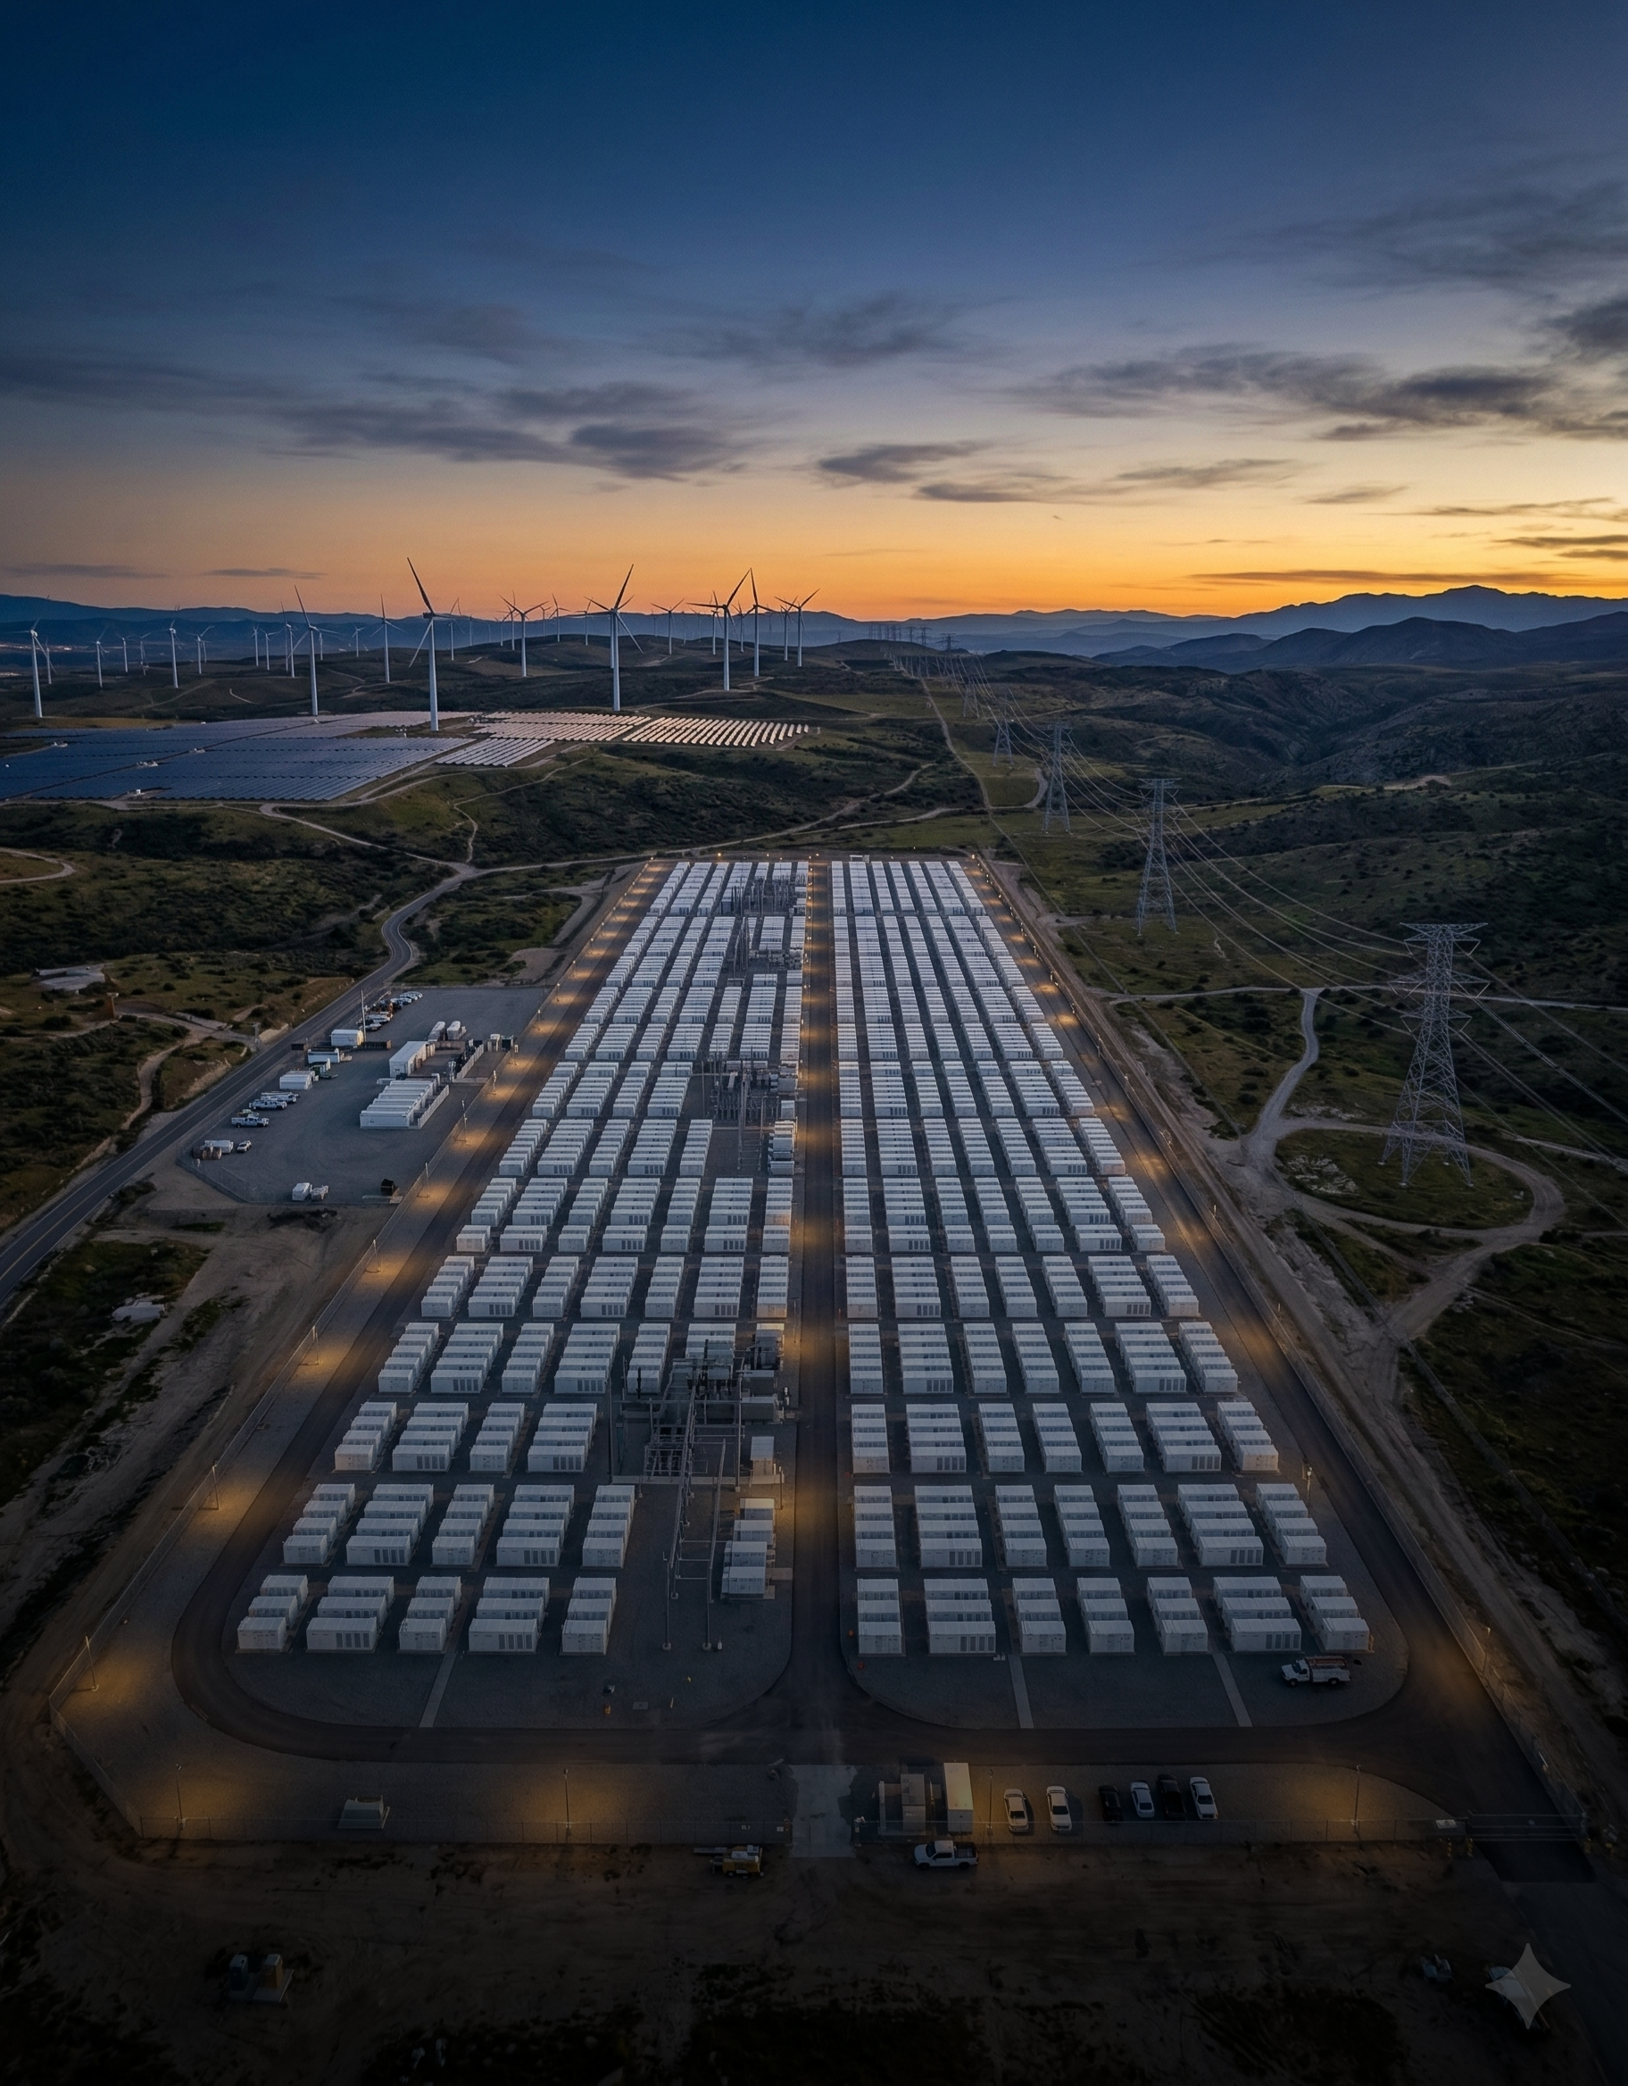


CONFIDENTIALITY NOTICE

This proposal and the engagement details contained herein constitute confidential and proprietary information and methodology of Continuum Associates LLC (“CA LLC”) and are provided to IntelliQuest Energy Consulting on the condition that the recipient will hold them in strict confidence and not reproduce, disclose, forward, or distribute them in whole or in part without the prior written consent of CA LLC. Study methodology, modeling basis, and results are for use by IntelliQuest Energy Consulting, its client, and their subsidiaries only. Results produced under this engagement may include Confidential Energy Infrastructure Information [CEII] and should not be disclosed or transmitted to any third parties.

Table of Contents

Table of Contents 3
1. About Continuum Associates LLC 4
2. Background & Objective 5
3. Scope of Work 6
4. Schedule 8
5. Fee Proposal 8
6. General Terms and Conditions of Engagement 9
7. Acceptance and Signatures 11

About Continuum Associates LLC
Continuum Associates (CA) is a leading renewable energy project development consulting and advisory firm with an extensive focus on grid technical and analytical studies. Formed in April 2011, CA focuses extensively on project development services related to renewable and clean energy power projects across North America and the world. CA provides engineering, technical, and quant‐heavy services for power project development from concept to completion. The CA team brings together cumulative project experience of 200+ years and has worked across the length and breadth of renewable energy technologies, including offshore and onshore wind, solar PV, and battery energy storage projects. CA team has developed extensive expertise in grid-related studies and analysis for renewable energy projects in all ISOs and RTOs across North America, which include ISO‐NE, NYISO, MISO, PJM, SPP, ERCOT, and CAISO, and non-ISO areas such as Hawaii Electric Company (HECO), Florida, SERC amongst others.
At Continuum Associates, our expertise extends beyond renewable energy technologies. We have a rich history of working with traditional power generation resources such as natural gas-fired power generation and hydropower generation. This comprehensive understanding of the energy industry, combined with our technical expertise, allows us to provide transaction advisory and financial advisory services for power projects, ensuring their successful financial close and implementation.
Genesis of CA’s strong technical expertise lies in the work that we have performed for utilities, power transmission and distribution companies, Independent System Operators (ISOs), Regional Transmission Organizations (RTOs), and equipment manufacturers. CA Principals have deep-rooted expertise in the ISO and RTO tariffs and processes. We understand the risks and opportunities that are embedded in the ISO tariffs and in their market and tariff construct, and have advised several solar PV, BESS, and wind developers on navigating the complex ISO processes and tariffs across the US.
CA has completed interconnection and advanced grid studies for over 300 GW of conventional and renewable capacity. These have included grid integration studies such as power flow, short circuit, and dynamic stability analysis, and economic studies such as production cost modeling in support of asset valuation, power purchase agreements, and transmission congestion and curtailment assessment. Beyond system-level studies, CA performs extensive data analytics on grid datasets to support project siting, interconnection strategy, and grid upgrade evaluation.

PSS/E Modeling and Large Load Capability
CA has extensive experience developing complete PSS/E steady-state and dynamic models for both conventional and renewable generation facilities across multiple ISO/RTO jurisdictions, including SPP. Our expertise includes detailed generator, exciter, and turbine-governor modeling; plant-level aggregation techniques; and preparation of submission-ready model packages that meet ISO technical and procedural requirements.
CA is currently supporting IntelliQuest Energy Consulting on the Arkansas Data Center Shadow Study, including FCITC analysis and grid-import assessment at the Fox Penn substation for the 2030 and 2035 study years. CA has also previously developed SPP PSS/E model packages for IntelliQuest for a hybrid gas-fired generation facility under the Attachment AX and High Impact Large Load Generation Assessment (HILLGA) process. This direct familiarity with the project, the study cases, and the SPP large load submission requirements allows CA to deliver the package efficiently and at minimum cost.
CA has supported developers, utilities, and investors including TotalEnergies, Equinor, SSE Renewables, Copenhagen Infrastructure Partners, EDP Renewables, US Wind, Corio Generation, Macquarie, Morgan Stanley, Goldman Sachs, LS Power, and Greenbacker Capital. Additional project references are available at www.continuum-associates.com.

Background & Objective
IntelliQuest Energy Consulting’s client is developing a large data center campus in Arkansas served from the Fox Penn substation within the SPP footprint. The campus will be supplied by a combination of grid import and on-site gas-fired generation, with an interim 2030 stage and a final 2035 buildout, as summarized below.
Study Year | Data Center Load (GW) | On-Site Gas Generation (GW) | Grid Import (GW)
2030 | 2.85 | 1.35 | 1.5
2035 (final buildout) | 4.5 | 2.0 | 2.5

The client will submit an SPP Attachment AX application and the associated High Impact Large Load (HILL) information. To keep the effort high level and cost-effective, IntelliQuest has requested a single model package representing the final 2035 buildout, rather than separate models for each study year. Loads, 230 kV substations, and generation blocks will be uniquely identified so that SPP can exclude the appropriate elements to derive the 2030 case.
In the absence of selected generation developers and OEM data, the on-site generation will be represented using Baker Hughes Frame 5 gas turbine units rated approximately 30–40 MVA each, resulting in approximately 50–70 units arranged according to the on-site 230 kV substations and the number of data center buildings served. The client understands that a revised AX application, and a corresponding revision of the models, will be required once the generation developers and data center off-takers are identified.
The objective of this engagement is to prepare a submission-ready PSS/E steady-state and dynamic model package, HILL Characteristics Form, and substation one-line diagram for the 2035 final buildout, together with a short modeling memo explaining how SPP can derive the 2030 configuration.

Scope of Work
CA will develop one model package representing the 2035 final buildout (4.5 GW load, 2.0 GW on-site gas, 2.5 GW grid import), structured so that SPP can derive the 2030 case by excluding identified loads, substations, and generation blocks. The scope comprises:

Data Review and Modeling Basis
CA will review the data provided by IntelliQuest and its client, including the site layout, number and size of data center buildings, on-site 230 kV substation arrangement, and the Fox Penn interconnection details. Where data is not available, CA will develop reasonable, documented assumptions for transformer impedances, line/cable parameters, and plant arrangement, consistent with the high-level intent of this submission.

PSS/E Steady-State Model Development
CA will develop the steady-state model (.raw / .sav) for the 2035 final buildout, including the on-site 230 kV substations, step-up and step-down transformers, interconnecting lines to Fox Penn, data center loads, and on-site generation. Key features:
- Data center loads represented at each 230 kV substation at 0.97 power factor, with unique load IDs and substation names per building group.
- Approximately 50–70 Baker Hughes Frame 5 units (30–40 MVA each, 0.80–0.85 power factor) totalling 2.0 GW, grouped into generation blocks by 230 kV substation and buildings served.
- Verification of power balance, voltage profile, reactive capability, and solved case convergence.

PSS/E Dynamic Model Development
CA will develop a single set of .dyr files for the entire 2.0 GW of on-site gas generation using standard library models (e.g., GENROU synchronous machine, a standard exciter model, and GGOV1 or GAST turbine-governor) with typical parameters for Frame 5-class units. CA will confirm successful dynamic initialization and a stable no-disturbance (flat) run, followed by a basic fault simulation to demonstrate reasonable behavior.

2030 Case Mapping and Modeling Memo
CA will prepare a short Word document identifying the load IDs, substation names, and generation blocks to be excluded by SPP to represent the 2030 configuration (2.85 GW load, 1.35 GW on-site gas, 1.5 GW grid import). The memo will also summarize the modeling assumptions used.

HILL Characteristics Form
CA will complete one SPP HILL Characteristics Form for the 2035 final buildout, based on the developed models and the load and generation characteristics provided by the client.

Substation One-Line Diagram
CA will prepare one substation one-line diagram representing the 2035 final buildout, showing the Fox Penn interconnection, on-site 230 kV substations, transformers, generation blocks, and load groups, labelled consistently with the PSS/E model so the 2030 exclusions can be traced.

Assumptions and Exclusions
- Generation is modeled on Baker Hughes Frame 5 units as directed by IntelliQuest. A change in generator technology or OEM before model completion will be treated as a scope change.
- Dynamic models use generic library models with typical parameters. OEM-specific tuning, detailed governor/droop refinement, and PSCAD/EMT modeling are excluded.
- Data center loads are represented as static loads. Dynamic or composite load modeling is excluded unless specifically required by SPP, in which case it will be offered as a change order.
- Separate 2030 models, interim ramp-up years, and power flow, short circuit, or stability study work (including Subtasks 3.1 and 3.2) are excluded from this proposal.
- Model revisions arising from a future AX resubmission (after generation developers and off-takers are selected) are excluded and will be proposed separately.
- The one-line diagram is a planning-level drawing and will not be PE-stamped.

Deliverables
- One PSS/E steady-state model (.raw / .sav) of the 2035 final buildout, with uniquely identified loads, substations, and generation blocks.
- One set of PSS/E dynamic model files (.dyr) for the entire 2.0 GW of on-site gas generation.
- One SPP HILL Characteristics Form for the 2035 final buildout.
- One substation one-line diagram (PDF) for the 2035 final buildout.
- One modeling memo (Word) describing the 2030 exclusions and modeling assumptions.

Schedule
All deliverables will be issued within three (3) weeks of proposal execution, contingent on timely receipt of the site layout, building and load allocation, on-site substation arrangement, and any client-specific data required for the HILL Characteristics Form.
Milestone | Timing from Execution
Data review, modeling basis, and assumptions confirmed with IntelliQuest | Week 1
PSS/E steady-state (.raw / .sav) and dynamic (.dyr) models | Week 2
HILL Characteristics Form, one-line diagram, and modeling memo; final package issued | Week 3

Fee Proposal
CA will perform the scope of services described in Section 3 for a fixed lump sum fee of USD 22,500, broken down as follows:
Item | Fee (USD)
PSS/E steady-state model of the 2035 final buildout (230 kV substations, loads, 2.0 GW Frame 5 generation, 2030 block structure) | 9,500
PSS/E generic dynamic model (.dyr) for Frame 5 units, initialization and test simulations | 5,000
SPP HILL Characteristics Form | 3,000
Substation one-line diagram (2035 final buildout) | 3,500
Modeling memo with 2030 exclusion mapping and assumptions | 1,500
Total | 22,500

The fee is inclusive of all labor, software, and routine expenses required to develop, verify, and issue the package, and includes up to eight (8) hours of follow-on support in responding to IntelliQuest and SPP review comments and clarification requests. Additional support beyond that allowance will be provided at USD 250 per hour, on prior written authorization from IntelliQuest. Mobilization will commence immediately upon execution of this proposal, and invoicing and payment will follow the commercial terms set out in Section 6.

General Terms and Conditions of Engagement
A. Confidentiality: All data and information provided to the Client under this contract is confidential and protected under the Mutual NDA signed between Continuum Associates LLC and the Client, which is hereby incorporated by reference as if set forth verbatim herein.

B. Prohibition of Reverse Engineering: The Client agrees that it shall not, directly, or indirectly, engage in, authorize, or assist any third party in reverse engineering, decompiling, disassembling, or otherwise attempting to derive the source code, algorithms, methods, techniques, or processes contained in the data or materials that the CA LLC provides to the Client. The obligations under this clause survive the termination or expiration of this agreement in perpetuity.

C. Communication: Communication between the Client and CA LLC shall be through telephone, fax, email, ftp (Dropbox or Sync), live chat (Slack), courier or mail. All communication will be through the CLIENT-assigned point of contact(s).

D. Deliverables: As mentioned in Section 3 of the proposal.

E. Schedule for Deliverables: We understand that compliance with the agreed deadlines is a relevant issue for the Client, and CA will do everything within our ability to expedite this project to the extent possible. At this time, the schedule for completing the scope of work outlined in this contract is provided in Section 4.0.

F. RFI: We will submit our RFI (Request for Information), by fax, email, or ftp (Dropbox), with a reasonable time to respond. If the requested information is not received promptly, work may be delayed.

G. CLIENT-Review of Deliverables: CLIENT may review any or all of the CA deliverables. CA shall promptly take necessary action to address CLIENT concerns. CA will incorporate CLIENT review comments and update relevant documents as appropriate, within the above-stated project time schedule.

H. Standard of Care and Professional Responsibility: CA will exercise reasonable skill, care, and diligence in the performance of its services and will carry out its responsibilities in accordance with customarily accepted professional practices. If CA fails to meet the foregoing standard, CA will perform at its own cost the professional services necessary to correct errors and omissions reported to CA in writing within one year from the completion of CA's services for the Project.

I. Modification: The Client shall have the right to make changes within the general scope of CA's services, with an appropriate change in compensation and schedule, upon execution of a mutually acceptable amendment or change order.

J. Term: This Agreement shall come into effect on the date set forth herein and shall remain in full force and effect until all Deliverables are delivered, or the Work is otherwise completed and paid for in full or terminated earlier by the parties’ mutual agreement.

K. Law and jurisdiction: This agreement shall be governed by and construed exclusively in accordance with the laws of New Jersey, without regard to principles of conflict of law. The parties shall use their reasonable efforts to resolve any claim or dispute arising out of or relating to this Agreement through negotiation within a reasonable time. Should the parties fail to resolve any claim or dispute by negotiations, the dispute shall be exclusively subject to the jurisdiction of the courts of New Jersey.

L. No assignment: Neither the Client nor CA shall assign or transfer interest in this Agreement without the written consent of the other.

M. Insurance: Both parties should maintain adequate insurance coverage for general and professional liabilities and their relevant personnel under the agreement, for such amounts and on such terms as are standard in their respective industries and with underwriters who are in good standing.

N. Validity of Proposal: Five days from the date of submittal.

Commercial Terms and Conditions:
1. Invoicing & Payment: CA will submit invoices via e-mail (as .pdf files) once the Client confirms that the deliverables are as agreed, or once 7 days have passed since the Client received the deliverables without any objections (whichever is earlier). Payment of the invoiced amount will be due upon receipt.

2. Expenses: All expenses will be billed at cost, and mileage-related expenses will be billed per IRS rules and regulations, provided that these expenses are approved in advance

3. Payment Terms: Continuum Associates LLC’s payment terms are 30 days. Any pending invoice amount outstanding for more than 30 days will incur an invoice finance charge of 1.5 percent per month.

Acceptance and Signatures
IN WITNESS WHEREOF, authorized representatives of both Continuum Associates LLC and IntelliQuest Energy Consulting have executed this agreement as of the date set forth above.

Continuum Associates LLC | IntelliQuest Energy Consulting
By: | By:
Name: Bir I. Kaur | Name:
Position: CEO | Position:
Date Executed: October 4, 2026 | Date Executed:

Signing on behalf of Bir I. Kaur
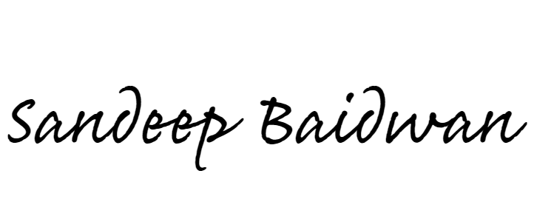
SANDEEP BAIDWAN
October 4, 2026

