# The Battle of Neighbourhoods

## **Exploring the Hyderabad for a Restaurant Business Opportunity**

### **Coursera Applied Data Science Capstone Project**

**Week: 4 Submission – Introduction and Data**

**By**

**Kurapati Venkatesh**

**20 August 2021**

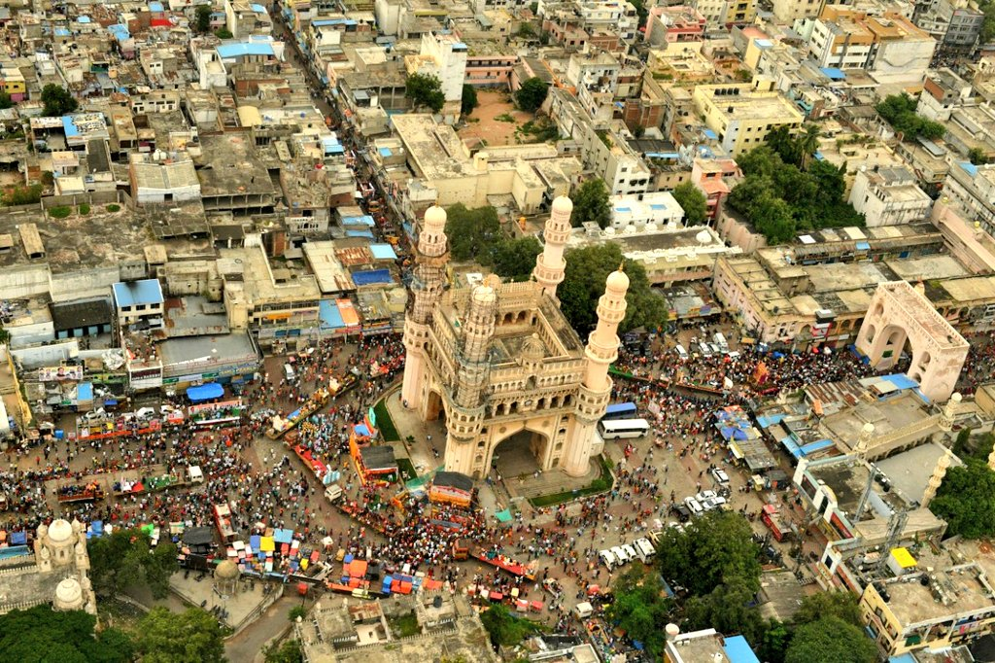

## **Introduction:**

The purpose of this Project is to help clients in exploring better opportunities around the City. It will help people making smart and efficient decisions on selecting great places for their investments in Restaurant business.

Restaurants is a service business and it is a place where people are come and pay for sitting and eating meal, India’s extensive cuisine is an amalgamation of influences from various cultures and traditions. Its popularity put the country on the global culinary map with [some chefs](https://www.statista.com/statistics/1127104/india-best-paid-chefs-by-earnings/) earning prestigious awards for their restaurants. Furthermore, restaurants and hotels accounted for the highest [consumption among food services market](https://www.statista.com/statistics/913028/india-consumption-value-of-restaurant-and-hotel-food/) across the country in financial year 2020. Increasing disposable incomes, urban lifestyles and an expanding market [allowed forgoing home cooked meals occasionally](https://www.statista.com/statistics/1126076/motivation-for-online-food-orders-india/). A symbiotic growth between the food industry and the growing middle class rendered the success of Indian restaurants.

A [location](https://www.restaurantindia.in/restaurant/restaurant-businesses-are-seeing-aerocity-as-the-prime-location-ingredient-in-delhi.12678) should be a prime concern. It is not that people do not travel for food. There are instances where people plan to travel 25 km for a restaurant and end up not attending due to traffic and might get late. There is a need to be very careful while choosing a location keeping an eye on the footfall available in that area - is it a business estate or a residential. So, the location is the one of the most important decisions that will determine whether the restaurant will be a success or a failure.

**Business Problem:**

The objective of this capstone project is to analyse and select the best locations in the Hyderabad city of Telangana, India to open a new Restaurant. Using data science methodology and machine learning techniques like clustering, this project aims to provide solutions to answer the business question: In the Hyderabad city of Telangana, India, if a property developer is looking to open a new restaurant, where would you recommend that they open it?

**Target Audience of this project:**

This project is particularly useful to Start-ups and investors looking to open or invest in new restaurants in the capital city of Telangana, India i.e. Hyderabad. This project is timely as the city is currently suffering from oversupply of restaurants. The Indian Restaurant Market is one of the fastest-growing in the world. It is expected to reach [INR 5.99 lakh crore by 2022-23](https://www.financialexpress.com/industry/food-service-industry-to-touch-rs-5-99-lakh-cr-mark-by-fy23/1605752/#:~:text=The%20overall%20Indian%20food%20service,lakh%20crore%20in%202018%2D19.), growing at a compounded annual growth rate of 9 percent, as per the National Restaurant Association of India (NRAI) report. Despite the hardships and challenges faced by restaurant owners in recent years, opening a restaurant in the near future would bring a host of new opportunities for budding restaurant owners. 

The restaurant business is quickly boost upping and growing fast nowadays mainly two factions are involved one is customer that means buyer and other is seller. Customers focused on service, quality, price and so many other factors while seller only wants to earn money. Nowadays restaurant business producing a lot with very little waste and various type of appropriate catering and restaurant services includes celebration of every event or a party. Even if it is a birthday party celebration, farewell parties for universities and colleges ,happy new -year party, social and culture related parties, traditional, wedding catering related to big business or political event - quality and delicious food serving is a must to complete the event.

**Data:**

To solve the problem, we will need the following data:

* List of neighbourhoods in Hyderabad. This defines the scope of this project which is confined to the city of Hyderabad, the metropolitan city of the country of India in South Asia.
* Latitude and longitude coordinates of those neighbourhoods. This is required in order to plot the map and also to get the venue data.
* Venue data, particularly data related to restaurants. We will use this data to perform clustering on the neighbourhoods.

**Sources of data and methods to extract them:**

This Wikipedia page – (<https://en.wikipedia.org/wiki/List_of_neighbourhoods_in_Hyderabad>) contains a list of neighbourhoods in Hyderabad, with a total of 50+ neighbourhoods. We will use web scraping techniques to extract the data from the Wikipedia page, with the help of Python requests and beautifulsoup packages. Then we will get the geographical coordinates of the neighbourhoods using Python Geocoder package which will give us the latitude and longitude coordinates of the neighbourhoods.

After that, we will use Foursquare API to get the venue data for those neighbourhoods. Foursquare has one of the largest database of 105+ million places and is used by over 125,000 developers. Foursquare API will provide many categories of the venue data, we are particularly interested in the Restauarant category in order to help us to solve the business problem put forward. This is a project that will make use of many data science skills, from web scraping (Wikipedia), working with API (Foursquare), data cleaning, data wrangling, to machine learning (K-means clustering) and map visualization (Folium). In the next section, we will present the Methodology section where we will discuss the steps taken in this project, the data analysis that we did and the machine learning technique that was used.