**Results**

**Summary of Main Findings**

- I found a weak positive correlation (0.04) between Median Household Income and COVID-19 Infection Rate, but it was not statistically significant.

- There was a weak negative correlation (-0.01) between the Percentage of Population Vaccinated and Infection Rate, which was also not statistically significant.

**Graphical Representations**

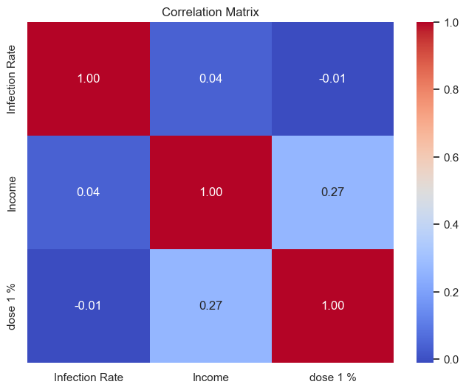

**Statistical Results**

- Coefficient for Median Household Income: 0.0061 (p-value: 0.676)

- Coefficient for Percentage of Population Vaccinated: -8.4253 (p-value: 0.835)

- Intercept: 31585.91

**2T-test results**

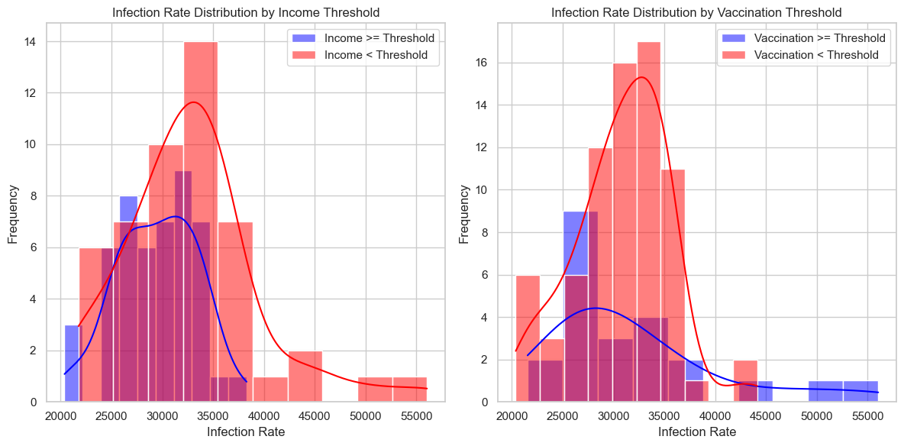

**T-Test Results for Income Thresholds:**

T-Statistic: -2.9718415514397916

-This t-statistic measures the difference in the means of infection rates between counties with median household income above the threshold and those below the threshold.

-A negative t-statistic suggests that counties with higher incomes have, on average, lower infection rates.

P-Value: 0.003749941062923792

-The p-value represents the probability of observing such a difference in means by random chance.

-In this case, the p-value is less than 0.05, indicating that the difference in means is statistically significant at a 5% significance level. Therefore, income appears to have a significant effect on infection rates.

**T-Test Results for Vaccination Thresholds:**

T-Statistic: 0.8375038137576495

-This t-statistic measures the difference in the means of infection rates between counties with a percentage of the population vaccinated above the threshold and those below the threshold.

-The positive t-statistic suggests that there is a slight difference in means, but it is not as pronounced as in the income threshold test.

P-Value: 0.4044114709769113

-The p-value for this test is greater than 0.05, indicating that the difference in means is not statistically significant at a 5% significance level. This suggests that vaccination rates may not have a significant effect on infection rates.

**Interpretation**

These findings suggest that income and vaccination rates have very weak and statistically insignificant associations with COVID-19 infection rates at the county level.

**Limitations**

It's important to note that this analysis is based on limited sample data and may not capture the full complexity of the relationships.

**Next Steps**

Future research could explore additional variables (Population Density, Travel and Commuting Patterns, Viral Variants. Etc) and conduct more in-depth analyses to better understand the factors influencing COVID-19 infection rates.

**Conclusion**

While our analysis did not find strong associations between income, vaccination rates, and infection rates as expected, it provides a foundation for further investigation into the socioeconomic impact on the spread of COVID-19.